Force and Laws of motion-

“Nothing happens until something moves.”

List of concept names-
- Introduction to Motion
- Force
- Balanced and Unbalanced Forces
- Inertia
- Newton's First Law of Motion
- Momentum
- Newton's Second Law of Motion
- Acceleration
- Newton's Third Law of Motion
- Applications of Newton's Laws
- Important Formulae

Motion-
Motion is the change in position of an object with respect to time. Everything around us is either at rest or in motion. Cars moving on roads, birds flying in the sky, and planets revolving around the Sun are all examples of motion. Understanding motion helps us explain how objects move and why they change their speed or direction.
The study of motion became more scientific with the work of Sir Isaac Newton, who developed three laws that explain the relationship between force and motion.
Examples of Motion
- A bicycle moving on a road
- A ball rolling on the ground
- Earth revolving around the Sun

Force-
Force is a push or a pull acting on an object. It is responsible for changing the state of motion or shape of an object.
Effects of Force-
- Can start motion.
- Can stop motion.
- Can change speed.
- Can change direction.
- Can change shape and size.
Examples-
- Kicking a football.
- Opening a door.
- Pulling a suitcase.
- Stretching a rubber band.

BALANCED AND UNBALANCED FORCES

Balanced Forces-
Balanced forces are equal in magnitude but opposite in direction.
When balanced forces act on an object, the net force becomes zero and the object does not change its state of motion.
Example
Two teams pulling a rope with equal force.
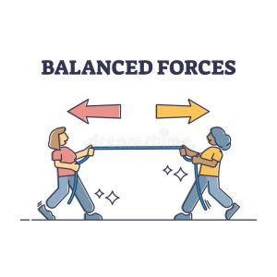

Unbalanced Forces-
When forces acting on an object are unequal, the net force is not zero.
This causes a change in motion.
Example
One team pulling harder in a tug-of-war.
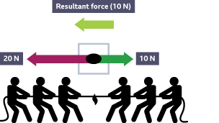

After putting both the cases together, we see-
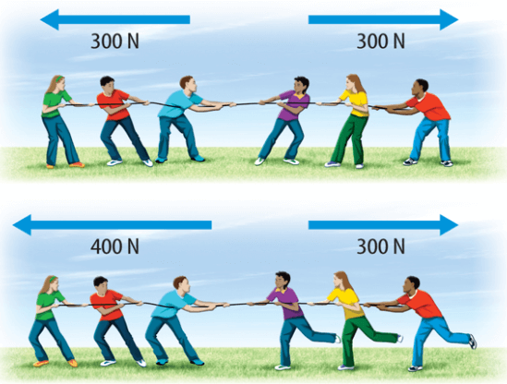

INERTIA-
Inertia is the tendency of an object to resist any change in its state of rest or motion.
The greater the mass of an object, the greater its inertia.

Types of Inertia-
Inertia of Rest
The tendency of an object at rest to remain at rest.
Example
Passengers fall backward when a bus starts suddenly.
Inertia of Motion
The tendency of a moving object to continue moving.
Example
Passengers fall forward when a bus stops suddenly.
Inertia of Direction
The tendency of an object to maintain its direction of motion.
Example
Passengers experience a sideways jerk when a bus takes a sharp turn.

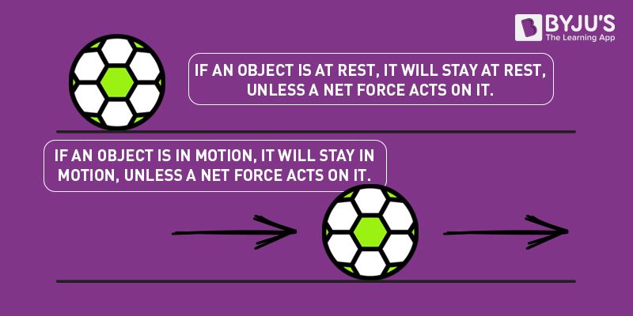

NEWTON'S FIRST LAW OF MOTION-
”It states that an object at rest will remain at rest, and an object in motion will continue moving in a straight line with constant velocity, unless acted upon by a net external force.”
This law is also known as the Law of Inertia.
- Objects do not change their state of motion on their own. A force is required to change their motion.
Real-Life Examples
- A book remains on a table until pushed.
- Dust comes out when a carpet is beaten.
- Fruits fall when tree branches are shaken.
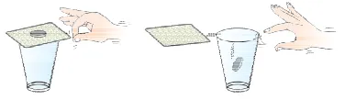
(the coin resists in the change of motion that’s why it falls in the glass)

MOMENTUM-
Momentum is a fundamental concept in physics defined as the product of an object's mass and velocity. It is a vector quantity meaning it possesses both magnitude and direction.
Formula
P = mv
Where:
p = Momentum
m = Mass
v = Velocity
- The SI unit of momentum is kg m/s.
Examples-

- A truck has greater momentum than a bicycle.
- A fast-moving cricket ball has more momentum than a slow-moving one.
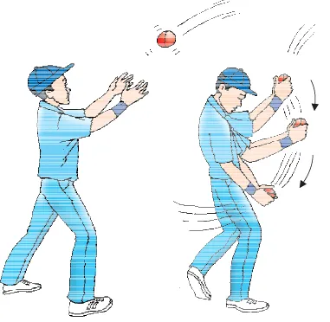

NEWTON'S SECOND LAW OF MOTION-

“It states that the rate of change of momentum of a body is directly proportional to the applied force and takes place in the direction in which the force acts.”
This law explains how force affects motion.
Mathematical Formula
F = ma
Where:
- F = Force
- m = Mass
- a = Acceleration
or
F = m (v- u) / t
- F = Force
- M = mass
- U = initial velocity
- V = final velocity
- T= time taken
Or
Ft = mv – mu
(This formula may sound confusing so here’s the derivation.)
Step 1: Write Initial and Final Momentum
Initial Momentum:
P₁ = mu
Final Momentum:
P₂ = mv
Step 2: Find Change in Momentum
Change in Momentum = p₂ – p₁
=mv – mu
=m (v−u)
Step 3: Find Rate of Change of Momentum
Rate of Change of Momentum means:
Change in Momentum​/ Time taken
= mv- mu / t
Step 4: Apply Newton's Second Law
Newton’s second law states = F = mv – mu/ t
Multiply both sides by t = Ft = mv - mu

[NOTE- A greater force produces greater acceleration.
A larger mass requires more force to accelerate.]
Applications
- Airbags in cars.
- Catching a cricket ball.
- Pushing loaded carts.

ACCELERATION-
Acceleration is the rate of change of velocity.
Formula – a = v-u/t
Where:
- u = Initial Velocity
- v = Final Velocity
- t = Time
SI Unit
m/s²
Example
A car increases its speed from 10 m/s to 20 m/s in 5 seconds.
Acceleration = 2 m/s²
Questions-
- A constant force acts on an object of mass 5 kg for a duration of 2 s. It increases the object’s velocity from 3 m/s ⁻¹ to 7 m/s⁻¹. Find the magnitude of the applied force. Now, if the force was applied for the duration of 5 s, what would be the final velocity of the object.
Ans- We have been given that u= 3 m/s⁻¹
V = 7 m/s⁻¹, t = 2 s and m = 5g.
F= m (v-u)/ t
Hence
F= 5kg ( 7 m/s⁻¹ – 3 m/s ⁻¹) / 2s = 10 N
[NOTE- Newton (N) is the SI unit of force.]
[One Newton is the force required to produce an acceleration of 1 m/s² in an object of mass 1 kg.]
Now, if this force is applied for a duration of 5 s (t= 5s) then the final velocity can be calculated by rewriting the eq.
V = u + ft/m
On substituting the values of u, f, m and t, we get the final velocity,
V = 13 m/s⁻¹
- A force acts on a 4 kg body for 5 seconds. Its velocity changes from 2 m/s to 12 m/s. Find the force.
= Ft = mv−mu
F (s) = (4)(12) – (4) (2)
5F = 48-8
5F = 40
F= 8 N.

NEWTON'S THIRD LAW OF MOTION
"For every action, there is an equal and opposite reaction."
Whenever one object exerts a force on another object, the second object exerts an equal force in the opposite direction.
Examples
- Walking
- Swimming
- Rocket launch
- Recoil of a gun
- Rowing a boat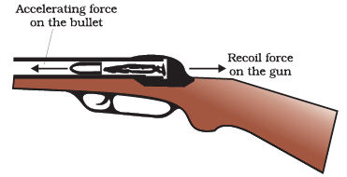
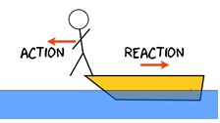CONSERVATION OF MOMENTUM-
"The total momentum of an isolated system remains constant if no external force acts on it."
Formula - m₁​u₁​+m₂​u₂​=m₁​v₁​+m₂​v₂​
Applications
• Rocket propulsion
• Gun recoil
• Collision of vehicles

APPLICATIONS OF NEWTON'S LAWS-
In Transportation
- Seat belts prevent injuries.
- Airbags reduce impact force.

In Sports
- Cricket players pull hands backward while catching a ball.
- Football players apply force to move the ball.

In Space Technology
- Rockets move using Newton's Third Law.
In Daily Life
- Walking
- Swimming
- Jumping from boats
- Dusting carpets

IMPORTANT FORMULAE
Formula | Meaning
p = mv | Momentum
F = ma | Force
a = (v-u)/t | Acceleration
m₁u₁ + m₂u₂ | = m₁v₁ + m₂v₂ Conservation of Momentum

PRACTICE QUESTIONS
Short Answer Questions
- Define force.
- What is inertia?
- State Newton's First Law.
- What is momentum?
- State Newton's Third Law.
- What is meant by an unbalanced force?
- Explain the role of force in changing the state of motion of an object.
- What is momentum?
- state Newton's Second Law of Motion.
- Define one Newton.
- Why do airbags reduce injuries during accidents?
- What are action and reaction forces?
- Do action and reaction occur simultaneously?
- Explain walking using Newton's Third Law.
- How does a rocket move upward?

Long Answer Questions
- Explain the three types of inertia.
- Explain conservation of momentum.
- Describe Newton's Laws with examples.
- Why do passengers fall backward when a bus starts suddenly?
- Why does dust come out of a carpet when it is beaten?
- Why does a heavier object require more force to accelerate?
- A 4 kg body changes its velocity from 2 m/s to 14 m/s in 6 seconds. Calculate the force applied.
- A 10 kg trolley moving at 5 m/s reaches 15 m/s in 5 seconds. Calculate the force acting on it.
- A car of mass 1200 kg accelerates at 3 m/s². Find the force produced.
- A truck of mass 5000 kg moves at 8 m/s. Calculate its momentum.

HOTS (HIGHER ORDER THINKING SKILLS)
- Why is it easier to stop a bicycle than a truck moving at the same speed?
- Why do athletes bend their knees after landing from a jump?
- Why are roads made rough near sharp turns?
- Why does a person standing in a bus move sideways when the bus turns suddenly?
- Why does a rocket work in space where there is no air?
- If action and reaction are equal and opposite, why doesn't a person remain stationary while walking?
- Why does a loaded truck have more momentum than a motorcycle moving at the same speed?
- Why is catching a fast-moving ball difficult?

Worksheet-
- The SI unit of force is:
- Joule
- Newton
- Watt
- Pascal

- Momentum is the product of:
(a) Mass and acceleration
(b) Force and time
(c) Mass and velocity
(d) Velocity and acceleration

3. Newton's First Law is also known as:
(a) Law of Gravitation
(b) Law of Inertia
(c) Law of Conservation
(d) Law of Motion

4. An object at rest remains at rest unless acted upon by:
(a) Balanced force
(b) Friction
(c) Unbalanced force
(d) Gravity

5. The formula for force is:
(a) $p=mv$
(b) $F=ma$
(c) $a=vt$
(d) $F=mv$

6. Which of the following has the greatest inertia?
(a) Football
(b) Bicycle
(c) Truck
(d) Tennis ball

7. For every action, there is:
(a) No reaction
(b) Equal and opposite reaction
(c) Greater reaction
(d) Smaller reaction

8. The SI unit of momentum is:
(a) Newton
(b) kg m/s
(c) m/s²
(d) Joule

9. A rocket moves upward due to:
(a) Gravity
(b) Friction
(c) Newton's Third Law
(d) Inertia

10. Momentum is a:
(a) Scalar quantity
(b) Vector quantity
(c) Unit
(d) Force

Section B: Fill in the Blanks
- The tendency of an object to resist changes in its state is called _________
- Force is equal to mass multiplied by __________.
- The SI unit of force is __________.
- Momentum is the product of mass and __________.
- Newton's First Law is known as the Law of __________.
- A moving bus stops suddenly and passengers fall forward due to inertia of __________
- The formula for momentum is __________.
- Action and reaction forces act on __________ objects.
- The total momentum of an isolated system remains __________.
- Airbags reduce injuries by increasing the __________ of collision.

Section C: True or False
- Balanced forces can change the state of motion of an object. ______
- Inertia depends upon mass. ______
- Momentum is a scalar quantity. ______
- Newton's Third Law applies to rocket propulsion. ______
- Action and reaction forces act on the same object. ______

Section D: Short Answer Questions
- Define force.
- What is meant by balanced forces?
- Why do cricket players pull their hands backward while catching a ball?
- What is meant by unbalanced forces?
- State Newton's Third Law of Motion.

Section G: Assertion and Reason
- Assertion (A): Passengers fall forward when a moving bus stops suddenly.
Reason (R): The upper part of the body tends to remain in motion due to inertia.
(a) Both A and R are true, and R is the correct explanation of A.
(b) Both A and R are true, but R is not the correct explanation of A.
(c) A is true, but R is false.
(d) A is false, but R is true.
2. Assertion (A): Rockets can move in space.
Reason (R): Rocket propulsion is based on Newton's Third Law of Motion.
(a) Both A and R are true, and R is the correct explanation of A.
(b) Both A and R are true, but R is not the correct explanation of A.
(c) A is true, but R is false.
(d) A is false, but R is true.

