**Project Deliverable 3 – User Manual**

**Faculty Name:** Information Technology

**Module Code:** ITECA3-B12

**Module Name:** Web Development and e-Commerce

**Content Writer:** Kariboba Mpwampu

**Copy Editor:** Mr Kyle Keens

**Submission Date:** Block 2 Week 5

|  |  |
| --- | --- |
| **Student Name** | Elle Reece Chetty |
| **Student Number** | C3WGVD453 |
| **Project Title** | RashidsFlorists |
| **Submission Date** | 14 June 2023 |

**Table of Contents**

3.1 Introduction 3

3.2 Basics: Accessing your website and Admin 4

3.3 Products: Adding, removing, and updating products 6

3.4 Changing menus 7

3.5 Shipping Options 7

3.6 The front page: adding and changing images. 7

3.7 Changing the logo 7

3.8 Orders 8

3.9 Updating a page on your site 8

3.10 Collecting money from the store 8

3.11 Checking Web Traffic and Statistics 9

3.12 Appendix 9

# Introduction

**3.1.1 Background**

Rashid's Florists is a family-owned business with a rich history spanning over 35 years. It all began in the charming town of Shallcorrss, where the founders, Rashid's parents, established a humble flower shop. With a passion for floral artistry and a deep understanding of customer needs, they laid the foundation for what would become a flourishing business.

Years later, Rashid, the son of the founders, took over the reins of the business and propelled it to new heights of success. Drawing inspiration from his family's legacy and armed with his own creative vision, Rashid expanded the business and relocated to the unique area of Overport.

Today, Rashid's Florists is a renowned name in the local community known for its impeccable craftsmanship, exceptional customer service, and an extensive selection of breathtaking floral arrangements. They continue to honour our heritage while embracing innovation, ensuring that every creation leaves a lasting impression on our valued customers.

**3.1.2 About this website**

The website for Rashid's Florists was developed using a combination of front-end and back-end technologies. The front-end of the website utilizes HTML, CSS, and JavaScript to create the user interface, design, and interactivity. HTML provides the structure of the web pages, CSS is used for styling and layout, and JavaScript adds dynamic functionality and enhances the user experience.

On the back end, PHP is used as the server-side scripting language. It handles data processing, form submissions, and interacts with the database. The website uses a MySQL database, managed through phpMyAdmin, to store and retrieve data related to floral arrangements, customer orders, and other relevant information.

These technologies work together to create a responsive and visually appealing website, allowing customers to browse and select floral arrangements, place orders, and interact with the business.

# Basics: Accessing your website and Admin

**3.2.1 Accessing the website**

Customer Links:

* Homepage (https://www.rashidsflorists.online):

This is the website's primary landing page. It acts as the customer's entrance point, presenting summary of Rashid's Florists' products and services. Serves as an introduction to Rashid Florists.

* About (https://www.rashidsflorists.online/about):

This link takes consumers to the about page, where they can discover more about Rashid's Florists' rich history and principles as well as its commitments as a business It delves into the family-owned business's dedication to floral creativity and client happiness.

* Contact data (https://www.rashidsflorists.online/contact):

Customers may reach the contact page via this link, where they can find contact information such as phone numbers, email addresses, and a contact form. It enables clients to contact the company for information, help, or special requests.

* Flowers Assorted (https://www.rashidsflorists.online/flowers-assorted):

This link takes consumers to a page where they may browse and purchase various varieties of flowers from Rashid's Florists. It displays a wide assortment of floral arrangements, bouquets, and individual flowers.

* Cart (https://www.rashidsflorists.online/cart):

This URL allows customers to access their cart. It enables consumers to evaluate and control the things they have put in their shopping cart. Customers can finalize their order by proceeding to the checkout procedure from the cart.

Admin Links:

* Admin Login (https://www.rashidsflorists.online/admin-access):

This link takes you to the admin login page. Authorized staff can access the secure administration area by logging in with their credentials.

* Product Addition (https://www.rashidsflorists.online/admin/add-products):

Admins can use this link to add new goods to the inventory. Admins may offer information such as the product name, description, and pricing, as well as submit photographs to highlight the new flower arrangements or bouquets.

* Florist Registration (https://www.rashidsflorists.online/admin/florist-registration):

Admins can use this link to add a new florist to the team. Administrators can include the florist's name, contact information, expertise, and any other information to keep the staff records up to date.

* Logout

Administrators can exit their administration session by clicking the "Logout" button or link. This safely terminates the administrator session, ensuring the administrative account's privacy and security.

**3.2.2 The Admin Area**

Rashid's Florists' admin area features a login page that gives authorized staff secure access. To log in and access the admin section, administrators must provide their username and password.

The login page is intended to safeguard critical administration functions and guarantee that only authorized users have access to and administer the website's backend. The combination of username and password serves as a security mechanism to prevent unwanted access to the admin area.

Administrators are allowed access to a dashboard or control panel after successfully logging in, where they can do a variety of operations such as adding and managing items, updating inventory, adding additional florists, creating reports, and performing other administration functions.

Login:

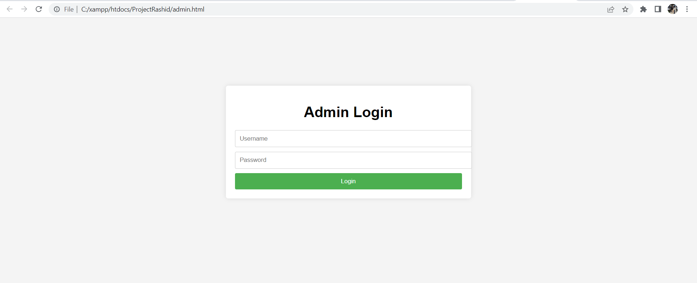

Dashboard:

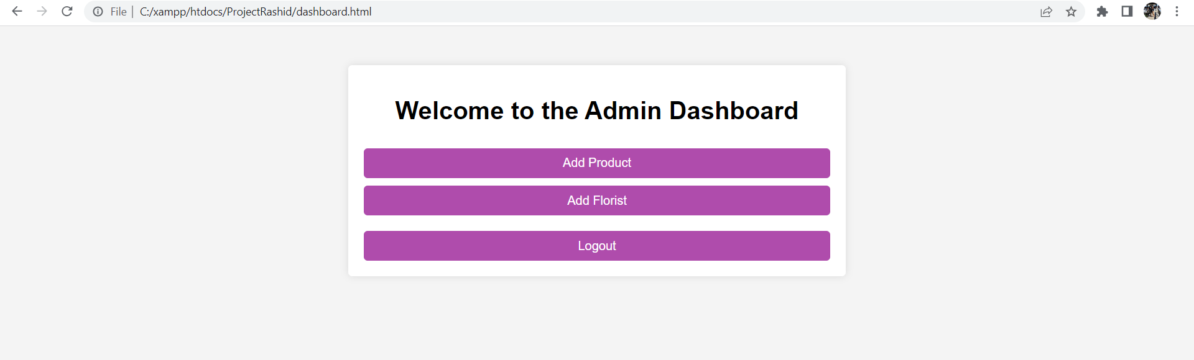

Add Product:

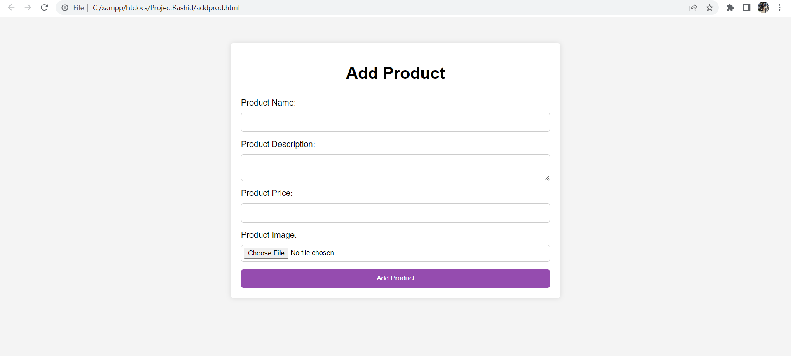

# Products: Adding, removing, and updating products

**3.3.1 Adding and Removing Products**

Administrators can add and delete goods from the Rashid's Florists website's admin section. This is how it works:

Admin Access: Log in to the admin area with the username and password supplied.

Introducing New Products: Navigate to the "Add Product" tab. Enter the necessary information, such as name, description, price, and photos. If relevant, provide availability and variants. After you save your adjustments, the new product will be uploaded to the website.

Remove Products: Navigate to the "Remove Product" area. Select the item to be deleted, confirm the deletion, and the item will be permanently removed from the website.

Product inventory should be updated on a regular basis to guarantee correctness and relevancy, offering customers an up-to-date variety, and improving their shopping experience.

**3.3.2 Updating Products**

Administrators can alter the product inventory in the Rashid's Florists website admin section by simply modifying the HTML code. They may update product details like the name, description, price, and photos simply editing the HTML files. Administrators may simply delete the necessary HTML code to remove a product. These changes are recorded, and the website is updated to reflect the new product inventory.

# Changing menus

The website does not cater for changing menus.

# Shipping Options

Rashid's Florists largely concentrates on in-store sales, with limited delivery possibilities. Shipping arrangements for bulk orders needing delivery, on the other hand, are personalized according on the order information, including quantity, flower kinds, and delivery area. Shipping quotes are offered on an individual basis, taking into consideration parameters such as the size and weight of the purchase, as well as any special delivery needs. Our customer support staff is available to help clients with the shipping process and to give tailored shipping choices depending on their specific requirements.

# The front page: adding and changing images.

Administrators can directly update the HTML code of the front page if Rashid's Florists' website only offers HTML as a method for adding and changing pictures. By including the HTML code for the picture with the required source URL or relative path, they may add new images. Administrators must find the HTML code for the previous picture and replace the source URL or path with the new image source in order to update images. The revised photos will then appear on the website's home page when the modifications to the HTML code have been saved.

# Changing the logo

Website does not acquire a logo.

# Orders

1. Ordering: The buyer chooses the flower arrangements they want, puts them in their basket, and then goes to the checkout page. They submit personal information such as their name and contact information. The consumer verifies and submits the order after studying it. For specific arrangements (bridal, anniversary, birthday etc.) a phone number will be provided to query and order over phone and thereafter same process will apply.
2. Collection: Instead of paying online, the customer takes the order confirmation email or receipt to the real business location. They submit the receipt to the store employees and complete the order payment in-store. This can be accomplished by presenting cash, a credit card, or any other acceptable payment method.
3. Order collection: For bulk orders, the client is alerted when their order is available for collection via phone. They may pick up their flower arrangements at the store at the agreed-upon hour. The order will be made and available for the client to pick up.
4. Feedback & Review: Rashid's Florists places a high focus on client satisfaction. After the customer has picked up their order, the team makes certain that they are pleased with the flower arrangements and the whole experience. They answer any problems or questions raised by the consumer and aim to surpass their expectations.

# Updating a page on your site

Administrators directly alter the HTML code associated with the individual page to make changes to the required elements such as text, graphics, and links to update pages. Administrators build new HTML files and design them using HTML code to add new pages. Administrators establish hyperlinks within the HTML code to link pages together, supplying the URL or relative path to the target page. Administrators have complete control over updating and adding new pages to the website by altering the HTML code.

# Collecting money from the store

Rashid's Florists provides simple payment choices on our website. All orders submitted through our website are meant for in-store purchasing because we are a small business. We do, however, provide the option for large purchases to be delivered for an extra cost. Here's an explanation of the possible payment methods:

Payment in-store: For regular orders, clients can pay in-store when they come to pick up their flower arrangements. At our physical store, we accept a variety of payment options, including cash and credit cards. To complete the payment, the consumer must provide their invoice or order number at the business.

Bulk Order Delivery: For clients who want delivery to a specified place, we provide the extra service of delivering the flower arrangements for a cost. The delivery fee is added to the product price and covers the cost of delivery and handling costs connected with delivering the bulk order. Customers can enquire about the delivery charge while placing their order or contact us for additional information.

# Checking Web Traffic and Statistics

I utilized a variety of techniques on our website to improve its functioning and user experience. While powerful analytics tools such as Google Analytics may not be required for in-store transactions, we may still use basic technologies to help website operations. Here are a couple such examples:

HTML/CSS/JavaScript: These are the essential technologies for developing websites. HTML governs the structure of online pages, CSS manages visual style, and JavaScript enhances the website's interaction and usefulness.

Database Management System: To store and manage customer information, product details, and other pertinent data, a lightweight database system, such as SQLite or MySQL, can be used. This aids in the effective storage and retrieval of data.

Using Domains.co.za has been shown to be advantageous in properly controlling online traffic. Domains.co.za, a domain registration and web hosting service provider, provides a variety of tools and services that have assisted businesses in optimizing their website performance and improving traffic management.

# Appendix

Answers to frequently asked questions (FAQs) concerning the website, order procedure, payment methods, delivery, returns, and more. These frequently asked questions address and clarify client issues.

Contact Information for Support: For more assistance, please visit the website's Contact page. There you will find contact information for our customer care staff, such as phone numbers and email addresses. The Contact page also includes information about our operation hours and response times.