**SQL Queries**

To find list of cities in Ireland I submitted the following request in SQL;

SELECT city FROM city_data WHERE country = 'Ireland'

Since Dublin is the only listed city in Ireland I used that city for my local city average temperature (°C).

To extract city and global average data, two SQL queries were submitted. As only one city is recorded in Ireland, I used Dublin as the city and submitted the following request to gain 271 records.

SELECT year, avg_temp FROM city_data WHERE city = 'Dublin'

Which resulted in 271 records and downloaded as CSV.

For global data

SELECT year, avg_temp FROM global_data

Which resulted in 266 records and downloaded as CSV.

**Data processing**

Data processing occurred in Excel. In Dublin between the years 1746-1749 no average yearly temperature was recorded. While a median could be calculated, the first and third year recorded in Dublin was quite low (See below) compared to the average (8.66°C) so these were removed so records of both global and Dublin temperatures could start from 1750.

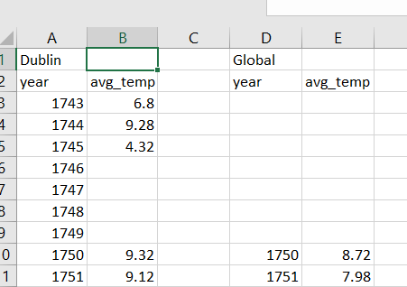

**Figure 1.** Yearly annual temperatures in Dublin in 1743 and 1745 were both low compared to average temperature in Dublin (8.66°C).

Since precipitation data is often recorded in decades, a moving average was conducted in decades for average temperatures (as in Figure 2). For example, for 1759 for Dublin data, the years 1750-1759 (cells B3-B12) were used for moving average calculation. Following this, 1760 was made up of the years 1751-1760 (Cells B4-B13) and each new calculation was made for the next ten years in this manner until all averages were calculated.

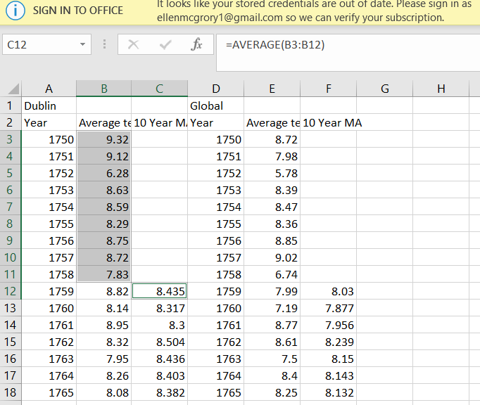

**Figure 2.** Excel screenshot illustrating how moving averages were calculated. For the year 1759, the years 1750-1759 (or cells B3-B12) were used for this calculation.

A resulting line chart showing average temperature in Dublin and global averages is shown below. The Figure axes for temperature were rescaled. In addition, summary statistics were provided below.

**Figure 2.** Line chart of yearly average temperature (°C) of Dublin and global data. A linear regression line has also been plotted in addition to the resulting correlation coefficient.

**Table 1.** Summary statistics of Global data and Dublin data

|  |  |  |
| --- | --- | --- |
|  | **Dublin data** | **Global data** |
| n | 264 | 266 |
| Average (°C) | 8.69 | 8.37 |
| Standard deviation (°C) | 0.56 | 0.58 |
| Minimum (°C) | 6.28 | 5.78 |
| Maximum (°C) | 10.11 | 9.83 |
| Median (°C) | 8.71 | 8.38 |

**Observations from data visualization**

Several observations can be made about this data visualization including;

* Both Dublin and global data show an increasing moving average of temperature (°C) throughout the years and have similar summary statistics (Table 1)
* The correlation coefficient of both global and Dublin data is strongly positively correlated, highlighting this previous trend.
* On average, average temperatures in Dublin are higher than average global temperatures (8.69±0.56°C for Dublin and 8.37±0.58°C for global).
* Average global temperatures show a sharp increase from 1975 onwards.
* In the year 1816, a low spike was recorded in average temperature (1816 often called the year without a summer) as average temperatures for this year dropped by 0.4-0.7 °C. this has been attributed to the volcanic eruption of Mount Tambora (Indonesia) in the winter of 1815.

**Reading material**

<https://scied.ucar.edu/learning-zone/how-climate-works/mount-tambora-and-year-without-summer>