Operational Analytics at Marriott International: Closing the 4 p.m. Readiness Gap
Ellen Alves
Trine University
Master of Science in Business Analytics
Course: Operations Analytics
Instructor: Ali Diab
October 08, 2025

Table of contents

Table of contents 2
Executive summary 5
Key issue 5
Analytical approach 5
Results 6
Recommendation 6
Limitations and next steps 6
Company profile 7
Overview and history 7
Leadership timeline 7
Business model 8
Main revenue streams 8
Core business segment 8
The most important facts surrounding the case 9
Arrival peak vs. room-ready window 9
Late check-out compresses cleaning time 9
Limitation on capacity 9
Scale and stakes 9
Implication for this case 9
The key issue 10
Data sources and methods 11
Specify alternative courses of action 14
Alternative 1 - Peak staffing & shift rebalance 14
How to implement (2-4 weeks): 14
Alternative 2 - Workflow standardization for reduce time per room 14
Alternative 3- Digital smoothing of arrivals & late-checkout controls to shape demand 15
How to implement (pilot 60–90 days): 15
New data models to support alternative solutions 17
Model 1 - Capacity calculator (Alternative 1/Alternative 2) 17
Model 2 - Arrival smoothing (Alternative 3) 18
Model 3 - Scenario worksheet (Baseline vs Alternative 1/Alternative 2/Alternative 3) 18
Evaluate each curse of action 20
Recommend the best course of action. 21
Final decision: 21
Reasons for prioritizing these: 21
Key Performance Indicators: 22
Ownership: 22
Expected outcome: 22
Conclusion 23
Section for exhibits 24
Tables: 24
Figures: 24
References 26

Executive summary
Marriott International (NASDAQ: MAR) is the largest hotel corporation globally by room count, employing an asset-light model across 31 brands and a highly interactive loyalty/digital platform (Marriott Bonvoy). The scale and digital adoption enhance operational reliability during the 3–4 p.m. check-in window.

Key issue
Properties do not consistently meet the 4 p.m. room-readiness target because housekeeping capacity (teams × average clean time) being exceeded by peak demand concentrated between 12:00–14:00. Digital behaviors (remote check-in, arrival-time setting, “room ready” alerts) concentrate arrivals, while late-checkout entitlements (guaranteed 4 p.m. for Platinum Elite members), compress the cleaning window (Marriott International, Inc., n.d.-b; n.d.-c; n.d.-d; 2025a).

Analytical approach
Using investor materials for context (RevPAR, pipeline), I compared peak departures with a back-of-the-envelope capacity estimate: capacity ≈ (60 ÷ average clean time) × teams. Baseline inputs (Table 1) set avg clean = 32 minutes, teams = 5, implying ~9–10 rooms/hour of capacity, versus ~27–30 rooms/hour of arrivals at peak (Figures 1–2). Then evaluated three alternatives:
- Alternative 1: Peak staffing & shift rebalance (+1 team 12:00–16:00).
- Alternative 2: Workflow standardization (−5 minutes per checkout room via standard work: zone cleaning, pre-stocked carts, stayover/checkout split).
- Alternative 3: Digital smoothing (arrival windows and moderated late-checkout approvals on peak dates).

Results
At baseline, readiness shows results around 68% by 4 p.m. Alternative 1 or Alternative 2 enhances the effective capacity to about 11 to 12 rooms per hour, increasing readiness to around 79–80%. In Alternative 3, the 12:00–14:00 peak is reduced by 10–15% and stabilizes performance when integrated with Alternative 1 and Alternative 2 (See Figures 1–4; Table 3). The expenses and complexity are low to moderate. Implementation duration is of 2 to 6 weeks for Alternatives 1 and 2, and 60 to 90 days for testing Alternative 3. Risk can be mitigated through personnel triggers, quality evaluations, and effective elite communications.

Recommendation
My recomendation is instantly implement Alternative 1 and Alternative 2 across properties, and pilot Alternative 3 for 60 to 90 days in hotels with high mobility or high occupancy rates. Then track the proportion of rooms ready by 4 p.m. (target: ≥80%), average clean time, arrivals per hour, service recovery cost, and Guest Satisfaction Score/Net Promoter Score. Expected results during 4–6 weeks encompass enhanced punctuality in readiness, reduced recovery occurrences, streamlined check-ins, and a more consistent workload.

Limitations and next steps
Inputs are illustrative; properties should run short time studies by room type, adjust staffing requirements to local demand, and maintain a light dashboard for continuous improvement.

Company profile

Overview and history
Marriott International, Inc. (Nasdaq: MAR), is a global leader in the hospitality business, with its main office in Bethesda, Maryland. The company was founded by J. Willard Marriott and Alice Marriott as a root beer stand in Washington, D.C., in 1927. The business was named Hot Shoppes when the menu expands, and good food and service at fair prices become guiding principles as the company grows. After 30 years since the first root beer, and have succes with the Hot Shoppes, in January 1957, Marriots entering the hotel business, opening its first hotel, the Twin Bridges Marriott Motor Hotel, in Arlington, Virginia (Stockrow, 2025). After almost 100 years, the company has grown into one of the largest hotel groups in the world, with about 1,736,000 rooms spread out over 9,600 properties in 138 countries and territories (Marriott International, Inc., 2025a).

Leadership timeline
Marriott’s leadership began with J. Willard Marriott (founder), who guided the company from its start in 1927 and served as chief executive until 1972, remaining an influential figure until his passing in 1985 (Stockrow, 2025). His son, J. W. “Bill” Marriott, Jr., became president in 1964 and then CEO from 1972 to March 31, 2012, almost 40 years, after which he moved to Executive Chairman (Marriott International, n.d.). In 2012, Arne Sorenson became the company’s third CEO and led Marriott’s global expansion and the Starwood integration until 2021 (Stockrow, 2025). Following Sorenson’s passing, Anthony “Tony”, who serves as President and Chief Executive Officer, was appointed CEO on February 23,2021, (atual CEO), becoming the fourth chief executive and continuing focus on innovation, sustainability, and delivering exceptional guest experiences (Stockrow, 2025).

Business model
Marriott international runs a mixed business model, that includes manage, franchise, and (to a lesser extent) own/lease hotels. Most revenue comes from management and franchise fees, which scale with hotel performance and require far less capital than owning properties outright. The company also earns from a smaller set of owned/leased hotels and from Marriott Bonvoy, which generates revenue through co-brand credit cards and other travel partnerships. (Stockrow, 2025).

Main revenue streams
- Management fees: Marriot receives a percentage of hotel revenues from property owners.
- Franchise fees: Payments received from third-party owners that license Marriott brands and systems.
- Owned and leased hotels: Generated direct room and additional revenue from a limited number of properties.
- Loyalty (Bonvoy): Partner fees from cards, airlines, and travel affiliates.

Core business segment
Marriott consists of 31 brands across four pricing levels that includes: luxury, premium, select-service, and extended-stay. This enables the company to accommodate various trip types and pricing ranges via an integrated operation and loyalty platform (Marriott International, Inc., 2025.a).

The most important facts surrounding the case

Arrival peak vs. room-ready window
Properties plan around a 3–4 p.m. check-in window while the Bonvoy app enables remote check-in, arrival-time setting, and “room ready” notifications concentrating arrivals (Marriott International, Inc., n.d.-b).

Late check-out compresses cleaning time
Platinum Elite+ members are entitled to a guaranteed late checkout of 4:00p.m, contrasts with typical check-in times and shifts some departures into the afternoon, tightening the housekeeping window.

Limitation on capacity
A constant problem is the housekeeping flow (teams × average clean time); arriving and departing at the same time causes more lines and "rooms-not-ready at 4 p.m." (analytical focus of this case; see Exhibits 2–3).

Scale and stakes
Marriott operates around 9,600 properties and 1.736M rooms, elevating the importance of consistent room-ready performance (Marriott International, Inc., 2025a).

Implication for this case
The intersection of late check-out benefits, mobile-driven arrival peaks, and finite housekeeping capacity explains recurring not-ready conditions at 4 p.m.; This case therefore focuses on capacity (staffing), workflow (time per room), and demand smoothing as the primary levers (to be quantified in Exhibits 2–4).

The key issue
Operational data and guest-arrival behavior point to a central problem: a delay in room readiness at the 4 p.m. check-in target, reflecting a structural gap between cleaning capacity (teams × average clean time) and peak demand, concentrate by mobile features in Marriott Bonvoy, as a remote check-in, arrival-time setting, “room ready” notifications that concentrate arrivals in the 3–4 p.m. window, while late-checkout benefitis is guaranteed at 4 p.m. for Platinum Elite and above members, shift some departures into the afternoon and compressing the cleaning window, increasing the likelihood of not-ready rooms, service-recovery costs, and a potential knock-on effects on staisfaction and RevPAR (Marriott International, Inc., n.d.-b; Marriott International, Inc., n.d.-c; Marriott International, Inc., n.d.-d; Marriott International, Inc., 2025a).

Data sources and methods
In this analysis, I use a straightforward approach to show why rooms are not consistently ready by the 4 p.m. check-in target. First, I summarize scale and recent performance from Marriott’s investor materials (RevPAR and development pipeline) to set context and urgency. Then, I compare peak demand (check-outs per hour) with a simple estimate of housekeeping capacity ≈ (60 ÷ average clean time) × number of teams, and show the before/after impact of two basic levers: adding one team at peak and reducing average clean time by a few minutes through workflow standardization.
The results are presented as two easy charts:
- Arrivals vs. Capacity
- A percentage of rooms ready by 4 p.m. (Before vs. After) and interpreted against an 80% readiness goal (Marriott International, Inc., 2024a; Marriott International, Inc., 2025a; Marriott International, Inc., 2025c).
Metric | Baseline | Note
Check-outs/hour (11–16h) | 26 | peak window
Avg. clean time (min) | 32 | checkout rooms
Teams (concurrent) | 5 | housekeeping
Target SLA | 80% ≤ 4 p.m. | case goal
Table 1
Baseline operational inputs (peak window 11:00–16:00)

Note. Capacity is estimated as (60 ÷ average clean time) × teams. Inputs reflect author assumptions for a mid-scale property; results are illustrative. Contextual performance data cited from Marriott investor materials (Marriott International, Inc., 2024a; Marriott International, Inc., 2025a; Marriott International, Inc., 2025c).
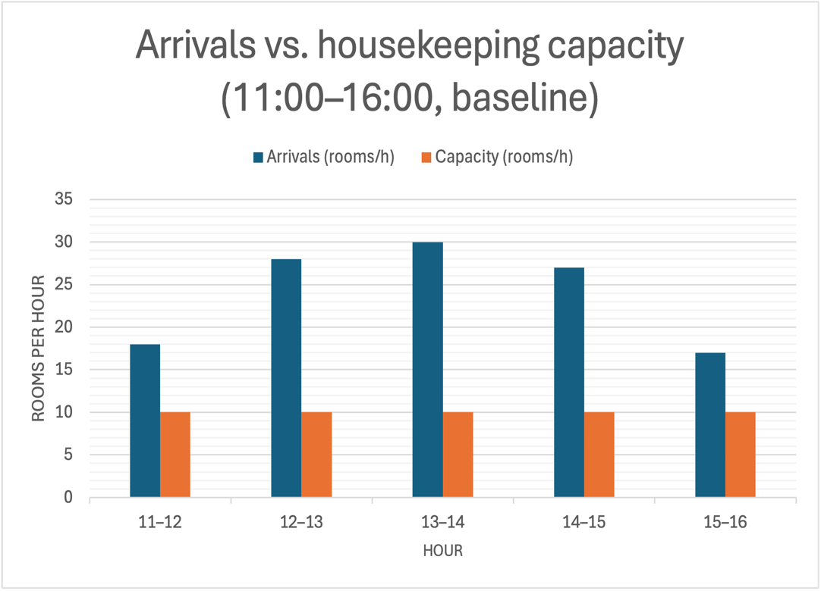
Figure 1
Arrivals vs. housekeeping capacity (11:00–16:00, baseline)
Note. Capacity ≈ (60 ÷ 32) × 5 ≈ 9–10 rooms/hour; arrivals peak 12:00–14:00.
As shown in Figure 1, peak departures between 12:00 and 14:00 exceed the estimated capacity of ~9–10 rooms per hour, explaining readiness gaps at the 4 p.m. window.

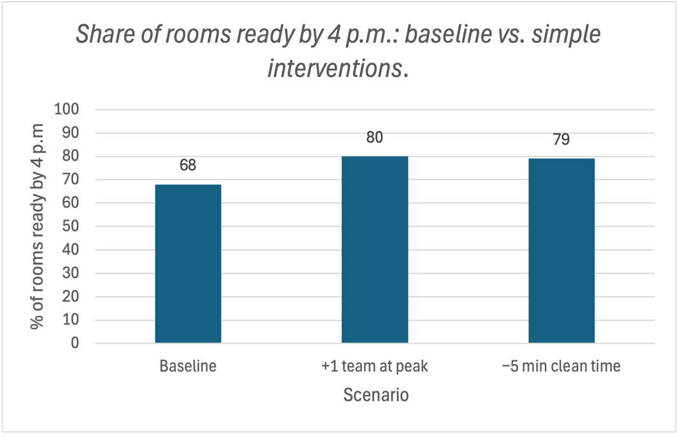
Figure 2
Share of rooms ready by 4 p.m.: baseline vs. simple interventions
Note “+1 team at peak” = peak-hour staffing; “−5 min clean time” = workflow standardization. Percentages are illustrative and tied to inputs in Table 1.

Figure 2 shows an improvement from ~68% to ~79–80%, meeting the 80% target with simple interventions.
As shown in Figures 1–2, peak departures between 12:00 and 14:00 exceed the estimated housekeeping capacity of ~9–10 rooms per hour (Table 1), which explains readiness gaps at the 4 p.m. window.
Two low-complexity levers adding one team at peak or standardizing workflow to cut ~5 minutes from average clean time, raise readiness from ~68% to ~79–80%, meeting the 80% target (Marriott International, Inc., 2024a; Marriott International, Inc., 2025a; Marriott International, Inc., 2025c).

Specify alternative courses of action
The objective in this analysis is close the 4 p.m. room-readiness gap by rebalancing capacity and demand during the 11:00a.m to 16:00p.m window time during check-in, using low-complexity actions that can be piloted and scaled.

Alternative 1 - Peak staffing & shift rebalance
The aim is add or shift one extra person for housekeeping team (or equivalent labor hours) targeted to 12:00–16:00 window time on peak days.
This alternative increases effective capacity from about 9–10 to ~11–12 rooms/hour at peak, reducing queueing and raising the share of rooms ready by 4 p.m. (see Figures 1–2).

How to implement (2-4 weeks):
- Build a weekly heatmap of check-outs/arrivals; with flag red hours (12:00–14:00).
- Rebalance rosters to place one additional team in red hours (OT or flexible shifts).
- Daily 11:30 a.m. stand-up to prioritize “due-by-16:00” rooms.
Resources/cost: Incremental peak labor; light training.
Key Performance Indicators: Percentage of rooms available by 4 p.m.; average turnaround time; cost of service recovery; overtime hours.

Alternative 2 - Workflow standardization for reduce time per room
The goal here is to cut average clean time by less 5 minutes via standard work: zone cleaning, pre-stocked carts, separation of stayover versus check-outs, and offer a 30/60/90-minute priority board.
This alternative helps to reduce 32 to 27 minutes/room lifts capacity ~15–20% without adding headcount, moving toward (or meeting) the 80% target (Figure 2).
How to implement(2-6 weeks):
- Simple time study (5–10 samples per room type).
- Redesign flow: fixed sequence, corridor linen staging, first-ready inspection to release critical rooms.
- Short training and checklists; and twice-weekly quality audits for the first 4 weeks.
Resources/cost: Light training; minor supply/layout tweaks.
Key Performance Indicators: Average cleaning duration; quality assurance rework; percentage of tasks completed by 4 p.m.; rooms sanitized per team.

Alternative 3- Digital smoothing of arrivals & late-checkout controls to shape demand
Alternative 3 consists in use Marriott Bonvoy features to offer arrival windows (ETA in-app, timed “room ready” notifications) and modulate late-checkout approvals on critical dates.
The objective is lowers the 12:00–14:00 peak and gives housekeeping minutes back before 4 p.m.; complements A1/A2.

How to implement (pilot 60–90 days):
- On peak days, offer arrival windows as 15:30–17:00 for example, with a small incentive (bonus point, extra water).
- Keep the late-checkout policy but require operational availability on high-occupancy dates; communicate proactively by 10 p.m. the night before.
- Synchronize front desk and housekeeping via a “due-by-16:00” board.
Resources/cost: Low (procedural/policy); coordination with Ops/IT.
Key Performance Indicators. Hourly arrivals; percentage by 4 p.m.; cancellations of late checkouts; GSS/NPS at check-in.
Table 2
Tie-back of alternatives to baseline inputs and outcomes
Alternative | Capacity effect (peak) | % rooms ready ≤ 4 p.m. | Notes
Baseline | ~9–10 rooms/hour (32 min; 5 teams) | ~68% | From Table 1 and Figure 1
A1 — Peak staffing (+1 team) | ↑ to ~11–12 rooms/hour | ~80% | Adds one team 12:00–16:00 on peak days (Figure 2)
A2 — Workflow standardization (−5 min/room) | ↑ to ~11–12 rooms/hour (via 32 → 27 min) | ~79% | Zone cleaning, pre-stocked carts, split stayovers/checkouts (Figure 2)
A3 — Digital smoothing | Demand ↓ ~10–15% at 12:00–14:00 | Stabilizes ≥80% when combined with A1/A2 | Arrival windows in app; moderated late-checkout approvals on peak dates

Note Capacity ≈ (60÷avg. clean time)×teams. Baseline uses 32 minutes and 5 teams (≈9–10 rooms/hour). Effects and percentages are illustrative and tied to Table 1, Figure 1, and Figure 2. Contextual performance references: (Marriott International, Inc., 2024a; 2025a; 2025c).

New data models to support alternative solutions
At this analysis, I use simple, spreadsheet-friendly models to quantify impact on the 4 p.m. target.

Model 1 - Capacity calculator (Alternative 1/Alternative 2)
- Idea: How many rooms per hour a housekeeping team can clean.
- Formula: Capacity ≈ (60 ÷ average clean time) × number of teams.
- Example: With 32 minutes each room and 5 teams results in around 9 to 10 rooms per hour, calculated as (60/32)×5.
- If Alternative 1 (increased one team) or Alternative 2 (decreased by five minutes per room) is implemented, the capacity will increase to around 11–12 rooms per hour.
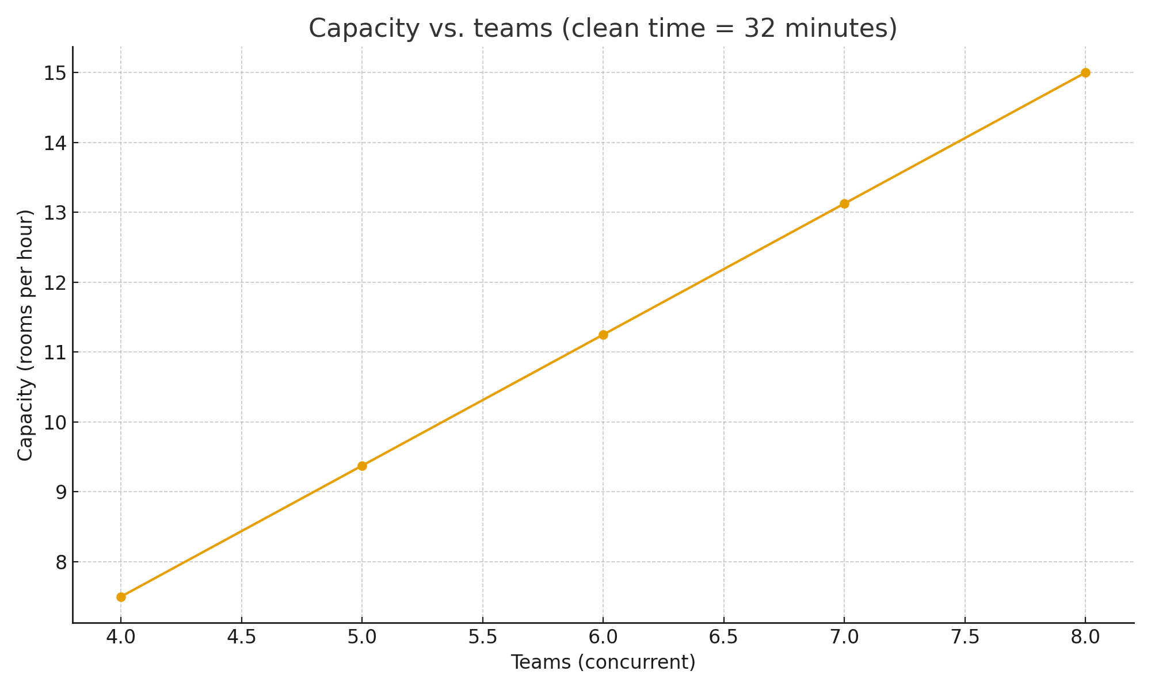
Figure 3
Capacity vs. teams (clean time = 32 minutes).
Note Capacity increases linearly with teams at a given clean time.

Model 2 - Arrival smoothing (Alternative 3)
- Idea: Reduce the arrivals peak between 12:00–14:00 by using in-app arrival windows and moderating late checkout on peak days.
- How to show it: Compare arrivals per hour “Before” vs. “After” with the same capacity line in both cases.

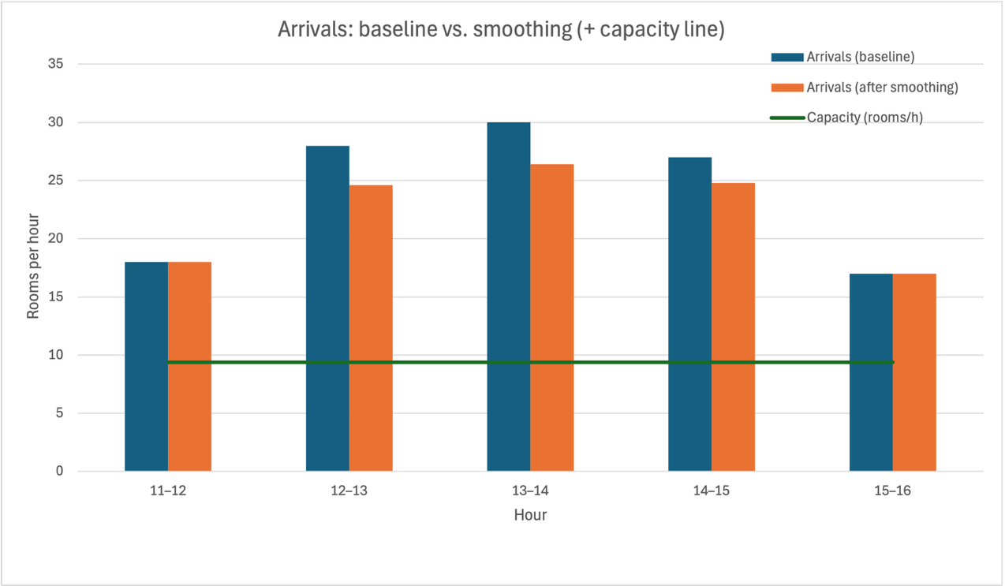
Figure 4
Arrivals: baseline vs. Smoothing (+ capacity line).
Note. Smoothing applies −12% at 12:00–14:00 and −8% at 14:00–15:00; the capacity line assumes 5 teams at 32 minutes per room (≈ 9.38 rooms/hour).

Model 3 - Scenario worksheet (Baseline vs Alternative 1/Alternative 2/Alternative 3)
- For each scenario, mention the following: Teams, average cleaning time, capacity, and the percentage of rooms ready by 4 p.m. (e.g., 68% → 79–80% with A1/A2).
Table 3
Comparison of scenarios (inputs -> percentage of rooms prepared by 4 p.m.)
Hour | Arrivals (Baseline) | Arrivals (After smoothing) | Capacity (rooms/h)
11-12 | 18 | 18 | 9.38
12-13 | 28 | 24.6 | 9.38
13-14 | 30 | 26.4 | 9.38
14-15 | 27 | 24.8 | 9.38
15-16 | 17 | 17 | 9.38

Note. Percentages are illustrative and tied to Table 1, Figure 1, and Figure 2; capacity = (60 ÷ avg clean time) × teams.

Evaluate each curse of action
This section evaluates alternatives 1 to 3 against impact on the 4 p.m. target, cost, speed, operational risk, and guest/associate impact.
Table 4
Evaluation of alternative courses of action
Criterion | A1 — Peak staffing | A2 — Workflow standardization | A3 — Digital smoothing
Impact on % ≤ 4 p.m. | High — lifts capacity to ~11–12 rooms/h; meets ~80% | High — −5 min/room ≈ +15–20% capacity; ~79% | Medium — lowers peak arrivals; stabilizes ≥80% with A1/A2
Cost | Medium (incremental labor on peak days) | Low–Medium (training, carts/stock, minor layout) | Low (policy/process; small incentives)
Time to implement | Fast (2–4 weeks) | Fast (2–6 weeks) | Fast (pilot 60–90 days)
Operational risk | Low–Medium (overstaff on slow days) | Low (quality drift if not audited) | Low (depends on guest adoption)
Guest/associate impact | Positive (shorter waits; smoother check-in) | Positive (more predictable work; consistent quality) | Mixed–Positive (clear comms needed for elites/late checkout)
Dependencies | Staffing rosters; OT rules | Training; supervisor follow-up | App usage; front desk/ops coordination

Note. Scores/labels are illustrative and tied to Figures 1–2 and Table 3 (scenarios); “Impact” reflects change in % of rooms ready ≤ 4 p.m.
Based on these criteria, I recommend implementing Alternative 1 and Alternative 2 immediately and piloting Alternative 3 for 60–90 days in high–mobile-adoption or high-occupancy hotels.

Recommend the best course of action.

Final decision:
- Implement Alternative 1 (add/shift one team during peak hours) and Alternative 2 (standardize workflow) immediately.
- Implement Pilot Alternative 3 (digital smoothing) for a duration of 60–90 days exclusively in hotels exhibiting strong mobile usage or exceptionally high occupancy rates.

Reasons for prioritizing these:
- Alternative 1 and Alternative 2 effectively address the fundamental issue promptly: they increase capacity throughout the 11:00–16:00 window and enhance readiness from approximately 68% to around 79–80% with minimal complexity (refer to Figures 1–2; Table 3).
Alternative 3 helps by reducing arrival peaks, but it depends on guest behavior—so start as a targeted pilot.
90-day strategy:
- Weeks 1–2: Conduct a rapid time analysis, adjust schedule to allocate an additional staf during peak hours, stock carts, and establish a "due-by-16:00" board.
- Weeks 3–6: Implement Alternative 1 and Alternative 2; conduct daily stand-up meetings at 11:30; perform quality audits twice a week and monitor KPIs.
- Weeks 7–12: Implement Alternative 3 during peak periods: Especify arrival timeframes, limit late-checkout authorizations during peak periods, and communicate clearly with elite members.

Key Performance Indicators:
- Percentage of rooms prepared by 4 p.m.: at least 80%.
- Average cleaning duration (checkout rooms): –5 minutes compared to baseline.
- Peak arrivals per hour (12:00–14:00): –10–15% at designated hotels.
- Service recovery expenses and check-in wait times: decreased compared to baseline.
- GSS/NPS (check-in item): comparison against baseline

Ownership:
- The General Manager is responsible for outcomes; the Operations Manager runs the dashboard; weekly review with Housekeeping + Front Desk; escalation is required if the percentage is less than 75% for three consecutive days by 4 p.m.

Expected outcome:
In 4–6 weeks, properties should hit or exceed 80% on-time readiness, with fewer recoveries and smoother check-ins; Alternative 3 adds stability on high-demand days.

Conclusion
The 4 p.m. ready gap at Marriott is caused by a fundamental discrepancy: the capacity of housekeeping (teams multiplied by average cleaning time) falls short of demand, which peaks between 12:00 and 14:00. According to spreadsheet estimates, the baseline capacity is approximately 9–10 rooms per hour, while peak arrivals range from 27 to 30, resulting in an on-time readiness rate of approximately 68%. Alternative 1 (adding or shifting one team at peak times) and Alternative 2 (workflow standardization, reducing time by 5 minutes each room) enhance effective capacity to around 11–12 rooms per hour and increase readiness to around 79–80%. Digital smoothing, which is option 3, makes peaks more stable and should be tested in places where mobile use is high. My recomendation on this analysis should be implement the Alternatives 1 and 2 as soon as possible, and test Alternative 3 for 60 to 90 days, keeping an eye on metrics like the percentage of rooms ready by 4 p.m., the average time it takes to clean, the number of arrivals each hour, and the cost of service recovery.

Section for exhibits

Tables:
- Table 1
Baseline operational inputs (peak window 11:00–16:00).
Note. Capacity ≈ (60 ÷ average clean time) × teams. Inputs are author assumptions for a mid-scale property.
- Table 2
Tie-back of alternatives to baseline inputs and outcomes.
Note. Capacity ≈ (60÷avg. clean time)×teams.
- Table 3
Comparison of scenarios (inputs -> percentage of rooms prepared by 4 p.m.).
Note. Percentages are illustrative and tied to Table 1, Figure 1, and Figure 2; capacity = (60 ÷ avg clean time) × teams.
- Table 4
Evaluation of alternative courses of action.
Note. Scores/labels are illustrative and tied to Figures 1–2 and Table 3 (scenarios); “Impact” reflects change in % of rooms ready ≤ 4 p.m.

Figures:
- Figure 1
Arrivals vs. housekeeping capacity (11:00–16:00, baseline).
Note. Capacity ≈ (60 ÷ 32) × 5 ≈ 9–10 rooms/hour; arrivals peak 12:00–14:00.
- Figure 2
Share of rooms ready by 4 p.m.: baseline vs. simple interventions.
Note. “+1 team at peak” and “−5 min clean time” are illustrative.
- Figure 3
Capacity vs. teams (clean time = 32 minutes)
Note. Capacity increases linearly with teams at a given clean time.
- Figure 4
Arrivals: baseline vs. smoothing (+ capacity line)
Note. Smoothing applies −12% at 12:00–14:00 and −8% at 14:00–15:00; the capacity line assumes 5 teams at 32 minutes per room (≈ 9.38 rooms/hour).

References
https://www.marriott.com/about/culture-and-values/history.mi
https://www.marriott.com/pt-br/culture-and-values/jw-marriott-jr.mi
https://stockrow.com/MAR/business-profile
https://marriott.gcs-web.com/static-files/b82978a6-9d28-4e38-9855-fc4ae2cebe11
https://marriott.gcs-web.com/
https://marriott.gcs-web.com/news-releases/news-release-details/marriott-international-reports-second-quarter-2025-results
https://marriott.gcs-web.com/static-files/2a3f1dbd-12fd-4ab6-93ef-de27ff759b72?
https://marriott.gcs-web.com/news-releases/news-release-details/marriott-international-reports-first-quarter-2025-results
https://www.marriott.com/marriott-brands/mobile-app.mi?
https://www.ahla.com/news/65-surveyed-hotels-report-staffing-shortages
https://www.reuters.com/business/marriott-cuts-2025-revenue-outlook-travel-demand-slows-2025-05-06/
https://xclusivestaffing.com/hotel-labor-shortage-expected-to-continue-in-2025/?
https://www.marriott.com/loyalty/member-benefits/platinum.mi?

