Report on Field Trial FieldName

# Field Management Information

# Trial Design and Implementation

This was a seed and nitrogen trial on corn Below is the information about the trial rates of seed. Figure 1 presents the trial design. The trial design used 4 seed rates. The treatments were laid out in a completely randomized design. The baseline treatment, what the producer would apply without participating in the trial, was (3.710^{4} K). Areas around the perimeter of the field received the baseline treatment and were not included in the analysis. There were 250 trial plots in total. Each plot was 60 feet wide.

* Baseline seed rate of 3.710^{4} K.
* Seed target rates: 31000K,34000K,37000K,40000K
* Planter width: 60 feet
* Harvester width: 30 feet

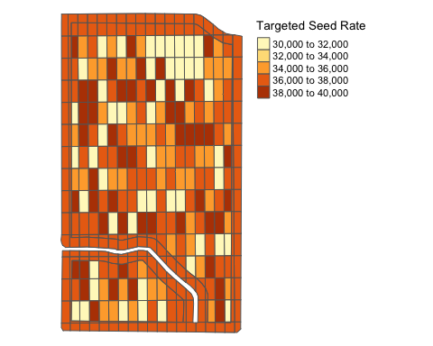 The planting map highlights the quality of the seeding data. The planter implemented the trial with a high level of accuracy.

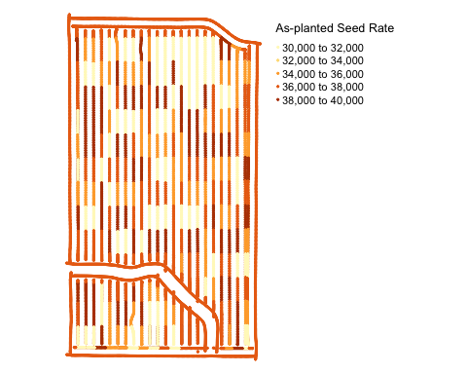 The raw yield map displays the importance of cleaning the data. We can see outliers throughout the field, where the harvester is registering very large yields. 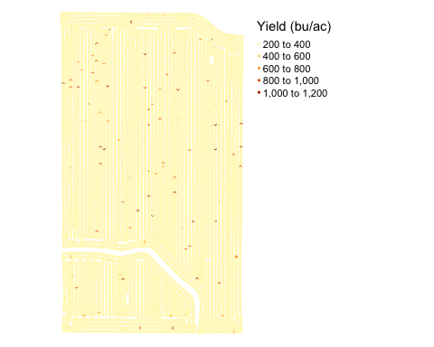

# Weather

The figure below displays the monthly rainfall in inches across 2018. The color of each month compares the rainfall from 2018 with the 10-year average. We can see that 2018 was an average year with rainfall within 1 to 2 inches of the historic average.

## `summarise()` regrouping output by 'month' (override with `.groups` argument)

## `summarise()` ungrouping output (override with `.groups` argument)

