**Product Details / Origin**

Table

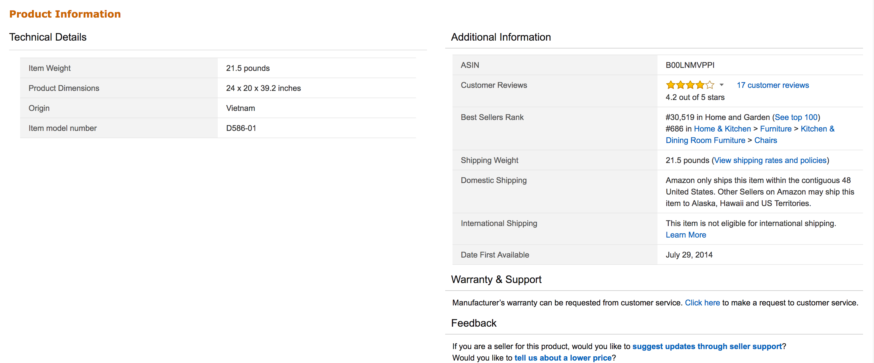

1. Check every <table> with id = productDe.*

2. For each table, check each <tr> if it has a <th> tag with inner html/text “origin”

3. For each of these record the <td>.

Using the same logic in 2,3 we can get manufacturer, model number too

List

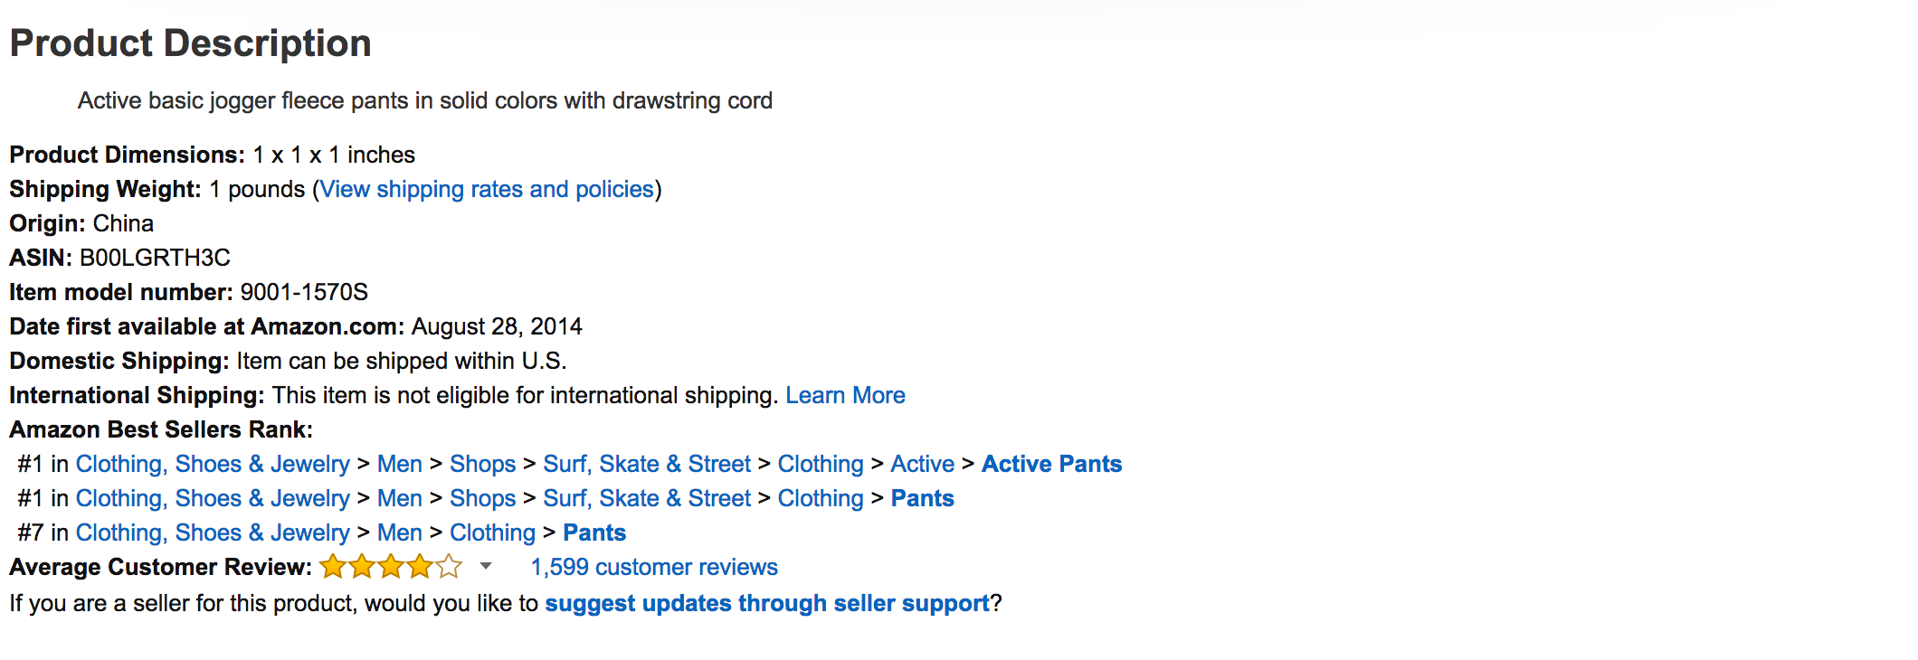

1. Check if a div has description or details
2. More specifically check if a div id = detailBullets.*
3. Check this divs for a ul, then get all the li
4. look for model number

**Price**

1. Look for a <span> with id = “priceblock_ourprice” or “^priceblock.*”

**Product Name**

1. Just look for an <h1> with id = “title” then extract the text

**Category**

Search for <a> tags with {"class" : "a-link-normal a-color-tertiary"}. These are right below the Amazon nav bar. In the photo it’s the ‘active shorts’

