Crouse 1987 Analysis

Ellie

14 October 2017

The code below is my re-creation of the analysis from Crouse's 1987 paper on loggerhead turtle demography.

# Creating the Crouse 1987 Matrix

Creating a stage-based projection matrix, for each stage, calculating the repro- ductive output (F,), the probability of surviving and growing into the next stage (G,) and the probability of surviving and remaining in the same stage (P,). This code needs the csv files 'table 3 from crouse' and 'sens'.

**Created a function for'matrixing'**

### making a function which creates the matrix   
lifetable <- table.3  
myFunc <- function (lifetable)   
{  
 fecs <- select(lifetable, fecundity)  
 pi <- select(lifetable, annual_survivorship)  
 di <-select(lifetable, stage_duration)  
 Pi <- ((1 - (pi^(di - 1)))/(1 - (pi^di)))*pi  
 Gi <- (pi^di*(1 - pi))/(1 - pi^di)  
 mat1 <- matrix(0, nrow = 7, ncol = 7)  
 #add Fs  
 mat1[1,] <- lifetable$fecundity   
 #add Ps (diagonals)  
 mat1[1,1] <- Pi$annual_survivorship[1]   
 mat1[2,2] <- Pi$annual_survivorship[2]   
 mat1[3,3] <- Pi$annual_survivorship[3]  
 mat1[4,4] <- Pi$annual_survivorship[4]  
 mat1[5,5] <- Pi$annual_survivorship[5]  
 mat1[6,6] <- Pi$annual_survivorship[6]  
 mat1[7,7] <- Pi$annual_survivorship[7]  
 mat1  
 #add Gs (off-diagonals)  
 mat1[2,1] <- Gi$annual_survivorship[1]  
 mat1[3,2] <- Gi$annual_survivorship[2]  
 mat1[4,3] <- Gi$annual_survivorship[3]  
 mat1[5,4] <- Gi$annual_survivorship[4]  
 mat1[6,5] <- Gi$annual_survivorship[5]  
 mat1[7,6] <- Gi$annual_survivorship[6]   
 return(mat1)  
}

**Table 4** Stage-class population matrix for loggerhead sea turtles based on the life table presented in Table 3. For the general form of the matrix and formulae for calculating the matrix elements see Theoretical Population Projections.

mat1

## [,1] [,2] [,3] [,4] [,5] [,6] [,7]  
## [1,] 0.0000 0.00000000 0.00000000 0.00000000 127.0000 4.0000 80.0000000  
## [2,] 0.6747 0.73710665 0.00000000 0.00000000 0.0000 0.0000 0.0000000  
## [3,] 0.0000 0.04859335 0.66105394 0.00000000 0.0000 0.0000 0.0000000  
## [4,] 0.0000 0.00000000 0.01474606 0.69066719 0.0000 0.0000 0.0000000  
## [5,] 0.0000 0.00000000 0.00000000 0.05183281 0.0000 0.0000 0.0000000  
## [6,] 0.0000 0.00000000 0.00000000 0.00000000 0.8091 0.0000 0.0000000  
## [7,] 0.0000 0.00000000 0.00000000 0.00000000 0.0000 0.8091 0.8086329

**Stage structure growth (multiple steps)**

**Eigen analysis**

## eigen() decomposition  
## $values  
## [1] 0.9451619+0.0000000i 0.7461850+0.2133014i 0.7461850-0.2133014i  
## [4] 0.3703761+0.0000000i 0.2666658+0.0000000i -0.0885565+0.1197225i  
## [7] -0.0885565-0.1197225i  
##   
## $vectors  
## [,1] [,2]  
## [1,] 0.2908023156+0i -1.257398e-02-2.954331e-01i  
## [2,] 0.9430392892+0i -9.344933e-01+0.000000e+00i  
## [3,] 0.1612958488+0i -7.329287e-02+1.836400e-01i  
## [4,] 0.0093458854+0i 1.065487e-02+7.840158e-03i  
## [5,] 0.0005125296+0i 8.281364e-04+3.078791e-04i  
## [6,] 0.0004387478+0i 9.183491e-04+7.132259e-05i  
## [7,] 0.0026001129+0i -6.901618e-04-3.281447e-03i  
## [,3] [,4] [,5]  
## [1,] -1.257398e-02+2.954331e-01i -0.4724748950+0i -0.5690459889+0i  
## [2,] -9.344933e-01+0.000000e+00i 0.8692452255+0i 0.8161181396+0i  
## [3,] -7.329287e-02-1.836400e-01i -0.1453139181+0i -0.1005555486+0i  
## [4,] 1.065487e-02-7.840158e-03i 0.0066901890+0i 0.0034971545+0i  
## [5,] 8.281364e-04-3.078791e-04i 0.0009362681+0i 0.0006797548+0i  
## [6,] 9.183491e-04-7.132259e-05i 0.0020453117+0i 0.0020624679+0i  
## [7,] -6.901618e-04+3.281447e-03i -0.0037760085+0i -0.0030790477+0i  
## [,6] [,7]  
## [1,] -7.769258e-01+0.000000e+00i -7.769258e-01+0.000000e+00i  
## [2,] 6.218000e-01+9.016198e-02i 6.218000e-01-9.016198e-02i  
## [3,] -3.839520e-02-1.197694e-02i -3.839520e-02+1.197694e-02i  
## [4,] 6.758153e-04+3.304866e-04i 6.758153e-04-3.304866e-04i  
## [5,] -4.740459e-05-2.575241e-04i -4.740459e-05+2.575241e-04i  
## [6,] -9.717431e-04+1.039147e-03i -9.717431e-04-1.039147e-03i  
## [7,] 9.838651e-04-8.058311e-04i 9.838651e-04+8.058311e-04i

**Finding the first eigenvalue (finite rate of increase)**

## Warning in which.max(eigs.A[["values"]]): imaginary parts discarded in  
## coercion

## [1] 0.9451619

**Power method**

using N0 <- matrix(c(10000,10000,10000,10000,10000,10000,10000), ncol=1) as a subsitute for actual data

t <- 20  
Nt <- N0/sum(N0)  
R.t <- numeric(t)  
for (i in 1:t) R.t[i] <- {  
 Nt1 <- A %*% Nt  
 R <- sum(Nt1)/sum(Nt)  
 R  
}

**Calculating the stable stage distribution**

## [1] 0.207 0.670 0.115 0.007 0.000 0.000 0.002

**Calculating the reproductive value**

## [1] 1.000000 1.400863 5.997875 115.559274 567.386379 505.836132  
## [7] 585.956078

**Created table 5 (from Crouse 1987)**

Table 5. Stable stage distribution (wJ) and reproductive values (v') for the loggerhead population matrix given in Table 4.

|  |  |  |  |
| --- | --- | --- | --- |
| Stage number | Stage Class | Stable stage distribution (Dominant eigenvector) | Reproductive values (left eigenvector) |
| 1 | eggs_hatchlings | 0.207 | 1.000000 |
| 2 | small_juveniles | 0.670 | 1.400862 |
| 3 | large_juveniles | 0.115 | 5.997875 |
| 4 | subadults | 0.007 | 115.559274 |
| 5 | novice_breeders | 0.000 | 567.386379 |
| 6 | 1st-yr_remigrants | 0.000 | 505.836132 |
| 7 | mature_breeders | 0.002 | 585.956078 |

## Sensitivity analyses

# Calculating changes in rate of increase r resulting from simulated changes in fecundity and survival of individual life history stages in the loggerhead population matrix decresing fecundity and survival by 50%

## Warning in which.max(eigs.AFd[["values"]]): imaginary parts discarded in  
## coercion

## Warning in which.max(eigs.A1d[["values"]]): imaginary parts discarded in  
## coercion

## Warning in which.max(eigs.A2d[["values"]]): imaginary parts discarded in  
## coercion

## Warning in which.max(eigs.A3d[["values"]]): imaginary parts discarded in  
## coercion

## Warning in which.max(eigs.A4d[["values"]]): imaginary parts discarded in  
## coercion

## Warning in which.max(eigs.A5d[["values"]]): imaginary parts discarded in  
## coercion

## Warning in which.max(eigs.A6d[["values"]]): imaginary parts discarded in  
## coercion

## Warning in which.max(eigs.A7d[["values"]]): imaginary parts discarded in  
## coercion

## Warning in which.max(eigs.AFi[["values"]]): imaginary parts discarded in  
## coercion

## Warning in which.max(eigs.A1i[["values"]]): imaginary parts discarded in  
## coercion

## Warning in which.max(eigs.A2i[["values"]]): imaginary parts discarded in  
## coercion

## Warning in which.max(eigs.A3i[["values"]]): imaginary parts discarded in  
## coercion

## Warning in which.max(eigs.A4i[["values"]]): imaginary parts discarded in  
## coercion

## Warning in which.max(eigs.A5i[["values"]]): imaginary parts discarded in  
## coercion

## Warning in which.max(eigs.A6i[["values"]]): imaginary parts discarded in  
## coercion

## Warning in which.max(eigs.A7i[["values"]]): imaginary parts discarded in  
## coercion

**Figure 1** Changes in rate of increase r resulting from sim- ulated changes in fecundity and survival of individual life history stages in the loggerhead population matrix (remaining components held constant). The dashed line represents the r determined in the baseline run on the initial matrix. 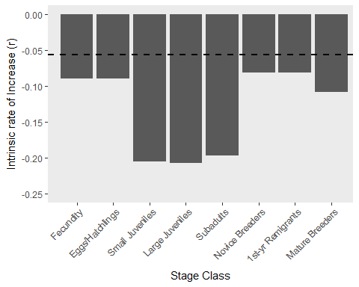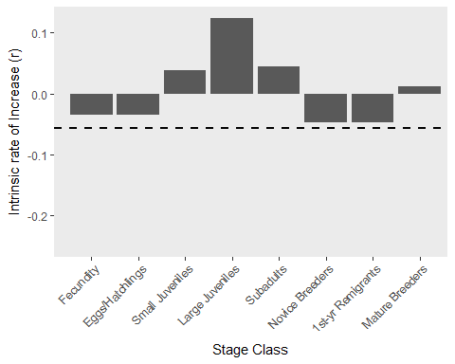 **Figure 2** These conditions, a 6-yr decrease or increase in tthe age of reproductive maturity, were simulated (Fig. 2) by subtracting and adding 2 yr to the calculations of P, and G, for each of the three immature stages. In fact, a mere 3-yr reduction in the age of first repro- duction, well within the bounds of the growth estimates available, comes very close to halting the decline in this population

## Warning in which.max(eigs.mat28[["values"]]): imaginary parts discarded in  
## coercion

## Warning in which.max(eigs.mat16[["values"]]): imaginary parts discarded in  
## coercion

## Warning in which.max(eigs.mat19[["values"]]): imaginary parts discarded in  
## coercion

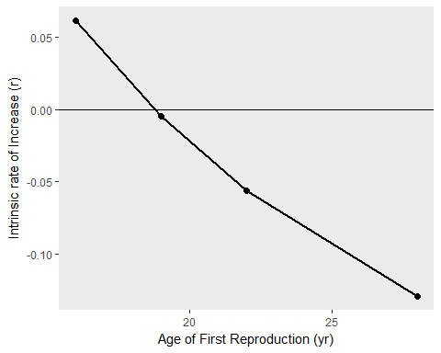

**Figure 3** The elasticity, or proportional sensitivity of lambda to changes in fecundity, F, survival while remainging in the same stage (P) and survival with growth (G). Because the elasticities of this matrix sum to 1, they can be compared directly in terms of their contribution to the population growth rate r.

