Jupyter Notebook + Google Colaboratory Instructions

This document provides instructions for generating designs using Jupyter Notebook files hosted on Google Colaboratory. This allows you to run the code without the need to download or install any software. Please follow the instructions below.

1. First **open Google Colaboratory** <https://colab.research.google.com/> . You should see the following pop up. Please click on the **GitHub tab**, circled in red.

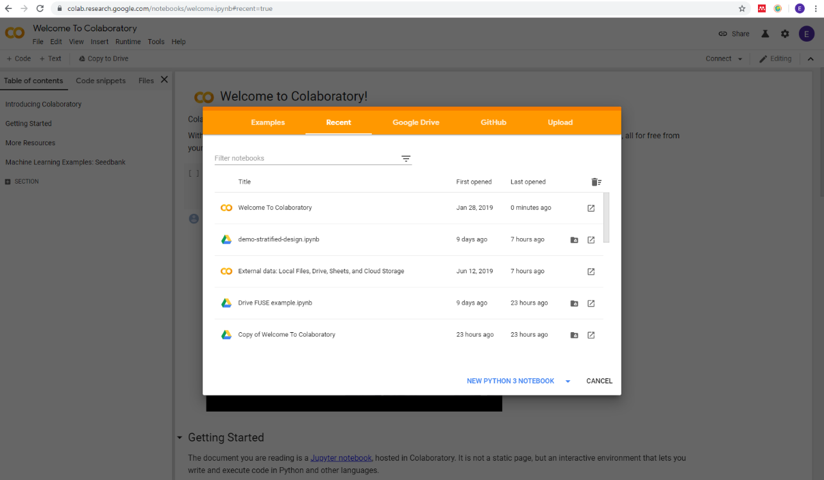

1. Under the top line ‘Enter a GitHub URL or search by organization or user’, enter the following URL <https://github.com/EllieBowler/optimising-sample-designs> .This links to the github repository where the code is stored.

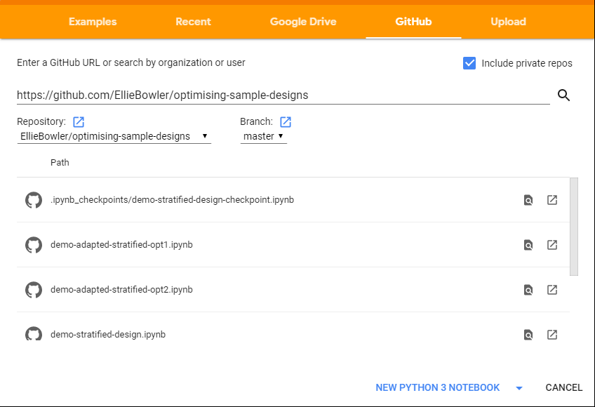

1. All jupyter notebooks (with file extension .ipynb) should appear listed as below. **Click on demo-stratified-design.ipynb.**



1. You should see the following page. This is the Jupyter Notebook for the Stratified Design. We now need to upload some maps to generate our designs. To do this click on the arrow on the left of the notebook, circled in red below.

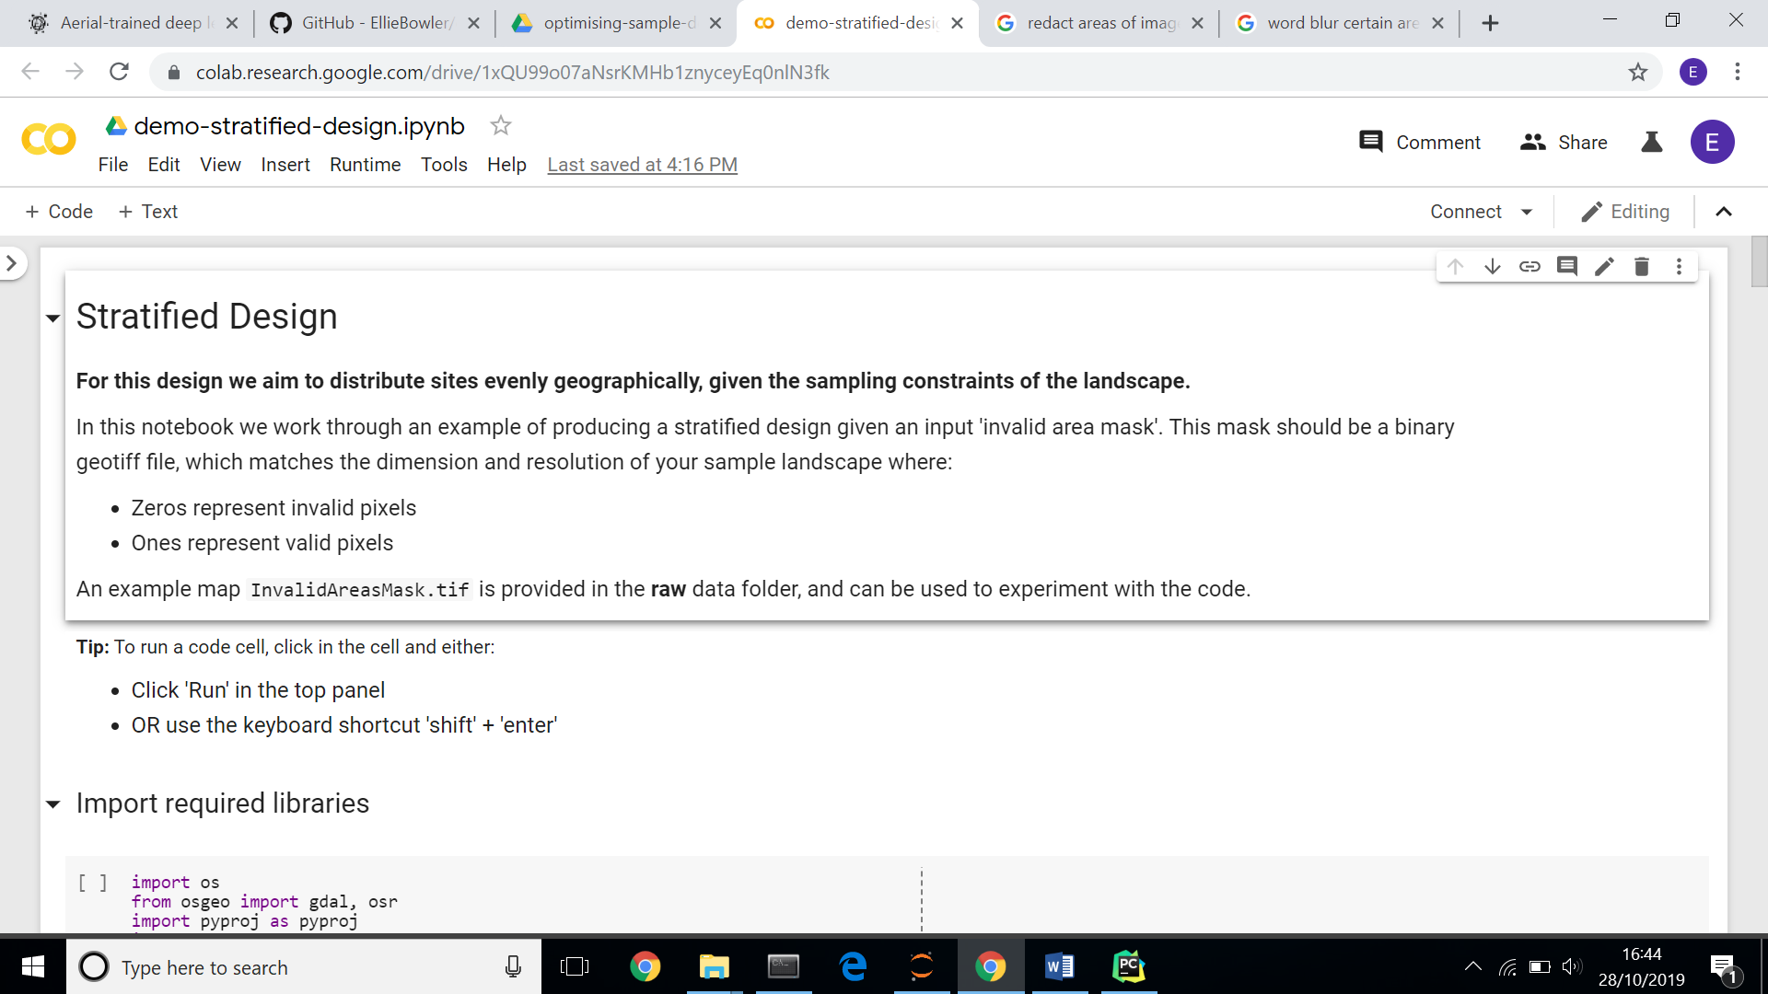

1. A panel will open with ‘Table of Contents’, ‘Code Snippets’ and ‘Files’. **Click on Files**. This is where we will upload the files needed to generate the design.

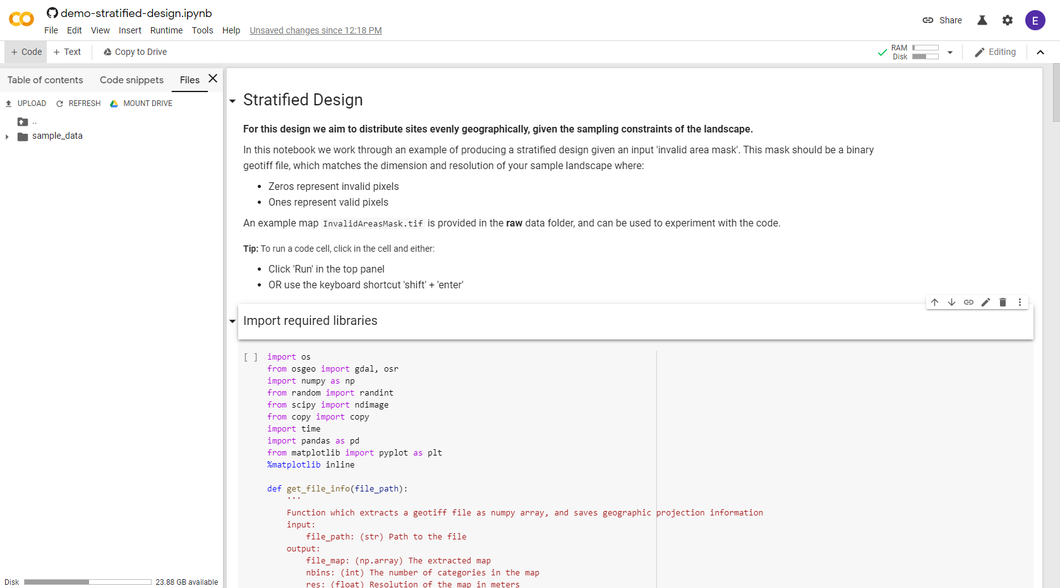

1. To follow the tutorial we have provided example files on dropbox. These can be downloaded from this link. <https://www.dropbox.com/sh/ss6wipfwpv87h1i/AACJqFQiUh-bQh8o9Nf6eJ60a?dl=0> . Please **download all the files in the TestData folder**.

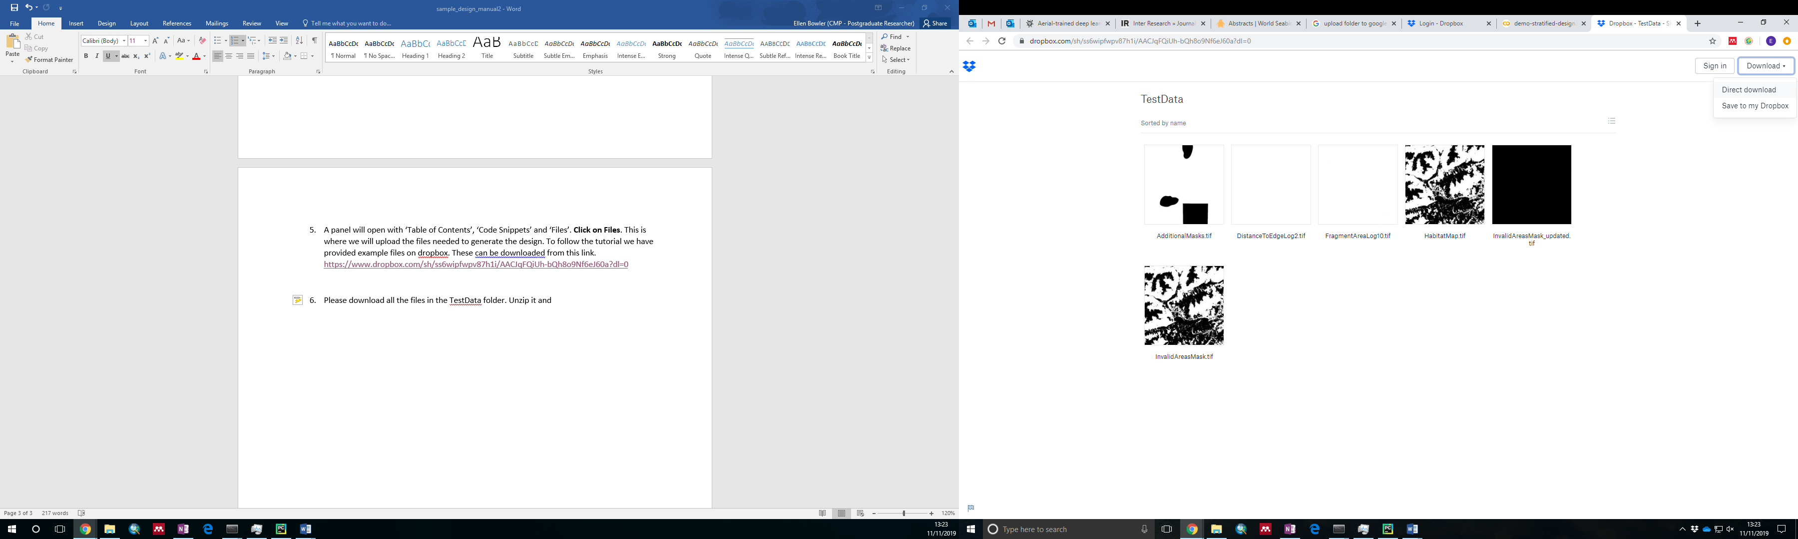

1. **Save and unzip the folder** in your chosen directory. You can now **upload these to Google Colaboratory**, either by using the ‘UPLOAD’ button, or by dragging and dropping. Please copy all files across, and ensure they are in the same directory as the sample_data folder as shown below.

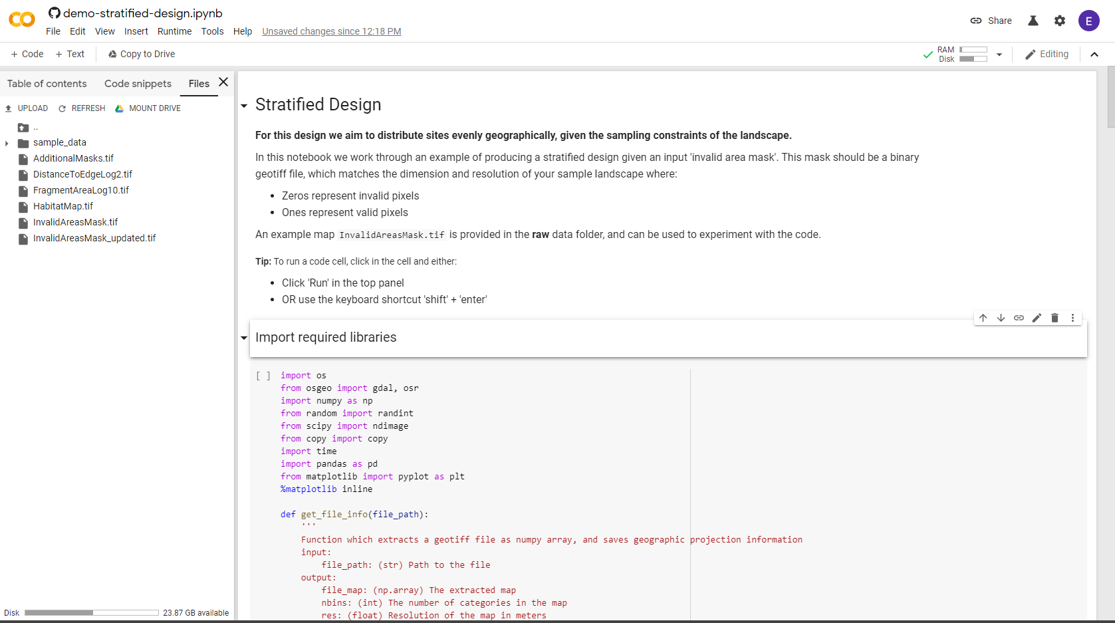

1. **You should now be able to run through the notebook!**

Instructions are provided within the notebook, please run through each block sequentially. Your results will be generated and saved in a **results** folder, shown in the file panel. You can download these directly from colaboratory and view them in your chosen software.

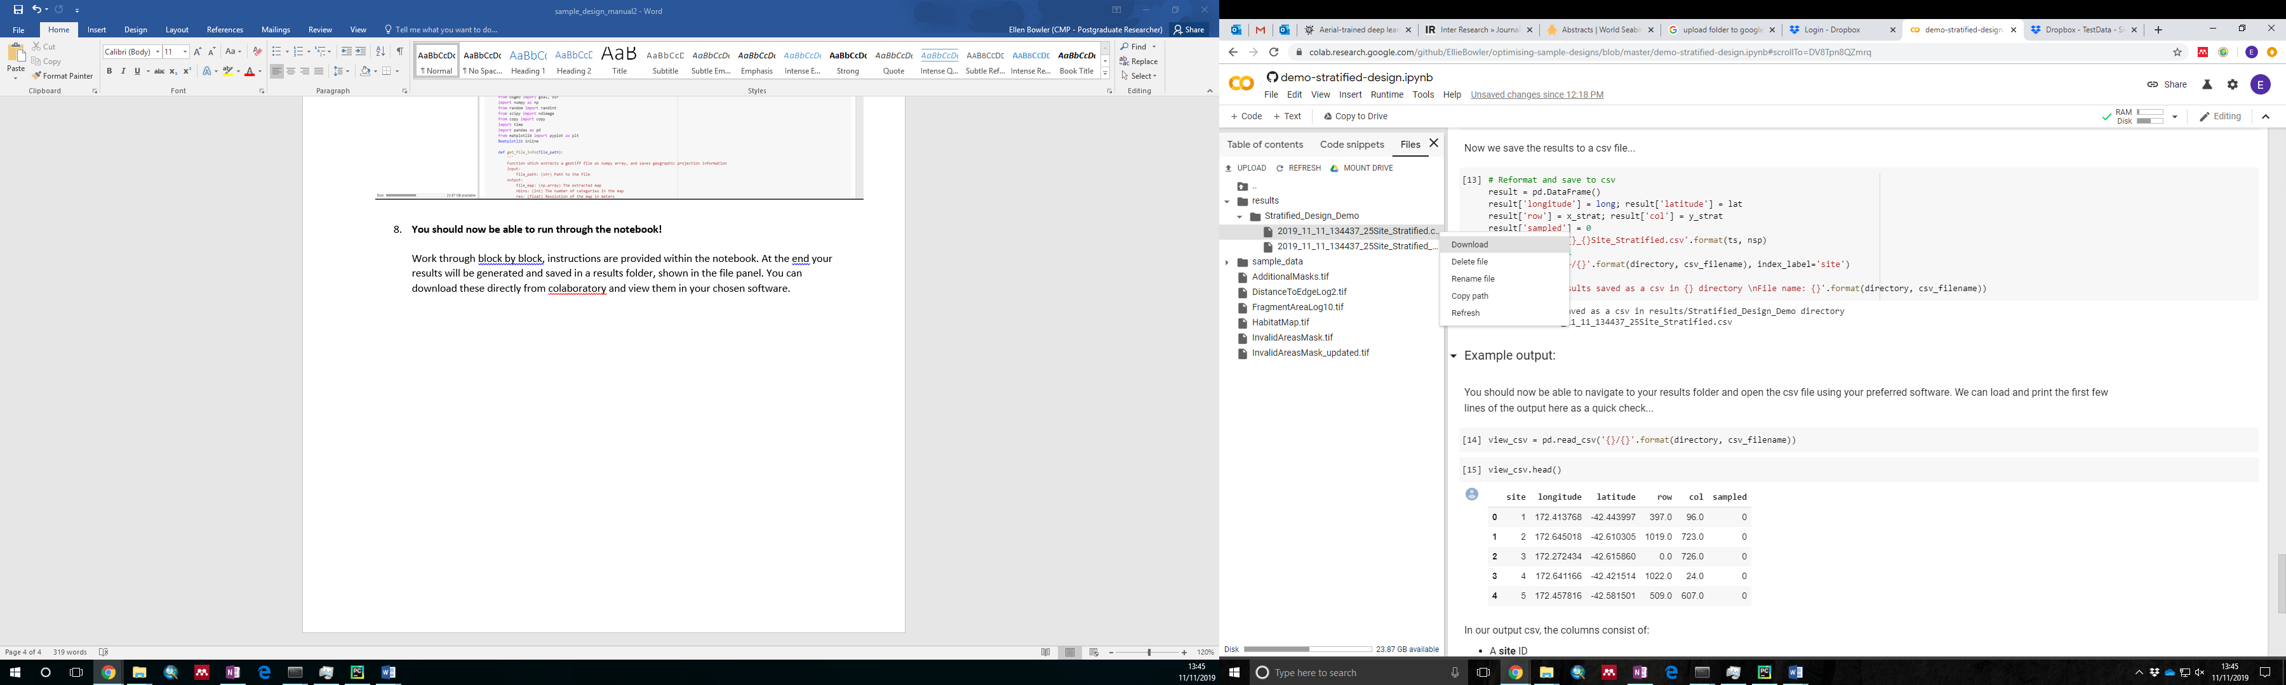

**Once you’re happy - test out uploading your own data to generate designs for your study site!**