# Jupyter Notebook + Google Colaboratory Instructions

This document provides instructions for generating designs using Jupyter Notebook files hosted on Google Colaboratory. This allows you to run the code without the need to download or install any software. Please follow the instructions below.

## Test Data

To follow the tutorial we have provided example files on dropbox. **Please download all files in the TestData folder, from the following link**:

<https://www.dropbox.com/sh/ss6wipfwpv87h1i/AACJqFQiUh-bQh8o9Nf6eJ60a?dl=0>

Once downloaded, please save and unzip the folder in your chosen directory.

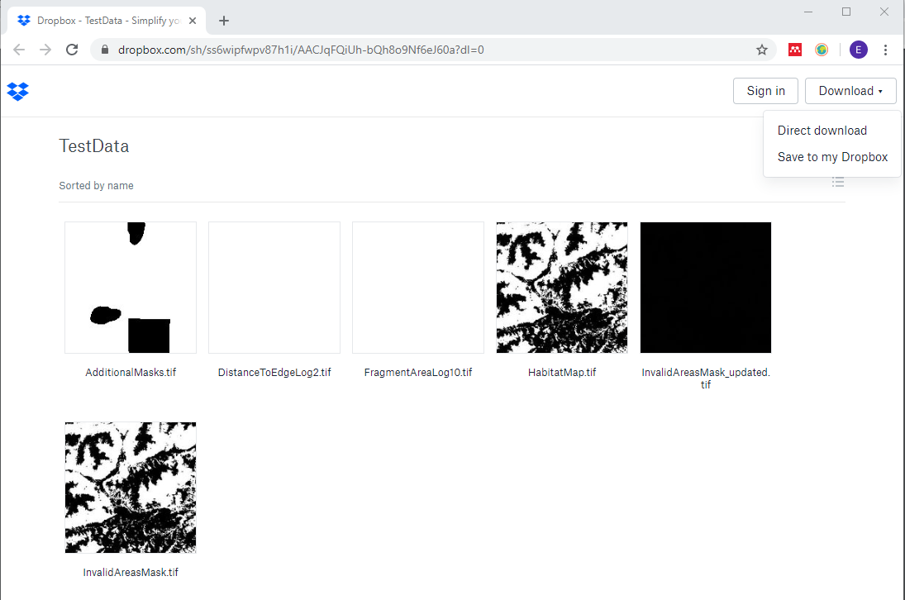

We will see how these files are used as we go through the notebooks, briefly we have:

* InvalidAreasMask.tif: *A binary map showing valid (coded with 1) and invalid (coded with 0) areas in the landscape*
* InvalidAreasMask_updated.tif: *An updated version of InvalidAreasMask.tif, with extra invalid areas added. This is used to demonstrate adapting designs*
* HabitatMap.tif: *A two class habitat map (with non-habitat = 0, habitat = 1). This was used to generated the two fragmentation metric maps:*
* DistanceToEdgeLog2.tif: *A log2 scaled distance to nearest habitat edge map*
* FragmentAreaLog10.tif: *A log10 scaled fragment area map*

**Please Note**: All files are in georeferenced tiff format, and information on projection and resolution are used to output results in longitude/ latitude coordinates. This is important to know when inputting your own study site.

## Google Colaboratory

Now we will open up our notebook files in Google Colaboratory, which we can use to run our python code online. **Please Note:** It is best to use Google Chrome browser.

1. First open up Colab via this link: <https://colab.research.google.com/>

You should see the following pop up. Please click on the **GitHub tab**, circled in red.

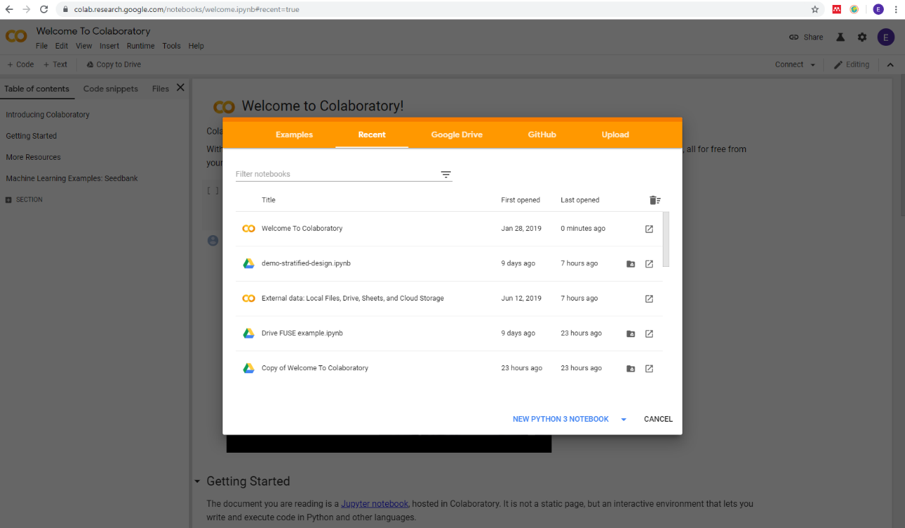

1. Under the top line ‘Enter a GitHub URL or search by organization or user’, enter the following github repo link <https://github.com/EllieBowler/optimising-sample-designs> . If this does not bring up the files, search by user instead with the name EllieBowler.

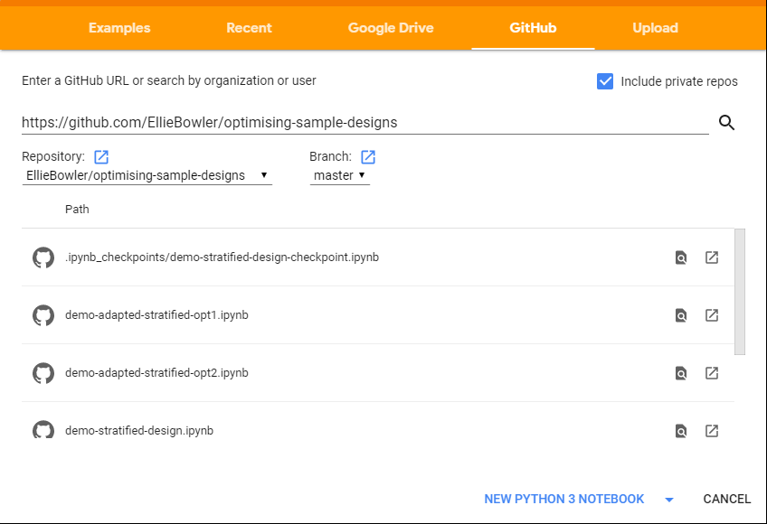

1. All jupyter notebooks (with file extension .ipynb) should appear listed as below. For this demonstration, **click on demo-stratified-design.ipynb.**



1. You should see the following page. This is the notebook for the Stratified Design.

To run the code, we will need to **upload our test files**. To do this click on the arrow on the left of the notebook, circled in red.

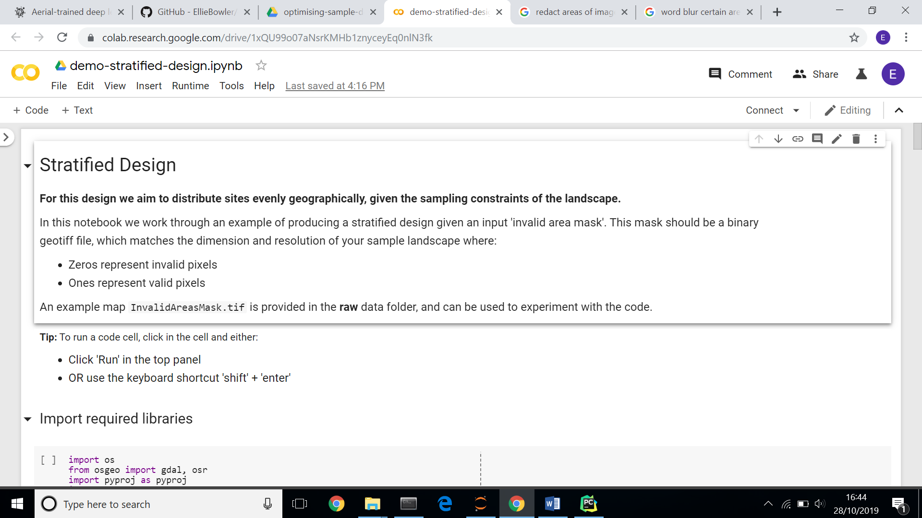

1. 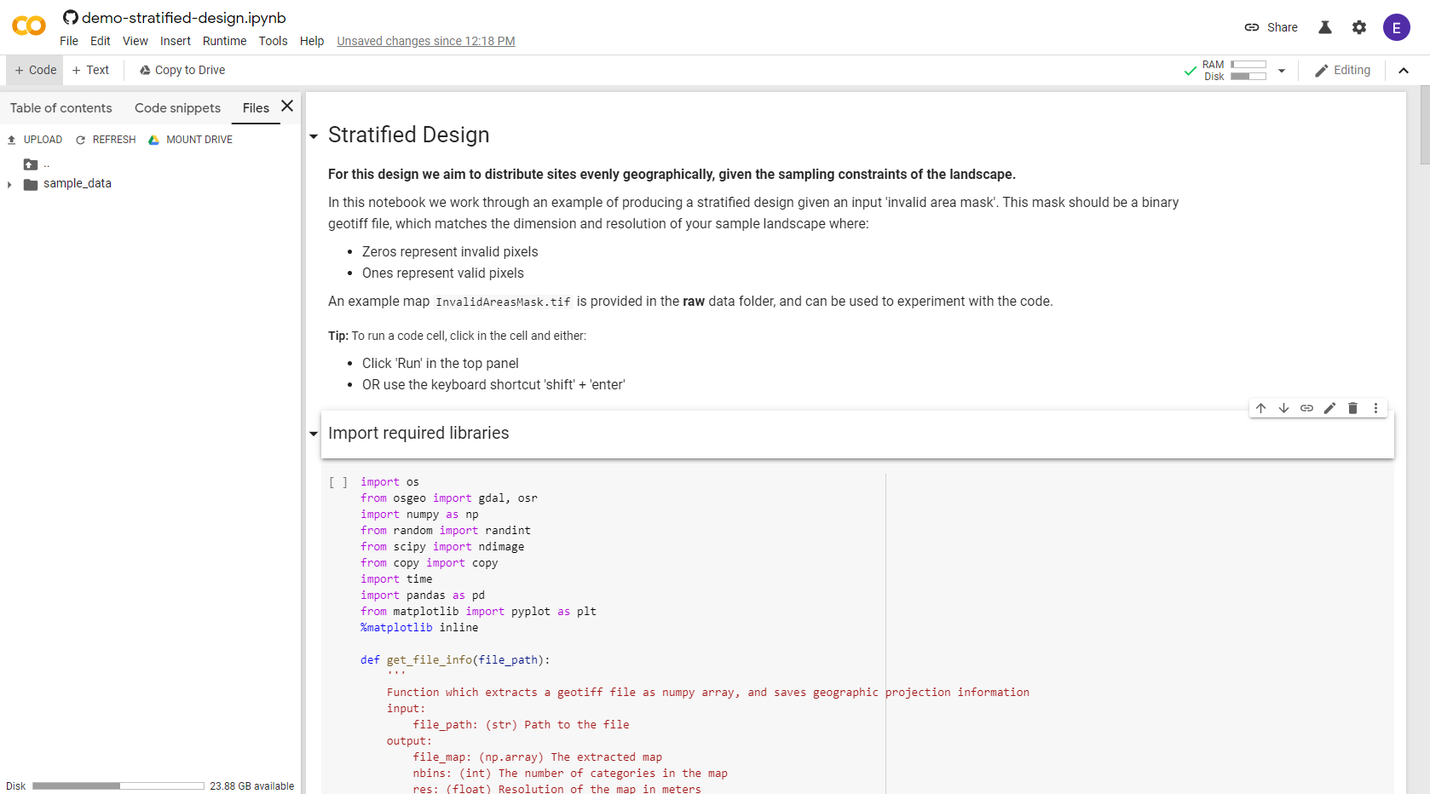A panel will open with ‘Table of Contents’, ‘Code Snippets’ and ‘Files’. **Click on Files**.
2. You can now **upload your files to Google Colaboratory**, either by using the ‘UPLOAD’ button, or by dragging and dropping. Please copy all files across, and ensure they are in the same directory as the sample_data folder as shown below.

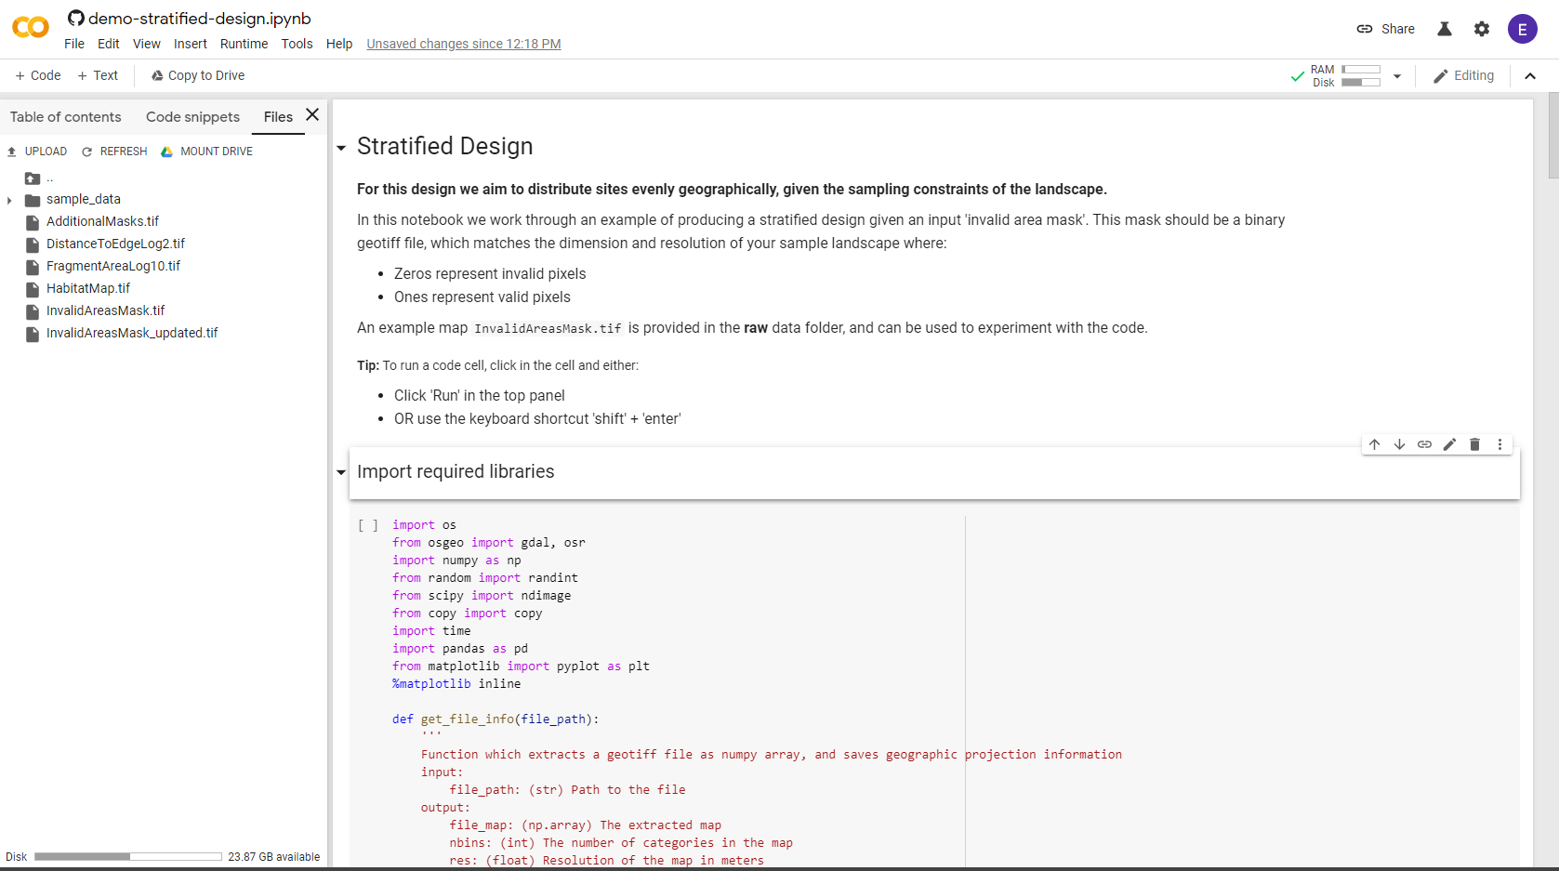

1. **You should now be able to run through the notebook!**

Instructions are provided within the notebook, please run through each block sequentially. Your results will be generated and saved in a **results** folder, shown in the file panel. You can download these directly from colaboratory and view them in your chosen software.

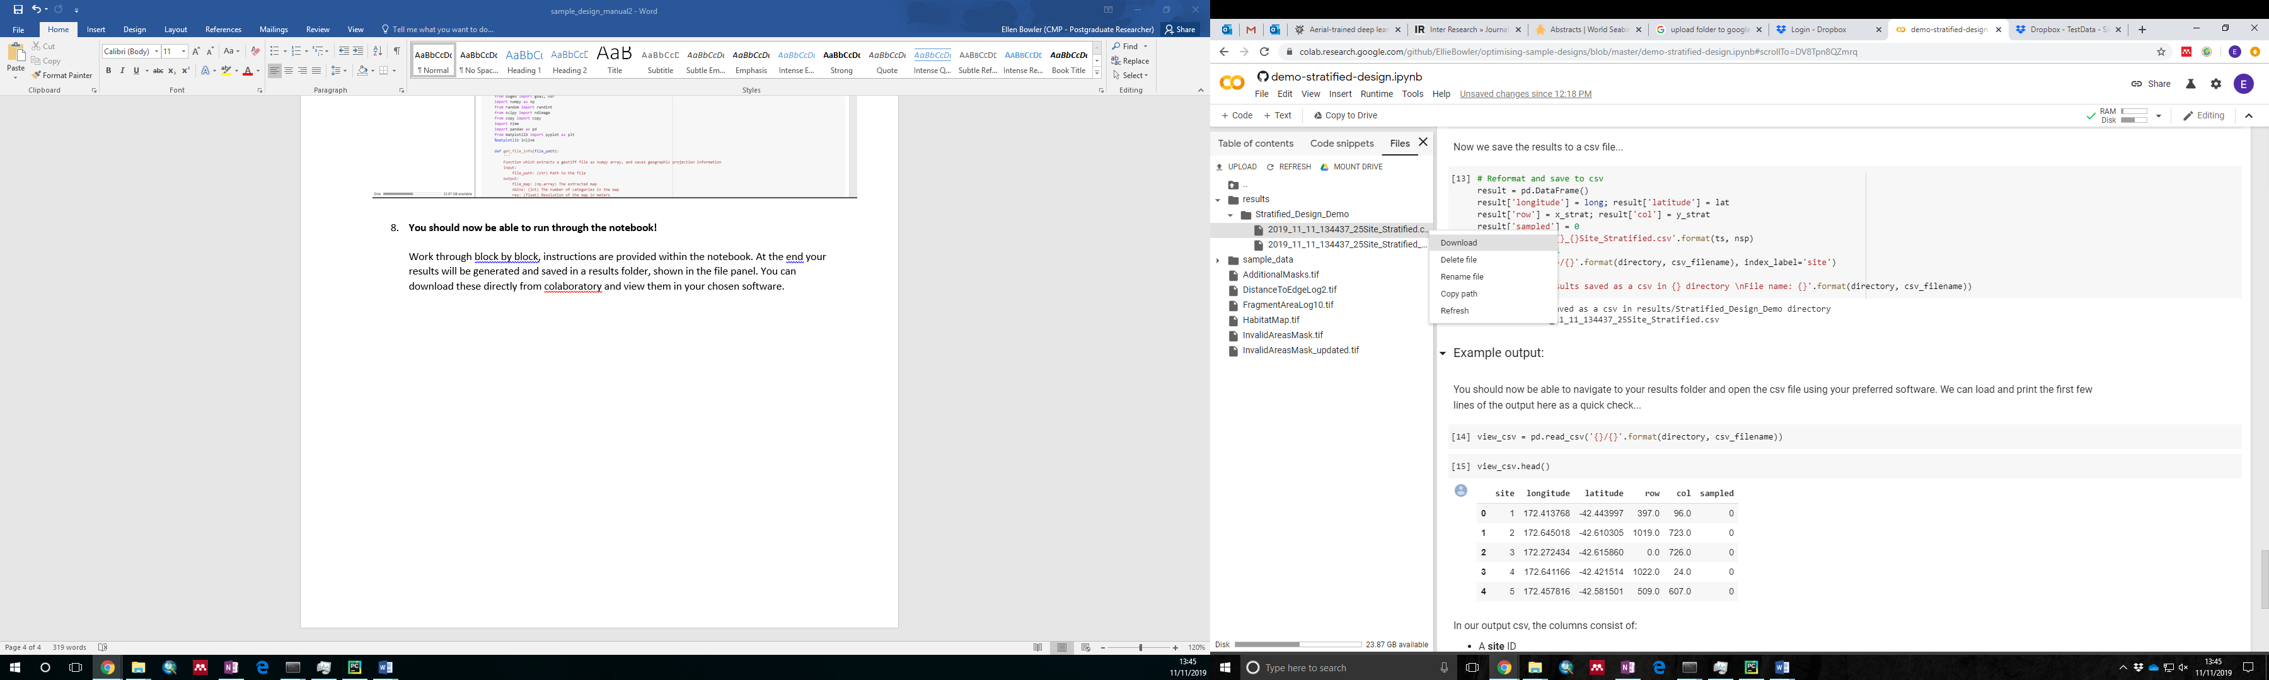

**Once you’re happy - test out uploading your own data to generate designs for your study site!**