problem 1 - Ingest data from a single table in SQL Server database to Azure Blob storage

step one – create a data factory.

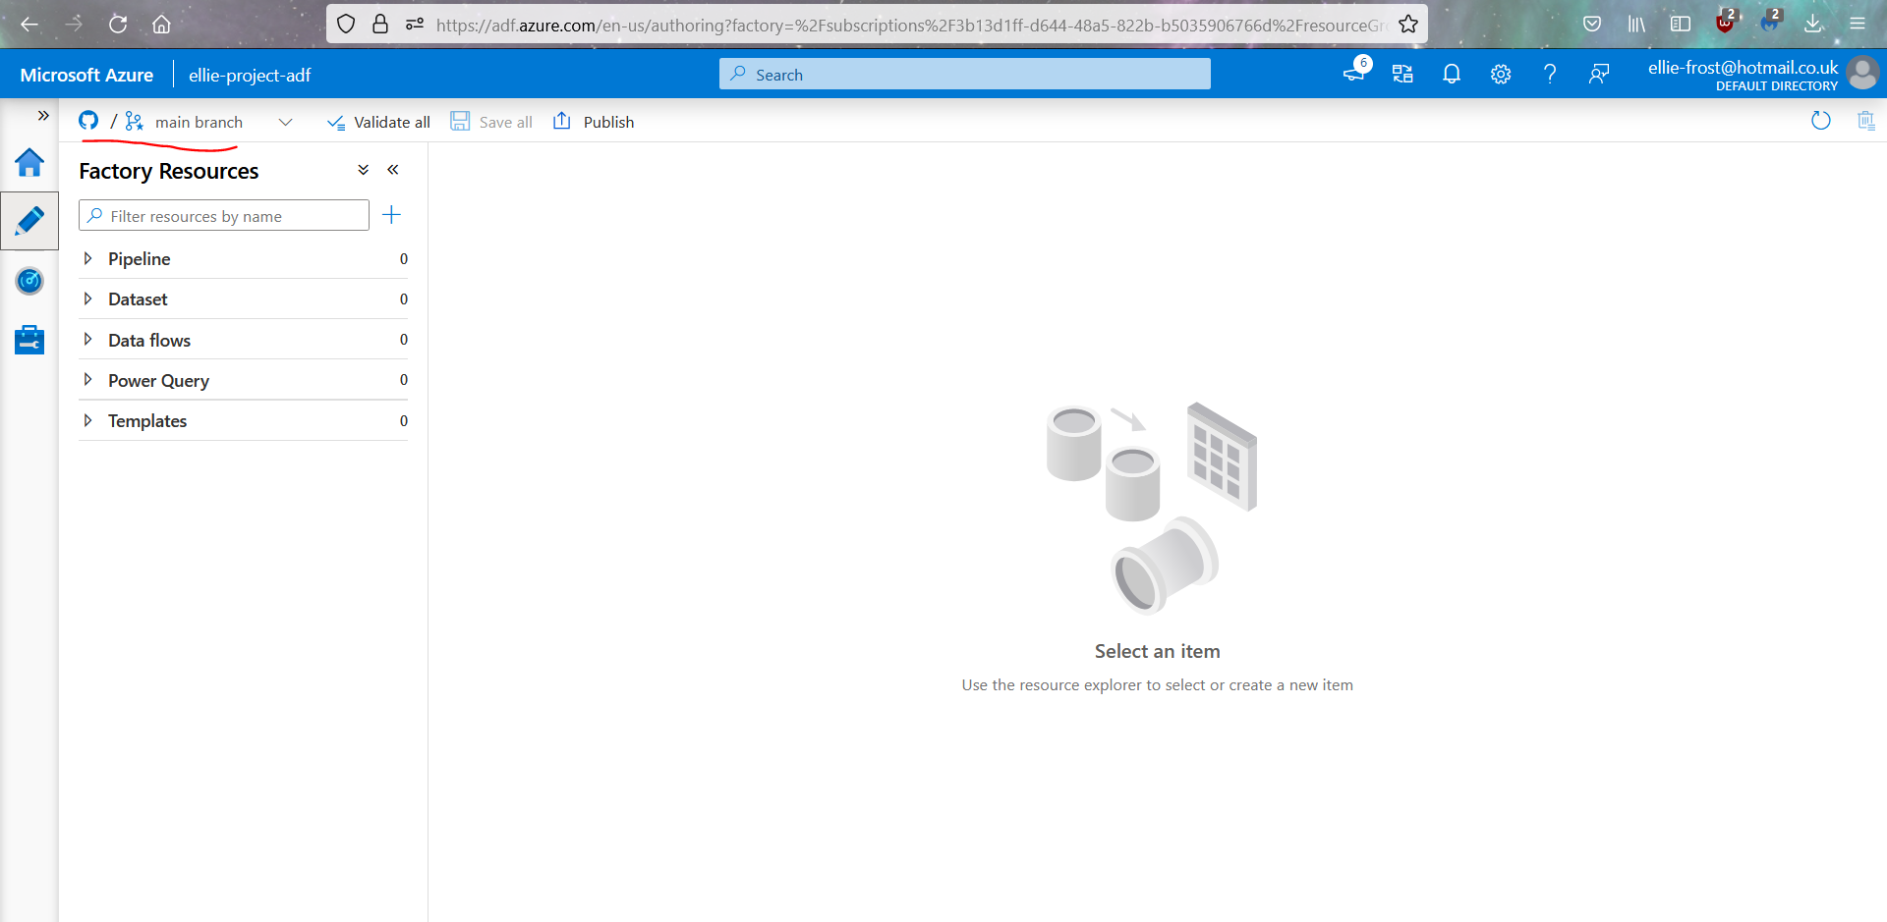
I created a resource group and a storage account with container which I then used to create a new data factory, which as you can see from this screenshot has been connected to a github repository.

Step two – create a self hosted integration runtime

As seen in the below screenshot, I have created a self hosted integration runtime.
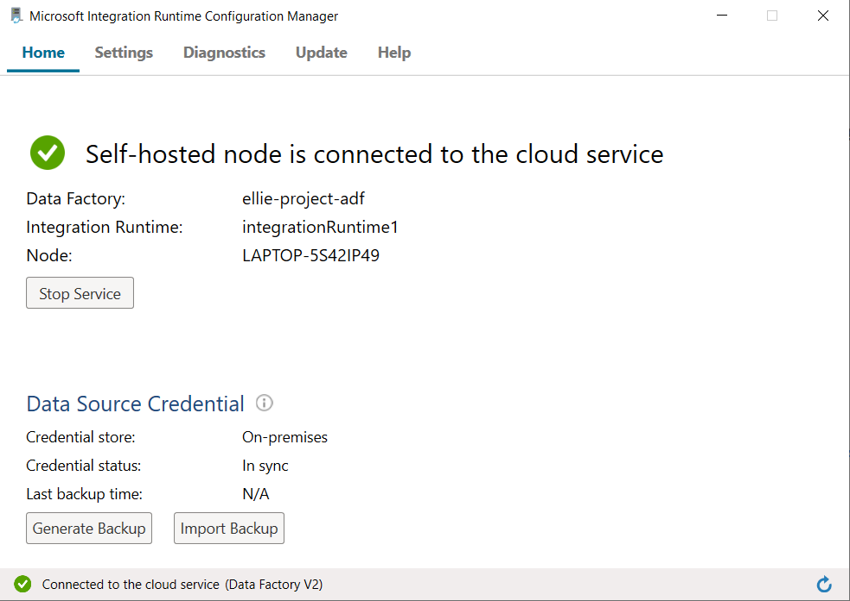

Step three - Create SQL Server and Azure Storage linked services.

In the below image you can see I created two linked data services – one SQL server and one blob storage.
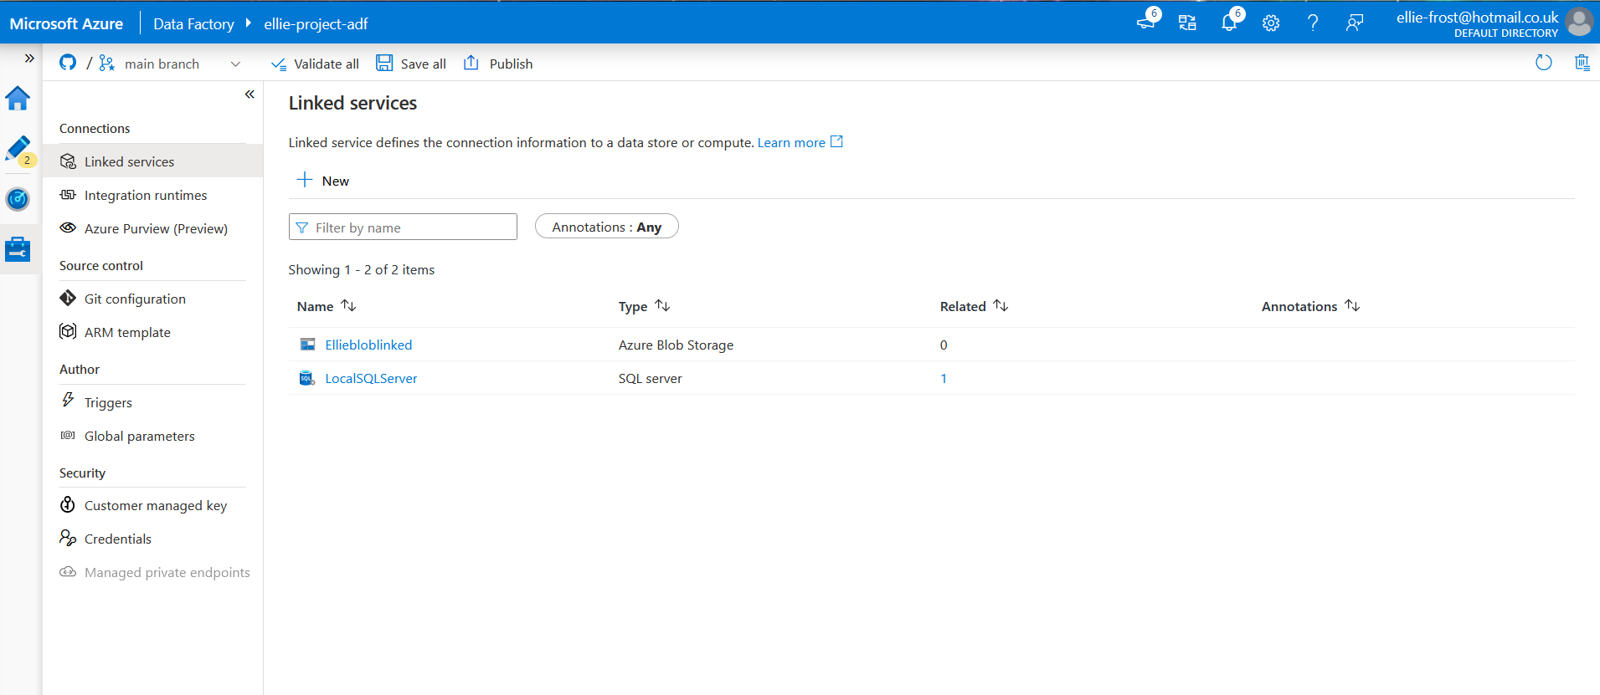

Step four – create SQL server and blob datasets

in the below image you can see I have created a SQL server and blob dataset
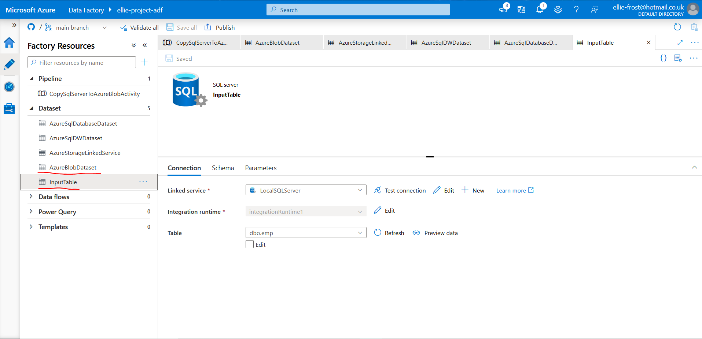
Step five – create pipeline

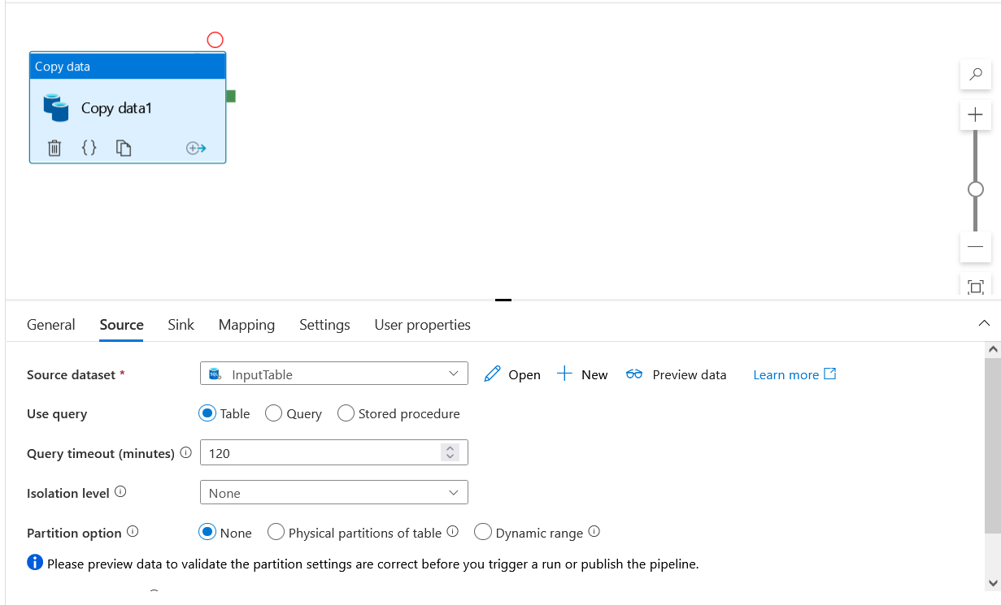
I created a pipeline which contains 1 copy activity. The screenshots below show the source and sink for this.
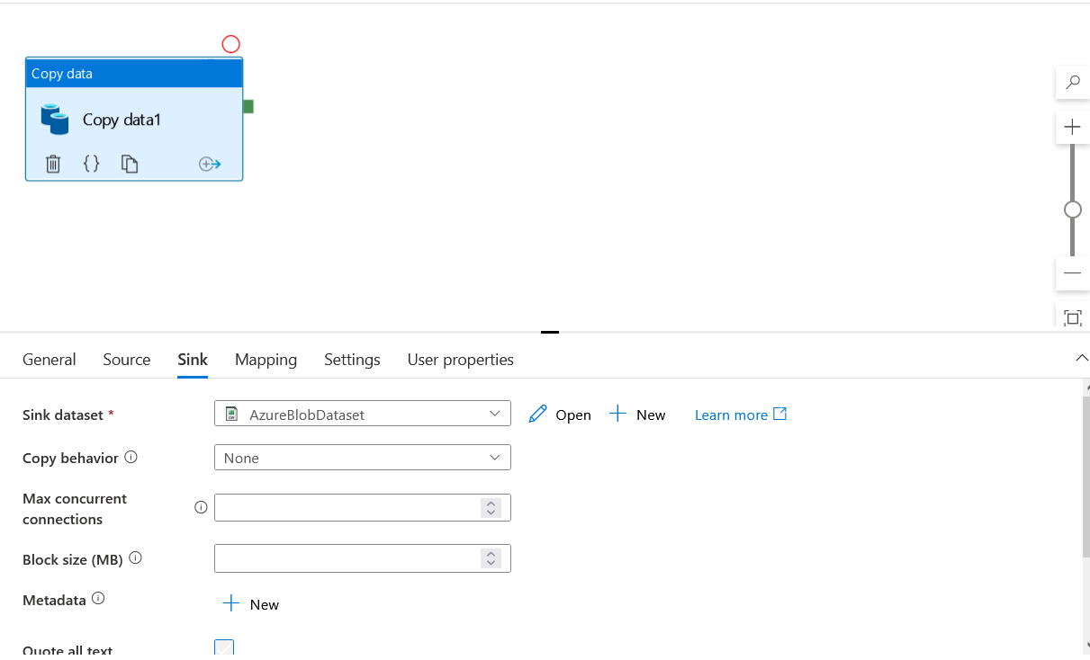
Step five – start a pipeline run

in the below image, you can see that I triggered a successful pipeline run
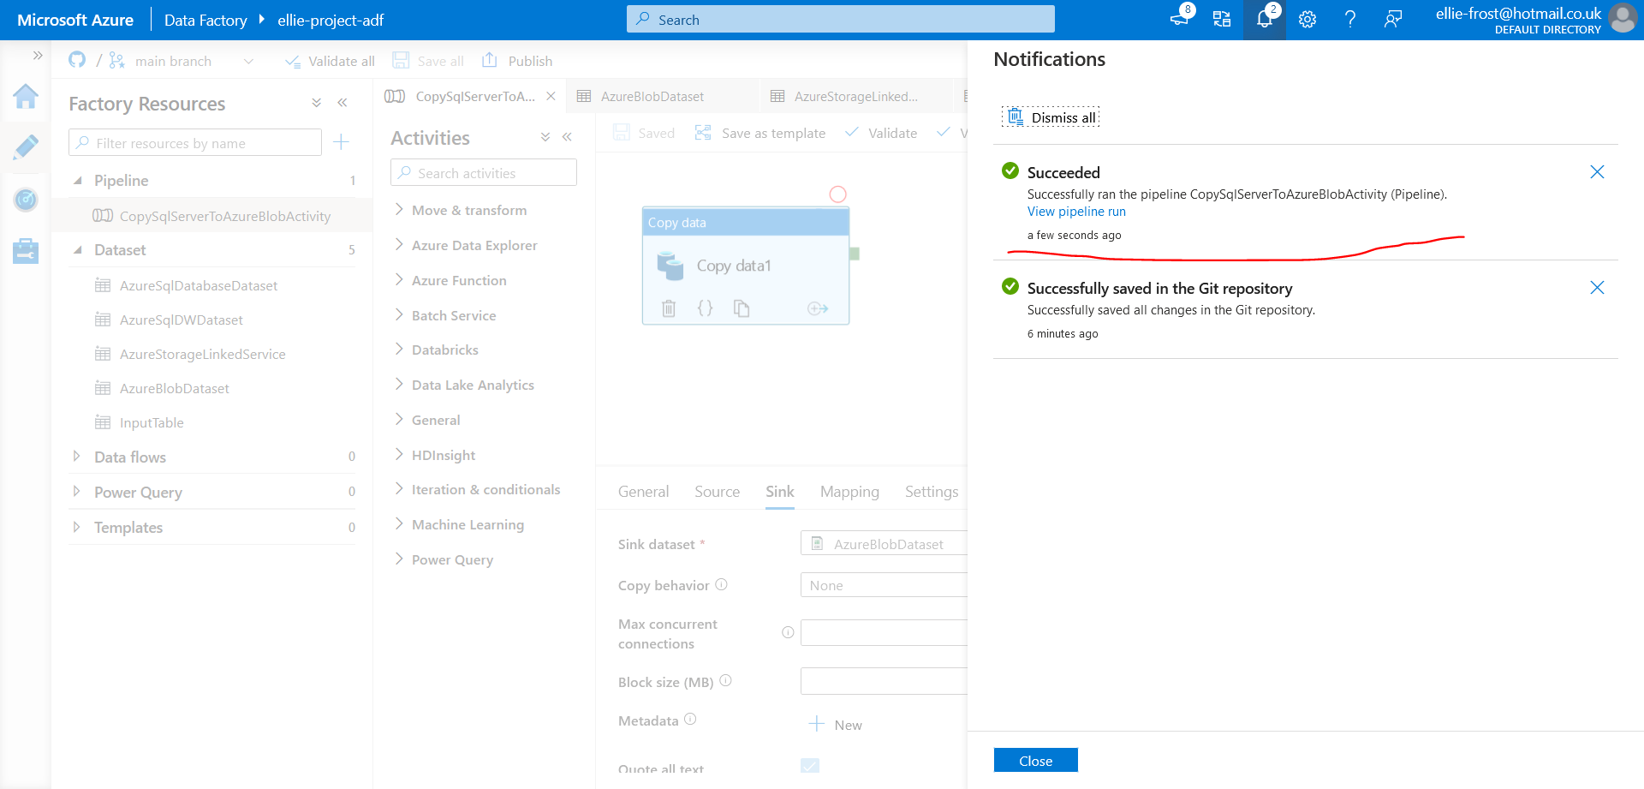
Step Six – Monitor a pipeline run

in the below image, we have navigated to the monitor tab in order to monitor the pipeline run, on which page we can see that is has been successful.
