Problem 2 - Ingest data from multiple tables in SQL Server database to Azure Blob storage

Step one – Create a data factory.

For problem 2 I will be using the data factory I created for problem 1, as you can see below.
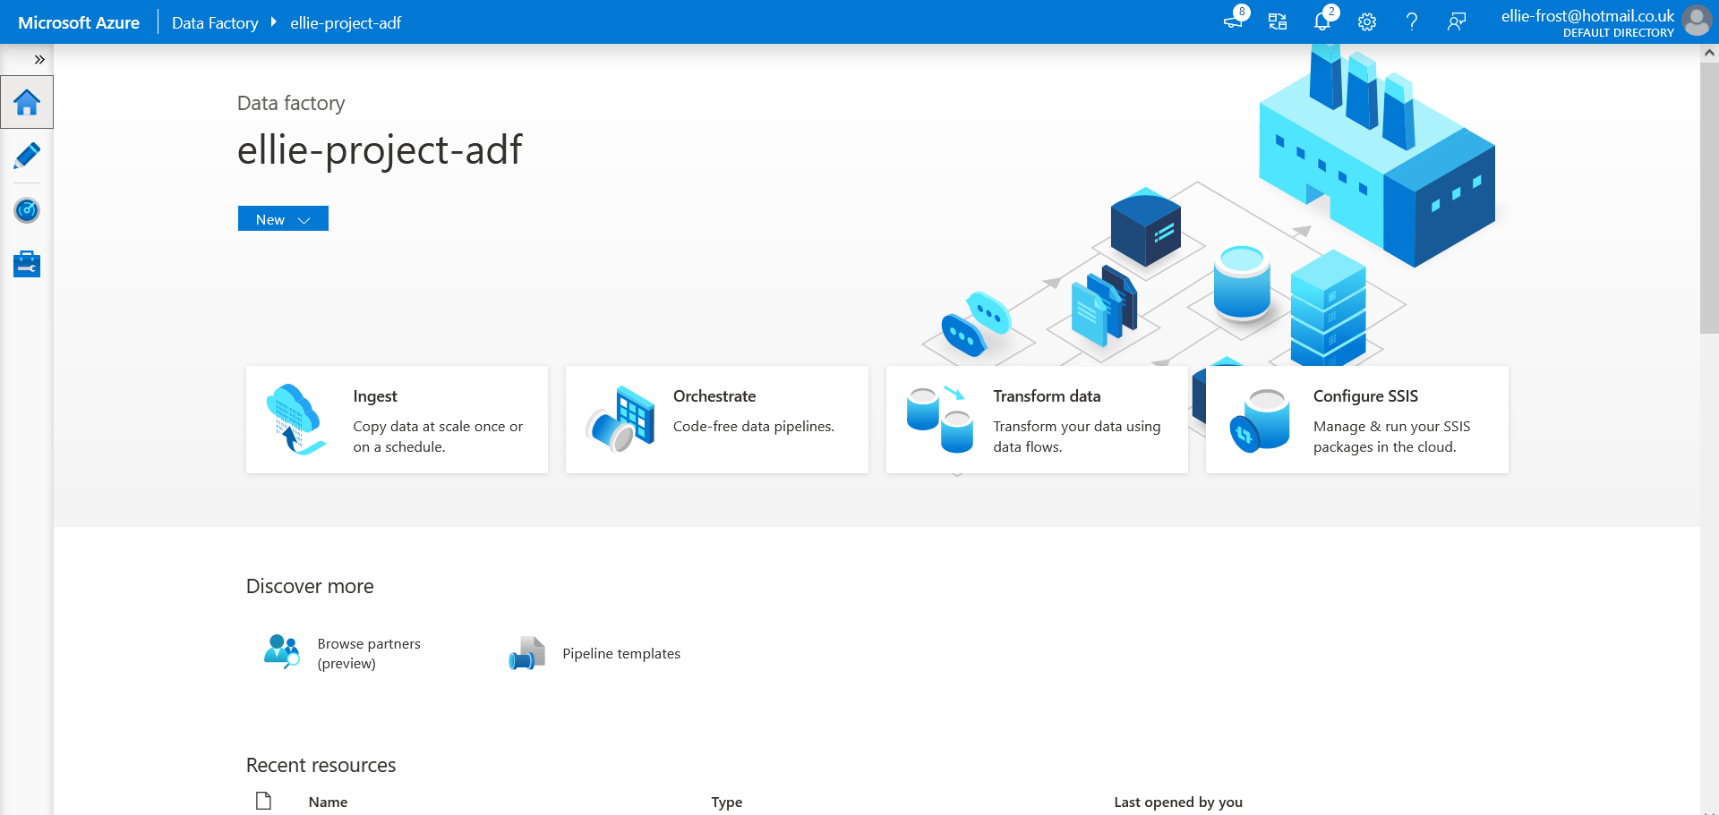

Step two – create an integration runtime

I will be using the same integration I created for problem 1 as I am using the same data factory, as seen below

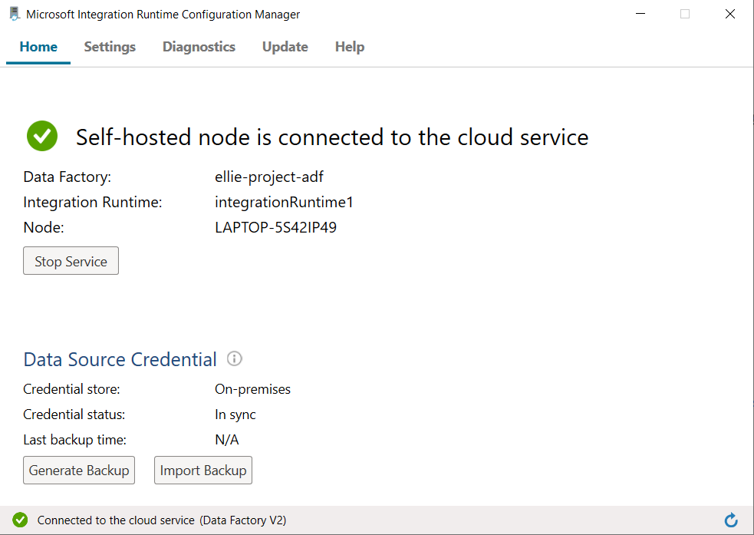

Step three - Create SQL Server and Azure Storage linked services.

In the below image, you can see that I created an SQL server and Azure storage linked services.
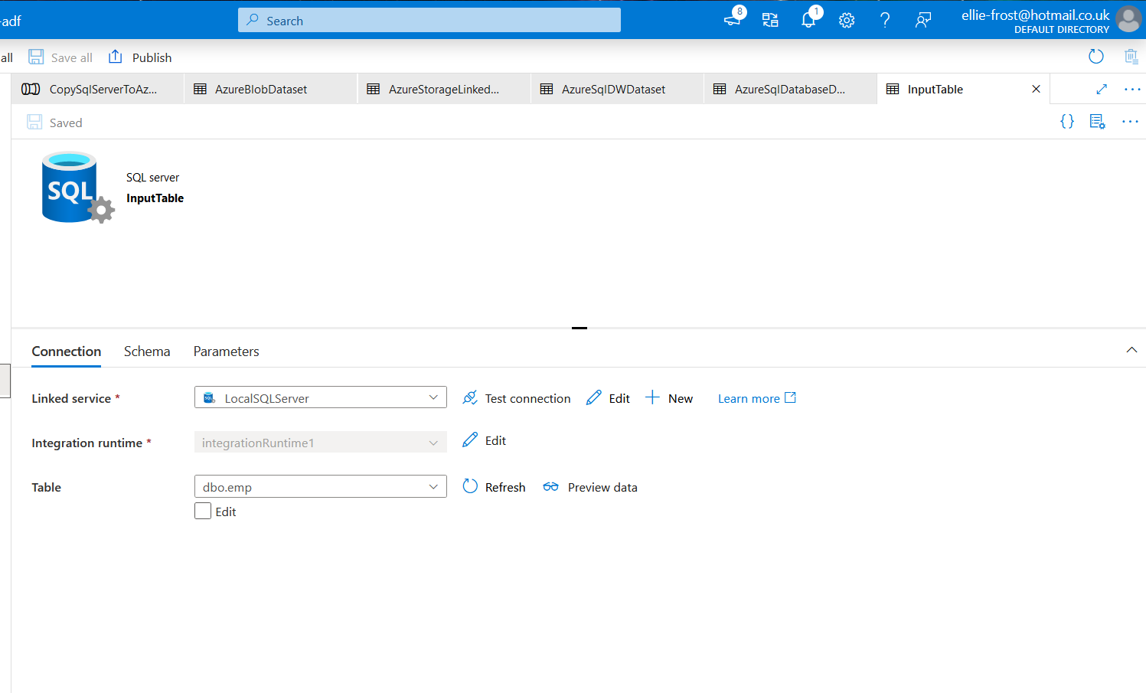

Step four - Create SQL Server and Azure Blob datasets.

You can see in the below image that I have created a SQL server and azure blob dataset
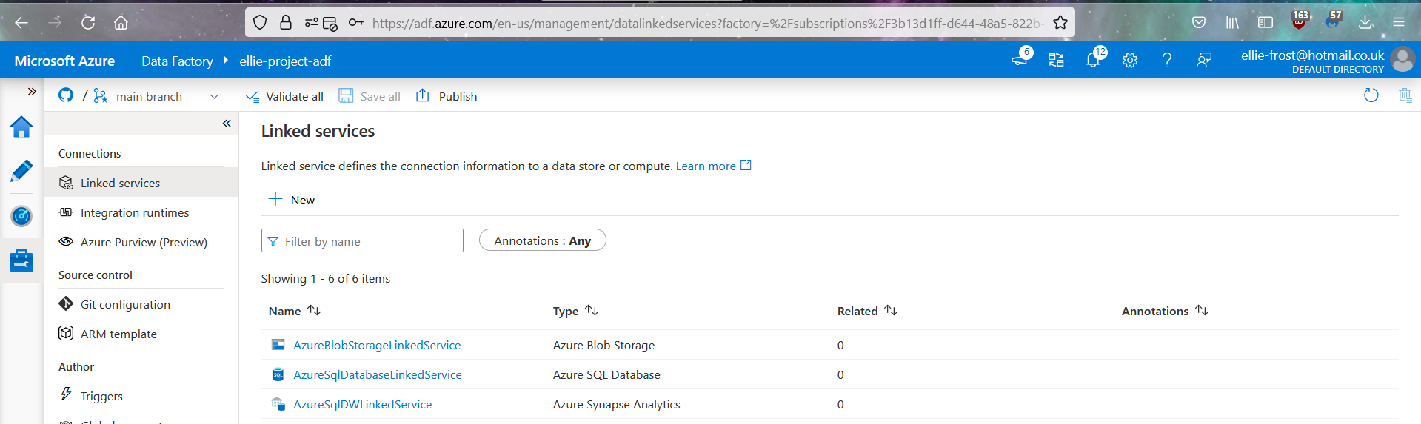
Step five - Create a pipeline with a copy activity to move the data.

In the below image you can see that I have created 2 pipelines. The pipeline named gettablelistandtriggercopydata has a look up activity which looks up a list of tables which need to be copied over to the sink data stores. It then triggers the second pipeline Iterateandcopysqltables, which performs the copy activity itself.
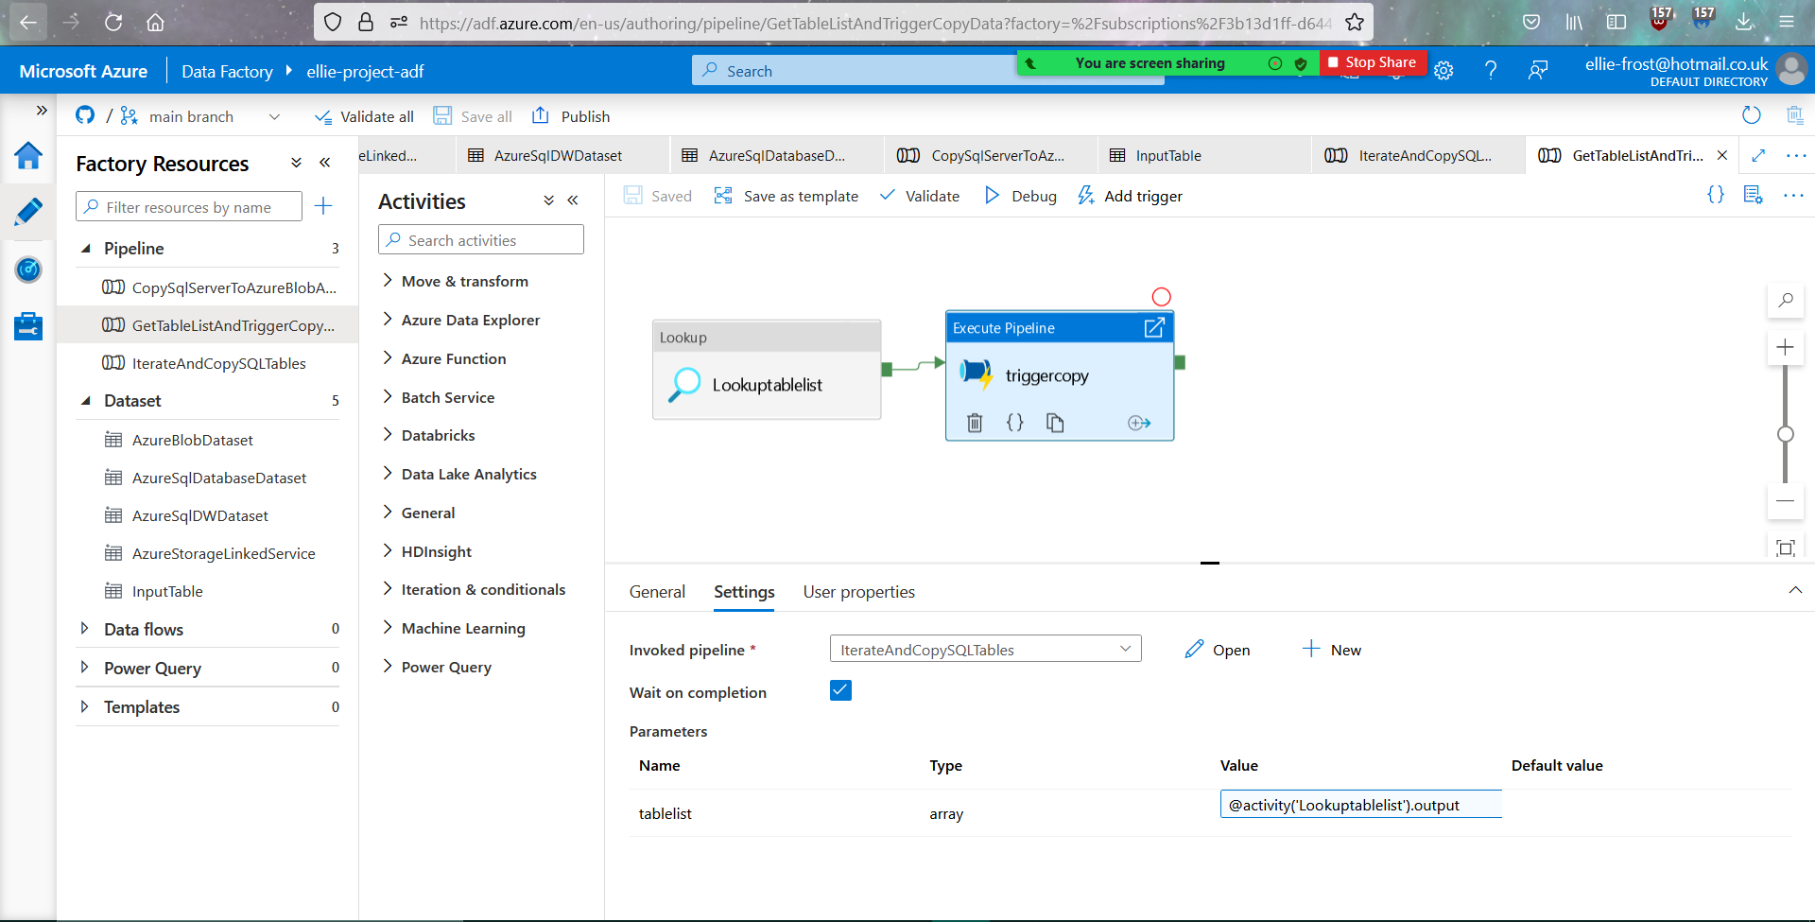

Step six - Start a pipeline run.

I triggered a pipeline run to ensure that the two pipelines work together.

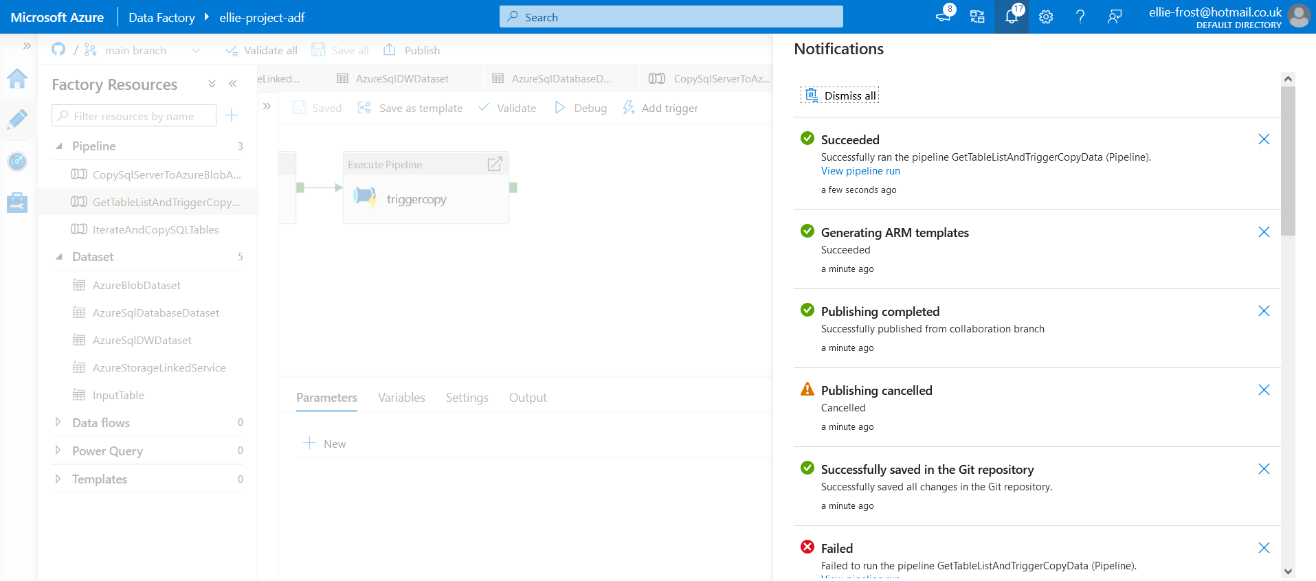
Step seven - monitor pipeline run

In the below image you can see where I monitored the pipeline runs, and they ran successfully.

