problem 3 - Load data from Azure Blob storage to a database in Azure SQL Database by using Azure Data Factory

in the following activities, I will be using the data factory and integrated runtime created in activity one, screenshots can be seen in problems 1 and 2.

Step one – Create table

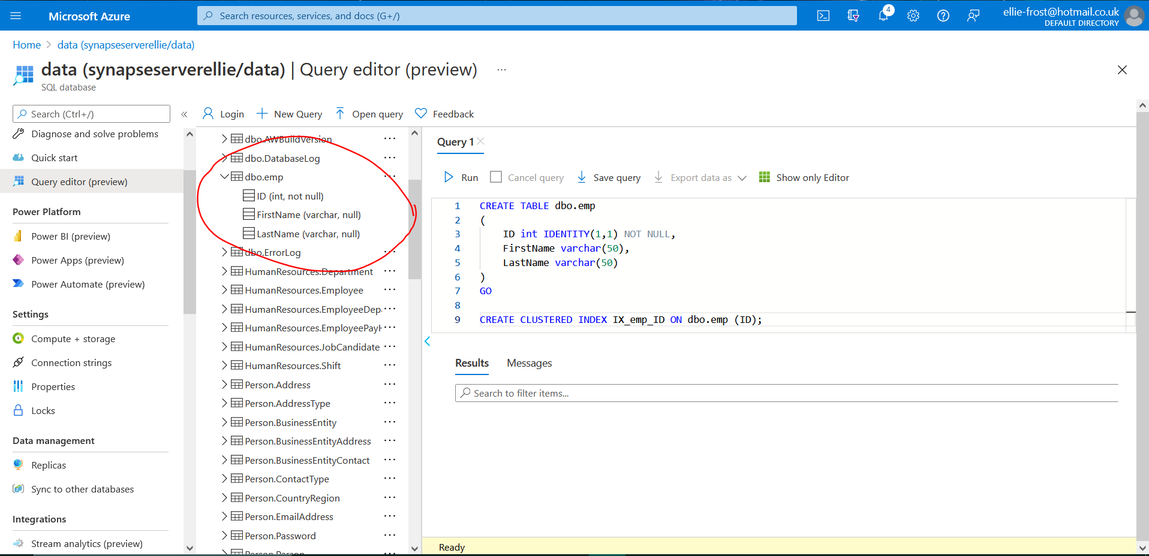
I created a new table in my sql database, called dbo.emp
Step two – Create Pipeline
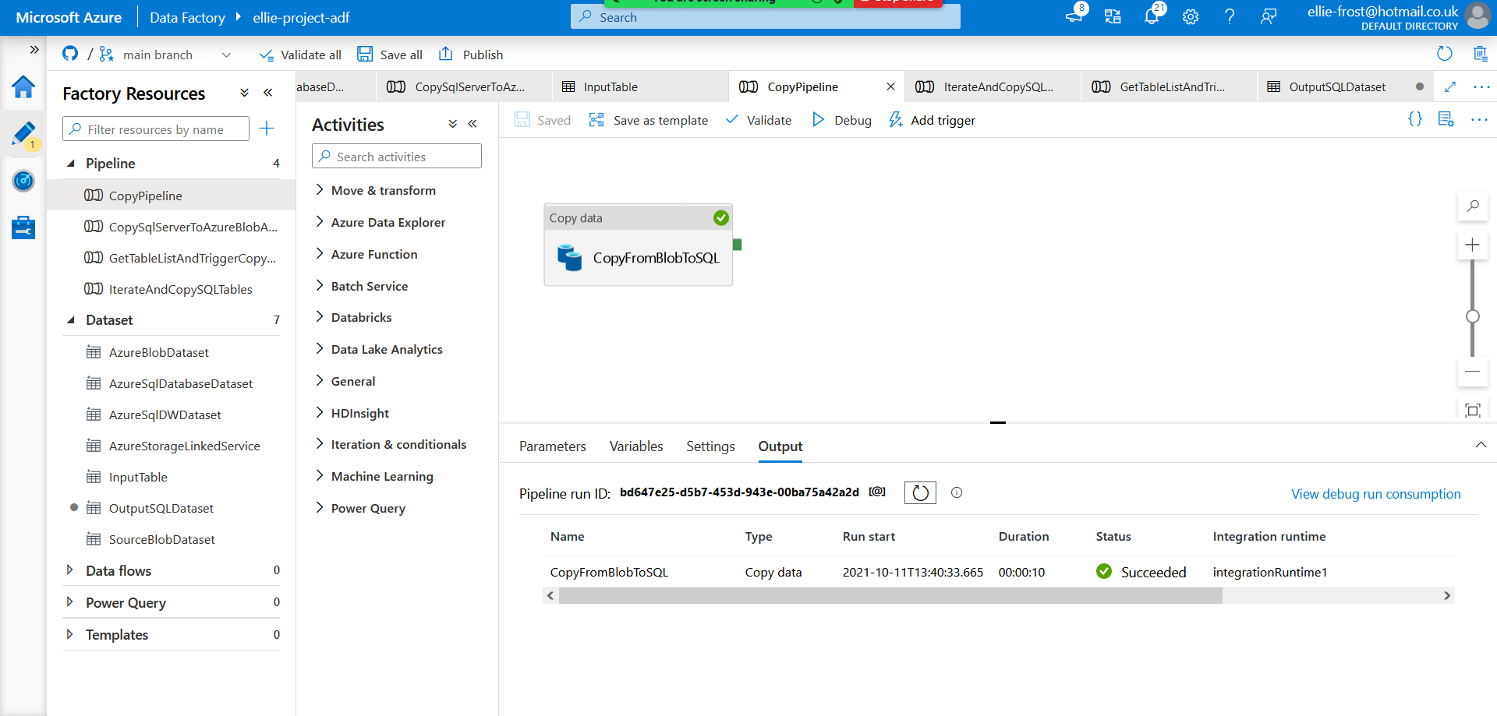
I created a new pipeline named copyfromblobtosql and as you can see it passed debug successfully.
The screenshots below show the sink and source tabs for the copy activity in the pipelines
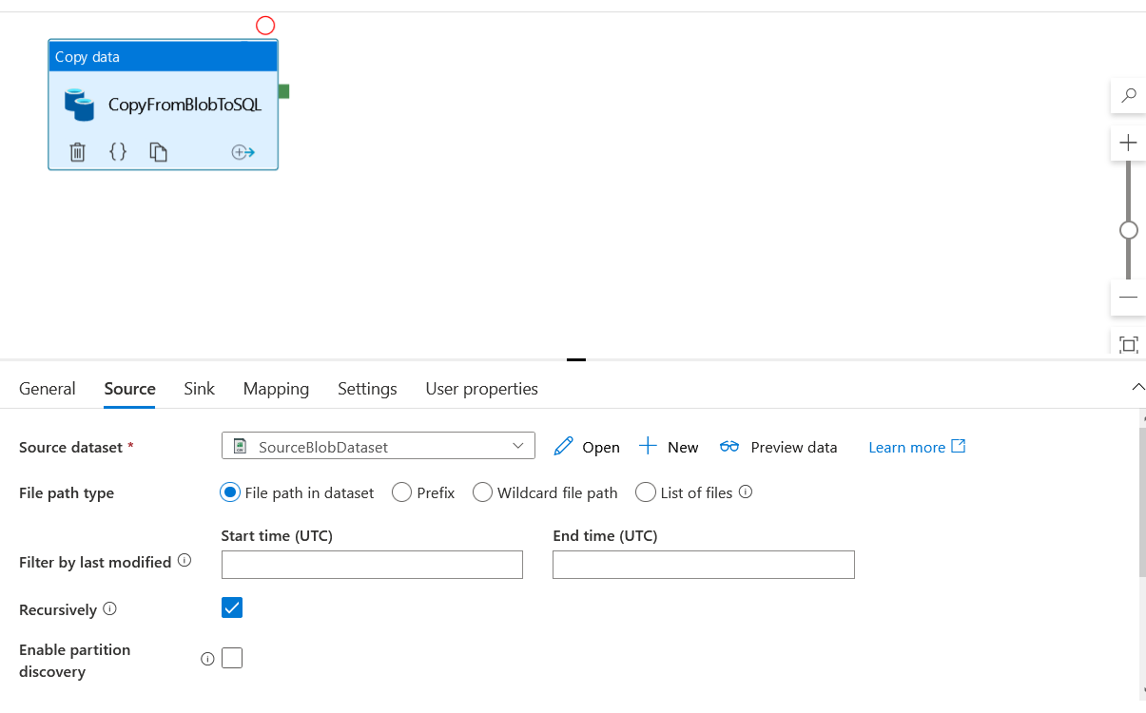
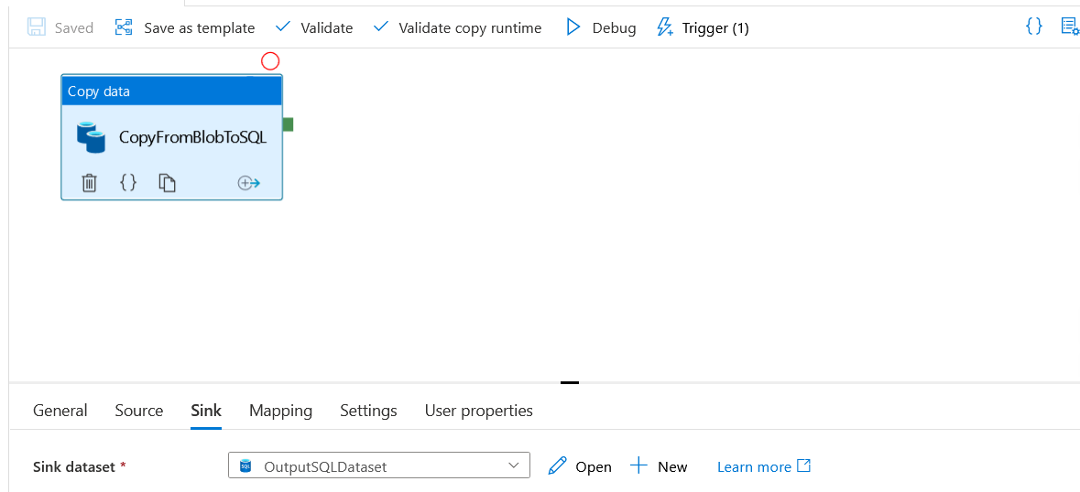

Step three – run pipeline

I ran the pipeline successfully

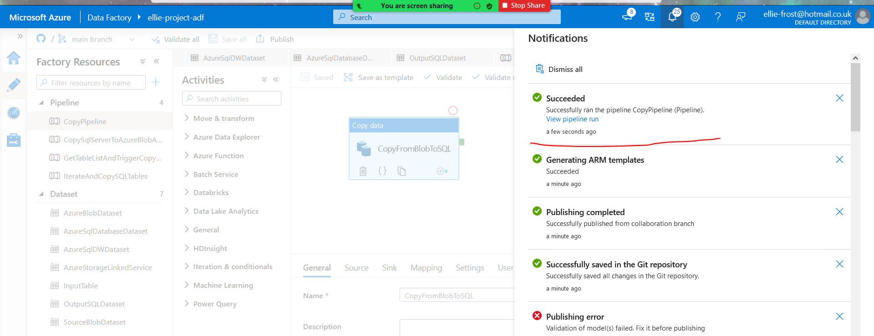
Step four - monitor pipeline run

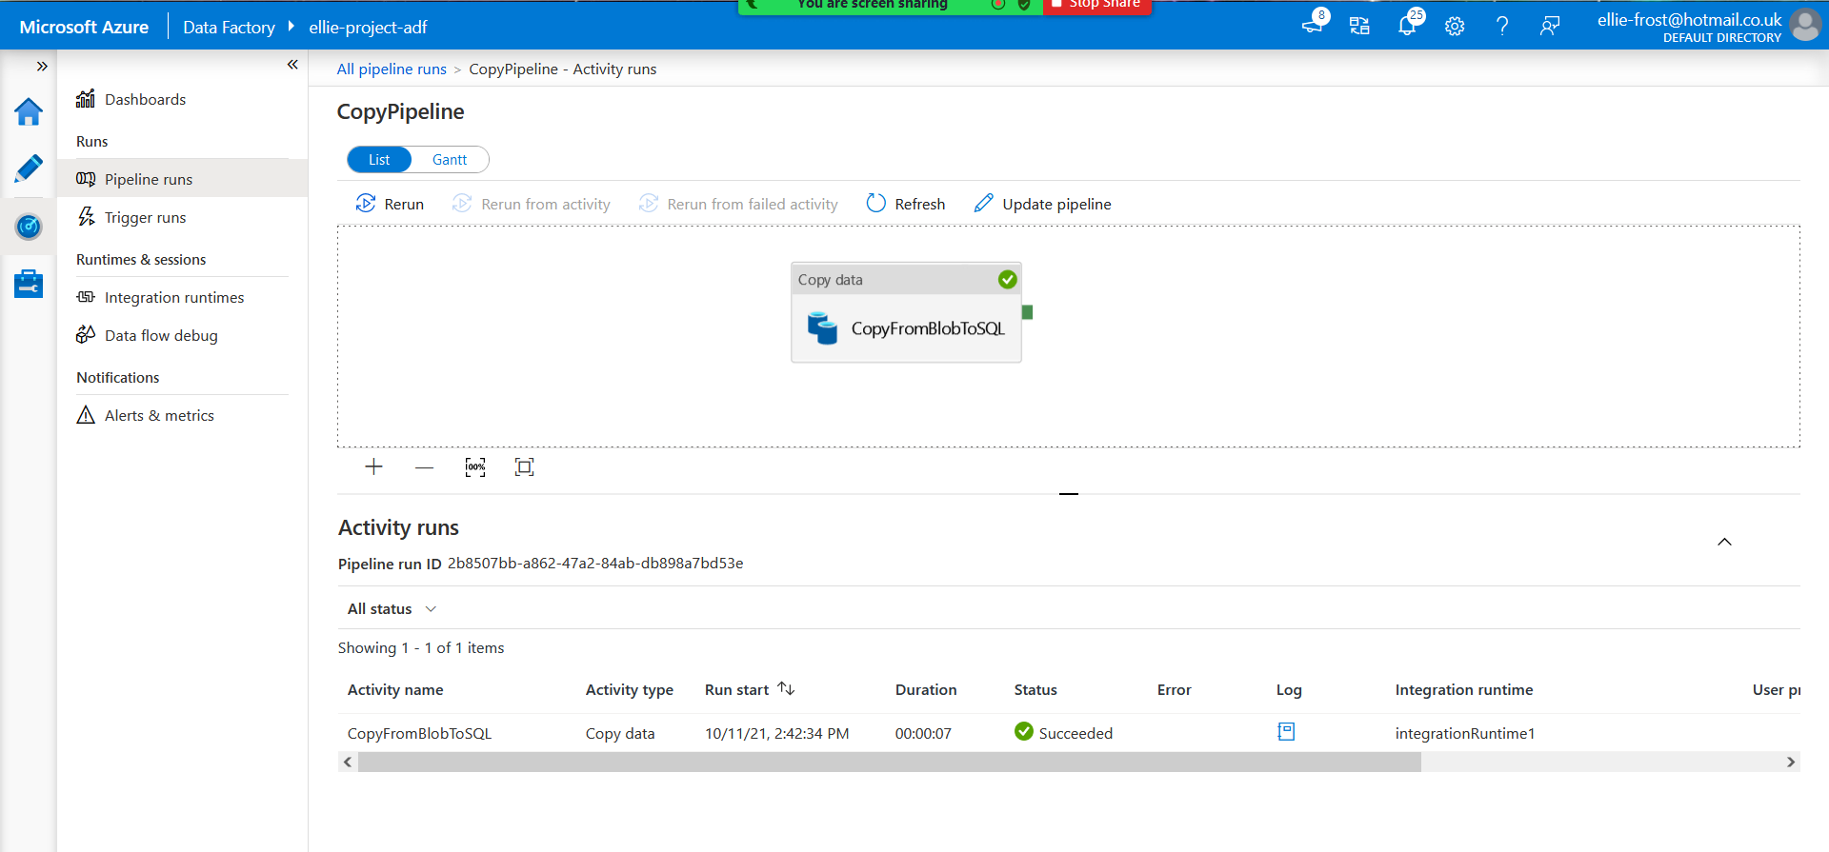
I monitored the pipeline run, and you can see that it is running successfully

Step five – check table

I went to check the table, and you can see that the data from the blob storage has successfully been copied to the SQL table.
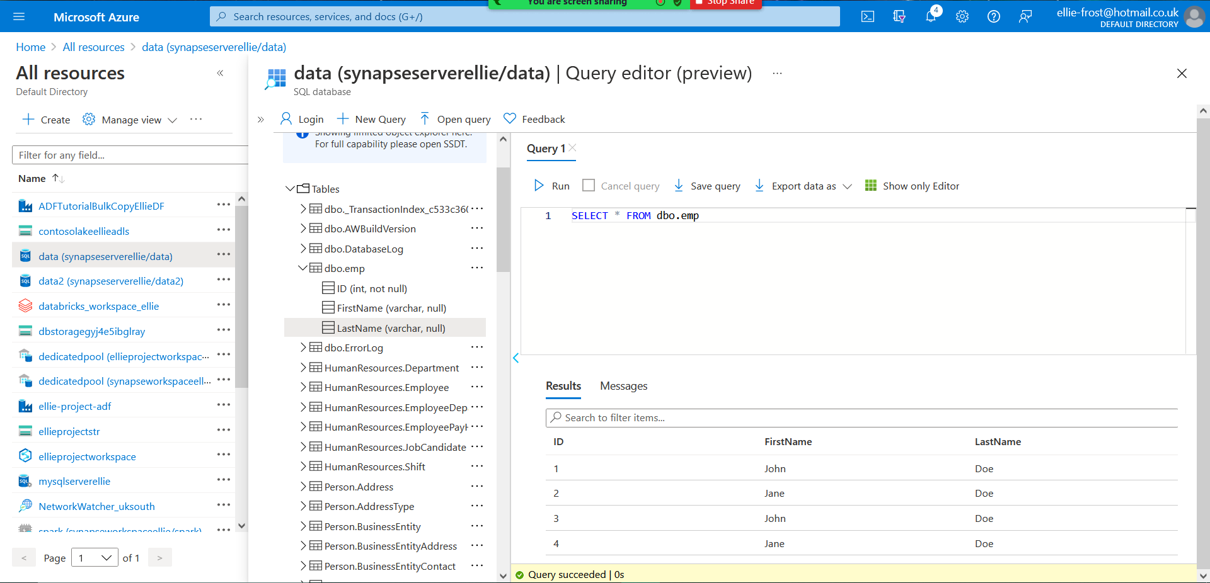

Step six – created new trigger and monitor pipeline run

I manually created a new trigger to run the pipeline every minute. In the below image you can see where it has been monitored and ran successfully.
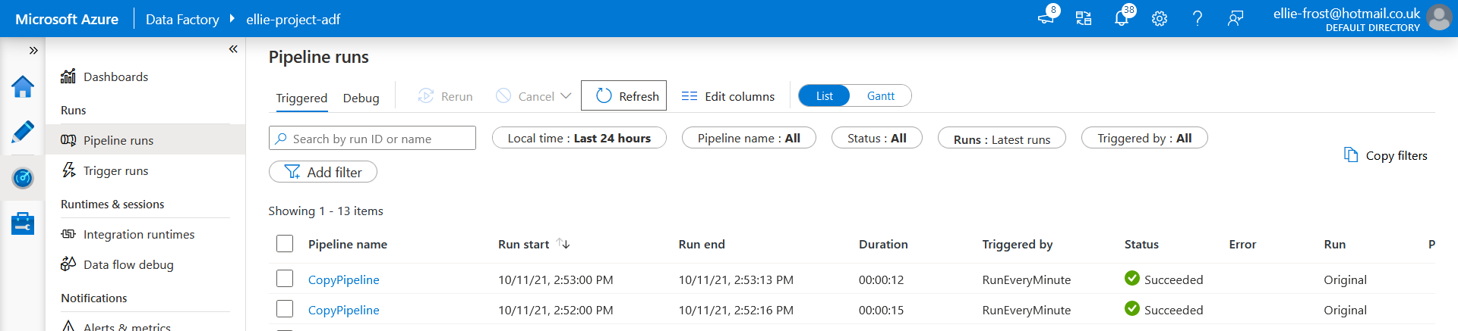

Step seven – check table again
You can see from the below image that the pipeline has successfully copied the data repeatedly following the triggers.
