Problem Statement 4: How to Load Multiple Files in Parallel in Azure Data Factory

Step one – uploaded data into virtual files

First I created 2 virtual folders inside a container named semicolon and comma, and stored 2 of the data files in semicolon and one in data.
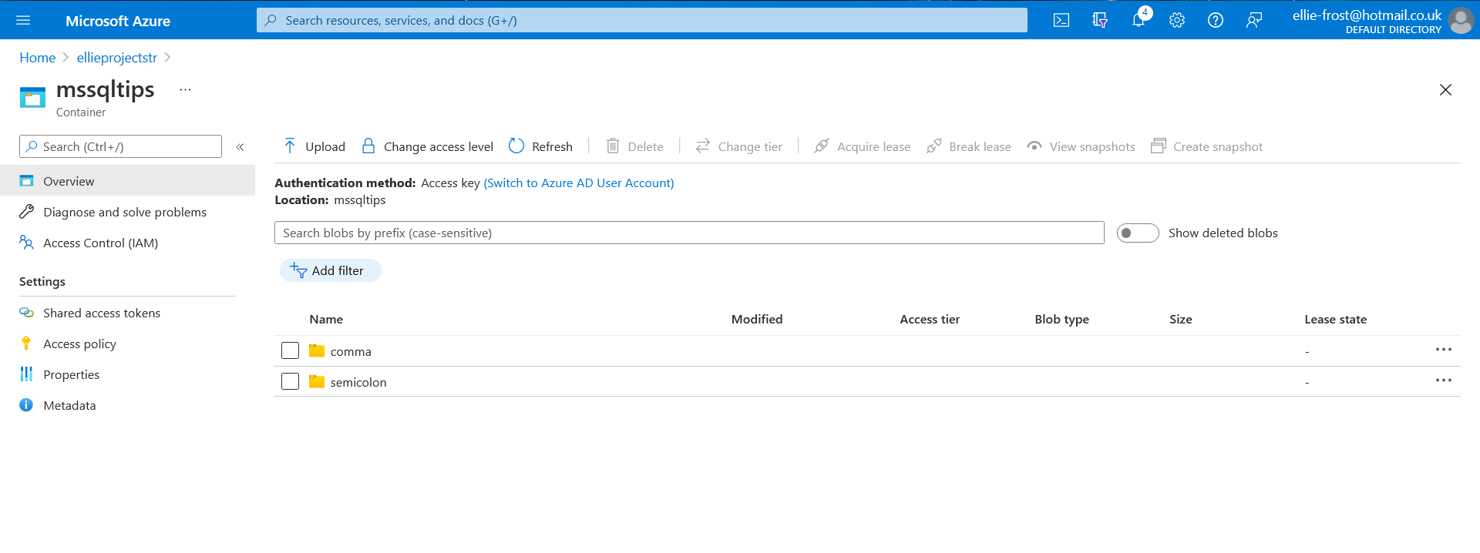
Step two – Insert metadata into table

I used Azure Data studio to connect to my Sql server on the azure portal, and used SQL scripts to create a table and insert the metadata into said table.

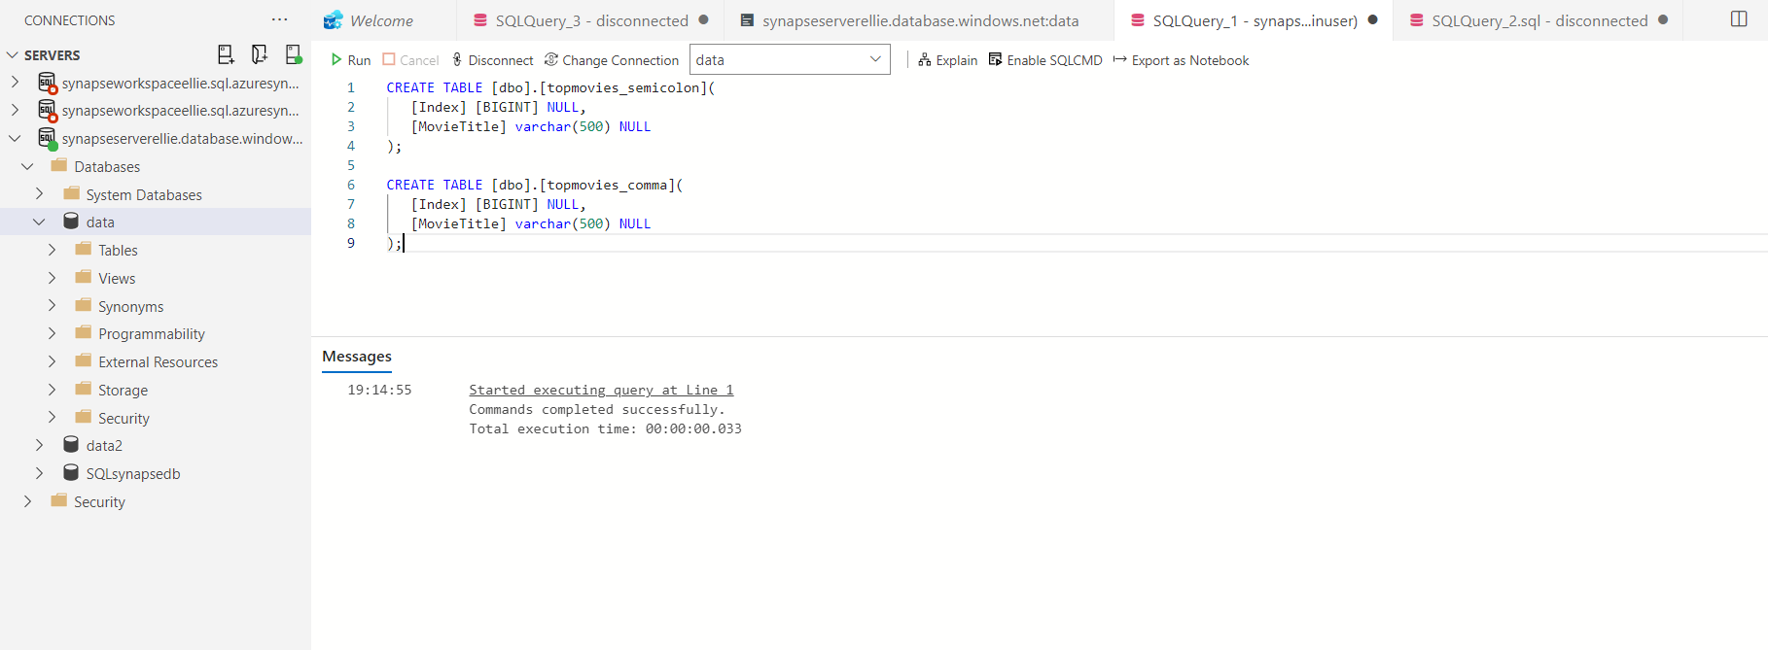

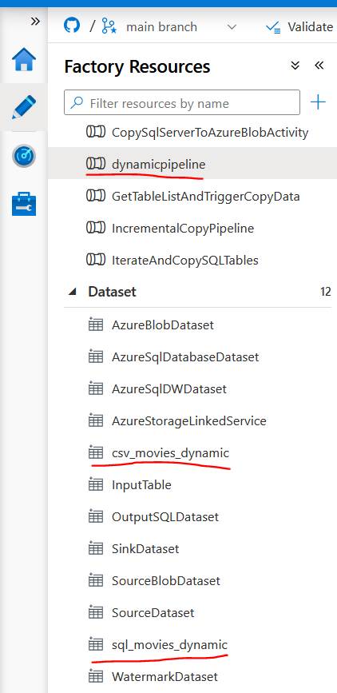
Step three – create datasets and pipeline

I created a pipeline named dynamicpipeline which uses the datasets csv_movies_dynamic as the source and sql_movies_dynamic.
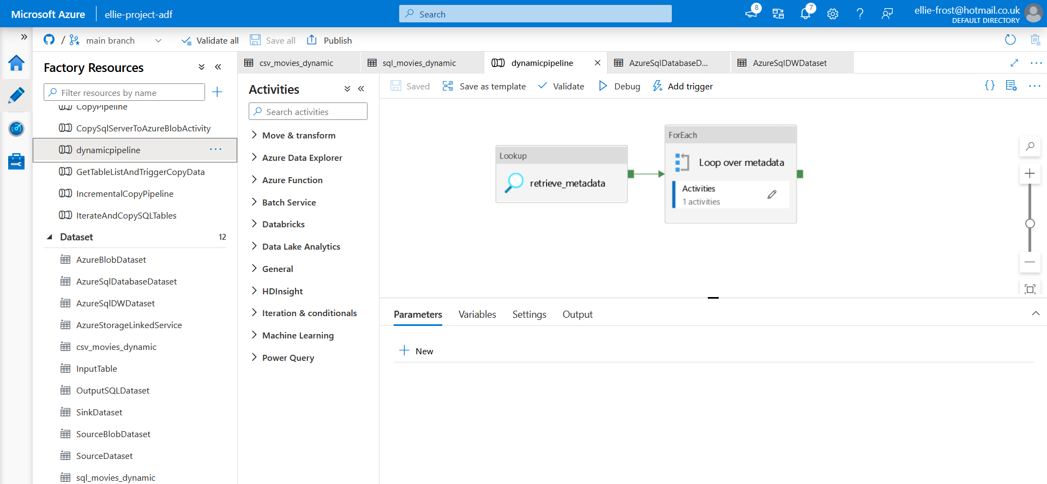
Below you can see the pipeline dynamicpipeline. The lookup activity retrieves the metadata from the sql server. A Foreach activity containing a copy activity which copies the blob data to the sql server is attached to the lookup activity.
Below you can see what is inside the lookup activity.
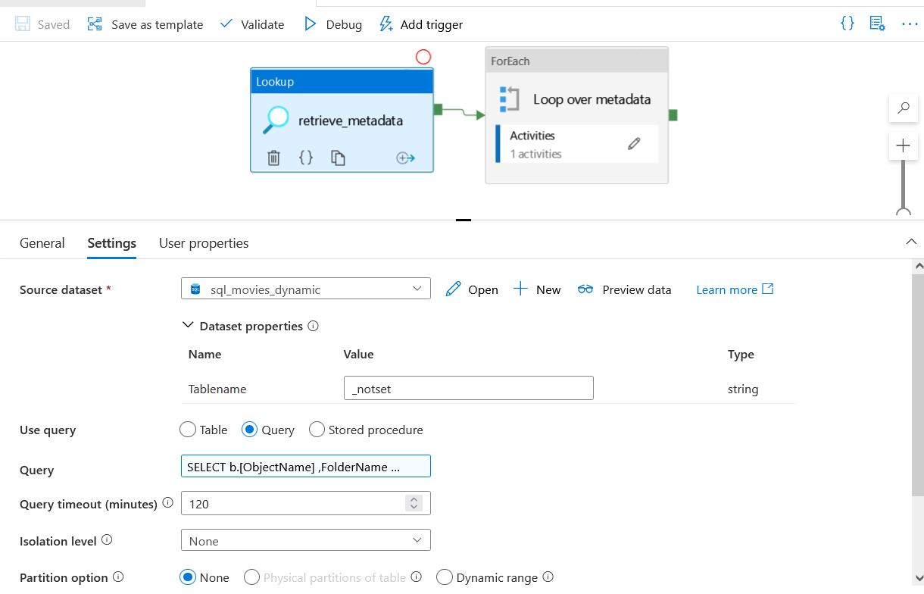
And the foreach loop which contains a copy activity

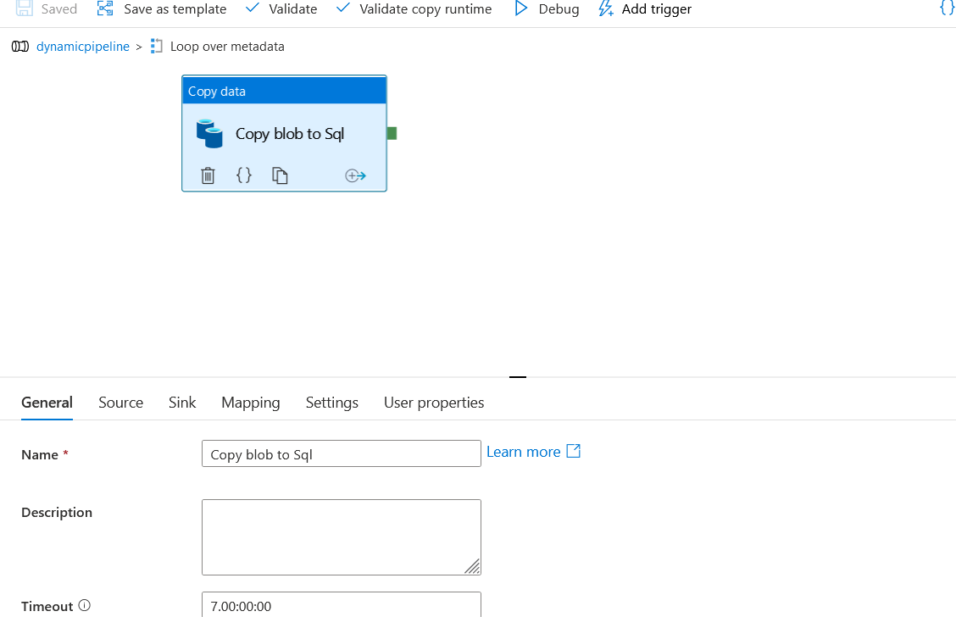
in the below image you can see a preview of the data used in the linked service Azuresqldatabaselinked service, which is linked to the sql_movies_dynamic sql server.

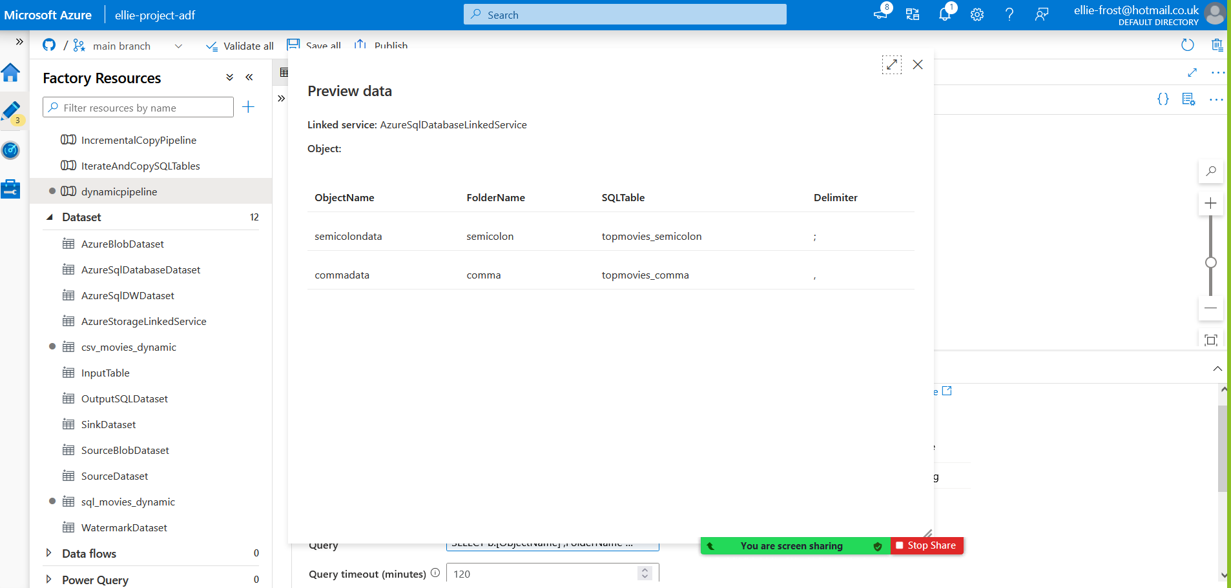

Step four – Debug pipeline

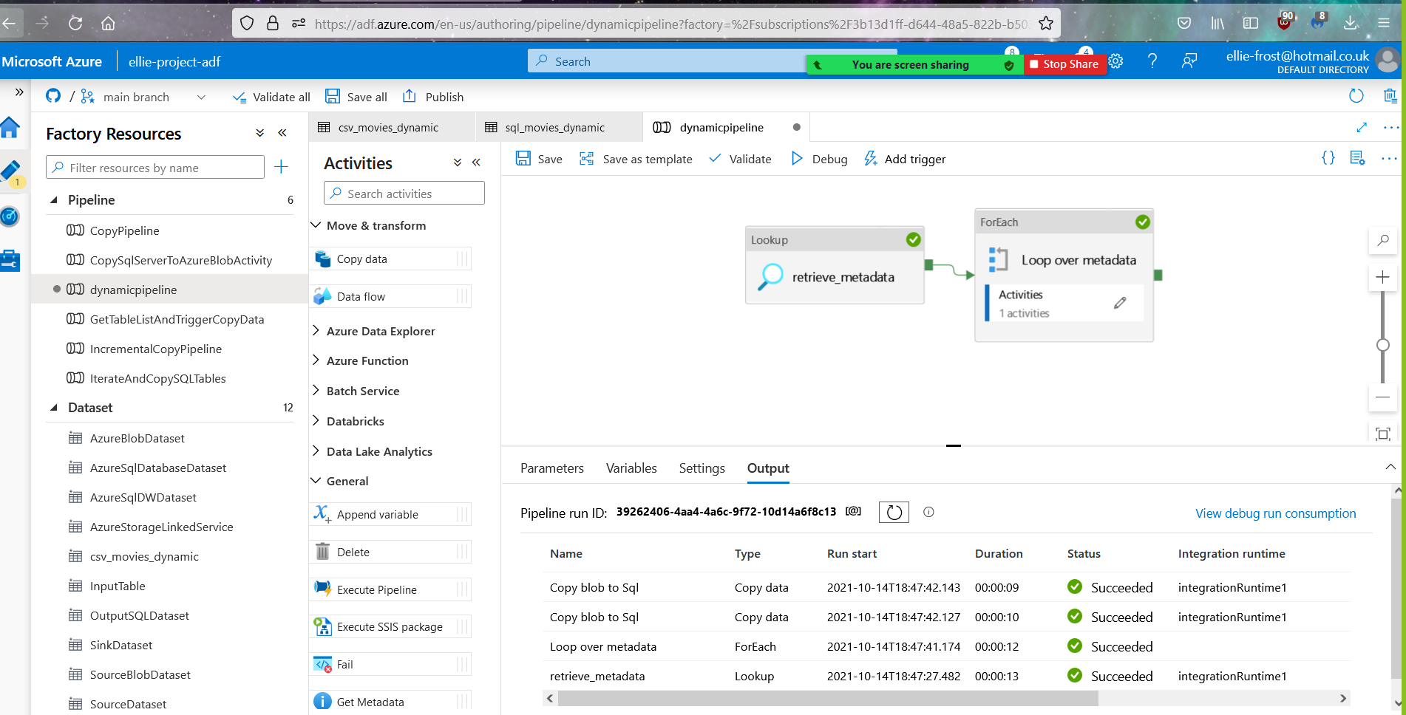
as you can see below the pipeline has successfully debugged.

