Problem Statement 5: Incrementally load data from Azure SQL Database to Azure Blob storage using the Azure portal

Step one – Create data source table in SQL database

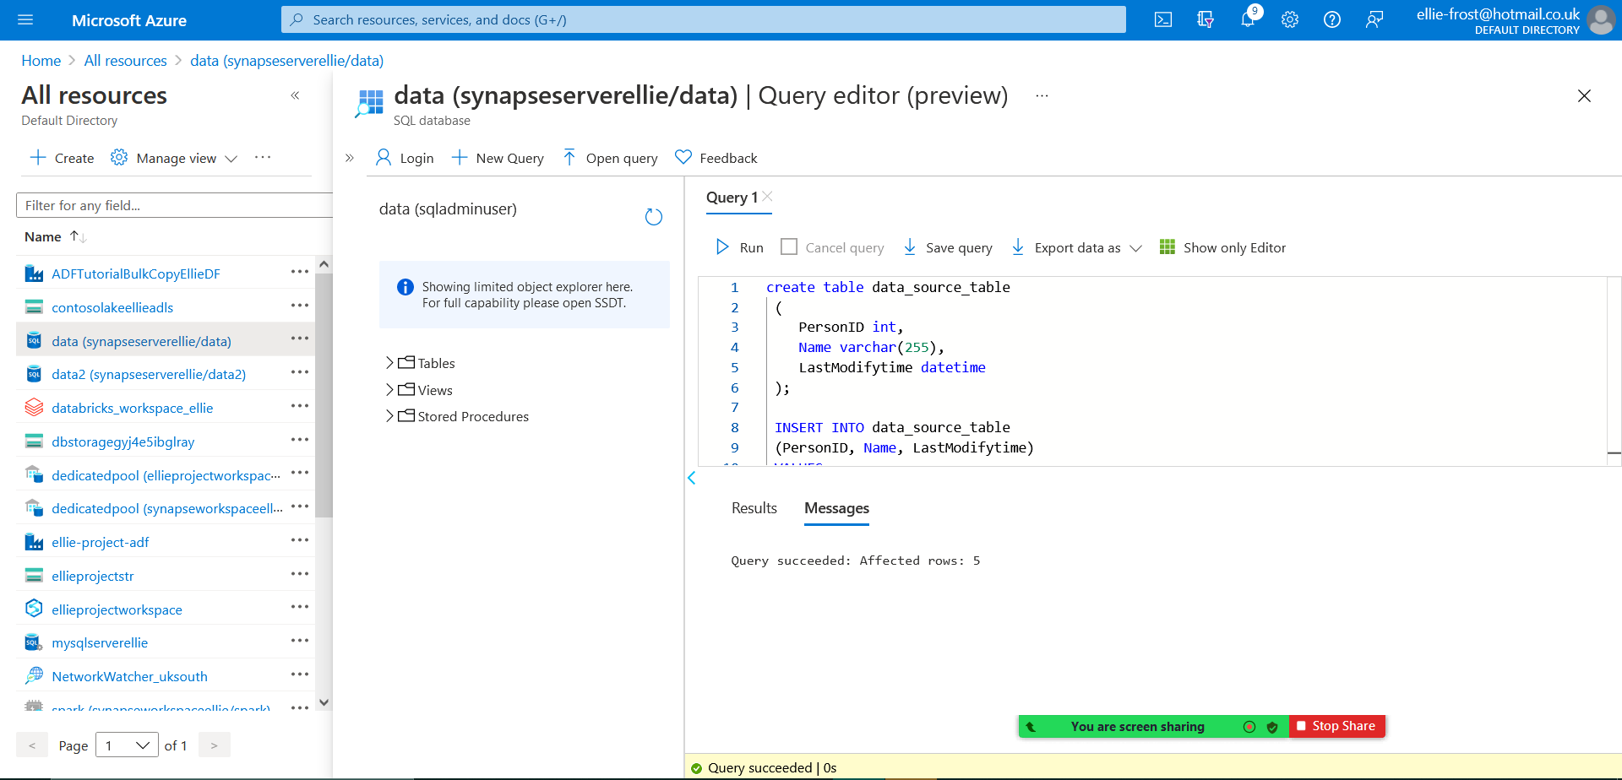
in the image below you can see that I have created the source table in my SQL database.
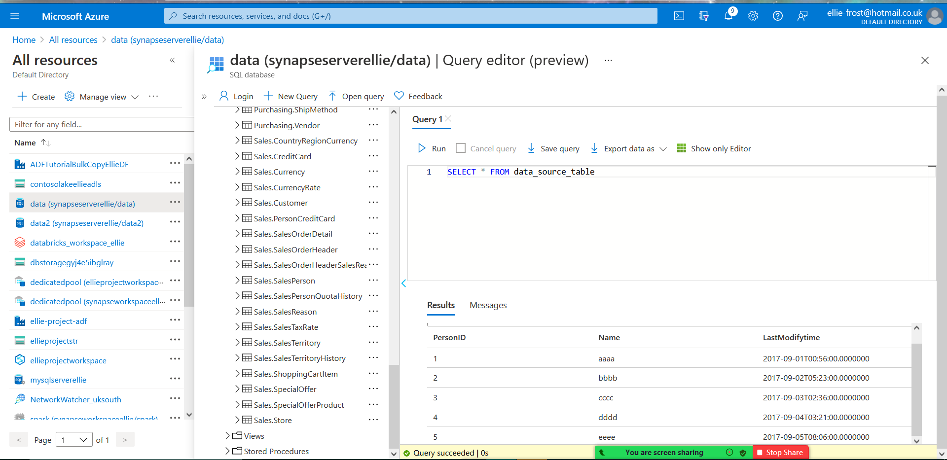
You can also see in this image a preview of the data stored in this table.
Step two – Create another table in your SQL database to store the high watermark value
in the image below, you can see that I have created the table named watermarktable to store the high watermark value.
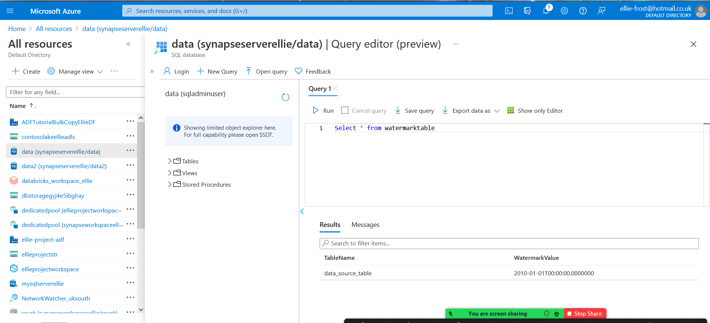

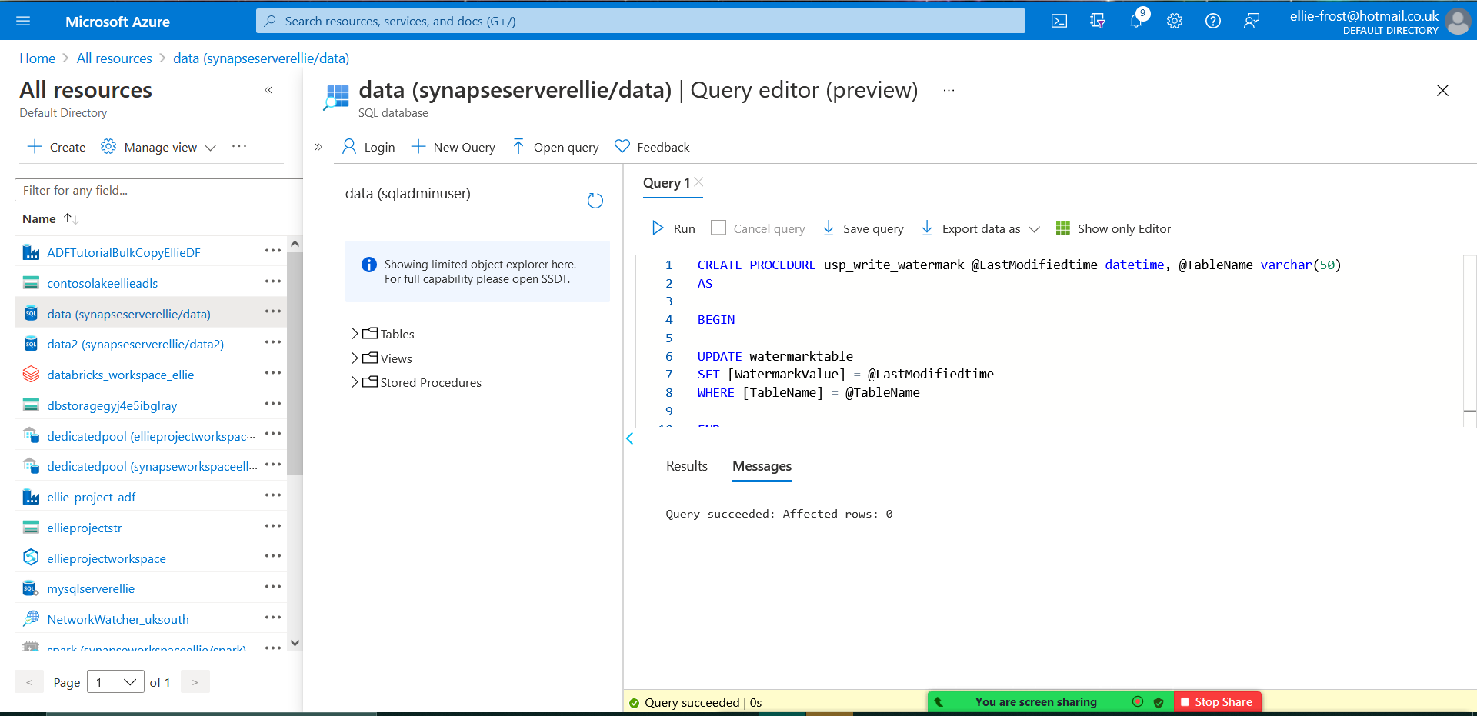
Step three – create a stored procedure in your SQL database
in the image below you can see where I have created a stored procedure named usp_write_watermark in the SQL database.

Step four – create a pipeline

I created a pipeline called Incrementalcopyactivity, which has 2 lookup activities and a copy activity. I also later added the stored procedure onto the pipeline connected to the copy activity.
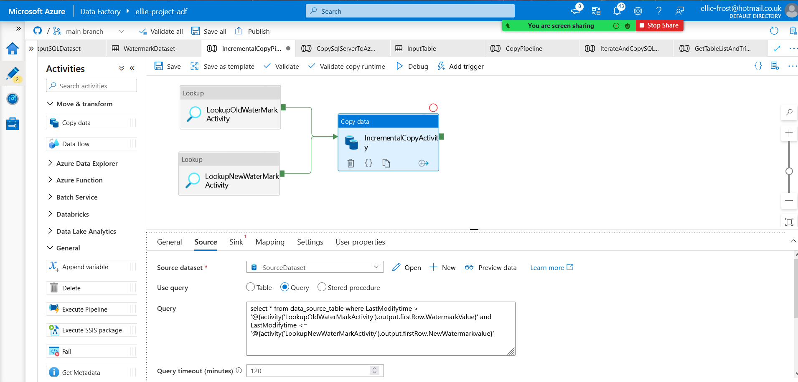

Step five – Trigger a pipeline run

I triggered a pipeline run, which was successful
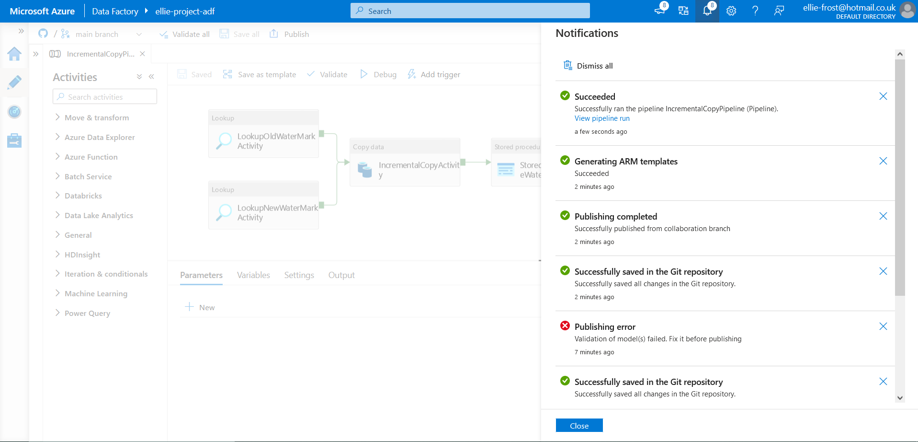

Step six – monitor pipeline trigger

in the below image you can see that in the monitor tab we can see that it has run successfully.
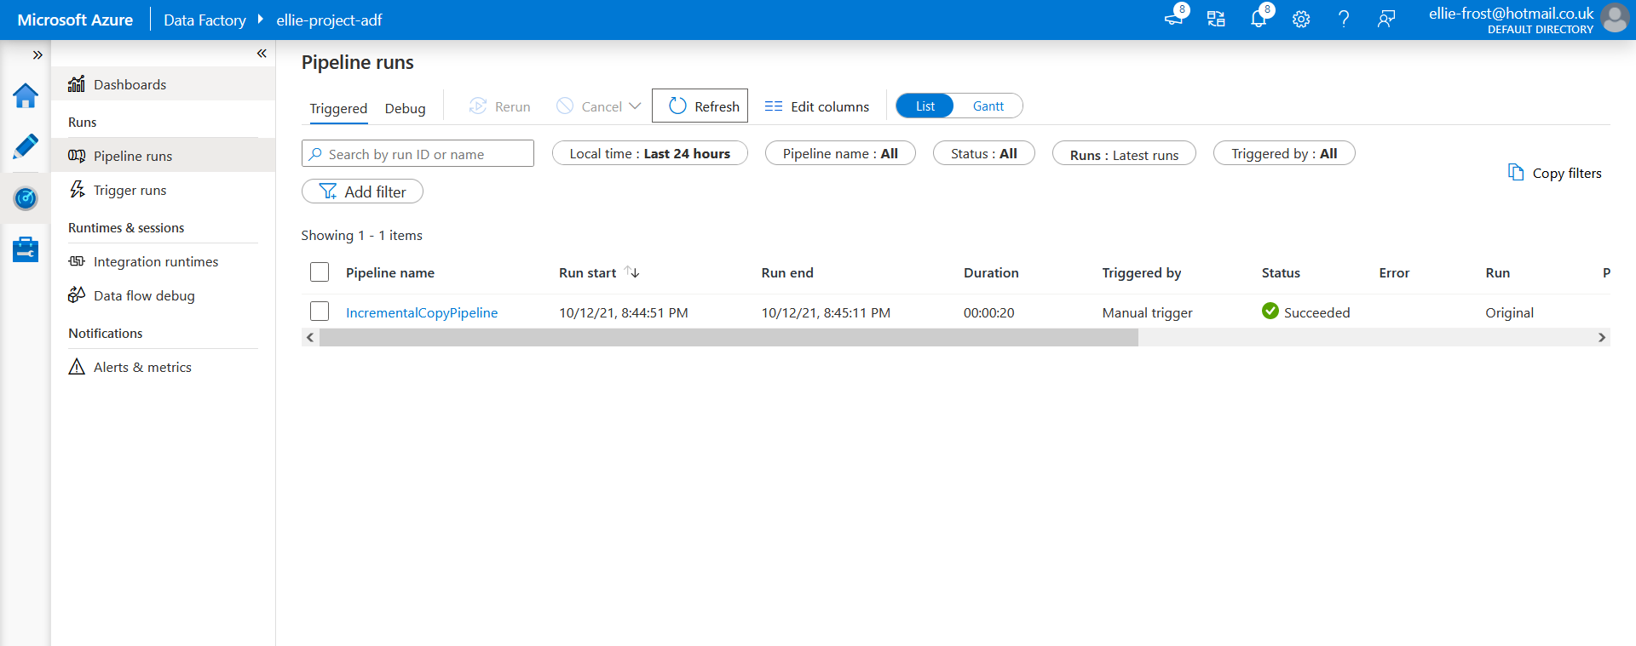
Step Seven – view data

in the image below, you can see the data from the database displayed in notepad
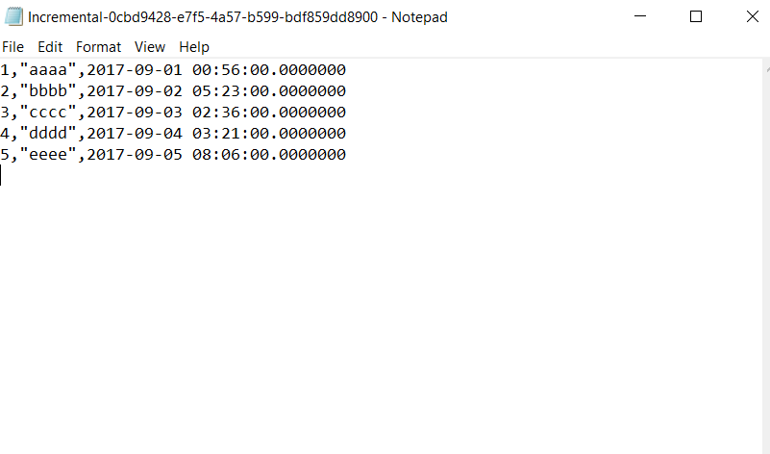

in the image below you can see the updated table

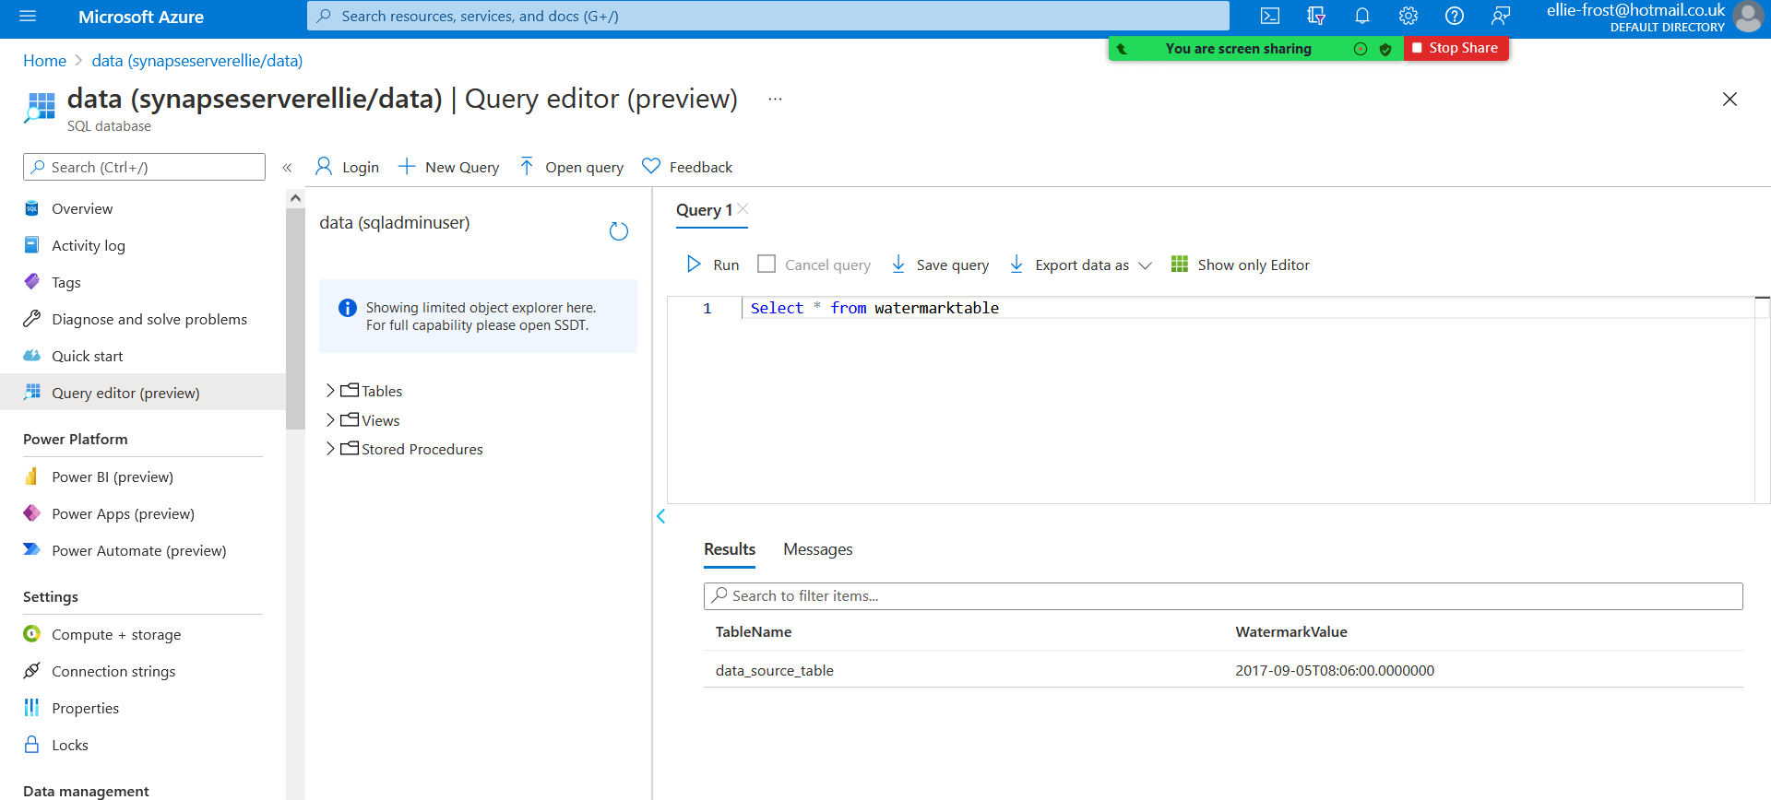
Step eight – add new data to table

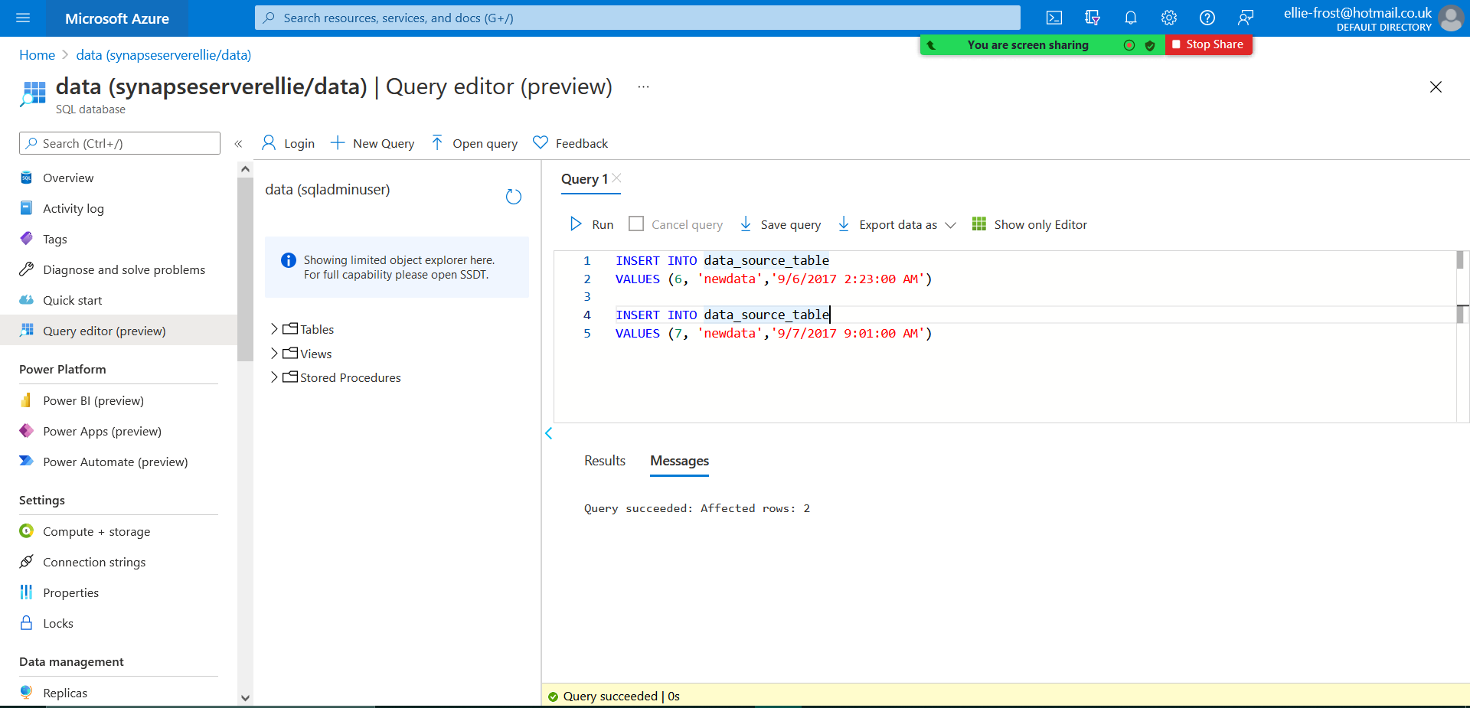
as seen in the image below, I then added new data to the table.
Step nine – Trigger the pipeline again

I triggered the pipeline for a second time and it ran successfully.

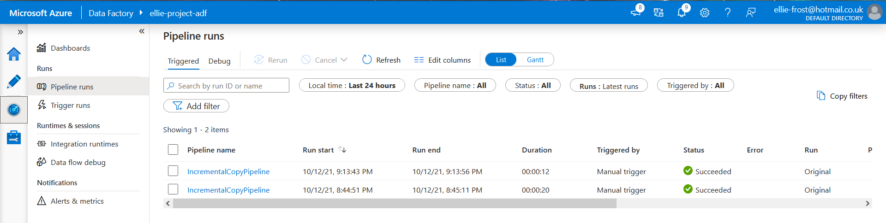

Step ten – view updated data
the image below shows the updated data on notepad

