Problem Statement 6: Design a Relational Database Model for the below scenario in Azure SQL Database
The database schema will consist of four tables that model a student management system for universities:
-Person
-Course
-Student
-Credit
The following diagram shows how these tables are related to each other.
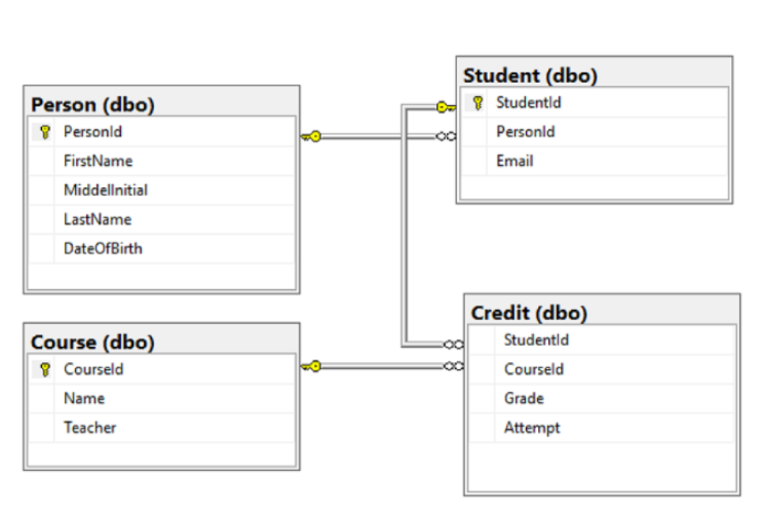
Step one – Create a database

I created a database in Azure Data studio called universitydb, and created the tables named person, student, course and credit.
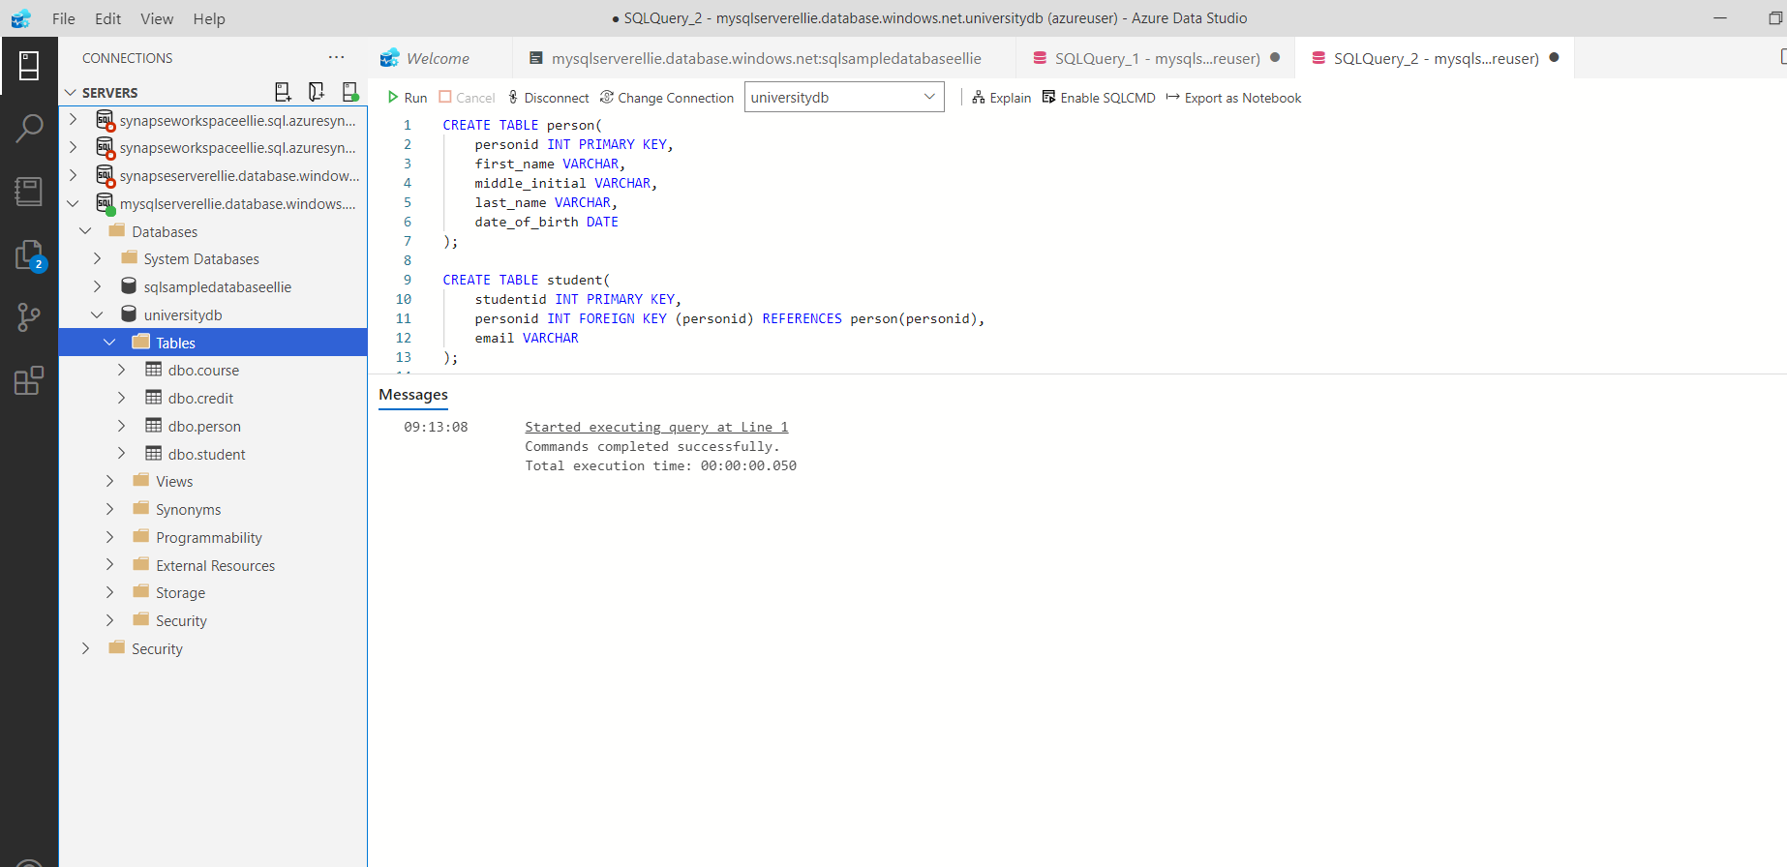
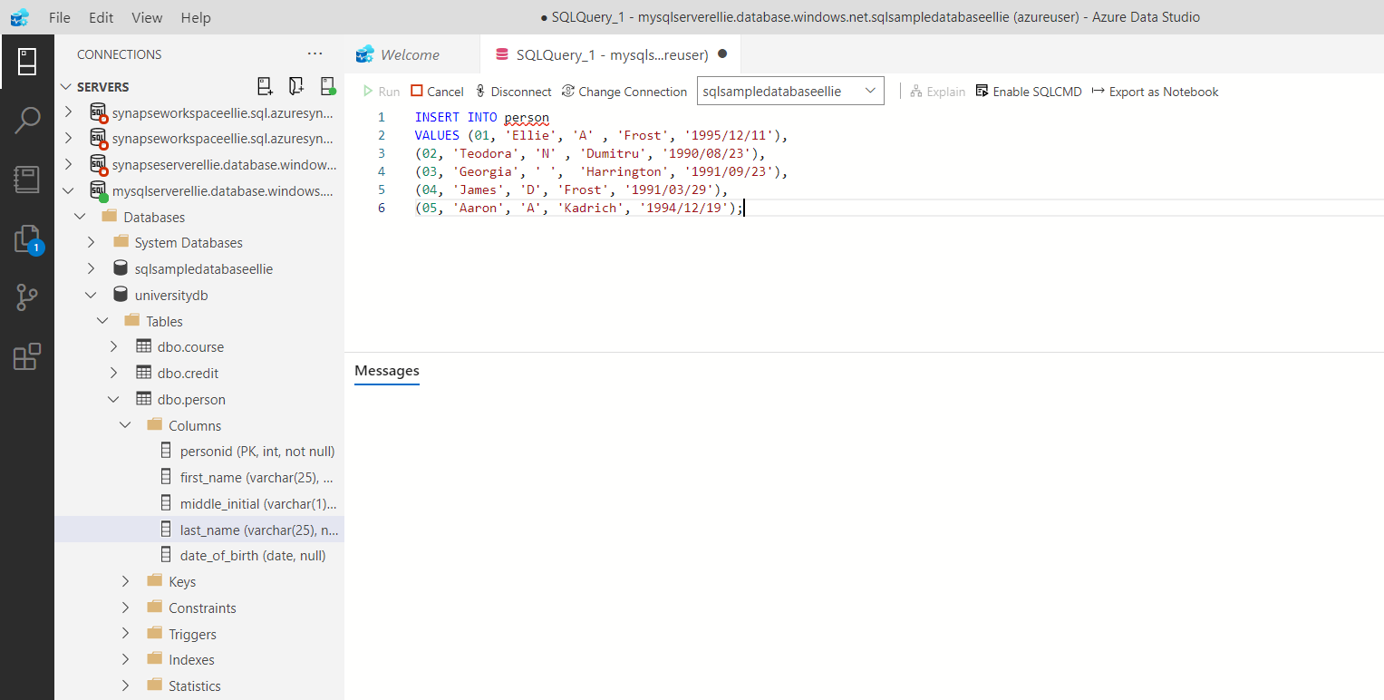
Step Two – insert data into tables
I then inserted fake data into each of the tables using SQL.
The image below shows the data I inserted into each table.
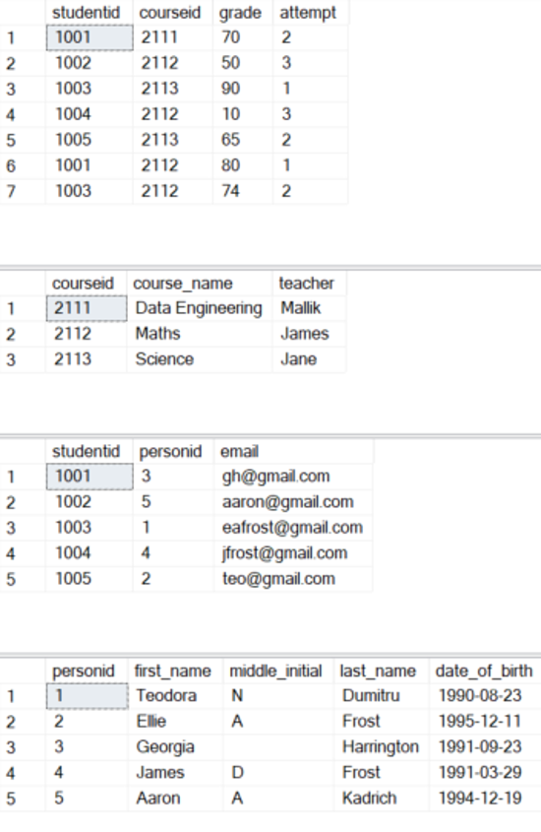
Step three – retrieve data using SQL queries
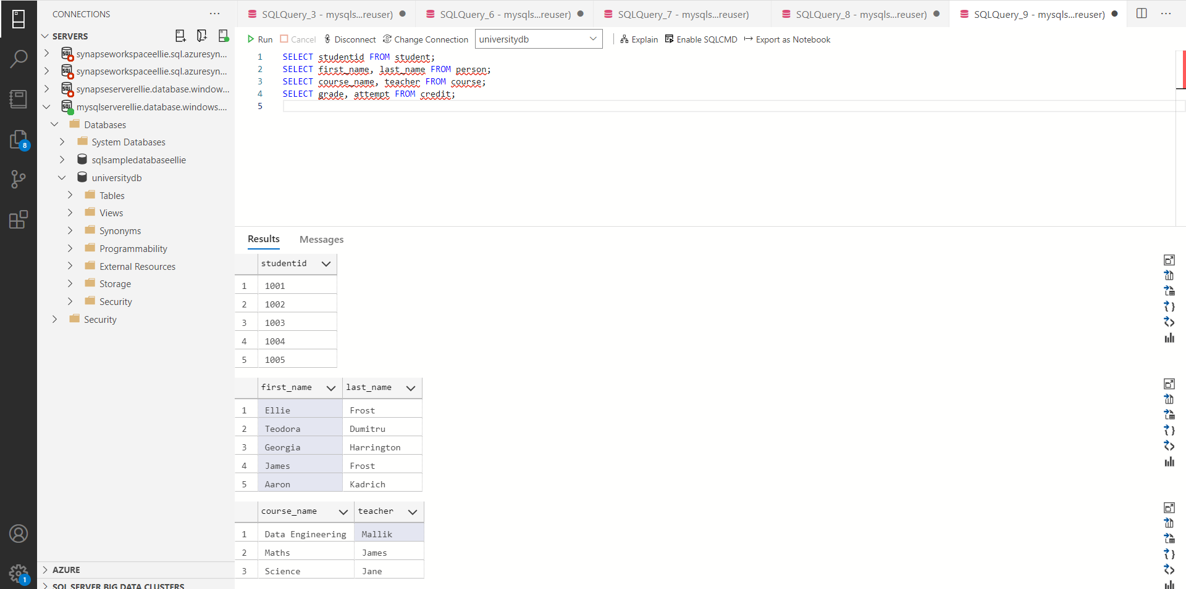
In the image below, you can see that I wrote SQL queries to show Student Id, Name, Course Name, Teacher, Grade, Attempt information.

