Problem Statement 7: Design a Relational Database Model for the below scenario in Azure SQL Database
for this problem statement I will be creating a database schema with four tables that model a Person's information:
-Person
-Address
-ContactDetail
-ContactDetailType
The following diagram shows how these tables are related to each other.
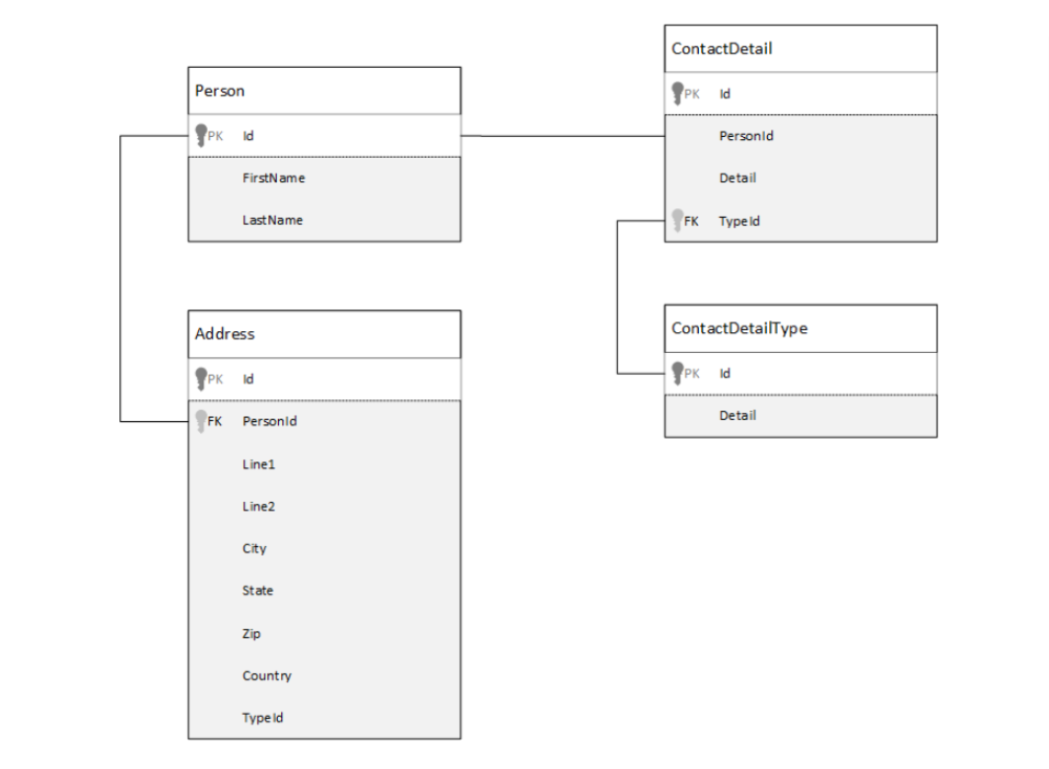

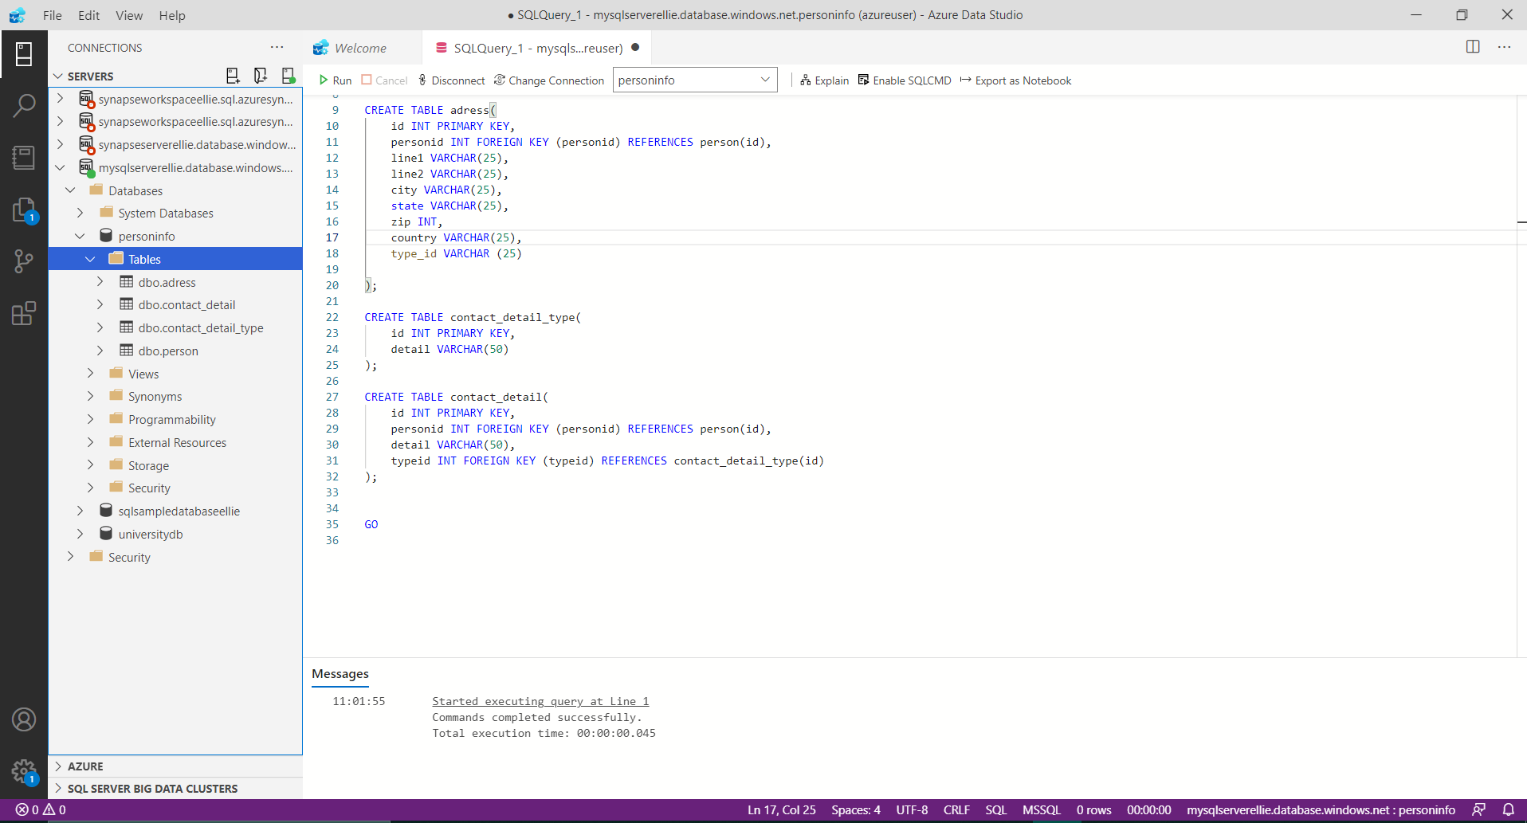
Step one – create database
in the image below you can see I created a database named persondb and created the tables called Person, address, contactdetail and contactdetailtype

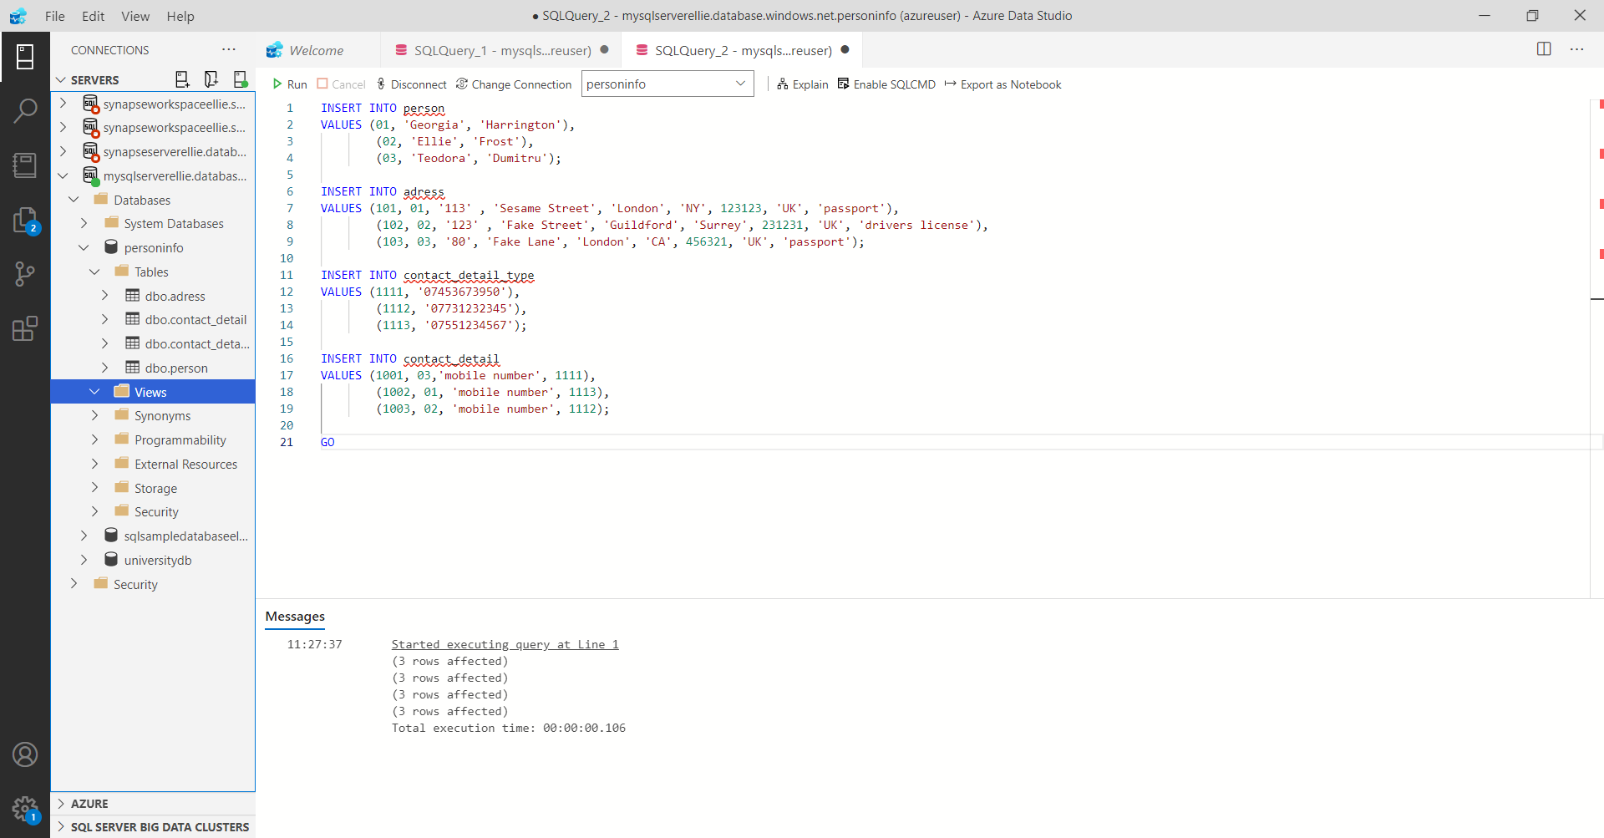
Step two – inserting data into tables
In the image below I populated the tables with fake data.
The following image shows how I used SQL statements to show the data in the tables.

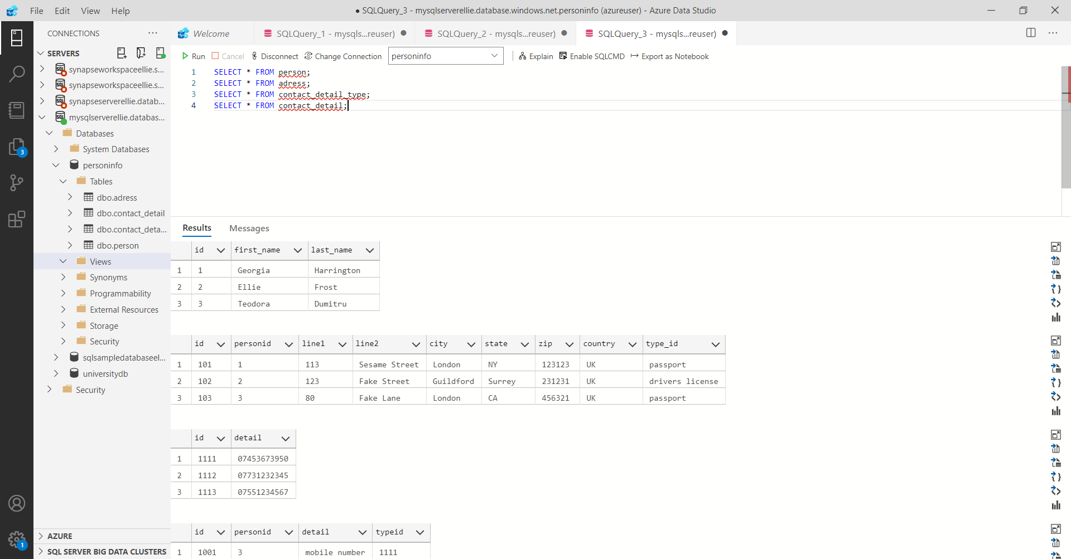
the following image shows data being displayed from multiple tables using joins.

