Problem Statement 8: Design a Non-Relational Database Model equivalent for a Relational Model

For this task we used information from the database created in the previous task, persondb.

The image below shows the data retrieved from this database using a few different types of joins.
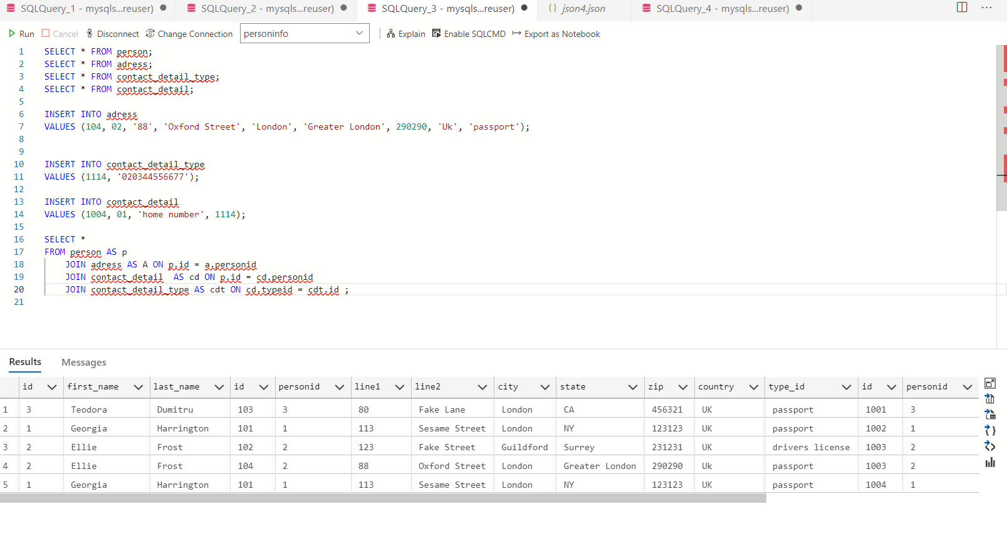
Below you can see this information converted into a Json format
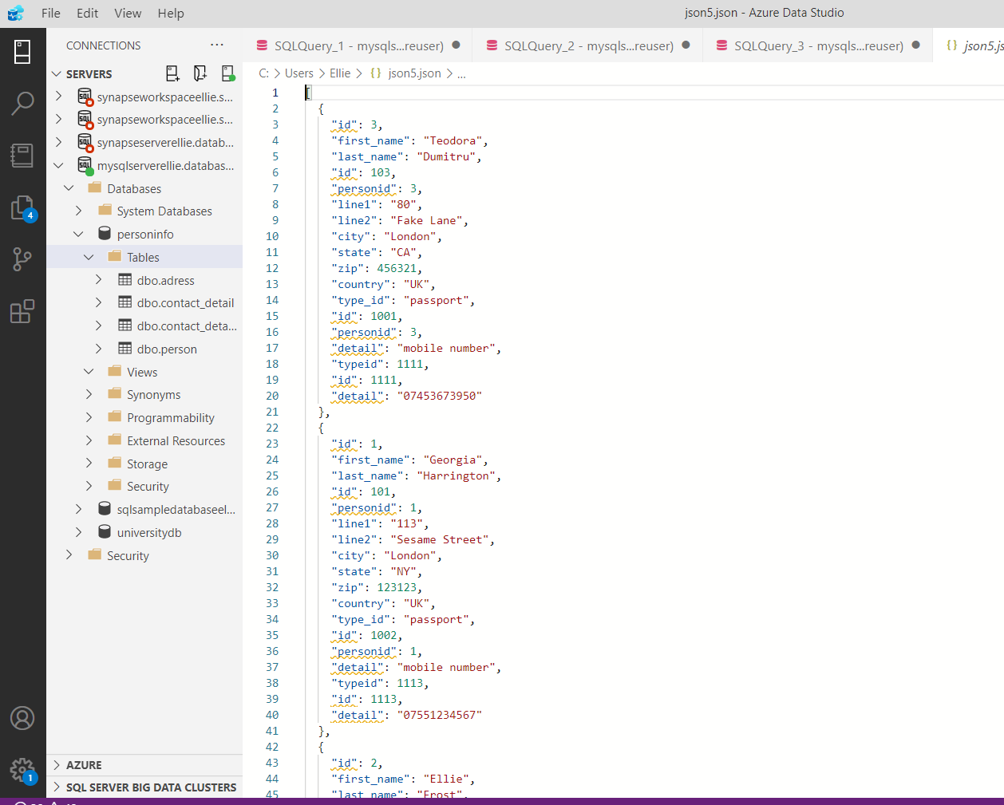

the full json code is below:

[
{
"id": 3,
"first_name": "Teodora",
"last_name": "Dumitru",
"id": 103,
"personid": 3,
"line1": "80",
"line2": "Fake Lane",
"city": "London",
"state": "CA",
"zip": 456321,
"country": "UK",
"type_id": "passport",
"id": 1001,
"personid": 3,
"detail": "mobile number",
"typeid": 1111,
"id": 1111,
"detail": "07453673950"
},
{
"id": 1,
"first_name": "Georgia",
"last_name": "Harrington",
"id": 101,
"personid": 1,
"line1": "113",
"line2": "Sesame Street",
"city": "London",
"state": "NY",
"zip": 123123,
"country": "UK",
"type_id": "passport",
"id": 1002,
"personid": 1,
"detail": "mobile number",
"typeid": 1113,
"id": 1113,
"detail": "07551234567"
},
{
"id": 2,
"first_name": "Ellie",
"last_name": "Frost",
"id": 102,
"personid": 2,
"line1": "123",
"line2": "Fake Street",
"city": "Guildford",
"state": "Surrey",
"zip": 231231,
"country": "UK",
"type_id": "drivers license",
"id": 1003,
"personid": 2,
"detail": "mobile number",
"typeid": 1112,
"id": 1112,
"detail": "07731232345"
},
{
"id": 2,
"first_name": "Ellie",
"last_name": "Frost",
"id": 104,
"personid": 2,
"line1": "88",
"line2": "Oxford Street",
"city": "London",
"state": "Greater London",
"zip": 290290,
"country": "Uk",
"type_id": "passport",
"id": 1003,
"personid": 2,
"detail": "mobile number",
"typeid": 1112,
"id": 1112,
"detail": "07731232345"
},
{
"id": 1,
"first_name": "Georgia",
"last_name": "Harrington",
"id": 101,
"personid": 1,
"line1": "113",
"line2": "Sesame Street",
"city": "London",
"state": "NY",
"zip": 123123,
"country": "UK",
"type_id": "passport",
"id": 1004,
"personid": 1,
"detail": "home number",
"typeid": 1114,
"id": 1114,
"detail": "020344556677"
}
]

