**Github/Gitkraken Guide**

**by Mick**

Firstly ensure you are signed up to github at this location:

<https://github.com/>

once you have an account let the team know your username or account email so it can be attached as a contributor, otherwise you can only Pull (Download) from the project, instead of Push (uploading) to the project.

While setting up contributor access, download a github client for your operating system, think of this like a shared dropbox or google drive, but with tracking for who changed what and why. The git client I chose to use is called GitKraken, Accessible here:

<https://www.gitkraken.com/>

can chose others, I just like dark tone GUI’s so chose this one, and my guide will refer to it directly.

So once you have an account and project permissions, in the git client you can now attach that project to a userfolder on your PC where it will “pull” the project too, which is where you can then work on it, and once ready to commit, “push” to the master version, which well get through now.

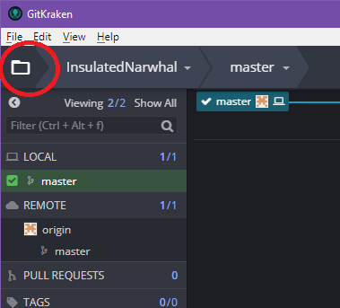Easiest way to setup the attachment of the project to the git client is to request a clone

Clicking this Folder icon will bring up clone UI.

Once in the clone area, select “clone with URL” and enter <https://github.com/Ellife/InsulatedNarwhal> into the url field. The “where to clone to” should be withing your xampp/htdocs/ directory wherever you installed Xampp too, so that while you edit the project you can test it with the xampp local server EG: C:/Xampp/htdocs/InsulatedNarwhalis where it is for me.

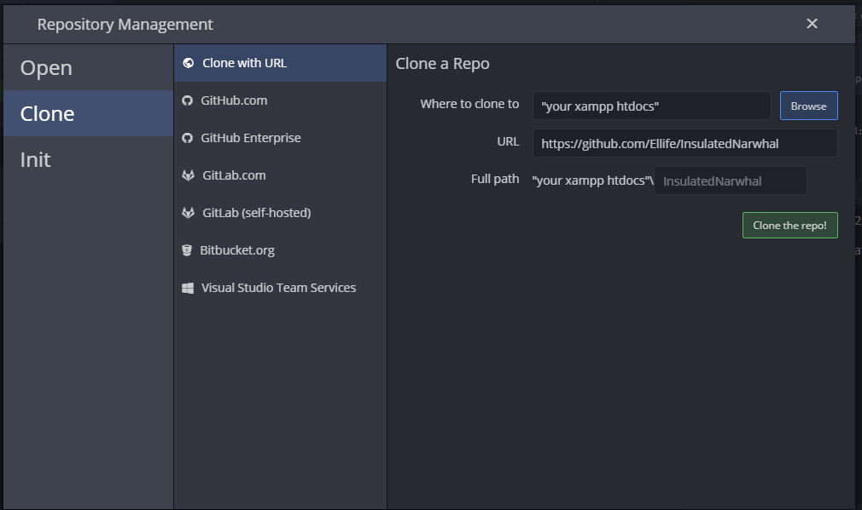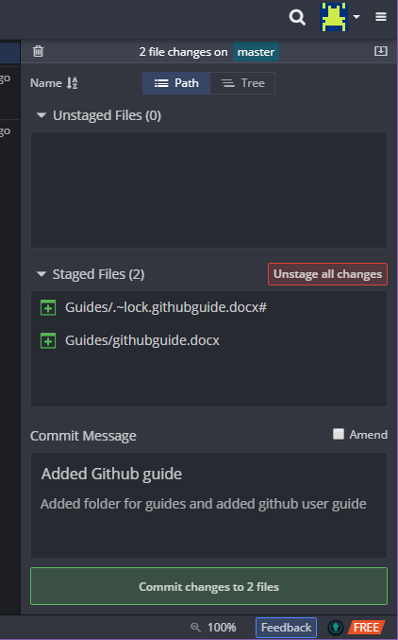Now once you clone, you should see the files and folders of the project in the manager, but also in your own file system. Then after you edit or create anything, you can push the “push” button to move it to the master, with a comment as to what you did. When you change files or add files a “file changes” button should appear on top right of the GUI, pressing on it should bring up this →

a button missing from the screenshot beside “unsstaaged files” that says staged files, should be pressed, this is saying “i want my changes to be part of the master version”

then you just add some info to the “commit message” down the bottom and commit the change and your done!