Speaker Diarization with Pyannote Audio Framework

According to my testing on pyannote audio for speaker diarization, the results are as follow
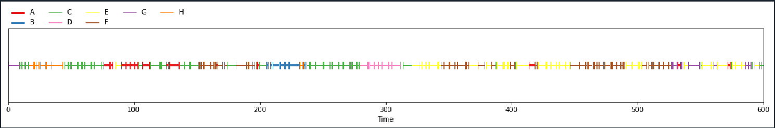
pretrained model → (DIHARD dataset)
test data → Google congress audio

