Feed Back

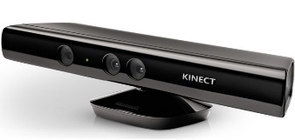

Motion Sensor – Xbox Kinect

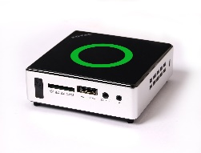

Main Computer

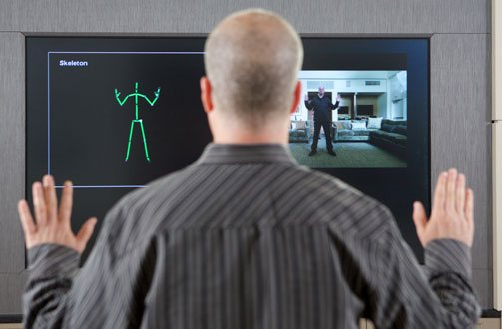

Human Motion Input for Kinect

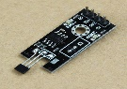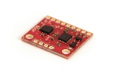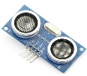

Micro Sensors

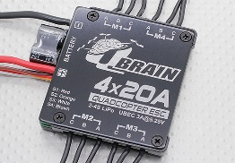

ESC for Brushless Motors

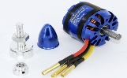

Brushless Motors

\

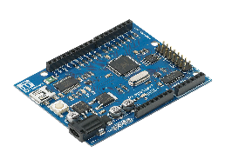

MCU