**Navigation of a Multi-Copter by Leading the Target Value with Microsoft Kinect**

PROPOSAL

Submitted to Engineering Department

244 Hitchcock Hall

The Ohio State University

2070 Neil Avenue

Columbus, OH 43210

By Hongyun Lee

Advisor: Clifford A. Whitfield, Ph. D.

Department of Mechanical and Aerospace Engineering

February 20, 2014

**Abstract**

Classic Proportional-Integral-Derivative (PID) controller was developed during mid-20th century and has been applied for complicated and tedious attitude the control of commercial Unmanned Aerial Systems (UAS) and multi-copters due to its accuracy and simplicity of implementation. Recently, with the advances of commercial visual motion sensor, such as Microsoft Kinect, PID controller can expand its application to utilize visual motion sensors; the PID controller can directly interacts with human motions without cumbersome radio-control signal by targeting a desired value set by a pilot’s visual command. Kinect can replace the radio-controlled signal and lead the desired value for the controller as it senses the visual motion.

This study is to perform basic rectilinear navigation of the multi-copter based on the visual motion sensor inputs. The drone performs linear movements as the object’s relative spatial coordinate changes to execute the visual command received through the Kinect. For the integrity of the system, a micro controller unit and the Kinect application cooperate with each other. The Kinect application interprets visual data to local coordinate data, and transmits the data to the micro controller, which in turn updates the target value of the PID to modify the multi-copter’s attitude so that it can translate to the corresponding location.

The result of this study will show that the control system can interpret the attitude and coordinate data transmit to feedback PID control loop. Based on the PID loop and the visual command, the system will navigate and maintain its location with simple motion such as linear retreat, advance, descend, ascend, left, right, and yaw.

**Background and Motivation**

Unmanned Aerial Systems, (UAS) are playing an important role in this century due to its versatile functions that can conduct various flight-related tasks. One of UASs, Remote-Controlled (RC) multi-copters have become frequently utilized from the public to government level; many fields like film industries and logistics companies use the multi-copters. For instance, Amazon Prime Air, who recently submitted a petition to U.S Federal Aviation Administration for their R&D.

Not surprisingly, the needs for RC pilots have increased. Yet, training processes for RC pilots require a great amount of time to deal with these highly maneuverable aircrafts due to their unintuitive dynamics. For instance, the high acceleration rates of UASs can be extremely challenging for untrained pilots to expect the vehicle’s movement. Besides, for professional missions such as rescue or military task, RC pilots are often expected to be the mission expert as well as piloting. Yet, because piloting a UAS requires the pilot’s uninterrupted attention, a certain level of vehicle autonomy is imperative for UAS operations, and commercial autopilots can be an example; the autopilots for hobby or photographic drones have PID loop that receives radio signal and calculates drone’s attitude or location.

For better autonomy, however, remote-controller is still a cumbersome device for professional purposes such as rescue or military missions, for which transient reaction is a must; therefore, the performance of the autopilot needs to leap to intelligence level so that UASs can not only understand human motion and conduct the mission, but also, manage flight maneuvers such as avoidance. Due to Artificial Intelligence (AI), especially computer vision technology, it is possible for a person to intuitively interact with systems so that on-board computers can understand the motion-command and carry out the independent mission. With such intelligence, the systems have manifold potential applications:

- Military: Cooperating and conducting mission with field soldiers.

- Construction: Carrying and placing heavy materials without a crane and cooperating

with in-the-field workers.

- Logistics: Delivering or carrying packages.

- Rescue: On-sight surveillance and cooperation with rescuers.

- Hobby: Advancing the sport-pilot enthusiasts recreation.

Numerous types of drones will be a part of the society shortly. Several efforts with multi-copters are already being invested and made for the future uses by the experts from the various fields.

Supporting such avid interdisciplinary research topics, for instance, intelligent UASs is a common trend. Therefore, student engineers also need to look outside of the traditional categorization of the fields. Together with the support from the community, the student engineers can play a significant role in interdisciplinary fields as well as the society can keep the high potential ability of innovation.

**Significance**

The autonomous systems are primarily composed of three sub-systems: sensing, actuating, and reasoning. Specifically, this research focuses on mostly about sensor fusion for visual sensor to forge the basis of intelligent UASs. Based on the sensor data, the drone will be able to follow an object with linear paths. Such performance will be the basis of complex path analogy and precise navigation research for the graduate level.

**Methodology**

To accomplish the objectives stated above, the research will consist of five phases:

Phase 1) Physical Assembly of Drone and Testing Stand

A prototype drone is built. The prototype is consist of drone frame, brushless AC motors, electric speed controller, Micro Controller Unit(MCU) by Parallax as an autopilot, and a power supply. To test the autopilot, the drone needs a constraining device that can protect the drone from damaging surroundings as well as itself. Also the testing stand can assist drone’s attitude control throughout the developing phases.

Phase 2) Ground Station Application

To monitor MCU which does not have an operating system, it is necessary to develop a monitoring application that receives data from MCU via USB and collects data into excel documentation. Microsoft Visual C# is used as a programming language.

Phase 3) Attitude Sensor Fusion

MPU6050, a commercial gyroscope and accelerometer, is used for attitude sensor. Gyroscope is comparatively stable but unreliable while accelerometer is reliable but noisy. To compensate each other, complementary filter is applied. Complementary filter is based on numerical integration since gyroscope reports time rate of angular position, while accelerometer reports angular position,. The major task is to experimentally find proper constants for numerical integration.

Phase 4) Building PID Loop

Basic PID loop equation is. term is responsible for time response, term is responsible for accuracy, and term is responsible for regulating overshooting. Since the constants are susceptible by physical shape of the system, the constants also can be found experimentally by applying Ziegler-Nichols Method.

Phase 5) Kinect Application

Kinect is a programmable sensor. To exploit Kinect, C# application is developed. The Kinect application can easily exploit the available open library by Microsoft. Also, the application can communicate with the MCU. Yet, Kinect should be physically dampened from the vibration due to motors.

**Anticipated Result**

This study seeks to develop the basis of such visual-based-command UAS autonomy. With the use of Kinect system, an object and understand human motion and convey such commands into actual navigation. The primary objectives are 3 aspects: sensor fusion, Kinect software, and the PID control loop development.

Autopilot can simply output PWM for motors and feedback the filtered sensor data. Based on this feedback control loop and visual data, the drone will be able to perform linear motions – advance, retreat, left, right, descend, and ascend on a plane only based on visual target. The operational facility of the UAS and its automatic control system will be in a controlled indoor laboratory space, to provide a safe, secure and controlled testing environment.

**Personal Statement**

For a dual major student, aerospace and computer science engineering, this project will foster the integration of the two fields. In the near future, I envision myself studying in aerospace-related robotics fields for the graduate program. This research project will be a great step stone for the future interests.

In this project, specifically, a simple autonomous system is built for a multi-copter, which enables human motion to interact with control loop. The project, so far, has accomplished first two phases. The prototype drone frame has been built and two testing devices have been also constructed. One testing device assist to verify one-axial (x and y axis respectively) attitude control, and one has 3 degree of freedom for x, y, and z axes attitude control while it prevents unexpected output, such as crashing, from damaging the other object in the facility. Besides, a ground control software has developed to collect the on-board data and analyze them as well as directly controlling the drone from the software.

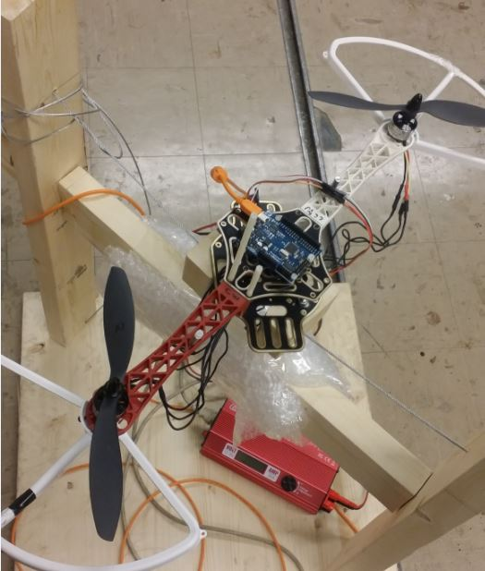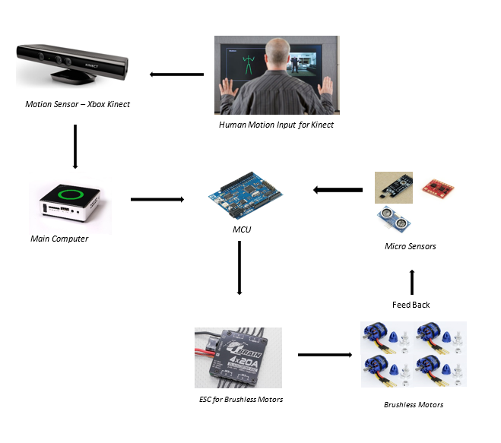

Figure 1: Kinect to PID Control Loop

Figure 2: One-Axial Attitude Tester and a

Multi-Copter

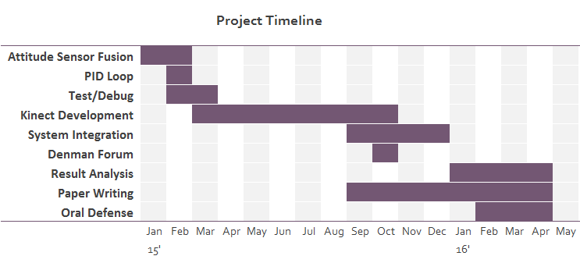

Figure 3: Project Timeline

**Bibliography**

1. Misener, P. (2014, July 9). Amazon Petition for Exemption. Retrieved January 30, 2015.

2. Whitfield, C.A., “An Adaptive Dual-Optimal Path-Planning Technique for Unmanned Air Vehicles with Application to Solar-Regenerative High Altitude Long Endurance Flight,” The Ohio State University, 2009.

3. Bennett, S., “A Brief History of Automatic Control”, IEEE Control Systems, 1996

4. Webb, J., & Ashley, J. (2012). Beginning Kinect programming with the Microsoft Kinect SDK. New York press.

5. Parallax, I. (2010). Programming and customizing the multicore propeller microcontroller: The official guide. New York: McGraw-Hill.