Loading chatbot-aiml.xml...done (0.01 seconds)

Kernel bootstrap completed in 0.04 seconds

Hi! I'm the dog breed information chatbot.

- Try asking me a question about a specifc breed.

- Ask me about groups of breeds(hounds, terriers, retrievers).

- Try and describe a breed for me to guess.

- Or ask me to tell you a dog related joke.

> Hello

Hello! How are you?

> I'm good

Nice!

Here the bot takes the word ‘hounds’ and searches through its database, using the similarity TF-IDF module to output all the dogs with the name hound.

> tell me about hounds

You can ask me about any of these dogs: American Leopard Hound, Afghan Hound, Basset Hound, Bavarian Mountain Scent Hound, Ibizan Hound, Pharaoh Hound

> tell me about coonhounds

You can ask me about any of these dogs: American English Coonhound, Black and Tan Coonhound, Bluetick Coonhound, Redbone Coonhound, Treeing Walker Coonhound

As you can see above, thanks to the TF-IDF module the bot is able to differntiate between hounds and coonhounds.

> please give me info on a bavarian mountain scent hound

The Bavarian Mountain Scent Hound is a purebred dog originally from Germany. These pups are loyal, intelligent, and reserved, which are some of the best qualities for a Hound dog breed.

The Bavarian Mountain Scent Hound goes by a few other names, including Bavarian Mountain Scenthound and Bayerischer Gebirgsschwei. Despite being a very rare breed, you can try and find these adorable pooches in local shelters or breed specific rescues, so remember to adopt! Don’t shop!

These reserved pups are very loyal to their pet parents and would fit great with families with children or larger households. They are a quiet breed but are very wary towards strangers or anyone theydon’t know approaching them or their humans. If you want a loyal pup who likes to be active and will love you unconditionally, the Bavarian Mountain Scent Hound may be the right dog for you!

Jokes are generated from the aiml and include context-based replies.

> Thanks. Can you tell me a joke?

You are welcome. What happens when it rains cats and dogs?

> I don't know, what happens?

You can step in a poodle!

> tell me about retrievers

You can ask me about any of these dogs: Chesapeake Bay Retriever, Curly-Coated Retriever, Flat-Coated Retriever, Golden Cocker Retriever, Golden Retriever, Labrador Retriever, Nova Scotia Duck Tolling Retriever

As can be seen the user recieves specific information on the questions asked about a breed. the result to the breed question has been parsed out of the data.

> is the chesapeake bay retriever a cross breed

A Chesapeake Bay Retriever is in fact a pure breed.

> how big is a chesapeake bay retriever?

A Chesapeake Bay Retriever is a large sized dog.

Thanks to the AIML, the chat below demonstrate the bot’s ability to get to the core of the user’s request, even though it does not remember having told a previous joke.

> tell me another joke

Why are dogs like phones?

> I dont know

Because they have collar IDs.

> haha

It seems I couldn't find what you were looking for. Would you like me to wikipekida search 'haha'?

> no thanks Here the bot manages to recongise the answer as non-positive

Right.

The conversation below demonstrates the bot’s ability to wiki search items

> can you please wiki search hounds

A hound is a type of dog that assists hunters by tracking or chasing the animal being hunted.

Hound may also refer to:

Dog, any dog of the subfamily Caninae

Learn more at https://en.wikipedia.org/wiki/Hound_(disambiguation)

> what are the cross breeds of dogs

Here are all the cross breeds: Afador, American Pugabull, Bassador, Bernedoodle, Bocker, Boglen Terrier, Borador, Bordoodle, Boxerdoodle, Boxmatian, Bullboxer Pit, Bullmatian, Catahoula Bulldog, Cav-a-Jack, Cavachon, Cavador, Cavapoo, Cesky Terrier, Chabrador, Cheagle, Chi-Poo, Chilier, Chipin, Chiweenie, Chug, Chusky, Cockalier, Corgi Inu, Corgidor, Dachsador, Doberdor, Docker, Dorgi, Doxiepoo, German Sheprador, Goberian, Golden Cocker Retriever, Golden Mountain Dog, Goldendoodle, Gollie, Horgi,

Jack Chi, Kyi-Leo, Lab Pointer, Labernese, Labmaraner, Labrabull, Labradane, Labradoodle, Labrastaff, Labsky, Mastador, Morkie, Mutt, Pitsky, Pomapoo, Pomchi, Pomeagle, Poochon, Saint Berdoodle, Schnoodle, Shepsky, Shih-Poo, Shiranian, Shorkie, Valley Bulldog, Westiepoo, Whoodle, Yorkipoo

**Image classification component**

The imaging component of the chatbot takes pictures of dogs and attempts to predict the breeds of the dogs. A training accuracy of roughly 59% was achieved, this could have been improved if more training data/better resources/time was available.

An image can be given to the bot in many ways:

1. Providing the path to an image

> please predict the image C:\aData\English_Setter\n02100735_3.jpg

It should be a English setter

1. Providing an image url

> predict https://upload.wikimedia.org/wikipedia/commons/thumb/8/88/Deutscher_Schaeferhund_Presley_von_Beluga.jpg/452px-Deutscher_Schaeferhund_Presley_von_Beluga.jpg

It should be a German shepherd

1. Using a file selector dialog

> Predict an image

*File chooser dialog opens*

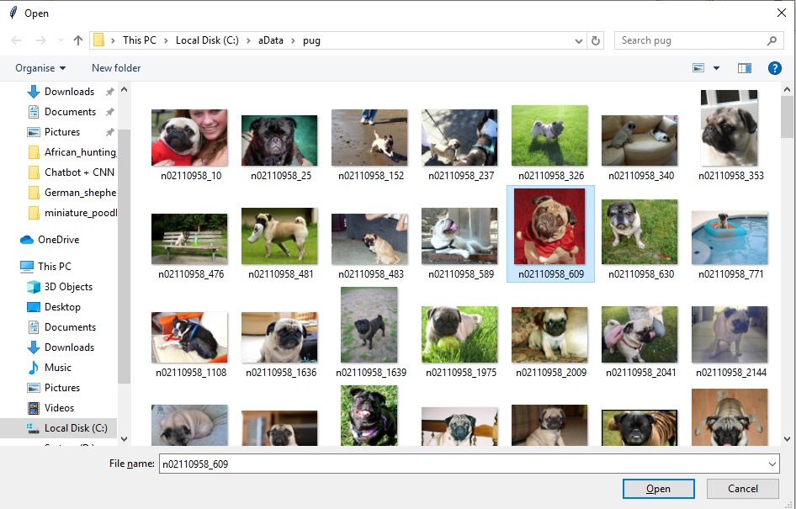

It should be a Pug

Thanks to the imaging component making use of the AIML component of the chatbot, requests for image prediction can be input in many different formats, such as;

Please predict the image “x.jpg”

What image is “x”

Predict “x”

The bot also handles incorrect paths in a suitable manner

> Predict “C://This is/a/bad/path.jpg”

Sorry. I couldn’t find that image

> Predict www.test.jpg

Sorry. I couldn’t find that image

**Toy world reasoning update**

The chatbot has been updated with a toy world reasoning system. When it starts up it now displays the option to describe the toy world.

> What is the toy world

The toy world contains:

Locations: field1, field2, field3, field4, the_lake

Dogs: rosie, bob, dennis, spark, charlie, max, rover

Actions for dogs: barking, sitting, walking, lying_down

Chaseable objects: rosie, bob, dennis, spark, charlie, max, rover, bone

Placeable objects: trees, grass, rosie, bob, dennis, spark, charlie, max, rover, bone

Try the command: Put rover in field1

Examples of commands to set the state of the toy world are below.

> Put rover in field2

Done.

> Make rover bark

Done.

> put rosie in field2

Done.

> put rover in field1

rover has moved to field1 ~ If an object is already in one place and it requested to be put in another, it is moved from the first location is was.

Done.

> put trees in field1

Done.

> make rosie sit

Done.

> put max in field3

Done.

> make max chase a bone

Done.

> put rosie on a leash

Done.

Example queries of the toy world are below.

> what is in field1

trees

rover

> what is in field2

rosie

> who is sitting ~ Code exists to prevent a dog from running and sitting at the same time.

rosie

> who is on a leash

rosie

> are there any dogs in field1 ~ All dogs are in the category ‘dogs’ which means queries for all dogs can be done in a single word.

Yes.

> who is chasing a bone

max

> is rosie in field1

No.

> are any dogs sitting

yes.

Users can reset the toy world at anytime

> reset the toy world

Done.

The chatbot performs error handling to make sure objects stick to what they should be able to do.

> put field1 in field2

Sorry, either field2 is not a location, or field1 is one.

> make field1 chase a bone

Sorry, either field1 is not a dog, or a bone can’t be chased.

> what is in the fields

Sorry can't help with that

**Transformer network extension**

For this part of the chatbot a transformer network was added to generate responses as a replacement if all other modules of the chatbot have no replies for input. Code for generating the model weights used, as well as the model used in the chatbot was adapted from: <https://github.com/tensorflow/examples/blob/master/community/en/transformer_chatbot.ipynb>

Previously loading times for the chatbot with this extension were an issue, however loading the model’s weights and its tokenizer from saved files instead of generating them at runtime fixed this loading time issue.

Examples of some of the transformer’s replies are shown below:

> im a doctor

i don t want to hear it .

> Are you alive?

no , i m fine .

> What is you're opinion on youtube

you re not making any fact . you gotta show it .

> Who are you

i m looking for you .

**Reinforcement learning extension**

For the reinforcement learning extension, a double deep Q network was added to the bot in order to demonstrate how to play a guessing game which was also added to the bot. The aim of the game is shown below in the chat. Code for the network was adapted from: <https://github.com/PacktPublishing/Advanced-Deep-Learning-with-Keras/blob/master/chapter9-drl/dqn-cartpole-9.6.1.py>

> Demonstrate the guessing game

Aim of the game is to guess the size of a dog. (Small, Medium, Large). Type 'quit' to stop.

Guess the size of a German Shepherd Dog

Guess : Large

Correct!

Guess the size of a Weimaraner

Guess : Medium

Incorrect!

Guess the size of a Borador

Guess : Small

Incorrect!

Guess the size of a Labernese

Guess : Large

Correct!

Guess the size of a Irish Wolfhound

Guess : Medium

Correct!

Guess the size of a English Cocker Spaniel

Guess : Medium

Correct!

Guess the size of a Chipin

Guess : Small

Correct!

Guess the size of a Golden Cocker Retriever

Guess : Small

Incorrect!

Guess the size of a Norwegian Elkhound

Guess : Medium

Correct!

Guess the size of a Old English Sheepdog

Guess : Large

Correct!

Correct: 7 Incorrect: 3 Once finished playing a total score is displayed

See you next time!

Playing the game is as follows:

> Play the guessing game

Aim of the game is to guess the size of a dog. (Small, Medium, Large). Type 'quit' to stop.

Guess the size of a Kyi-Leo

> small

Correct!

Guess the size of a Labmaraner

> medium

Incorrect!

Guess the size of a Polish Lowland Sheepdog

> medium

Correct!