COSC4353

Prof. Raj Singh

Group #19

**Final Assignment**

1. **GitHub Repository Link**

<https://github.com/ElliotMadsen/COSC4353---Software-Design.git>

* The final demo is called “COSC_Website_Final.zip”

1. **Code Coverage Report**

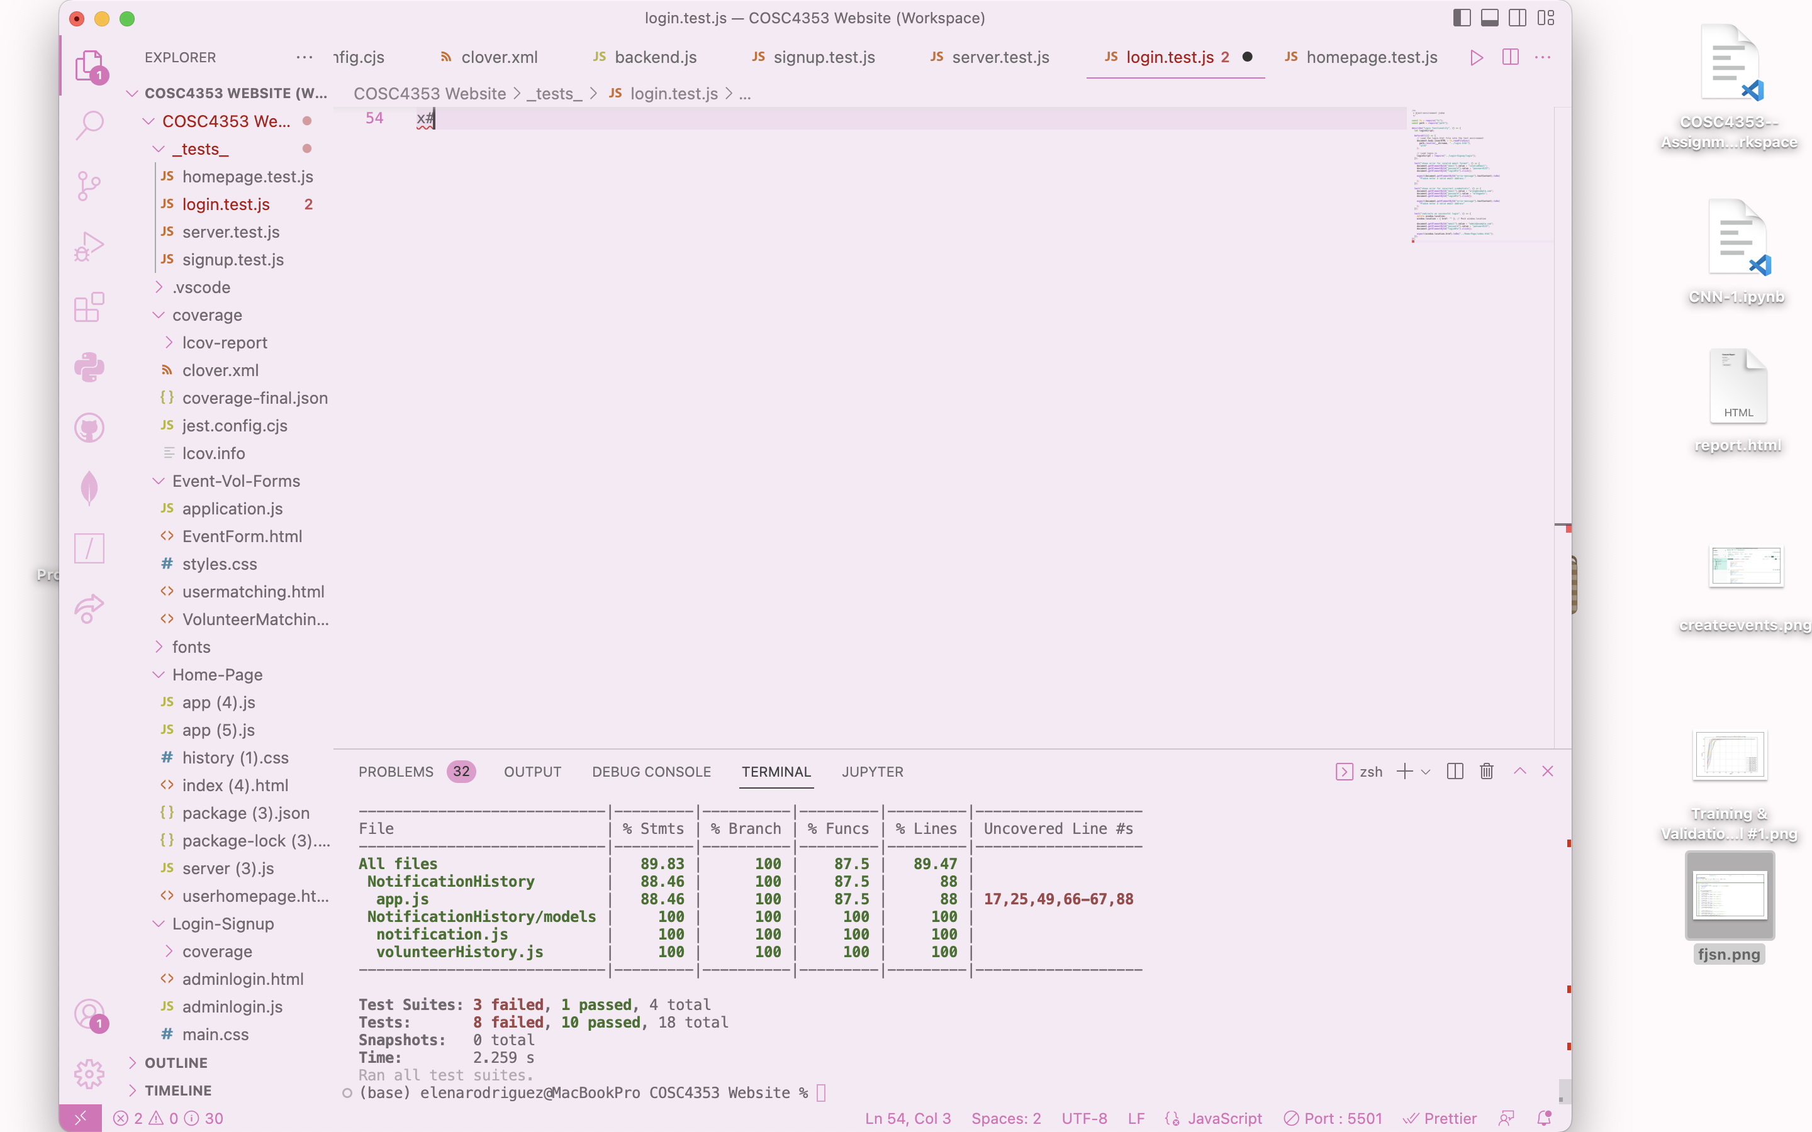

1. **Team Responsibilities**

|  |  |  |
| --- | --- | --- |
| **Member Name** | **Contribution** | **Notes** |
| Wendy Lizbeth Lacan | Event Management Form, Volunteer Matching form | N/A |
| Elena C Rodriguez | User Profile Management, Reporting Module | N/A |
| Prakash Adhikari | Notifications, History Module | N/A |
| Elliot C Madsen | Login, User Registration, Integration, Database Implementation | N/A |

**4.Report Generation Example**

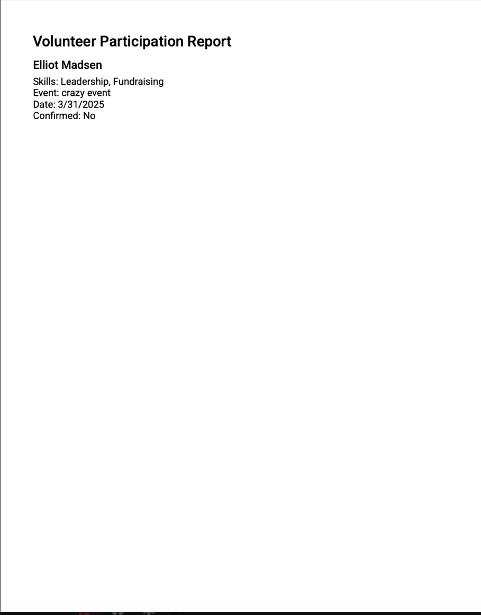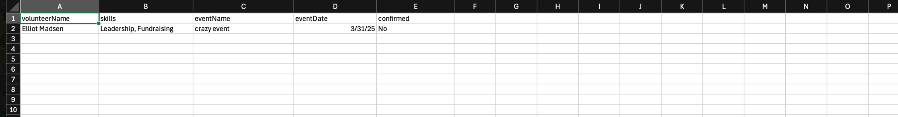

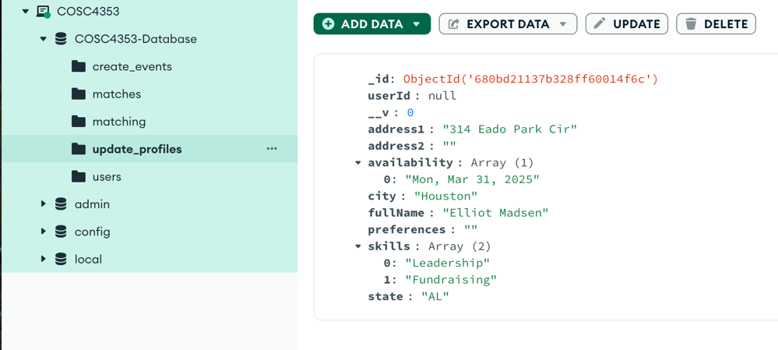

**Explanation:**

This reporting module allows administrators to generate summaries of volunteer participation and event assignments. It pulls data from a MongoDB database and offers reports in PDF, CSV, or JSON format. The backend is built with Express, while the frontend provides a simple interface for selecting the report type and format. When a user clicks “Generate Report,” the file opens in a new tab for download or viewing.