Word Count: 2,645

Alice MacNab S30035205

Destination hillend

## Part I- The Proposal

Midlothian Snow sports Centre (Hillend) was established in the 1960’s on Caerketton, Pentland Hills, Southern Edinburgh. Facilities presently on site include a main reception building with changing rooms and ski hire, two main slopes, three nursery slopes, tubing slopes, café and chairlift. Currently managed by Midlothian Council, it is a publically owned facility utilised by many from local schools and recreational skiers, to top athletes in ski and snowboarding. Therefore, it has proved to be a valuable asset in Great British Olympic snow sports. However, many of these athletes have had to seek training facilities at other dry ski slopes due to the centre “falling into despair” (The Newsroom, 2019). In 2010, Hillend faced near closure as Midlothian Council predicted an estimated £18m in cuts over a three year period (BBC News, 2010) in addition to the slope experiencing approximately £500,000 in annual losses. Prior to the success of an internet campaign signed by over 27,000 people to keep Hillend functioning, August 2010 saw Midlothian Council secure a £600,000 investment from SportScotland into the centre to save it (BBC News, 2010). The centre was predicted to breakeven in cost within three years of this injection (BBC News, 2010).

In 2017, Midlothian Council submitted a proposal to redevelop the already existing Hillend snow sports centre. This proposal would involve the following added to the already existing ski slope facility;

* A zip-line which will be the highest in the UK;
* An Alpine coaster to be the longest in the UK;
* New reception building for the existing snow sports centre;
* Food court;
* Function space;
* Retail space to be associated with the centre;
* Tourist accommodation
  + Wigwams/Glamping
  + Hotel development opportunity;
* Activity dome to include high ropes and soft play;
* Upgrade and extension to the decommissioned freestyle slope (Midlothian View, 2019).

With Edinburgh’s already large tourist population, Midlothian Council proposed ‘Destination Hillend’ to potentially launch Hillend as a tourist destination that attracts both users from the local region and nationally. Midlothian Local Development Plan 2017 Policy VIS 1 stated that “*The establishment of new, or expansion of existing, tourism-related development will be supported where it can be demonstrated that it improves the quality of visitor facilities or extends the tourism offering within Midlothian, subject to the Council being satisfied that there are no significant negative environmental or amenity impacts and that the proposal accords with all other policies in the plan*” (Midlothian Council, 2017). In May 2019, the project received the £13.8million investment it required for the development.

## Part II- Air Quality Environmental Impact Assessment Process

As part of the planning process, an Environmental Impact Assessment (EIA) is often necessary. This is to assess if there are any significant impacts to the environment before the application is passed. Under the EU EIA, the environment is defined as;

1. “Population and human health;
2. Biodiversity with particular attention to species and habitats protected under Directive 92/43/EEC and Directive 2009/17/EC
3. Land, soil, water, air and climate;
4. Material assets, cultural heritage and the landscape;
5. The interaction between the factors referred to in points (a) to (d) (The European Parliment , 2014).”

Before an EIA is carried out, it must first be decided if it necessary through “screening”. The screening for Destination Hillend was carried out by Midlothian Council following guidance under section 17 of the Town and Country Planning (Environmental Impact Assesment) (Scotland) Regulations 2017 (SWECO, 2019). For an effective EIA, the relevant roles of various bodies involved in the project must have an equal input. For Destination Hillend, Engineering firm SWECO were commissioned in March 2019 to carry out the EIA. The Swedish based company have established themselves in the United Kingdom and have a strong, experienced work force. This allowed for the relevant expertise to manage the identification of environmental issues without the bias of the developer aiming for the project proposal to go ahead with minimal environmental concern. In the UK, the EIA process is often criticised as being too bias as the developer would be the body to carry out the assessment (Glasson, et al., 2012). Following the screening to determine if an EIA is necessary, Destination Hillend was identified as requiring a schedule 2 EIA was required due to the location being potentially vulnerable to any significant impacts as a result of the nature of the project, its location or size (David Tyldesley and Associates , 2009). The following were assessed for environmental effects during the scoping stage;

* Noise and vibration;
* Flooding;
* Air quality;
* Biodiversity
* Socioeconomics;
* Landscape and visual;
* Traffic and transport;
* Culture and heritage.

By evaluating a range of environmental factors, many possible impacts can be identified and addressed. Here, the main issues and environmental pressures are prioritised and a baseline is established. With the experience SWECO provide, the company recognise that EIA has to consider cumulative impacts and effects that may not be immediately evident during the construction and operational phases. Therefore, they follow a 6 stage process;

1. **Baseline Assessment**

This is the non-statutory stage in which the contractor carrying out the EIA would establish what is already on the site. This is a stage that is often not carried out to the level required as the developer may carry this stage out themselves in order to cut costs. This is where lack of expertise may prove detrimental to the outcome as if this stage is carried out adequately as this baseline will determine if the EIA and development when completed have been successful. However, the developers for Destination Hillend contracted SWECO to start from this stage. For air quality, the baseline assessment carried out in 2017 established that with the Edinburgh City Bypass to the North of the site and A702 also nearby, air pollution may be a consideration necessary.

1. **Review of Policy and Guidance**

This is a statutory stage in which relevant policy and guidance must be identified and followed for the project. The EIA that will be carried out in accordance with the Town and Country Planning (Environmental Impact Assessment) (Scotland) Regulations 2017. It is through this legislation (section 12(a) *“Tourism and Leisure”*) that the EIA was identified as a schedule 2 development as it development involves *“ski-runs, ski-lifts and cable cars and associated developments”* and exceeds one hectare.

The site of the development already had policy in place in the event of its upgrade. Policy VIS 3 in the Midlothian Development Plan (MDP) states that *“Development proposals will be permitted for the upgrading and enhancement of the Midlothian Snowsports Centre and ancillary facilities in order to secure its future as a centre of excellence for artificial skiing and snowboarding. Proposals with significant adverse environmental impacts will not be supported unless the Council is satisfied that satisfactory mitigation measures are available to overcome relevant concerns. Consideration should be given to any relevant management plans in the formulation and assessment of proposals.”*

In order to monitor the air quality impacts, the necessary baseline assessment was carried out in 2017. To comply with Part IV of the Environment Act 1995, the Air Quality Strategy for England, Scotland, Wales and Northern Ireland was developed in 2011 to establish a framework for guidance on air quality monitoring. This involved the requirement that local authorities must assess the local air quality yearly (Department for Environment, Food and Rural Affairs in partnership with the Scottish Executive, Welsh Assembly Government and Department of the Environment Northern Ireland, 2011). This leads to the establishment of Local Air Quality Management (LAQM).

Midlothian Council have therefore set up their own LAQM to monitor their progress toward the Air Quality Objectives (AQO’s) set out in the Air Quality Strategy and the Air Quality Standards (Scotland) Regulations 2010. This ensures that the local authority is complying with national regulations. This has been accounted for and acknowledged within the EIA for Destination Hillend. Therefore, during the construction and operational phases for the project, it is important that the EIA considers these parameters to minimise production and concentrations of PM10 and NO2 as a specific pollutant focus point.

1. **Identification of Impacts**

As air quality was an identified concern for this project, it was recognised that this was likely to have highest environmental impact during the construction phase. (SWECO, 2019). Specifically, SWECO identified the following as risks to consider;

* Construction Dust

Sources include; Demolition/excavation activity, earthwork, movement of construction vehicles (both exhaust and re-suspension), material transfer (spillage, wind) and passing vehicles.

* Operational Air Pollution
* NO2
* PM10

With the EIA focussing on these pollutants, there is the potential for other pollutants that negatively impact air quality to be present. Despite PM10 and NO2 being the most likely to have significant detrimental impacts, there is the risk of high concentrations of CO2, CO and other pollutants that can have an impact on human health. These sources and potential effects have not been highlighted in the EIA. However, it is positive that the EIA is aiming to cover those that are considered to be of a greater issue.

1. **Evaluation of Significance of Impacts**

At this stage, other bodies are consulted to aid the evaluation of these identified impacts. For Destination Hillend, Historic Environment Scotland, Midlothian Council, Scottish Environmental Protection Agency and Transport Scotland were all included in this stage.

The EIA has recognised that Midlothian Council already monitors levels of NO2 in the local area. This is via a system of 17 passive diffusion tubes located in the Midlothian towns of Penicuik, Loanhead, Bonnyrigg, Pathhead, Dalkeith and Lasswade. This has allowed for the establishment of a baseline due to 2017 data. However, Hillend is closer to the City of Edinburgh Local Authority Area than it is to any of the Midlothian monitoring tubes (see *figure 1*). Despite being the responsibility for air quality being the issue of Midlothian Council, it may be appropriate to use baseline data for City of Edinburgh if there was a closer monitoring station to the project.

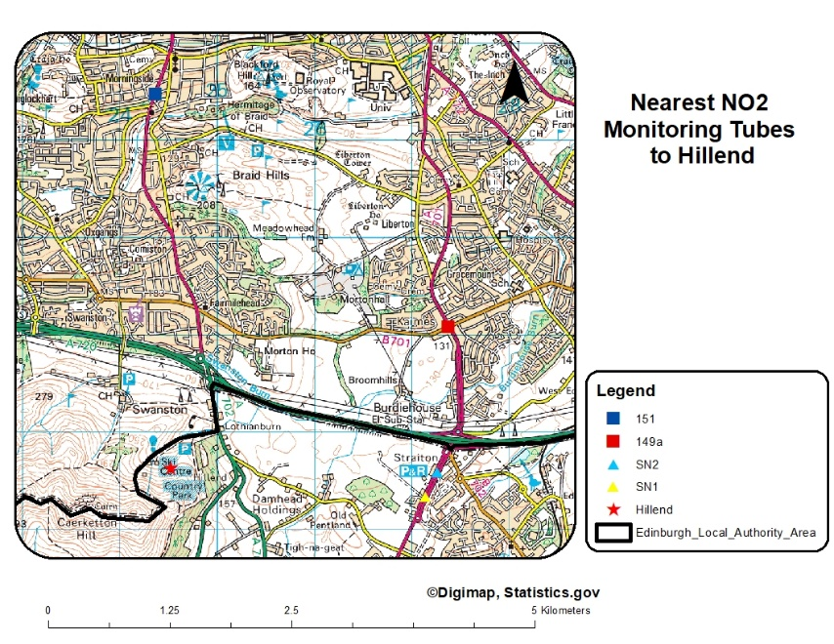

Figure 1- Location of Hillend in relation to NO2 Monitoring Tubes

Transport is expected to increase when the facility is operating with a larger car park included in the plan. This will however cause an increase in potential pollutants. With Hillend’s location adjacent to the A720 (Edinburgh City Bypass) and direct access to the site via the A702 which lies at the entrance to the centre will provide a convenient journey for customers. However, the pollutant levels on site may be higher than that of the towns in which NO­2­ is measured due to the bypass being near. Consideration as to the height of the facility being significantly above this major route may have been accounted for as pollutants may not reach the site in high volumes or not at all. As Hillend is within Midlothian council zone, the two closest NO2­ monitoring stations are at Loanhead (SN1 and SN2), 2.5km from the site (SWECO, 2019). However, SN1 diffusion tube is kerbside and must be discounted under the DEFRA Local Air Quality Management Technical Guidance due to their proximity to the road (Department for Environment, Food and Rural Affairs, 2018) The EIA has considered Hillend to be close to the City of Edinburgh Local Authority Area. Two other diffusion tube sites have been used in the analysis of air quality for this site 3.5km from the Destination Hillend proposal. These are tubes 149a and 151 (Clarke, 2018).

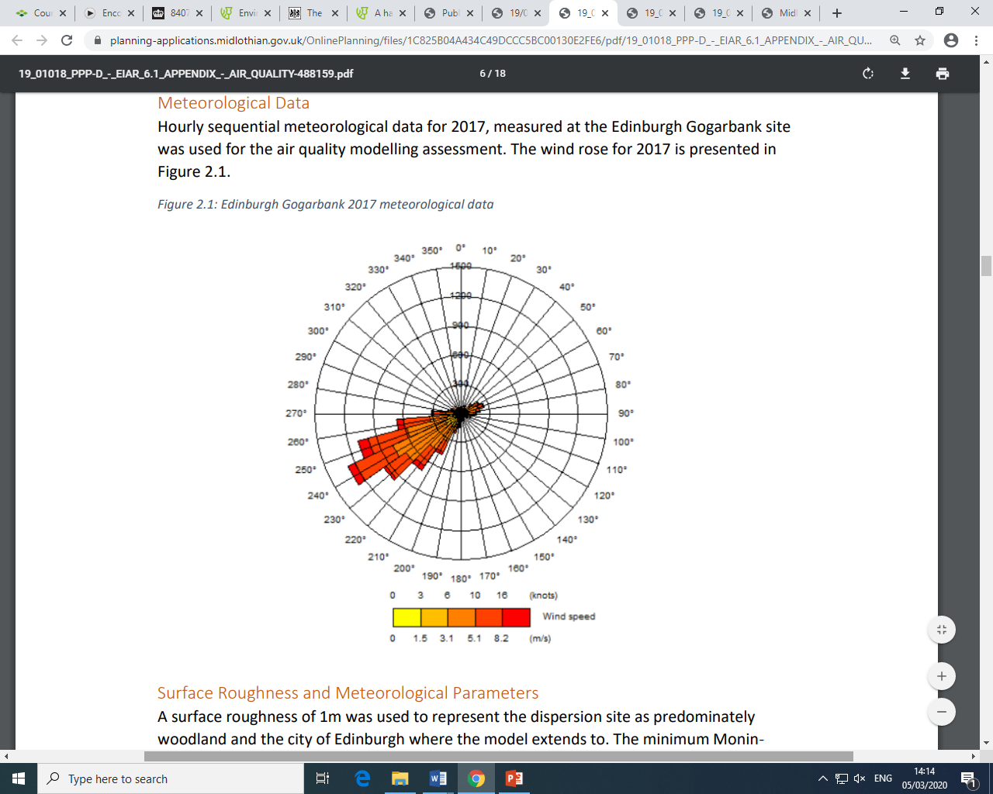

Figure 2- Wind Rose using Edinburgh Gogarbank Meteorological Data 2017 (Source: SWECO, 2019)

SWECO carried out model testing to predict the likely pathways of the air pollution produced by construction. A wind rose (*figure 2*) was produced to identify prevailing wind direction and therefore what areas would be likely to be impacted if air pollution occurred. Modelling pollutant pathway is important when carrying out an EIA as this will only enhance its effectiveness in mitigation due to the ability to recognise pathways in addition to presence. Again, the EIA recognised that a gradient of 1:10 would impact pollutant dispersion.

Traffic impact was also modelled with the existing baseline data from 2018 with a predicted baseline in 2022 (year of development completion) and future years with the development in operation. This was predicted using data from a reliable source, the Department for Transport (SWECO, 2019).

1. **Identification of Mitigation Methods**

Dust release from construction was categorised as “*low”* risk*.* A mitigation plan would only be required if risk was “*medium”* risk.Annual release of NO2 was classified as “*negligible”* with PM10 impacts being classed between “*negligible*” and “*slight*” meaning they are not predicted to exceed the annual mean of 40µg/m3 and 18µg/m3 respectively (SWECO, 2019).With these results and considerations, it was determined that air pollution from opening would not be a significant impact. SWECO did recognise however that best practice should always be used where there is a risk of any impact and therefore caution should always be taken.

1. **Residual Impacts**

No cumulative impacts are anticipated by the EIA as a result of construction and operational phases. Any residual effect would be insignificant.

## Part III- Does the EIA process address environmental sustainability?

To achieve sustainability, a project must incorporate an equal balance between economic, social and environmental factors. *Figure 3* displays the 3 pillars of sustainability as well as the interconnections that must be addressed. In order for an EIA to achieve environmental sustainability, it must incorporate the main environmental protection goal along with the ecological economics involved whilst still retaining a sense of place. In order to achieve sustainability, the UK government recognised in the publication *“This common inheritance: Britain’s Environmental Strategy”* that the responsibility lay with not only the highest body that produce policy, but all businesses additionally to members of the public in their everyday activities (Department of Evironment, 2005).

Economic Prosperity

Communal Health

Social Advancement

Sense of Place

Environmental Protection

Ecological Economics

Sustainability

Figure 3- Dimensions of Sustainability (Source: (Glasson, et al., 2012)

Ecological economics is the relationship between human economies and ecosystems with the aim as viewing human activity as not a separate entity from the environment (Costanza, 1989). This can be missed as humans often disassociate themselves with the wider environment. Many projects are driven with the goal of reducing the overall construction and operating cost as much as possible. This process can often cause the environmental pillar of sustainability to be neglected during the EIA. Presently, an EIA contract is often part of a bidding process involving multiple contractors who will put forward their best price to the developer. It is at this stage that an effective EIA can be at risk. Contractors who may have little experience may take on EIA’s simply because they were the low-cost option as opposed to the thoroughness of their previous work (Wright, et al., 2013).

Incorporating sustainability through EIA can be of great benefit to generations both present and future. Especially when carrying out EIA when a development is in the Planning Permission in Principle (PPiP) stage. This is the stage in which permission has been granted to plan a project before it is approved to go ahead. PPiP allows the developer to integrate the findings of the EIA report into the design of the project. This can allow for any identified areas of concern from the EIA to be reconsidered in relation to their environmental impact early in the development. This can be of additional benefit as it includes the developer in the process. This is an opportunity to share knowledge within the industry (Weaver, et al., 2008). Considerations such as materials, location, construction methods can all be reconsidered in terms of the pillars of sustainability.

Those who are carrying out the EIA can consider a range of steps to contribute to sustainability. This can include simply thinking of another means of which something can be achieved to minimise environmental impact. This can include the recommendation of Best Available Technique (BAT) to developers. EIA is also an opportunity to identify areas in which finite resource and virgin material use can be minimised. By incorporating BAT, developers can consider different options for energy use and production on site by considering the implementation of renewables to anaerobic digesters on site.

As many EIA reports are made available to the public, this can allow more people to learn about the processes involved in an effective EIA. With Destination Hillend, extensive documentation including a non-technical summary of the full EIA report are available on the Midlothian Council planning portal. The EIA is therefore actively encouraging those in the area who wish to know about the development process but do not have the technical knowledge, to still read and understand the processes undertaken and the results of the EIA.Including the community in the EIA process is key for passing on knowledge of sustainability.

With sustainability, it is essential that the work carried out today does not compromise the ability of future generations to utilise the same resource (IEMA, 2011).

# References

BBC News, 2010. Deal to save Hillend dry ski slope backed. *BBC News*, 27 August , p. 1.

BBC News, 2010. Olympic effort to save Midlothian ski slope. *BBC News*, 11 February, p. 1.

Clarke, S., 2018. *2018 Air Quality Annual Progress Report (APR) for Edinburgh City Council,* Edinburgh: Edinburgh City Council.

Costanza, R., 1989. What is Ecological Economics. *Ecological Economics,* Volume 1, pp. 1-7.

David Tyldesley and Associates , 2009. *A Handbook on Environmental Impact Assessment,* Edinburgh: Scottish Natural Heritage.

Department for Environment, Food and Rural Affairs in partnership with the Scottish Executive, Welsh Assembly Government and Department of the Environment Northern Ireland, 2011. *The Air Quality Strategy for England, Scotland, Wales and Northern Ireland (Volume 1),* London: TSO.

Department for Environment, Food and Rural Affairs, 2018. *Local Air Quality Management Technical Guidance (TG16),* London: DEFRA.

Department of Evironment, 2005. *This Common Inheritance; A Summary of the White Paper on the Environment,* London: Department of Evironment.

Glasson, J., Therivel, R. & Chadwick, A., 2012. *Introduction to Environmental Impact Assessment.* 4th ed. Oxon: Routledge.

IEMA, 2011. *The State of Environmental Impact Assessment in the UK,* Lincoln: IEMA.

Midlothian Council, 2017. *Midlothian Local Development Plan 2017,* Dalkeith : Midlothian Council.

Midlothian View, 2019. *What is your view on ‘Destination Hillend’?.* [Online]   
Available at: http://www.midlothianview.com/news/what-is-your-view-on-destination-hillend/  
[Accessed 30 Jan 2020].

SWECO, 2019. *Destinatio Hillend EIAR: Appendix 2.1: Scoping Opinion,* Edinburgh: SWECO.

SWECO, 2019. *Destination Hillend EIAR: Appendix 6.1 Air Quality,* Edinburgh: SWECO.

SWECO, 2019. *Destination Hillend Environmental Impact Assessment Report ,* Leeds: SWECO.

The European Parliment , 2014. Directive 2014/52/EU of the European Parliment and of the Council amending Directive 2011/92/EU on the assessment of the effects of certain public and private. *Official Journal of the European Union,* 57(124), p. 8.

The Newsroom, 2019. Hillend dry ski slope: The breeding ground of Olympic stars. *Edinburgh Evening News*, 19 January, p. 1.

Weaver, A., Pope, J., Morrison-Saunders, A. & Lochner, P., 2008. Contributing to sustainability as an environmental impact assessment practitioner. *Impact Assessment and Project Appraisal,* 26(2), pp. 91-98.

Wright, A. J. et al., 2013. Myth and Momentum: A Critique of Environmental Impact Assessments. *Journal of Environmental Protection,* Volume 4, pp. 72-77.