Megan McInnes

Rural Planning & EIA

S30005201 ERM Year 3

Assessment 1

Evaluation of Environmental Sustainability of the Hillend Project Development.

Introduction

On the side of the Pentland Hills on the outskirts of the City of Edinburgh is Hillend. Hillend is a recreational centre offering snow sport activities for all members of the public outlined by Midlothian Council, 2019. *Image 1* below shows the location of Hillend snowsports centre. The ski centre is comprised of two main dry ski slopes along with smaller slopes and freestyle structures. However, the centre is in desperate need of repair and the centre would risk losing money or closing, Midlothian Council, 2019 noted in their report. In January 2019 plans were created to completely transform Hillend and the facilities. Midlothian council are investing in £13.8 million pounds into the development. The development would see an all year facility with features such as a zip line, upgrades to car parks, glamping, retail space, ski slope improvements and a hotel. Midlothian council have stated that this would be a great social and economic opportunity for the area. Potentially bringing in up to over 50 jobs (full time) and activities that would suit all members of the public. The project has been created to ensure the snowsports centre has a long and stable future. The plan overall is to assess the potential environmental impact from developments that are due to be carried out. This accounts for the likely impact as well as the significance of the impacts and mitigation measures, MidlothianCouncil, 2019 stated. Midlothian council have assessed impacts which can arise from the development. Carrying out the development is SWECO alongside other partners.

An environmental impact assessment (EIA) is a tool used to assess the likelihood of environmental impacts arising from a project or process. It is the responsibility of the process leader to take full responsibility of the consequences should they arise. An EIA helps with decision making as well as minimising or mitigating environmental impacts through careful options and considerations, Smith, 2008 outlined.

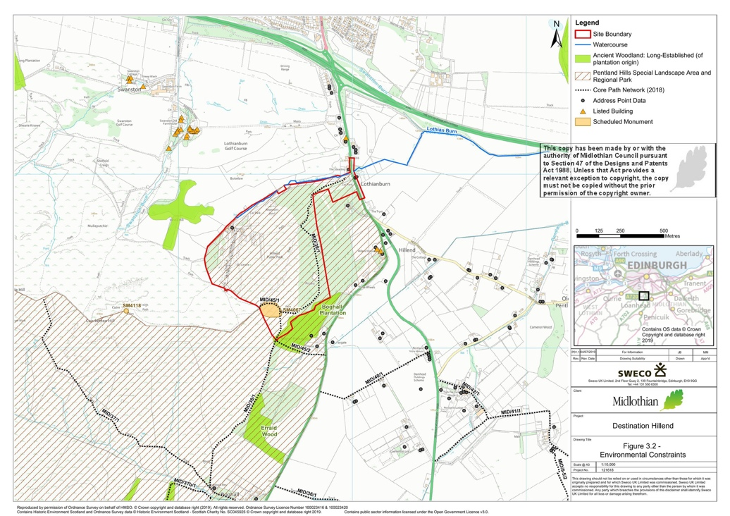*Image 1, Hillend Snowsports Centre development area.*

*Image 1,* above shows the location of the snowsports centre and development. The environmental features have also been noted in order to protect this when development occurs. Provided by Midlothian Council, 2019.

This report will critically evaluate one of the environmental impacts which have been included within the development report. This will look at specifically the positives and negatives in terms of assessing and mitigating the environmental impacts. Along with this, the potential need for an environmental impact assessment (EIA) will be discussed in order to fully address the environment and sustainability of Hillend.

Focussing specifically on Noise and Vibration as a potential impact. Noise pollution is unnecessary and unwanted sounds which occur in the environment. Noise can heavily impact the health of individuals and species living within the environment. Due to population growth it is likely to increase over time as Goines et al, 2007 stated on her article on noise pollution.

Noise and vibration in the development will be most apparent during construction and operation at a range of levels and processes.

Evaluation

Construction

Noise

Construction is the first phase that will occur on the development. Midlothian Council, 2019 have stated that they will aim to prevent any noise from the development occurring which can impact residents and the surrounding environment. British standards (BS) have been set to help improve the overall management and sustainability of projects or developments the BSI Group, 2018 outlined. The noise from construction has been outlined in the BS 5228 where noise from emissions, construction, structures and distance have been measured. It has been stated by Midlothian Council, 2019 a construction limit of 70 decibels (dB) have been deemed acceptable between the hours of 7am and 7pm (total of 12 hours). An impact of 70dB have been said to have minor adverse on the noise from construction where the significance of this is insignificant. Anything above 71dB would be significant. Under the Health and Safety Executive, 2005 controlling noise at work regulations it states that personal noise exposure should not exceed a weekly or daily limit of 80dB as a lower limit. It can be said that the noise levels from construction are estimated to be at a maximum of 70dB and is therefore would have no significant impacts on health or environment.

The noise survey was undertaken is various areas of the proposed development. This was conducted using various instruments such as pre-amplifier, microphone and a sound level meter. All instruments have been accredited by the UKAS Laboratory and were checked pre and post survey. Short- and long-term measurement were taken – 16 hours during the day and 8 hours during the night. Data was gathered and compared against day and night. Measurements were taken over a range of days. The measurements were first taken at Swanston Village. It found that sounds levels were 45dB (short term) and 46dB (long term). The second readings were taken at Calderstones where noise levels were 44dB (short) and 45dB (long), again noise levels did not change significantly. The last reading was taken at the Access Road with readings of 46dB (short) and 49dB (long) with a difference of 3dB, although slightly higher than previous there was little change in noise from day and night. As well as this the readings taken did not exceed the limit of 70dB set by Midlothian Council. Which is a positive result in addressing noise and the environment, however it was not clear when exactly each reading was taken for short and long term and using which instrument. During this measurement some factors were not considered which WHO, 2011 outlined. This includes instrument influences. Each method works differently so different levels decibels of noise may be picked up. Location is another main subject within this, as WHO, 2011 also noted that it can be hard to quantify noise as if measuring closer to source it will be higher, but the development at Hillend has not been conducted yet so it is impossible to identify what the noise levels would be. Human error can also influence these results due to incorrect instrument use. Bruel, 2008 also stated that noise data should be effectively recorded along with the individual that conducted it. This has not been outlined in the EIA report for Hillend. Suggesting that there needs to be more clarity on these to ensure best practise has been carried out.

Too add, during these observations were taken at each location and found that noise generally came from the bypass. The environmental conditions during this did not influence data as there was no rainfall and short intervals of wind. Again, human error can influence this as noise can be subjective and travels therefore this should be taken as an estimation and not actual real observations due to the probability that it could be incorrect.

Vibration

As for vibration guidelines for this have been outlined, however there has been no measurements or figures provided to estimate the damage from vibration. This shows negative practise towards local residents and the environment in which may experience significant impacts from this. The UK Government, 2005 has recommended an exposure limit in the control of vibration at work regulations which state that whole body vibration should not exceed 1.15mm/s. This can arise from machinery, earth-moving machines or structure vibration which can heavily impact an individual’s health – particularly for employees as the Health and Safety Executive, 2005 stated. Therefore, it can be concluded there is no clear impact that vibration may cause from the development, but an estimation can be predicted based on the type and scale of development. Comment on green: identifying a source of the problem is a good part of the process

Vibration surveys were taken as close to the predicated source as possible. This has been conducted in accordance with BS 5228. It has been predicted by Midlothian Council, 2019 that there is potentially a 33.3% probability vibration would exceed the levels set with 66.7% not. The threshold for this has not been outlined within Hillend’s EIA report. The main area where vibration is to occur is the site for glamping. They have successfully identified a source as a result. It has been predicted that vibration during start up is 0.74mm/s and construction is 0.39mm/s. The effects from this are both insignificant which lies in accordance with the Control of Vibration at work regulations 2005 by the UK Government Health and Safety, 2005 stating that individuals must not be exposed to vibration higher than 5m/s2 per day. This is clearly well below the UK threshold which is good practise. It can be said that no intensive machinery will be used for example a piling machine and that a vibratory roller is all that will be used.

Operation

Noise

In relation to the operational side of the development. The increase in road traffic is a big factor which may have an impact within the area. This relates to both noise and vibration. The design manual relating to road and bridges (DMRB) has estimated that there will be a significant change in traffic at Hillend of about 25% or -20% and a change in noise of 1dB. The UK Government, 2010 state that there is no set noise limit that can arise from road transport therefore there is no set legal limit that has to be followed as it is difficult to predict. However, it was concluded that a change in noise levels of 3dB was more appropriate. The noise and vibration criteria were set out and changes in traffic noise of 3dB to 4dB has moderate adverse effects which is a negative but significant impact on the surroundings. As the numbers in this scale become more negative the noise effects become positive due to a decrease in decibels. It can be concluded that an increase in traffic increases noise and vibration in the area.

Measurements were taken a 5m from the road within the development area. Noise levels have been estimated to show noise levels by 2022 with and without. The predictions have been set out by Midlothian Council, 2019 as well as Transport Scotland. It estimated that noise without the development is between 59.8dB and 74.3dB. However, the development estimations did not change significantly where noise levels are estimated at 59.8dB and 74.6dB. This was excluding the Hillend Access road where post development predicts levels to be 58.4dB and with increasing to 63.6dB (a change of 5.2dB) the impacts have been said to be significant and cause adverse disruption. The negative effects of this suggest that there is no identification of who has carried out the survey as a specialist such as a consultant would be required the UK Government, 2018. This could be seen as incompetent practise without the individual identified. Repeating the experiment would give a reliable result and reduce the likelihood of human error.

Vibration

Within the destination Hillend project, vibration had been mentioned at operation phase. However, the effects of vibration from operational activities have not been estimated or measured. This can suggest that they are no impacts from any operations or that this was not considered at all and that noise was the main focus. This could result in major consequences for the development if vibration impacts were to occur. As there is no further information outlined in Midlothian Council, 2019 report. An evaluation on this cannot be commented on but this shows incorrect practise has been conducted.

Limitations and Suggestions

Although the majority of work carried due to be carried out at construction and operational level ties in with UK legislation there has to be better practise in how it is carried out. The majority of surveys or monitoring methods do not state if a qualified individual has conducted it as well as this how it was carried out and using unknown equipment. There is little mention on potential impacts to flora and fauna and surrounding environment from the investigation – again bad practise. As this EIA relates to noise and vibration there was little mention of vibratory impacts that could arise which is a negative response to successfully addressing the EIA.

During the construction phase it was concluded that traffic was confined to daytime hours as well as using local roads only. Too add, piling equipment was not required and the use of a roller was more suitable.

During operation there will be no activity during the hours of 23:00 and 07:00 in keeping with noise legislation. Noise traffic had been predicated to show there would be little change in levels already present with no significant impact.

Addressing Environmental Sustainability

It can be said that the EIA processes are not sufficient to address environmental sustainability at destination Hillend. Traffic noise for both construction and operation were the most important where various measurements had been taken relevant to addressing an EIA. However, many professional practises had not been included such as

For construction noise successful measurements had been taken and the decibels predicted are lower than the standards set. This also tied in with British standards which encourage best practise. There had been no identification of what instruments had been used. Noise is also extremely hard to predict. Human error may have influenced the results and there was no professional known in the plan who had carried it out which shows incompetence of what should be included.

In Cvetkovic et al, 2018 report into the investigation the effects of vibration rollers during construction and found that the roller to be used at Hillend has a significantly lower impact that other types as it maintains close contact with the ground and therefore produces less vibration. It has not been predicted how long the construction of the glamping site will last. The method Hillend are using to construct the glamping area seems to be the best alternative to keep vibration levels low. However, what has not been considered is the damage to the ground soil. A heavy roller may cause soil compaction, erosion and damage to the structure as well as the invertebrates that live within it. In turn, this can also be a positive as it has been found to reduce water loss, irrigate the soil for new growth and permeability as Avalle, 2004 noted. Due to the short use of the machinery and the low impact predicted it can be said that the development of the glamping site should go ahead as there is little limitations to prevent it. As well as this, no measurements were taken to assess damage predicted.

As for operation, the measurements were estimated – although the use of figures is positive but not reliable and again no individual was identified. The assumptions suggest that there would be little difference in traffic noise by 2022 apart from the access road.

For vibration this showed that there was no clarity at all for operational vibration. This again shows poor practise in addressing environmental sustainability as it had not been considered in the development plan. No comments on this could be made except for that the plan is not suitable to address environmental sustainability.

Overall, it can be concluded that the Destination Hillend EIA report is not sufficient enough to address environmental sustainability.

Word Count – 2,518

# References

Avalle, D., 2004. Use of the impact roller to reduce agricultural water loss. *Geomechanics.* - Last Accessed 13/02/20

Bruel, 2008. *bskv.* [Online]   
Available at: https://www.bksv.com/media/doc/br0139.pdf  
[Accessed 25 February 2020].

BSI Group, 2018. *BSI Group.* [Online]   
Available at: https://standardsdevelopment.bsigroup.com/search/Standards?Term=Environmental%20impact%20assessment&Source=category  
[Accessed 20 February 2020].

Council, M., 2019. *Development Area,* Edinburgh: Midlothian Council. - Last Accessed 05/02/20

Cvetkovic et al, 2018. Evaluation of the whole body vibration expsoure of vibratory roller operations. *Noise and Vibration,* 6(7.12). - Last Accessed 12/02/20

Environmental Protection Act UK Government, 1990. *Environmental Protection Act.* [Online]   
Available at: http://www.legislation.gov.uk/ukpga/1990/43/contents  
[Accessed 6 February 2020].

Goines et al, L., 2007. Noise Pollution: A modern plague. - Last Accessed 07/02/20

Health and Safety Executive, 2005. *Control back-pain risks from whole body vibration.* [Online]   
Available at: https://www.hse.gov.uk/pubns/indg242.pdf  
[Accessed 20 February 2020].

Health and Safety Executive, 2005. *Controlling Noise at Work,* s.l.: HSE. - Last Accessed 10/02/20

Midlothian Council, 2019. *Destination Hillend EIA Intro,* Edinburgh: Midlothian Council. - Last Accessed 05/02/20

Midlothian Council, 2019. *Midlothian Council.* [Online]   
Available at: https://www.midlothian.gov.uk/info/200281/snowsports_centre/181/about_the_snowsports_centre - Last Accessed 23/02/20

Midlothian Council, 2019. *Midlothian Council.* [Online]   
Available at: https://www.midlothian.gov.uk/info/200281/snowsports_centre/586/destination_hillend - Last Accessed 20/02/20

Smith, 2008. *EIA.* [Online]   
Available at: https://www.soas.ac.uk/cedep-demos/000_P507_EA_K3736-Demo/unit1/page_08.htm - Last Accessed 10/02/20

UK Government, 2005. *Control of Vibration at Work Regulations.* [Online]   
Available at: https://www.hse.gov.uk/vibration/wbv/regulations.htm  
[Accessed 20 February 2020].

UK Government, 2010. *Noise from roads, trains, or planes.* [Online]   
Available at: https://www.gov.uk/noise-pollution-road-train-plane/noise-from-roads  
[Accessed 20 February 2020].

UK Government, 2018. *Who carries out the assessment.* [Online]   
Available at: https://www.hse.gov.uk/noise/risks.htm  
[Accessed 28 February 2020].

UK GovernmentHealthandSafety, 2005. *HSE.* [Online]   
Available at: https://www.hse.gov.uk/vibration/hav/advicetoemployers/responsibilities.htm  
[Accessed 28 February 2020].

WHO, 2011. *Noise Measurement.* [Online]   
Available at: https://www.who.int/docstore/peh/noise/Comnoise-2.pdf  
[Accessed 25 2 2020].