2020

Lauren Graham – S30000950

SRUC Environmental Resource Management

3/8/2020

Destination Hillend



Figure 1 Artists representation of Destination Hillend (Council, 2020)

**Table of Contents**

Introduction 1

Need for Development 1

Cultural Heritage 3

Competency 3

Methodology 3

Baseline 6

Construction Impacts 6

Mitigation 6

EIA Process & Environmental Sustainability 7

References 9

# Introduction

Midlothian Council have (MC) been given the go ahead by councillors to invest £13.8 million into Hillend Midlothian Snowsports Centre. The snowsports centre has previously faced a financial crisis with the possibility of closure due to lack of funding being made available (Midlothian Council, 2020). There has however been a recent increase in the amount of visitors which is putting further pressure and demand on the facilities.

The idea behind the new development is to help secure the site and enable it to continue to successfully function as a multipurpose, all year round leisure facility. It will attract high numbers of tourists and potentially establish a destination with regional and national importance (Sweco, 2020). The new development will see the possible introduction of:

* Alpine Coaster
* Zipline
* Infrastructure upgrades including a new car park and a new entrance road layout
* New reception building for snowsports centre
* Food court and function suite
* Retail opportunities
* Glamping site with wigwams
* Activity dome including high ropes and a soft play
* Freestyle jump extension and upgrade
* Hotel development opportunity

## **Need for Development**

The Scottish Planning policy’s (SPP) purpose is to look at how nationally important land use and planning policies are addressed. Plan making, planning decisions and development design are at the forefront of the Scottish Governments priorities to encourage a successful country which opens up the core values of the planning system including opportunities for all of Scotland to flourish, whilst increasing sustainable economic growth (Scottish Government, 2014).

The National Planning Framework 3 (NPF3) sets out the long term plans for development and the investment for infrastructure in Scotland for the next 20-30 years. Any statutory developments must be in keeping with the NPF3 where the Scottish Ministers expect planning decisions to support the delivery of the NPF3. In accordance with the NPF, local authorities should work to achieve the main visions which are:

* A successful sustainable place
* A low carbon place
* A natural resilient place
* A connected place

Together the NPF3 and SPP will allow the Scottish Government to continue the success of plans and strategies important to Scotland’s future (Scottish Government, 2014).

The Strategic Development Plan (SDP) for Edinburgh and South East Scotland is currently under review. The previous SESplan was in 2013 and is prepared by taking into consideration both the NPF and SPP, with a local vision up to the period 2032 (SESplan, 2013). This is then fed into the regional context of the Midlothian Local Development Plan (MLDP) with the expectation to manage and meet the development needs of South East Scotland (MDLP, 2017). Promoting economic growth is one of the primary objections for Midlothian and included in this is tourism development. Midlothian snowsports centre (Policy VIS 3) is included as part of this section. The development will help to promote tourism which in turn will secure economic benefits (MLDP, 2017). The development will also provide further employment opportunities as highlighted by the SPP, NPF, SESplan and MDLP.

# Cultural Heritage

Scotland has a rich and diverse collection of cultural heritage and with the increase and rapid growth in development projects it is an integral part of the planning process to consider protecting and preserving these features. As part of the planning process and as mentioned in the Environmental Impact Assessment (EIA) Scoping Report, the developers, who in this case are MC, have opted for an EIA to be carried out as part of this schedule 2 development. The Planning Permission in Principle (PPiP) allows for the application to be formerly outlined and will determine whether or not the development will be acceptable in principle. This provides all the required details without the added cost and time of preparing full plans for it to be potentially rejected (Scottish Government, 2020). The main principles of an EIA is to identify any negative effects likely to occur on the environment caused by a new development. This section will analyse the effectiveness of the EIA as described in the Environmental Statement (ES) carried out in regards to the Cultural Heritage aspects as part of the Destination Hillend development.

## **Competency**

Sweco are the contracted organisation who carried out the EIA and produced the ES. Sweco have development expertise in over 70 countries throughout the world. However it is Headland Archaeology, a chartered institute for Archaeologists, who are responsible for carrying out the cultural heritage aspect of the EIA. It is suggested to achieve a high quality EIA it should be carried out by an appropriate contractor and even more beneficial when the contractor has local knowledge and a good reputation (Wright et al., 2013). The fact that Headland Archaeology are a registered chartered institute organisation means they will have excellent work ethic and professional standards to make the EIA an efficient process. Including the competency statement is good practice and not all ES include this as an absent section from the Jacobs EIA for the new Queensferry Crossing (Jacobs, 2008). As mentioned by SNH and as part of their EIA handbook, drawing on specialist knowledge from external organisations and including separate authors is encouraged but it is important to integrate this into the ES to ensure a clear and precise conclusion (SNH, 2018). As part of this ES this has been done effectively.

## **Methodology**

Thorough detail has been provided in regards to the methodology approach to the EIA. This included desk based study identifying the documented heritage assets, followed by a site visit to said assets. This then allowed for the importance of the heritage assets to be identified and proper mitigation measures to eliminate, reduce, or offset adverse effects. As suggested by Scottish Natural Heritage (SNH) in their EIA handbook, good practice states that early site visits should be made to ensure matters of natural heritage are appropriately addressed which was carried out as part of the first stages.

Background and baseline information has been collected from the relevant data sources and is evident that the most current information has been utilised. For example the designation data downloaded from HES was published in 2019 as well as the Midlothian Council Historic Environment Record received also in 2019. The cultural heritage importance was also included as part of the scoping report where discretion was applied to help identify the features of highest importance.

Following on from this baseline information, which will be further discussed in this report, clear and precise study areas have been identified. Figure 2 below demonstrates both the Inner Study Area (ISA) and Outer Study Area (OSA).

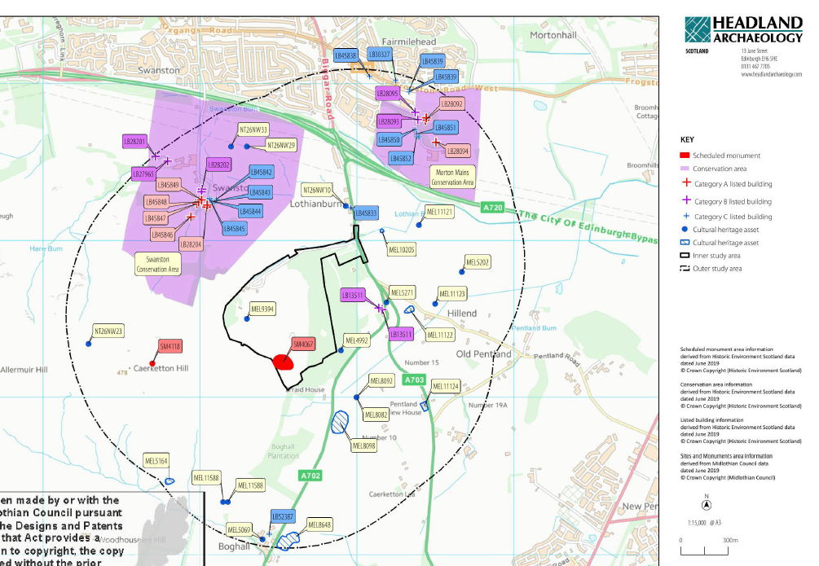

Figure 2 Study Areas (Headland Archaeology, 2019)

The study areas and their size should be appropriate depending on individual projects and the overall scale of the project. Within the ISA all assets are being considered for operational and construction effects which includes one of two of the nationally important scheduled monuments on site. The OSA, which extends 1km from the site, and its assets will be considered on whether or not they are designated, whether or not they continue into the ISA and the level at which they might be affected. As demonstrated in figure 2 it is evident a large amount of heritage assets have been identified and are being considered. During the scoping stage further consultations were carried out and are detailed below in table 1.

Table 1 Detailed account on consultations (Sweco, Destination Hillend EIAR, 2019)

|  |  |  |
| --- | --- | --- |
| Consultee | Issues Raised | Action Taken |
| HES Pre application discussion | Potential for direct effects to Caerketton Hill Fort, scheduled monument | Applicant and HES agreed that a 25m exclusion zone will be included, ensuring that direct impacts on the scheduled monument could be coped out of further assessments |
| HES – Pre Scoping consultation dated May 2019 | Recommended a detailed setting assessment of the scheduled monument | Setting assessment was undertaken and discussed in a further section |
| HES Scoping Response 12th June 2019 | HES confirmed they were content with the information provided, only significant impacts that worried them was of the scheduled monument | Assessment of potential construction and operational impacts were undertaken |
| East Lothian Council (ELC) as archaeological advisors to Midlothian Council, Scoping Response 2019 | Stated the EIA should include:   * Include a setting assessment * Identify the current cultural heritage baseline through a desk based assessment and a walkover survey * Consider the archaeological potential * Assess the impact on the baseline * Recommend mitigation | All the required stages were addressed as will be discussed in this report |

From this table it is evident that relevant consultations were made during the scoping stage and all issues raised have been clearly identified and dealt with appropriately. It is also reassuring that the dates for the requests and/or the responses were all made in a similar timescale to the release of the EIAR. This shows the requests and/or the responses are current and will not have been changed. Part of the developer’s responsibilities when involving cultural and heritage assets is to ensure a survey is carried out and that this survey should be consulted on (SNH, 2018). As seen in table 1 this has been carried out successfully and details involving two surveys have been described in the EIAR. This was again carried out in 2019 so was current, the scheduled monument was included in the first walkover with all other assets within the study areas being looked at as part of the second walkover. Limitations and assumptions have been clearly identified with only a small limitation being identified during the walkover stage relating to the presence of gorse and bracken potentially reducing visibility, however it was clarified that the walkovers were carried out during the early growing season so potential assets would still have been visible. Comparing this section to that of the new forth crossings EIA would establish a clear difference as consultations have not been mentioned or identified within the specific cultural and heritage section.

## **Baseline**

Within this section of the EIAR full details have been listed of any previous archaeological investigations that have been carried out. This includes details of intrusive and non-intrusive techniques that may have been used. As suggested by SNH during the gathering of baseline information, all relevant aspects of receptors should be covered, which has been done effectively within this section due to the detailed list of what has previously been found on site. It could be seen as important as this could potentially be impacted further in respect to this development. This information has also been underpinned by the importance of designations, especially when discussing the prehistoric assets. The total number of designated assets have been clearly identified and SPP guidelines state all listed buildings should be protected at all times from any works that could adversely impact them. Visual representations have also been included which gives the reader an opportunity to see views to and from specific assets in various directions. Included with this are in depth details about the topography, the current land uses and different aspects of each of the identified assets found within the ISA.

## **Construction Impacts**

With the number of potential assets being impacted the EIAR has included potential risks relating to construction. This section covers both the ISA and the OSA even though the likelihood of any impacts being felt in the OSA is extremely low. A 25m buffer for the scheduled monument has also been put in place which will provide extra protection. The construction impacts continue to inform extra risks that may occur but all are seen as low to medium risk with an unlikely chance of happening. Operational impacts are also discussed and the main feature is the scheduled monument. As the height of any new buildings will not exceed the current height of the buildings no negative impact will be caused.

## **Mitigation**

Potential risks and accidental damage have been considered and mitigation is therefore explained. This includes a buffer zone around the scheduled monument and also a programme of archaeological works has been suggested with the permission and agreement of MC. This has been suggested to be in the best interest of any unknown or unrecorded assets. Combined and cumulative effects are seen as an important factor in an EIA (SNH, 2018). This is explained in great detail in a separate chapter as it is a lengthy standalone document. However as far as cultural heritage is concerned no impacts are predicted.

# EIA Process & Environmental Sustainability

In June 1992 at the Earth Summit the Rio Declaration called for EIA’s to be introduced as a part of any developments that could have a negative impact on the environment. This tool was seen to be crucial for project developers on the establishment of what these negative impacts would be, how they would affect the wider environment and mitigation processes that could be adopted to prevent these implications. If an EIA is carried out correctly it should concentrate on both the direct and indirect effects of a project on the environment for both the short term and long term (Bruhn-Tysk and Eklund, 2002).

The EIA process encompasses impacts on the environment as a whole whether this be water, air or soil, the conservation of nature and habitats and more local issues including visual aspects and impacts on populations. Predications can then be made on interactions of environmental impacts from development proposals allowing for early interventions. EIA’s came into effect in 1985 when it was made a legal requirement as part of the EIA directive. It is estimated that 16,000 EIA’s are undertaken each year across the EU. This has surpassed the estimated numbers predicted when first introduced in the UK in 1988 (IEMA, 2010). It is in the developer’s best interest to abide by and follow the guidelines set throughout the EIA process as failure to do so can result in a legal challenge and the retraction of the development.

One of the main concerns over the EIA process is how it differs from the developed world to the developing world. This can be down to a diverse set of political, cultural, economic and social foundations. Environmental considerations/concerns can also vary from country to country. It is thought that several key steps of the EIA including the application and review stages are not effectively dealt with in developing countries and this could be associated with lack of funds, time and expertise (Abdul-Sattar, 2007). Another aspect that can be significantly different in the developing world is the lack of public engagement. Some countries will keep the EIA completely private so additional concerns and opinions can be missed.

The quality of an EIA can be looked at case by case but can be heavily impacted by the consenting authorities. It is fundamental to ensure the EIA is being carried out by a competent party who are aware of the environmental implications as well as the social and economic factors. For large developments it should also be part of the criteria to ensure that experience and expertise is as important when choosing the environmental professionals. It can be easy for the cheapest and fastest options to be chosen to ensure the development is completed promptly. This can cause implications to be missed and baseline information ignored. Mitigation therefore plays a key role in the effectiveness of the process as a whole and included in this is the decisions that need to be made to reduce or perhaps compensate for predicted impacts.

Research carried out by the institute of Environmental Management and Assessment (IEMA) heard how 80% of UK EIA practitioners support the thought that an Environmental Management Plan (EMP) should be fully embedded into the EIA process. The main reasoning behind this is the document allows for the mitigation, compensation and enhancement that has already been identified within the EIA to be implemented throughout the construction and operation stages. This allows for engagement between the developers and contractors to ensure the EMP in put into practice effectively. The EMP is becoming more common in the UK and becoming more readably used as a part of the ES’s. The same research project identified the support for adding tighter rules around the EIA Directive in regards to monitoring the direct environmental effects. This includes aspects of developers being made aware of the potential reputation damage if such projects are not monitored to a high standard and the responsibilities that come with monitoring including environmental compensation for many years after the completion date (IEMA, 2011).

The effectiveness of an EIA can be questioned by the objectives set and whether or not these are being met. There are indicators of effectiveness that have been suggested and these are whether environmental issues and awareness is being raised throughout the EIA and what decisions are then made to incorporate these. Within the UK the EIA Directive plays a key role in the continued improvement of EIA reports. There have been many changes made to the EIA system with a continuing theme to make the EIA easier to comprehend by reducing the complexity of regulations, better understanding on strategic decisions, clearer screening, more focus on the scoping and more attention to detail on the follow ups (ARTS et al., 2012). This will ultimately lead to a more cohesive procedure and better decision making.

# References

Gov.scot. (2020). *National Planning Framework 3 - gov.scot*. [online] Available at: https://www.gov.scot/publications/national-planning-framework-3/ [Accessed 3 Mar. 2020].

Council, M. (2020). *Multi-activity centre planned | Destination Hillend | Midlothian Council*. [online] Midlothian.gov.uk. Available at: https://www.midlothian.gov.uk/info/200281/snowsports_centre/586/destination_hillend [Accessed 26 Feb. 2020].

GOV.UK. (2020). *Permission in principle*. [online] Available at: https://www.gov.uk/guidance/permission-in-principle [Accessed 26 Feb. 2020].

Gov.scot. (2020). *Scottish Planning Policy - gov.scot*. [online] Available at: https://www.gov.scot/publications/scottish-planning-policy/ [Accessed 3 Mar. 2020].

Sesplan.gov.uk. (2013). [online] Available at: https://www.sesplan.gov.uk/assets/files/docs/290813/SESplan%20Strategic%20Development%20Plan%20Approved%2027%20June%202013.pdf [Accessed 3 Mar. 2020].

Midlothian-consult.objective.co.uk. (2020). *Midlothian Council - Midlothian Local Development Plan 2017 - Midlothian Local Development Plan 2017*. [online] Available at: https://midlothian-consult.objective.co.uk/portal/midlothian_local_development_plan_2017?pointId=4791461 [Accessed 3 Mar. 2020].

Wright, A., Dolman, S., Jasny, M., Parsons, E., Schiedek, D. and Young, S. (2013). Myth and Momentum: A Critique of Environmental Impact Assessments. *Journal of Environmental Protection*, 04(08), pp.72-77.

Transport.gov.scot. (2020). [online] Available at: https://www.transport.gov.scot/publication/forth-replacement-crossing-environmental-statement/j11223-005/ [Accessed 4 Mar. 2020].

Scottish Government. (2014). [online] Available at: https://www.gov.scot/publications/scottish-planning-policy/ [Accessed 5 Mar. 2020].

Bruhn-Tysk, S. and Eklund, M. (2002). Environmental impact assessment—a tool for sustainable development?. *Environmental Impact Assessment Review*, 22(2), pp.129-144.

Iema.net. (2010). *The state of the Environmental Impact Assessment in the UK*. [online] Available at: https://www.iema.net/ [Accessed 6 Mar. 2020].

ABDUL-SATTAR, N. (2007). *Comparative Analysis of the EIA system of Developed and Developing Countries: Cases of Hydroelectric Power Plants*. [online] Available at: http://publications.lib.chalmers.se/records/fulltext/43366.pdf [Accessed 6 Mar. 2020].

ARTS, J., RUNHAAR, H., FISCHER, T., JHA-THAKUR, U., VAN LAERHOVEN, F., DRIESSEN, P. and ONYANGO, V. (2012). THE EFFECTIVENESS OF EIA AS AN INSTRUMENT FOR ENVIRONMENTAL GOVERNANCE: REFLECTING ON 25 YEARS OF EIA PRACTICE IN THE NETHERLANDS AND THE UK. *Journal of Environmental Assessment Policy and Management*, 14(04), p.1250025.