skye OLIVER

The development of the Midlothian ski centre on the outskirts of Edinburgh city , Scotland . Along with a critical evaluation of EIA in addressing environmental sustainability.

Destiation Hillend development and eveluation of EIA process

S30035220

# Introduction & Background

Midlothian Snow Sports Centre, located on the north slope of Caerketton hill in Edinburgh’s South, is an all-weather dry slope ski centre based on the outskirts of Edinburgh. The facility formerly known as Hillend Ski Centre is the only dry ski centre in Scotland’s central belt and is home to the United Kingdom’s longest artificial ski slope at 400m. Hillend was built and became operational in the 1960s, but the centre, under the operation of Midlothian Council, faced closure in 2010 due to a lack of financial viability and funding shortages. A grant from Snow Sports Scotland of £600,000 and the sale of green belt land to developers ensured the continued operation of the facility, however Midlothian Ski Centre has stagnated over the years. (Midlothian Council, 2019)

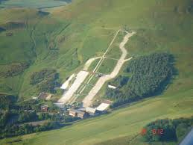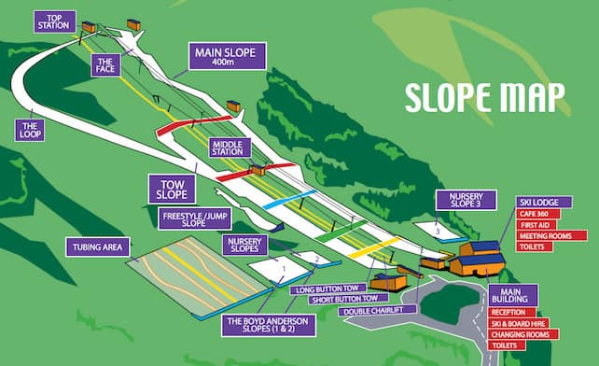

Figure 1- Site map of Hillend in its current condition (DSUK,2006)

Figure 2- Ariel view of Hillend ski centre in its current condition (Sharp, M., 2019)

A proposal for development was put forward in 2018 to redesign the site, with plans put forward by Mid Lothian Council set to see £13.8 million pounds of capital investment earmarked for the development and future of the centre. The plan, which is in line with the local development plans, sets out a vision of a centre for the future of Scottish snow sports. The development of the centre will see the three ski runs updated along with the nursery slopes; furthermore, the site will see the installation of the UK’s highest zip line, Alpine coasters, hotels, and glamping sites, with retail and food courts brought to the site. 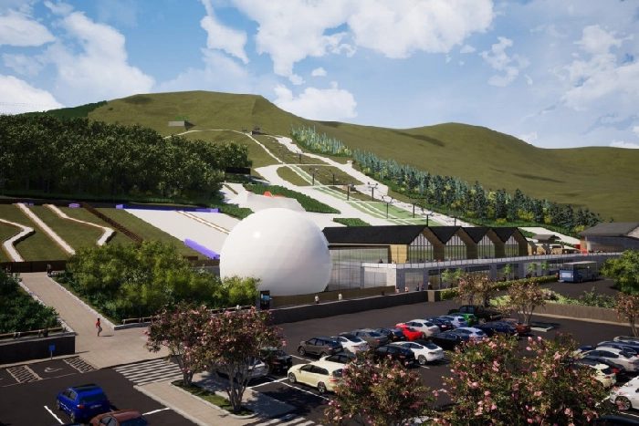

Figure 3- artistic impression of Destination Hillend, Ariel view (Malone,M, 2019.)

Destination Hillend should secure the future of the site and ensure its financial security in the coming years. Not only will the project bring economic stimuli to Midlothian, it is estimated that 30 full time jobs will be created on site and 50 third-party sector jobs in food vendors, cafes and shops. While the proposal may have many positive benefits for the council, residents and avid skiers, the possible environmental impact that the project may have must be investigated and mitigated where possible. 

Figure 4- Artistic impression of the welcome centre at Destination Hillend (Malone,M, 2019.)

The production of an Environmental Impact Assessment (EIA) report was undertaken by Sweco on behalf of Midlothian Council for Destination Hillend. Sweco has produced an EIA for the project which meets the requirements for a Schedule two development under *Tourism – ski-runs, ski-lifts and cable cars and associated developments: (i) the area of the works exceeds 1 hectare”* Doherty, D. (2019).

Sweco published their full EIA in December 2019 on the behalf of their client Midlothian Council. The document covers many areas in which the development of Destination Hillend may have an impact on the surrounding environment, the goal is to assess the scope of impacts and mitigate for these by harmonising the development and natural environment. The Destination Hillend EIA covers many different possible impacts such as environmental, social, and economic factors. Each chapter has been produced by a relevant professional in the area’s discipline. In the next section this paper will evaluate Sweco’s EIA chapter on noise and vibration, hereby referred to as Chapter 4 of the report.

# Critical Evaluation of Chapter Four – Noise and Vibration

Noise pollution can have detrimental health effects for both human and animals; these can range from disrupted sleep patterns and hypertension, to heart disease and tinnitus in humans who are exposed to elevated noise levels. Animals can be affected in a similar manner to humans but may also suffer from detrimental effects on prey/hunter relationships and can lead to habitats being abandoned due to changes in species niches. These are just a few of the reasons that noise pollution is taken into consideration in any EIA, throughout the whole project timeline, from the construction phase through to the operational phase.

The evaluation of Chapter 4 will be undertaken below, and for ease of reading each subsection will be addressed separately. Chapter 4 in its entirety and the relevant technical appendix were both used for the critique. Doherty, D. (2019).

Introduction, Competency, Policy and Guidance – Chapter 4.1, 4.2 & 4.3

This section introduces the need for a report in lines with the previously produced EIA Scoping Report and states that the chapter’s purpose is to consider the possible effects of the development during both construction and operation.

Chapter 4 was produced by Dan Doherty, a principal consultant at Sweco, and section 4.2 states that he is a member of the Institute of Acoustics and has over thirteen years of working knowledge. This section lists the author’s previous projects/experience and provides the reader with knowledge that Mr Doherty has a wealth of experience in Environmental Impact Reports and their execution. It should also be noted that a glossary of acoustic terms has been provided for the reader, enabling access to all with regard to the report.

The remainder of this section covers the legal requirements that the project must meet, along with sections on areas such as national guidance and the local development plan for Midlothian Council. The section is methodical in its approach and lists each policy along with a small blurb as to why the proposal is accountable of each policy/guidance etc.

The acknowledgment that the lack of a recognised methodology for the noise assessment of new attractions such as the project proposes is noted and two different guidance documents sited in section 4.3.9 have been used to develop a new assessment method for the report. This can be seen as commendable working conduct as it goes beyond legal requirements but has not been externally verified.

Methodology – 4.4

Section 4.4 is an overview of the reports remit with regard to the scoping report and the opinions given in different sections such as statutory/non statutory consultees. The Chapter has been divided into different stages of the development, a timeline approach that means impacts can be identified, mitigated and stated at each point. The full timeline is given in section 4.4.3 and allows the reader to understand the remit of each phase from 1a Earthwork through to Phase 3a Demolition. This approach allows for better understanding of the impacts and exactly the range of time they will be present. Doherty, D. (2019).

An example given by Mr Doherty is that of construction traffic – the operational hours of which will be daytime only unless prior consent is granted. It should be noted, however, no time window e.g. 10.00-17.00 is given in the report along with a possible plan that consent out with daytime hours may be given.

It is also stated in section 4.4.4 that in the initial phase of construction, noise pollution from construction traffic is not being taken into consideration due to the pre existing traffic volumes. The provision of some background information to the reader may have been advantageous at this stage, as understanding that the site sits close to Edinburgh city bypass may provide the reader with a better understanding of why construction noise has been designated negligible in this section of the timeline. Doherty, D. (2019).

Several surveys were undertaken on the site to asses the noise impact on local residents – the areas these covered were Swanston village, the proposed site of an approved housing development and the site’s closest current residents. The surveys appear to have been undertaken in a logical and scientific approach, the main finding is that during daytime hours ‘’ambient noise levels were predominantly affected by road traffic noise ‘’

The findings of this chapter seem to state all the logical sources of noise pollution that may affect the site, and the main outcomes of the scoping opinion, using noise and vibration limits in accordance with national guidance. The reach of this chapter is rather impressive in its scope and research undertaken, along with the architectural recommendations to envelope sound within operational buildings, however, due to increased volume of guests, consideration of the noise for anti-social behaviour could have been considered. Dry slope championships are held at Hillend each year and attract large numbers of students from across the UK; each year users complain of illegal sound systems being bought on to the slopes and causing disruption to other users. If not contained in the report, perhaps this could be considered in the operating plan to mitigate this source. Doherty, D. (2019).

Baseline – 4.5

Sweco undertook a noise survey to determine the baseline of prevailing noise at the site and surrounding areas – this chapter details the methods used and the results of surveying the site. This section is clear in its approach and delivery.

Design – 4.6

Section 4.6 states to the reader that no design changes are proposed from the findings in Chapter 4. This section will contain a construction EIA provided by the contractor in the final document.

Significant effects – 4.7

The main finding of 4.7 are that of noise pollution during all stages of the development and including the operational phase. These are cited as permanent effects primarily brought on by the increase in road traffic around the development. These effects will most likely be shouldered by local residents, workers and users of the site, with a risk of adverse health effects, loss of amenity and annoyance.

The table 4.6 provided in this chapter provides an assessment of the predicted noise levels at three residential areas close to the site during construction; all three sites where found to have insignificant effects on the noise receptors surveyed.

Table 4.10 is a calculation of the road traffic noise that will result from different aspects of the development. The only significant effect is that of the Hillend development access road, which is an integral part of the project. This is due to the current condition of the access road in terms of surface, width and design any development would require the access road to change in some manner. Doherty, D. (2019).

Mitigation and Enhancement – 4.8

Mr Doherty’s findings for noise and vibration are that of minimal significance and would have little impact on the project’s outcome. This is a fair statement when all evidence is considered.

Combined and Cumulative Effects – 4.9

No significant effects or findings.

Summary – 4.10

No mitigation measures are proposed from the chapter’s research and findings; the only point raised is that that of temporary residential accommodation but has been deemed suitable in this instance.

Conclusion on Chapter 4

Chapter 4 in review is an in-depth piece of research into many possible factors in the field of noise and vibration at the proposed Destination Hillend. The fact that many different receptors have been taken into account and that three separate residential site were surveyed shows a level of commitment to those living within the development’s possible impact zone. However, it should be stated that a lack of any research, data or information is provided on how noise levels may adversely affect animals and their ability to hunt. For example, animals due to noise may not be as alert in situations of predation or death by vehicle.

The processes that have been used in the chapter seem within government recommendations and where no standard process has been agreed, the chapter has set out clear reasoning as to how and why they have taken approaches to certain issues and sections within the chapter. Consistency throughout allows easy of comprehension for the reader along with the provision of an acoustic glossary. In conclusion it is a well thought out investigation with clear methods, reasoning and presentation of results.

# Environmental impacts assessments and environmental sustainability

The production of an environmental impact assessment takes into consideration a wide remit in the scoping process, this aims to cover all areas in which environments could be effected during the process of construction and operation process.

However, as demand for housing with in the United kingdom is on the rise, the process of assessing the potential impacts must be given great importance to insure the protection of habitats, ecosystems and wild life corridors. All of the afore mentioned which are essential parts of managing green spaces for our current needs but ensuring that environments are managed for future generations.

The EIA process aims to scope and identify the possible areas that developments will effect the natural environment and then produce a plan to mitigate the impacts that have been found. Below are the main issues that in regards to the environment a well-produced EIA will cover. All of which are interconnected, each area may affect another if not correctly investigated and understood. All decisions that are taken in regards to the findings should consider all the environmental impacts and be mitigated for at all stages of planning , construction and operation.

* Air Quality
* Noise and Vibration
* Socio-economics
* Ecology and biodiversity
* Landscape and Visual Impact
* Built Heritage and archaeology
* Hydrology, water quality and flood risk
* Ground conditions
* Transport and Access
* Climate Change, sustainability and carbon balance
* Materials and Waste

The legal requirement for both the production of an EIA depending on the project type is fundamental in creating infostructure projects that are not only beneficial for society’s, economic growth and future generations but the protection of valuable greenspaces. The process should ensure that natural systems and resources are not put under stresses that could have wide reaching environmental damage. The process is designed to produce a document that can help developers better understand projects cause and affecters, however development in the UK is big business and economic growth will in most cases be but ahead of environmental sustainability.

In future better legal requirements may be beneficial to protect sustainable environments, this could be used in conjunction with environmental impact reports to revolutionize the construction, planning and implementation of future planning projects. But I should be stated that rapid climate change that has been noted in the past decade may bring with it changes and challenges such as flooding, soil structure, changing temperatures and rain fall patters may all require a new approach in planning. These issues have previously been ignored, resulting in mass developments on flood plains and the creation of settlements that in decades to come will not be sustainable .

EIA is an important tool to systematically identify impact, however better legal protection for the natural environment would be beneficial to insure environmental sustainability in rural and urban planning.

Due to the location of the site few local residents will be affected by noise on site. However

# References

Doherty, D. (2019). *19/01018/PPP | Application for planning permission in principle for redevelopment of existing snowsports centre to include additional leisure facilities, tourist accommodation, hotel, function suite, ancillary retail and restaurant, formation of access road and car parking (this application is accompanied by an environmental impact assessment report submitted under the terms of the Town and Country Planning (Environmental Impact Asssessment)(Scotland) Regulations 2017 | Midlothian Snow Sports Centre Biggar Road Edinburgh EH10 7DU*. [online] planning-applications.midlothian.gov.uk. Available at: https://planning-applications.midlothian.gov.uk/OnlinePlanning/applicationDetails.do?activeTab=documents&keyVal=Q2AIJJKVKPP00 [Accessed 5 Mar. 2020].

DSUK, 2006. DSUK Edinburgh. *DSUK Edinburgh*. Available at: https://www.disabilitysnowsport.org.uk/adaptive-lessons/dsuk-edinburgh [Accessed March 5, 2020].

Malone,M, 2019. Have your say on Hillend proposals. *People*. Available at: https://www.midlothianadvertiser.co.uk/news/people/have-your-say-on-hillend-proposals-1-4860394 [Accessed March 6, 2020].

Midlothian Council, 2019. Funding injection for Destination Hillend. *Midlothian Council*. Available at: https://www.midlothian.gov.uk/news/article/2720/funding_injection_for_destination_hillend [Accessed March 3, 2020].

Sharp, M., 2019. Planning application submitted for huge £13.8m Hillend Destination including 'UK's highest zipline' and Alpine coaster. *Edinburgh News*. Available at: https://www.edinburghnews.scotsman.com/news/politics/council/planning-application-submitted-huge-ps138m-hillend-destination-including-uks-highest-zipline-and-alpine-coaster-1342123 [Accessed March 4, 2020].

‌