Loren Mowbary

s30020753

Word count- 2,515

Destination Hillend

Introduction

Hillend Ski Centre is located within Hillend Country Park the southside of Edinburgh, in the Pentland Hills Regional park, this ski centre has been open to the public for 50 years and is run by the Mid-Lothian council. The centre currently consists two longer ski slopes, one of which is the largest dry ski slope in the UK, this is accessed by a long tow and chair lift long up the side of the Pentland hills. It also has another three smaller ski slopes, and a single jump slope. This facility is had floodlighting so is able to be open and used all year round to the public. As well as the current slopes, they have a 360-degree café and main reception which offers equipment hire. As this ski centre has been open since 1965, the centre is in need of refurbishment for it to be able to be place of enjoyment for the public. This has resulted in a development being proposed called Destination Hillend (Midlothian Council, 2019). This proposal is being presented by Mid-Lothian Council, a £13.8 million investment into the centre which consists of, infrastructure upgrades, a new reception building for the snow centre, a food court and function space, retail space, hotel development, glamping tourist accommodation, a zipline, an activity dome, an alpine coaster and a free style jump slope (Lucy Aspden, 2020). This is needed for this development to continue to be popular with the public as current usage of the site is starting to decline in popularity. Along with the decline of the ski centre, as in recent years the jump slope has been closed to the public. This new proposal will bring new attraction to the site as it offers an upgrade of the currently facilities as well as much wider range of new services and activities to the public.

This report will be evaluating one of the environmental aspects looked at through the environmental statement of the planning document for Destination Hillends environmental impact assessment. Specifically, for this report chapter 9 which is the Landscape and Visual impacts assessment will be looked at and studied. the environmental impact assessment has been carried out by a Swedish company called Sweco. This assessment considers the potential landscape and visual effects the development of Destination Hillend will have on the landscape and views from the surrounding areas. This includes the on-site effects and from the development’s surroundings from further away. As well as establishing how this development will impact the residual effects which will be predicted. Taking into account that the current developments that are already in place have set the height limitation for the developments, meaning no new development can be over that height. This process is carried out firstly by establishing what policies are relevant to this project, on a national, regional and local scale. On a national scale two polices where applied to this development being, The Scottish Government (2014) Third National Planning Framework (NPF3) and The Scottish Government (2014) Scottish Planning Policy (SPP). The regional planning documents reverent to this development include, Strategic Development Planning Authority for Edinburgh and South East Scotland (2013) Strategic Development Plan. The local planning document is Midlothian Council (2017) The Midlothian Local Development Plan.

Methodology

The Land and Visual Impact Assessment is carried out so landscape and visual effects caused by the development can be identified on both the landscapes environment and the effects on peoples visual of the development. In this section Identification of areas of the development that may result in significant effects on the landscape resources or on visual impacts are investigated. A description of the landscape and visual conditions which then identifies how people in specific locations may be affected visually affected. Identification of mitigation and enhancement measures appropriate to the development. The significance of the likely effects of the Development on the identified landscape and visual receptors, are assessed by a professional judgement.

Data collection

The field research for this report included field surveys which took place on 28th May and 9th October in 2019. This was recorded during periods of temperate weather from different location which consisted of public highways, footpaths and areas of public open space. On site data collection included confirming the desk review, collecting further information on the landscape character, elements, different views on site, local screening and also taking photos from the viewpoints mentioned.

Consultation on how the area will be affected visually was carried out over 10 viewpoints from around Edinburgh looking on to the development to see how it would be affected with this new development in place. These viewpoints where located ranging from 0.1km away from the development to 7km. this was carried out following The Landscape Institute and Institute of Environmental Management and Assessment (2013) Guidelines for Landscape and Visual Impact Assessment, Third Edition (GLVIA3) and the Scottish Natural Heritage and the Countryside Agency (2002) Landscape Character Assessment: Guidance for England and Scotland. it was carried out by using desk and field data collection, including using Ordnance Survey mapping and aerial photography, plans containing information relating to landscape designations and landscape related policies at the local and national level, conceptual Masterplan, and published landscape character information (Sweco, 2019). This was created using the Landscape Character Assessment which displays the land data on to maps to create maps from, using data from 2019.

Assessment of Landscape and Visual Effects is carried out by experienced professional judgement and it is based on the identifying how sensitive the baseline landscape and visual environment are. Along with taking into consideration the potential change that could occur which is based off of the findings of the field and desk research carried out. This is done using the scale of high, medium or low for both sections. The landscape section is carried out by assessing the magnitude of landscape change, professional judgement is used to determine this. Taking in to account, the level of change that takes place, the geographical extent of the landscape area that would be changed, along with whether the change to the landscape is likely to be reversible. The visual section related to how views will be affected by this development and on what scale is assessed by seeing how much the site will change visually, the extent of geological change that would be visible, the duration of the change and if it will be able to be reversible. Significance of effects is also taken into account, by these changes categorised as either ‘significant’ or ‘not significant’.

Assumptions and limitations

Due to the flexibility which is a requirement in this design parameters, it has meant that a worst-case scenario has been created, this is to cope with uncertainties as well as bring a reduction to later adaptations to the design of the development.

Landscape Character Review

A Landscape Character review of the relevant published landscape assessments was carried out in order to be able to identify has been carried out to identify appropriate landscape character areas and types that are within a 2km radius of the Site. This information was presented on maps showing the radius and facts such as site boundaries shows in figure 1.1, recreation paths surrounding the development shown in figure 1.2, land type on and surrounding the development shown on figures 1.3 and 1.4. This information was sourced from published information at national and also local levels, which has been supported by field observations. Information from the following sources has been reviewed as part of the scoping process.

Figure 1.1: Displays the site boundary and buffer zones, council boundary and further viewpoints (Sweco,2019)

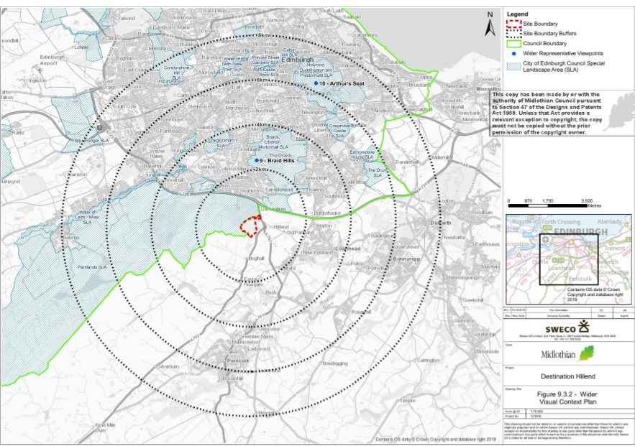

Figure 1.2: displays recreation paths surrounding the development (Sweco,2019).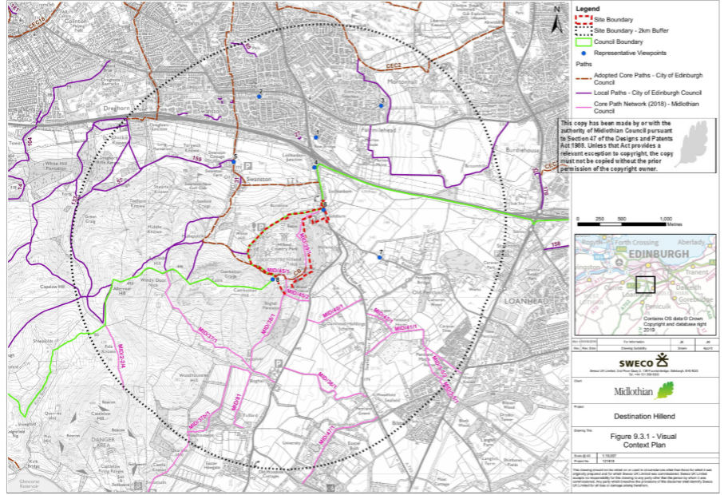Figure 1.3: Displays the different land coverage of the site and surrounding area(Sweco,2019). 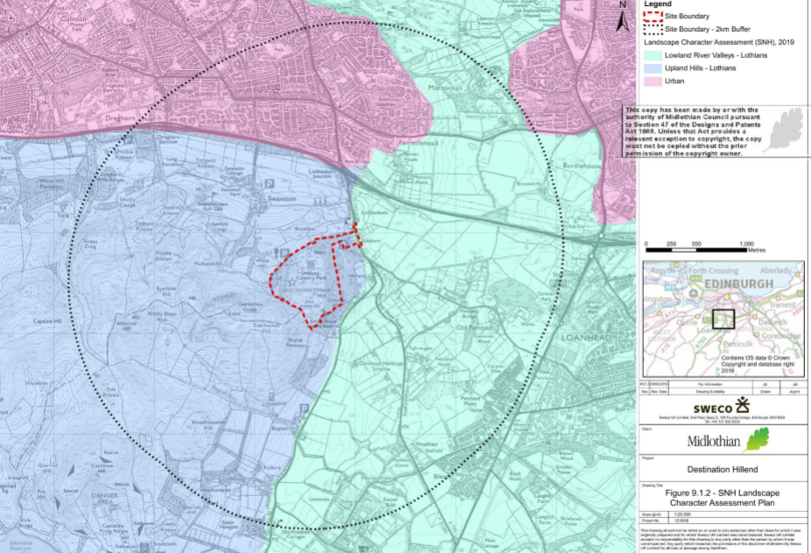Figure 1.4: Displays the different land coverage on and surrounding site(Sweco,2019).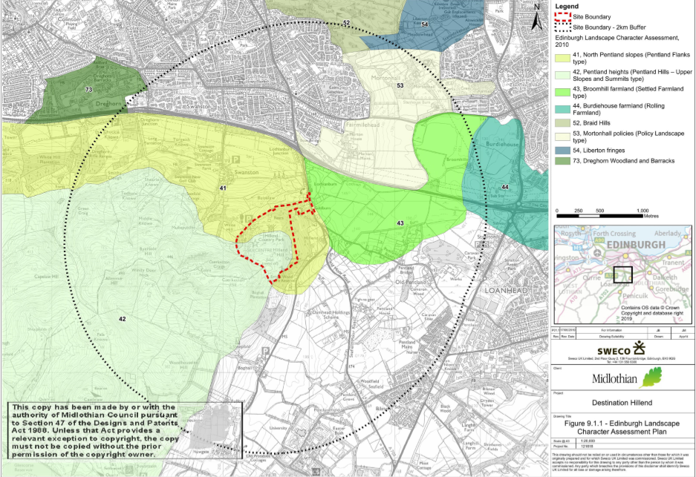

Visual Context and Receptors

For this part of the report the most visible parts of the Site are being focused on, which has found to be the southern and western extents as they are at the highest point of the development as well as having no screening cover from and are not screened by any woodland cover surrounding. The height, colour, area coverage and positioning of the developments are taken into consideration to how it may affect the surrounding views. The surroundings of the development are taken into consideration for least visual change possible to the existing development compared to the new one. This has been taken up with the surroundings of main roads, A720 which was found that road side vegetation screened the development from the roadside. As well as local residential areas such as along Biggar Road and Swanston. Other popular reactional routes which look out to the Pentland Hills where alos taken into account as viewpoints, such as Braid Hill and Arthurs Seat.

The first eight viewpoints are site located within the study area, whereas two viewpoints, 9 and 10 are located out with the main study area, which gives a view from much further away. The different viewpoints that have been chosen allow a wide range of different angles to be taken on this development.

Significant Effects

Construction of the development is taken into consideration regarding what effects it will bring to the site and surrounding area. This includes what machinery will be needed, where it will be used and kept as well as for how long. Including alternate routes will be created where needed though existing access routes will be used to get on site along with any temporary construction staying on site. As well as on site effects, if any vegetation will be lost in result for infrastructure.

Operational Landscape Effects

When carrying out the effects the focus has been on Edinburgh City Council landscape character areas, due to the sensitivity to change that the landscape has. This has been focused on to preserve any damage occurring to these areas. As well as assessing other surrounding existing features such as pylons being taken into account when assessing each area and the possible effects. Evaluating how visible the developments will be from different angles of the landscape, mainly referring to the larger structures such as the alpine coaster due to the high and shape of the structure on the landscape.

Operational Visual Effects

An assessment of visual effects experienced at the ten representative viewpoints has been recorded in depth at each of the ten points across the boundary area. For each viewpoint a field study was carried out with great explanation of the viewpoint and the visual effects caused by the development. Including the area, direction from the development, the type of land and use of the area to understand the full effects posed by this development could potentially have to the landscape from different locations. While grading the visual effect on a high, medium or low scale as well as on the significance scale, being a ‘significant’ or ‘no significant’.

A summary of the operating visual effects on the landscape is followed on from the viewpoint reviews, which a general conclusion is made in regards to the visual effect of this development to the landscape. With taking all data into consideration to result in if there is or is not a significant effect.

The process which Sweco has followed when carrying out the Environmental Impact Assessment on Destination Hillend has mentioned the correct and relevant legislation to the development. This shows that Sweco’s recommendations are reliable to be sustainable as they follow the correct and related guidelines which are relevant to the development. The site data and the field data collected from the surroundings of the site have been recorded in depth and explained well within the report. As well as with maps on the displaying the ranges of the viewpoints and buffers. The data used to produce these maps where from the Landscape Character Assessment (LCA) which was from 2019, showing the use of up to date and reliable data was used. Though improvements could be made by adding more map work into the landscape and visual assessment to display the development from different angles. This could be achieved by using Geographical Information Systems (GIS) which allows landscape data to be shown in 3D along with the developments created to real life scale. This could have been featured within the report in order to show what the development will look like from different angles and locations on the site and for different viewpoints. This data could have been download from national heritage Scotland and Ordinary survey mapping. On site data collected regarding the developments placement on the site have been acknowledged to keep the site having less effect as possible, such as the height limitation meaning developments cannot be built larger than any current infrastructure. Throughout the report legislation has been referred to biodiversity, in order to keep the natural environment of the landscape natural and undisturbed as possible, including keeping off woodland on site. This has been a sustainable way to place the development as the less damaged or interruption caused it will keep the surrounding environments as normal as before. Helping maintain the surrounding habitats and vegetation cover.

Field data, such as the ten viewpoints located around the sites boundaries and without have been well varied in relation to the distance of the site, ranging from 0.1km to the furthest point being 7km away from the site and out with the boundary. As these always lie within different areas of land type such as residential areas like Swanston, from large infrastructure like the busy A720 and other recreation viewpoints such as Arthurs Seat gives a wide range of what visual effect it will have on the landscape and to the skyline of the Pentland Hills. This has helped to notify the angles of developments should be built at on the slope to avoid interruption of the city’s skyline. As this will keep the landscape looking natural and the development unnoticed as it can be. As well as the data being record at two different times of year, both in moderate weather conditions to allow the results to be trusted in order to see how the developments visual impact. The viewpoint data reassures that the new developments are not going to impact the visual on the landscape much more than the current development in place.

The EIA processes help to achieve sustainability as it helps reduce change in natural areas and the impact that the development will be having to either reduce or stop the impact pending from the development to the surrounding environment. This report acknowledges a wide range of factor to ensure the impacts of this development are minimised and have mitigation put in place to combat issues.

This development is presented by Midlothian Council as well as submitting this development to be accepted or denied to Midlothian Council, meaning is it an internal decision. This could be changed to allow another body to accept or decline the proposal as it could be a bias result for this development due to this internal decision. As an external body should be choosing if this development is to be accepted or not.

References

Gov.uk, (2020). *The Town and Country Planning (Environmental Impact Assessment) Regulations 2017*. [online] Available at: http://www.legislation.gov.uk/uksi/2017/571/contents/made [Accessed 8 Mar. 2020].

Lucy Aspden (2020). *Edinburgh dry ski slope multimillion-pound makeover to include "alpine rollercoaster"*. [online] The Telegraph. Available at: https://www.telegraph.co.uk/travel/ski/news/edinburgh-hillend-ski-slope-set-to-receive-multi-million-transfo/ [Accessed 8 Mar. 2020].

Midlothian Council. (2020). Snowsports Centre | Midlothian Council. [online] Midlothian.gov.uk. Available at: https://www.midlothian.gov.uk/info/200281/snowsports_centre [Accessed 8 Mar. 2020].

midlothian.gov.uk. (2020). 19/01018/PPP | Application for Planning | Midlothian Snow Sports Centre Biggar Road Edinburgh EH10 7DU. [online] Available at: https://planning-applications.midlothian.gov.uk/OnlinePlanning/applicationDetails.do?activeTab=documents&keyVal=Q2AIJJKVKPP00 [Accessed 8 Mar. 2020].

SNH (2019) Landscape Character Types [Online]. [May 2019]. Available from: <https://www.nature.scot/professional-advice/landscape/landscape-characterassessment/scottish-landscape-character-types-map-and-descriptions>, City of Edinburgh Council (2010) Edinburgh Landscape Character Assessment (LCA).

Sweco (2020). [online] Arcgis.com. Available at: https://www.arcgis.com/apps/Cascade/index.html?appid=4f9ef6eb9c43400d8cb5f72847f9f729 [Accessed 8 Mar. 2020].

Sweco.co.uk. (2020). The most approachable and committed partner with recognised expertise. [online] Available at: https://www.sweco.co.uk/about-us/ [Accessed 8 Mar. 2020].