Hannah Jenkins

MAtriculationL: S30024846  Word Count:2700

Destination Hillend – Rural planning and eIA

Contents

Introduction: 1

Critical Analysis: 3

Environmental sustainability of an EIA 7

References: 10

# Introduction:

Hillend, a snow sport centre located within Mid Lothian, situated adjacent to the Edinburgh City Bypass overlooking the city from the edge of the Pentlands. It is Britain’s largest artificial ski slope, hosting two main slopes, 3 nursery slopes and a jump slope (Midlothian Council, 2020).

Midlothian Council are proposing for a new £13.8 million project on expanding Hillend snow sports centre into an all year sports and leisure centre (Midlothian Council, 2020). The upgrades will look to include:

* Alpine coaster
* Zipline
* Infrastructure upgrades – additional car parking and upgrading of access road to two lanes
* New reception building for Snow sports Centre
* Food court and function space
* Associated retail space – open plan space for one or more tenants
* Glamping tourist accommodation in wigwams
* Activity dome with high ropes and soft play
* Freestyle jump slope upgrade and extension
* Hotel development opportunity

The council are aiming to keep the site open as the phased developments are brought to the site over time (Midlothian Council, 2020).

One of the main reasons for the Destination Hillend going ahead is that it links back to the tourism within the Midlothian Local Development Plan (LDP) that they are trying to promote the tourism rates within the city and boost the local economy. Jobs will be provided throughout the building to the development as well as creating posts when the development is complete for further staff (Midlothian Council, 2020).

Before proceeding with the development, a number of policies and legislations will need to be consulted with, before any progression of the development can go forward.

**Scottish Planning Policy (SPP):**

The Scottish Planning Policy (SPP) is a non- statutory government planning policy that is required by Scottish Ministers, and sets their priorities for the running of the national planning system for the land uses and the development within the country (The Scottish Government, 2014). The purpose of the SPP is that it provides consistency within the planning application policy and the procedures throughout Scotland, through being flexible and also taking into account for local circumstances (The Scottish Government, 2014).

**National Planning Framework (NPF):**

The National Planning Framework (NPF) runs alongside the Scottish Planning Policy, providing a statutory framework for the long term development within Scotland. The NPF development priorities are set by Scottish Government for the next 20 to 30 years (The Scottish Government, 2014). The NPF 3 is the most current and up to date framework in place, with plans to improve infrastructure investment, with aims to produce places that will support economic and sustainability through transport, energy, climate change, regeneration and the environment. These aims will aid the growth throughout Scotland, providing a vision of what Scotland would adapt and evolve over the next 20 to 30 years (The Scottish Government, 2014).

Local authorities should consider the NPF 3 when working with planning partners within the communities. The NPF 3 visions for Scotland that should be considered can be found below:

* A successful and sustainable place
* A low carbon footprint
* A natural and resilient place

**South East Scotland (SES) Strategic Plan:**

The strategic development planning authority for the areas of South East Scotland and Edinburgh is conformed into the SES plan, covering 6 regions including Midlothian, West Lothian, East Lothian, the City of Edinburgh, the Scottish Borders and the South part of Fife (SES plan, 2016). Strategic development plans are a statutory planning document which is required to be updated every five years, and is to cover a time period of twenty years. It links in with the Scottish Planning Policy and National Planning Framework, guided by the Scottish Government. The South East Scotland Strategic Plan is then utilised to inform and guide the Local Develop Plan (LDP) for the individual regions, tying into the Midlothian local development plan.

**Midlothian local development plan:**

The Midlothian local development plan takes the South East Scotland spatial development frameworks into account, along with the National Planning Framework 3 and the up to date Scottish Planning Policy. The SES plan have high expectations of development from the Midlothian region, aiding employment opportunities and improving public transport links within the area due to the ideal location being within close proximity of the capital. An improvement in the transport links have already been witnessed with the Borders Railway being opened in 2015.The Midlothian local development plan also works to achieve the goas set by the third National Planning Framework.

# Critical Analysis:

An environmental impact assessment was carried out for the proposal of Destination Hillend, and it looked at many different aspects of the proposal and possible issues. Main implications that were considered included noise and vibration from the site, air quality, flooding risks, impacts on cultural heritage present and the effects that could be felt by traffic and transport.

Visual impact and the landscape are important attributes to an area, contributing to general wellbeing and the quality of life for both humans and biodiversity (Environmentguide.org.nz, 2020). The landscape provides a sense of place and wellbeing, and can also bring cultural heritage along with a particular setting.

As Destination Hillend are proposing to expand on an already developed site of the current Hillend snow centre, there are multiple restrictions that will need to be taken into consideration.

The landscape and visual impact is a factor that the Environmental impact assessment completed by SWECO was considered. A number of legislations were used and consulted throughout the EIA, and the chapter of visual impact and landscape chapter. This including the Scottish Planning Policy and the third National Planning Framework at a national level. At regional level the Strategic Development Planning Authority for Edinburgh and South East Scotland (2013) Strategic Development Plan was consulted and the Midlothian Local Development Plan was used at a local level (Midlothian Council, 2019). Other policies that were utilised, due to links with the landscape included Policy ENV6, Special Landscape Areas (SLA), due to the site being located within the Pentland Hills which is classified as an SLA. Any proposed developments located on a SLA are required, and proposals are only permitted if there will be low impact levels on the landscape qualities present (Midlothian Council, 2019).

Policy ENV7, Landscape Character is also implemented within the visual impacts on the site, and it prevents developments being accepted if there was a chance of the landscape character being effected. Any development that would be to accepted would need to fit in with the character of the area, scale of the land and the design of the current proposals (Midlothian Council, 2019).

The third policy ENV11, Woodland, trees and hedges was also used, with the policy stating that the development would not go ahead if there was to be any loss or damage to the trees, woodlands or hedges that were of high nature conservation, high biodiversity, cultural/heritage value, proving as a shelter, place of recreation or any other high importance (Midlothian Council, 2019).

Baseline data collection for the landscape section of the EIA included ordinance survey mapping and ariel photography to gain information on the vegetation on the site at present, the location of the current development, but also to collect information and data from possible viewpoints of where the new development would be visible from around Edinburgh area. Landscape character information was used along with a conceptual masterplan, indicating any possible designs for potential future construction and developments (Midlothian Council, 2019).

Collecting baseline data allows to get an overall understanding of the site and try to highlight any potential limitations or problems for the development, so that when looking at the EIA, the developers may have more time to think of possible solutions around particular issues.

The assessment for the landscape for the most part, with exception of 2 viewpoints, 8 viewpoints for the development are within a 2km radius of the site boundary. The other two viewpoints outwit the 2km boundary included Arthurs Seat, 7 km away to the north, north east of the city. The reason as to why this was chosen as a viewpoint is that this is a popular recreational site, with views accessible across the whole city. The second site is located on the Braid Hills around 4km away from the site boundary. The site is located on a North and East facing slope, on the side of the Pentland hills, resulting in being sheltered resulting in a low viewshed from areas particularly from the South and West sides of the development. The north side of the slope is sat at 170 meters above ordinance datum (AOD), and the southern section sitting at 345 meters AOD. (Midlothian Council, 2019). A number of viewpoints were scoped to try and see where the development may be seen across the surrounding areas (Midlothian Council, 2019).

Midlothian council also state within the EIA for the visibility of the development that with the exception of two viewpoints, have ruled that all viewpoints over 2 km away from the site, would have limited site of the development.

This is a good way to gather a number of viewpoints and then see where the project would be seen from, however utilising tools such as ARC GIS, the mapping system would allow for a visual representation of who can and cannot see the proposal, and also when coming forward for public consultations, it makes it a lot easier for people to get a visual representation of where the site can be visible from, giving a little more perspective for the development.

An assessment on the landscape sensitivity was also undertaken classifying the land into categories such as high, medium, low and negligible. Resulting that of the land was negligible that the development would have little to no difference on the landscape, and would not change the characteristics of the landscape either (Midlothian Council, 2019). Professionals would then make the final decision and judgement on the total effect that the development would have on the landscape, with points being given for the effects they might have on the environment and the landscape. They are awarded by substantial, moderate, slight and negligible. By having an independent and professional judgement of the landscape and determining the value of the land and the potential risks the development poses to it, makes it harder for results to be bias, as if someone from the development company were to conduct those surveys within the company.

A range of legislations and advice from Scottish Natural Heritage (SNH) and the Midlothian council landscape character assessment (LCA) documents were used as part of the scoping process of where the site would be visible from. The site cover two LCA types, Pentland heights which covers the highest of the grounds at the most southern part of the site and then the slopes on the North end of the Pentlands. (Midlothian Council, 2019). As the site is located within one of the Pentland Hills LCAs this requires for the development to follow through with some of the rules that may need to be applied. The Pentlands is also classified as a Regional Park so any development would need to fall within any current legislations that the regional park may have.

The EIA also looks at the height of the current buildings on the site, and to help preserve the landscape, due to the proposals height on the slopes of the Pentland hills, that no knew buildings are to be developed higher in height than the ones present. The idea for the development was to cluster the buildings as to not have a significant impact on the landscape and the overall visual impacts of the development.

Overall, the assessment concluded that the development would not have significant long lasting impacts on the landscape or the visual effects due to the mitigations and design interventions being placed (Midlothian Council, 2019).

# Environmental sustainability of an EIA

EIA is a statutory process being controlled and supervised by both the European and UK law (Iema.net, 2020). Environmental impact assessments acts as the tool in between developments, the environment and the local communities, allowing developments and projects to go ahead and not have exceeding amounts of damage to the environment (Iema.net, 2011). The assessment also highlights any potential dangers to the environment in which the development may pose, taking air and soil, water, conservation of biodiversity and the visual impacts and effects on the landscape, therefore having the authority to prevent or alter developments from damaging the environment by creating mitigation solutions (Iema.net, 2011). According to (Iema.net, 2011), the EIA is then considered as one of the more critical documents required within the decision making of the proposals of developments, and it can be used alongside the EIA Directive (85/337/EEC), allowing for environmental issues to be considered within large developments are being proposed.

There are several processes to an Environmental Impact Assessment, with the process being displayed below in table 1.

Table 1: EIA processes of screening and scoping (Iema.net, 2011),

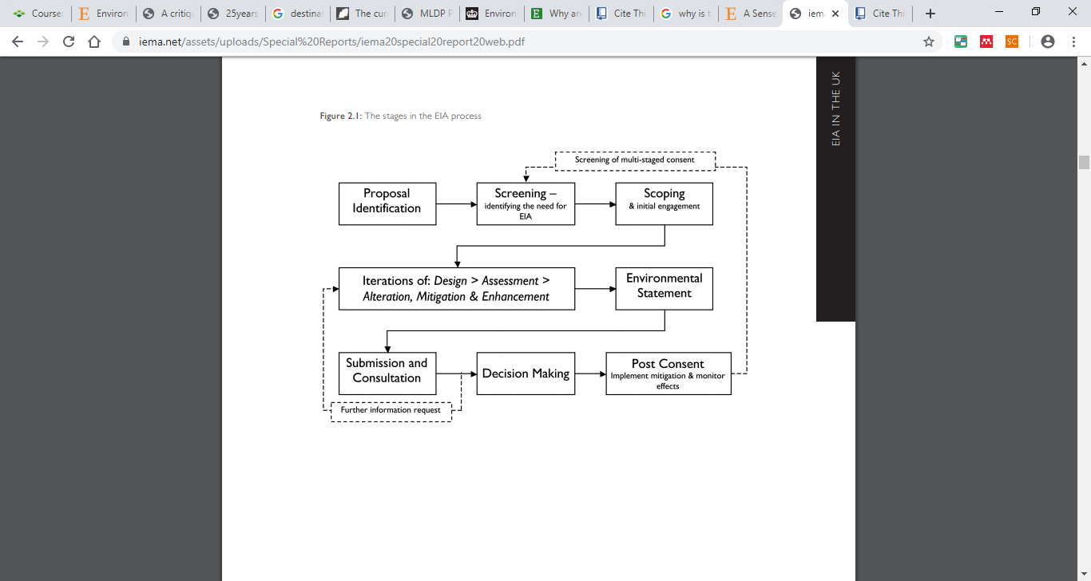

Utilising table 1, it allows for an efficient and accurate process in which the best way to run an Environmental Impact Assessment, if an Environmental Impact Assessment is appropriate for the potential type of development looking to be proposed.

The two main sections within the EIA is if there the screening and the scoping. The screening identifies if there is a need for an EIA to be done for the proposed project. Scoping is then completed to identify any issues that may arise throughout the course of the development, and eliminating those that may not pose as much of a problem (Iisd.org, 2020). The scoping within the environmental impact assessment includes engaging with the public and review the site and possible issues. Important issues within the EIA will be highlighted and considered as well as concluding the timescale and boundaries of the EIA (Iisd.org, 2020).

Mitigation and prediction strategies would then be completed for the potential issues within the development. Strategies should encompass the prediction methods, how to interpret the predictions with the mitigation strategies and without as well as looking at the assessment of comparisons.

Management and monitoring of the site is then able to be commenced with and then the auditing of the assessment can progress forwards. The audit is completed by a board of specialists and will look to analyse the technical aspects of the assessment along with the decision making sections of the EIA. An Environmental Statement is then able to create. Public consultations should also be held with the members of the public to ensure the opportunity is there for inclusion and a time to express opinions should they wish to take part. A decision should then be reached on if the development should go ahead or not and if so with as little disruption to the environment.

Within an EIA, a number of things should be looked at for a proposed project. Destination Hillend looked at a range of aspects that could have brought issues to the site, local community and the environment. Noise and vibrations, flooding risks, air quality, landscape and visuals on the land, traffic and transport as well as cultural heritage. The project for the expansion of Hillend will consider all of the above within the EIA, as these are possible factors that could be effected by the expansion of the project. In general the EIA, is a statutory piece of legislation, and if completed correctly, and developers seek help out from different organisations then the environmental impact assessments would be sustainable for the environment. The EIA would also fall under the SPP, NPF and certain LDP, therefore being able to collect information from the legislations for particular developments. As can be seen from the Destination Hillend development, the EIA that was completed looked at a range of potential issues, and mitigation solutions for the site, and went in to details. Help and advice was sought from a number of external bodies on biodiversity, historical monuments, and other potential conflicts. The correct steps were also followed from table 1 above. As these steps were followed within detail, nothing rushed and the community were involved with the proposal so far, this also proves to show that the EIA is working, with concerns for the environment being regarded as important and vital.

# References:

The Scottish Government. (2014). *National Planning Framework 3 - gov.scot*. [online] Available at: https://www.gov.scot/publications/national-planning-framework-3/ [Accessed 3 Mar. 2020].

SES plan (2016). *The Strategic development planning authority for Edinburgh and South East Scotland*. [online] Available at: https://www.sesplan.gov.uk/assets/publications/SDP2/Proposed%20Strategic%20Development%20Plan.pdf [Accessed 3 Mar. 2020].

Environmentguide.org.nz. (2020). *Why are landscapes and features important? • Environment Guide*. [online] Available at: http://www.environmentguide.org.nz/issues/landscape/why-are-landscapes-and-features-important/ [Accessed 8 Mar. 2020].

Anon, (2019). *Environmental Impact Assessment Report - Chapter 9*. [online] Available at: https://planning-applications.midlothian.gov.uk/OnlinePlanning/files/356E86E291A4B249B72E2F05A97DFA92/pdf/19_01018_PPP-D_-_EIAR_9_CHAPTER_-_LANDSCAPE_AND_VISUAL-488168.pdf [Accessed 8 Mar. 2020].

Iisd.org. (2020). *Step 2: Scoping – EIA Online Learning Platform*. [online] Available at: https://www.iisd.org/learning/eia/eia-7-steps/step-2-scoping/ [Accessed 8 Mar. 2020].

Iema.net. (2011). *THE STATE OF ENVIRONMENTAL IMPACT ASSESSMENT PRACTICE IN THE UK*. [online] Available at: https://www.iema.net/assets/uploads/Special%20Reports/iema20special20report20web.pdf [Accessed 8 Mar. 2020].

Council, M. (2020). *About the Snowsports Centre | Midlothian Council*. [online] Midlothian.gov.uk. Available at: https://www.midlothian.gov.uk/info/200281/snowsports_centre/181/about_the_snowsports_centre [Accessed 8 Mar. 2020].

Iema.net. (2020). *Environmental Impact Assessment*. [online] Available at: https://www.iema.net/assets/uploads/EIA%20Articles/EIA%20Presentation%202016%20Savills.pdf [Accessed 8 Mar. 2020].