

Rural Planning and EIA

Destination Hillend

Alessandra Harper

RBM3 s30007608

Table of Contents

Introduction 4

Competency 4

Policy and Guidance 4

Impact Assessment Methods 5

Consultation 5

Assumptions and Limitations 6

Baseline 6

Flood risk 6

Surface Water Flood Risk 6

Additional sources of flood risk 7

Water Quality 7

Mitigation and Enhancement Measures 8

Construction 8

Summary of Residual Effects 9

Discussion 9

Bibliography 11

The ‘Midlothian Local Development Plan 2017’ supports the proposals which will support the Snowsport Centre and to help secure its future-long term success. The Midlothian LDP (Local Development Plan) was approved by the Council on the 7th November 2017. It forms part of the Development Plan for Midlothian along with the Strategic Development Plan (SDP) for Edinburgh and South-East Scotland. It provides the development strategy and policy framework for the next 10 years and is the basis for determining planning applications in Midlothian. (Planning, 2017)



https://www.telegraph.co.uk/travel/ski/n 1

The development proposals are yet to be defined however, the key parameters are highly considered to determine an appropriate scope and assessment for the Environmental Impact Assessment (EIA).

The current proposals incorporate the reinvestment of £13.8 million of capital funding into the development of Midlothian Snowsport Centre into an all-year-round, multi activity leisure facility by the Midlothian Council in May 2019.

As well as the redevelopment to include:

* Leisure facilities- both internal and external;
* Buildings including reception, food courts, function space and retail space;
* Glamping accommodation;
* Hotel;
* Additional car parking;
* Improved access road. (SWECO, 2019) (SWECO, 2019)

Midlothian Snowsport centre located at Hillend Country Park, situated on the edge of the Pentland Hills Regional Park, near Hillend to the South of Edinburgh, is the UK’s longest artificial ski slope. The existing facilities specified are:

* Main reception building
* 2 main slopes
* 3 nursing slopes
* Tubing runs
* Chairlift accessing the Pentland hills
* 360 café

The Snowsport centre has a history and reputation amongst visiting schools for educational and recreational uses as well as high demand from the general public as well as tourism. The Midlothian Council are proposing to invest and renew the centre by achieving the following:

* ‘create all year round, all-weather, inclusive and family orientated attracttions (for local, national and international visitors);
* Safe guard the future educational facility of the Site; and
* Create economic and employment opperunities for Midlothian and generate income to be reinvested into Council service. (SWECO, 2019)

# Introduction

Destination Hillend, Environmental Impact Assessment Report (EIAR) 2019, Flood Risk and Water Quality.

This chapter describes the baseline Flood Risk and Water Quality within the Development area of Midlothian Snowsport Centre. The chapter also evaluates potential effects that the development could have on the flood risk and water quality. To avoid and reduce significant effects on the environment, mitigation measures are recommended on identified and possible effects in close proximity to the development area.

# Competency

James Franklin is a Chartered Member of the Chartered Institute of Water and Environmental Management (MCIWEM) and has experience of 5 years with flood risk and hydrology assessments.

John Preston has 10 year’s experience for flood risk and hydrology assessments and is also a Chartered Geomorphological with the Royal Geographical study

# Policy and Guidance

The following legislation, policy and guidance was used in this report (James Franklin, 2019):

***Flood Risk Management (Scotland) Act 2009 (FRMS Act****)* which is a statutory framework in Scotland that delivers a sustainable and risk based approach to manage flooding. Scottish Ministers, SEPA, local authorities, Scottish Water all have a duty to manage and reduce flood risk and to promote sustainable flood risk management.

***Scottish Planning Policy (SPP)***

SPP requires planning authorities to include all sources of flooding; their associated risks when preparing development plans and review planning applications. Climate change also needs to be considered. To prevent development if the development has a significant impact with the effect of flooding or to increase flooding elsewhere. As the development will increase the area of impermeable surfaces compared to existing conditions, and the borders the Lothian Burn, flood risk must be assessed to control the impact from the Development.

***Surface Water Management and Flood Risk Guidance (The City of Edinburgh Council, April 2017)***

The document sets out the requirements for Developers when considering surface water flood risk consequences of any new Development within the City of Edinburgh. Guidance delivers a range of mitigation options to avoid an increase in surface water flood risk and includes a suggested assessment of surface water.

***The Water Environment (Controlled Activities) (Scotland) Regulations 2011 (as amended)***

Due to no modifications to watercourses are included in the Development plan, legislation related to the (CAR) is not to be considered. A Controlled Activities Regulations (CAR) licence will be required to protect the Lothian Burn from the construction site runoff and pollution. SEPA will confirm consent at the appropriate time.

The following technical guidance and resources were utilised for the assessment (James Franklin, 2019):

* Design Manual for Roads and Bridges (DMRB) Volume 11, Section3, Part 10 (HD45/09): Road Drainage and Water Environment[1];
* Scottish Planning Policy (SPP);
* The SUDS Manual C753;
* SEPA’s Regulatory Method for SuDS; and
* SEPA’s Technical Flood Risk Guidance for Stakeholders v12

# Impact Assessment Methods

Potential Impacts of the Development on water quality during the construction phase, the water quality assessment considered the possible effects (SWECO, 2019):

* Increase in slit-laden runoff and suspended sediment released into the Lothian Burn and unnamed drain as a result if earthworks and other construction activities;
* Accidental spillage of oils, fuels, chemicals and other hazardous substances into the Lothian Burn and unnamed drain;
* Risk of unidentified contaminated soils/sediment being disturbed and entering the watercourses; and
* The estimated size of the receiving watercourses to dilute pollutants and dispense sediment. (SWECO, 2019)

Careful consideration has been taken into account regarding the construction phase of the Development as this is the most polluting and contaminating process as the resources used such as cement and bricks often leave debris, dust travel and rubble. Oil spills from heavy machinery can all find their way into a nearby water source via rain or runoff can heavily impact on the environment and water sources. By being aware of the possibilities, which can affect the environment during the construction phase is a conscious and responsible consideration to further avoid or reduce the effects on the water quality as well as environment.

# Consultation

SEPA (Scottish Environment Protection Agency) were consulted regarding fluvial flood risk to the site. Two areas of concern were raised regarding flood risk:

* The area adjacent to the proposed hotel could be impacted. Or impact upon, the fluvial floodplain of the Lothian Burn. (SWECO, 2019)

The report further added that SEPA’s Surface Water flood maps were referred to for fluvial flood risks. (SEPA, 2020).

Developers are to consult with SEPA to make sure that they are in compliance with regulations as this helps minimise risk to flood prevention and water quality. Consulting with SEPA in regards to fluvial flood risks to the Site is a good action to take as the developers are being conscious to potential threats and to double check the area for potential risks. By referring to the Surface Water flood maps also helps observe potential areas that can be flooded and help further understand the fragility of the Site to fluvial flooding making the developers aware.

# Assumptions and Limitations

According to the report, detailed design of the Development is yet to be completed (as set out in Chapter 2), (SWECO, 2019) and detailed topographic data of the Site and surrounding area is not available for the assessment. As a result, hydraulic modelling of surface water runoff patterns could not be taken.

This is disappointing and not good or beneficial for the Development of the Site as surface water runoff patterns needs to be assessed in order to avoid or reduce contamination to the quality of water as well as the environment. By not having a detailed design of the Development is poor as this should be a priority for developers in order to provide and show areas that could be of concern as well as nearby watercourses which aids the strategic development for Environmental Impact (EI).

# Baseline

## Flood risk

The majority of the Site falls within the Lothian Burn catchment, surface water from the Site currently drains to this watercourse (SWECO, 2019). The surface water flooding on the watercourse is interpreted as an indication that the channel may be ‘**medium to high risk’ of fluvial flooding** (SWECO, 2019).

According to the report, there has been no recorded flooding on the Lothian Burn. It is therefore considered to have **low sensitivity** to modification (SWECO, 2019).

This poses no potential risk as the Lothian Burn is not subject to flooding and by changing the natural integrity of the Burn won’t make a significant difference to the sensitivity of flooding as its been deemed “low sensitivity” to modifications.

## Surface Water Flood Risk

The report mentioned that SEPA’s surface water flood maps indicated that there is a low risk of surface water flooding within the majority of the Site. As the site is surrounded by permeable, vegetated slopes, the likelihood of surface water flooding causing any adverse impacts to the proposed site is unlikely. Overall, surface water flooding within the site boundary is considered to have **medium sensitivity** to modification (SWECO, 2019).

If there is no threat to surface water flood risk then this is a positive outlook on the development proposal as flooding on surface water poses as a detrimental risk.

## Additional sources of flood risk

The report states that the SEPA’s Reservoir Flood Map indicates that the Site is not at risk from nearby reservoirs (SWECO, 2019).

There is also no reported groundwater flooding.

## Water Quality

SEPA does not monitor the Lothian Burn. The Lothian Burn may receive irregular nutrient-rich runoff from the surrounding woodland and random source pollutants washed off the road surface, which could impact water quality. This is sometimes out with the control of developers and occurs naturally which is often not managed due to the events being at random and not causing much effect in the long run. The Lothian burn is considered to have a **low sensitivity** for water quality, (SWECO, 2019).

Baseline Summary

Table 1 summarises the overall sensitivity of for flood risk and water quality.

Table 1 Overview of sensitivity classification for flood risk and water quality

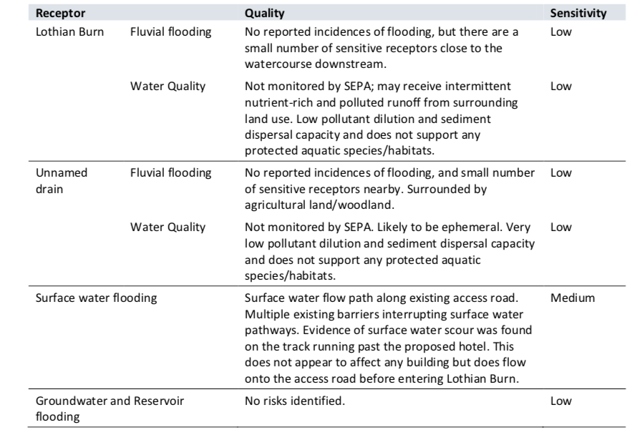

Source: Destination Hillend, EIRA

The majority of receptors in Table 1 show that their sensitivity to fluvial flooding and water quality is very low which imposes a reduced risk to the water quality and flood impacts caused by the Site and imposes no potential threat to the environment.

# Mitigation and Enhancement Measures

Table 2 lists the mitigation measures that could be used to minimise risk to the Lothian Burn, access roads and to address any water quality issues. Mitigation helps reduce the severity of an environmental impact, minimising risk to the environment.

Table 2 SuDS mitigating options

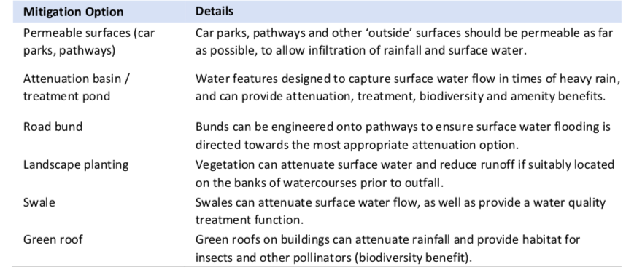

Source: Destination Hillend, EIRA

# Construction

A few examples of enhancement measures to reduce the Environmental Impact (EI)

1. The Contractor may be required to apply to SEPA for a Construction Site Licence under the CAR Regulations, which will include preparation of a Pollution Prevention Plan to describe how construction site runoff will be managed on site.
2. During site clearance works, the extent and duration of bare/exposed surfaces will be limited as much as possible, and restoration works undertaken as soon as possible following construction, to minimise risk of silt-laden runoff entering the Lothian Burn (FL02).
3. The contractor will be required to implement temporary SuDS to provide treatment and attenuation of runoff prior to discharge to the Lothian Burn (FL03).
4. Temporary drainage systems will alleviate localised flood risk and prevent obstruction of surface runoff pathways (FL05).
5. A Suitably Qualified Person (SQP) will undertake regular site inspections to ensure working methods and temporary mitigation measures are effectively protecting the downstream Lothian Burn (FL06). Silt barriers/netting and other temporary sediment control measures will be replaced when required to ensure optimum effectiveness (FL07). (SWECO, 2019)

By applying for a construction site licence under the CAR regulations, is a good way to prepare and educate the builders on the signs and management of site runoff and how to manage implications as soon as they are noticed and reported, which will immensely help the reduction of site run off into the Lothian Burn, minimising risks.

By limiting bare/exposed surfaces in order to minimise risk of silt-laden runoff entering the Lothian Burn is another way to reduce contamination of water quality as well as flood risk prevention. This is a good measure.

By implementing temporary SuDS (suitable drainage systems) on the Site is a good measure in the treatment of runoff as this will re-direct and collect all the runoff from the Site into a temporary drain which will minimise contamination of the Lothian Burn.

The use of temporary drainage systems will reduce flood risk and prevent blockages of surface runoff pathways, this is a great preventative measure.

By having a Suitable Qualified Person (SQF) to regularly inspect Site conditions is responsible as they will be able to monitor and implement better practices to the working methods and mitigation measures that are being carried out to the highest of standards which will protect the Lothian Burn. Slit barriers and netting are a great way to control sediment produced during the construction phase and will reduce sedimentation on water quality.

# Summary of Residual Effects

The report states that, “Following implantation of mitigation, no significant residual effects are predicted on flood risk or water quality of the Lothian Burn and surrounding areas”, (SWECO, 2019).

If the use of mitigation stated are designed and implanted then this would be an improvement upon the baseline surface water and fluvial flood risk and the water quality of the Lothian Burn.

# Discussion

Upon reading the full chapter (Chapter 5) on Flood Risk and Water Quality for the Environmental Impact Assessment Report for Destination Hillend, I have concluded that the Development of the Site will not have a significant impact on the water quality or pose a fluvial flood risk upon the environment. although the Lothian Burn has been identified as a water course that may receive a negative environmental impact, the report concludes that the risks are low and minimal unless the implication of mitigation measures are implemented.

The use of temporary drainage systems to divert runoff and residual contamination on the Site is a beneficial way to divert contaminants away from the Lothian Burn as well as surface water. Netting/ slit barriers are also preventative measures in ensuring no contamination to water quality as well as flood risk. I believe that the Development of Destination Hillend poses no immediate threat to the environment and that the appropriate developers have carefully researched the appropriate policy and guidance in order to ensure minimal risk to potential flooding and comprised water quality.

The only issue(s) of concern raised, is the absence of the Development Design which is disappointing as areas highlighting the natural environment were not represented to view and to further understand the ecological issues of concern in order to pin point areas that may be affected during construction or areas to be concerned of is impossible without a detailed picture or map of the design of the development.

Another issue was the absence of topographical data of the Site and surrounding area not being available in the assessment. This impacts on identifying runoff patterns around the area which can impede on the risk assessment as well as soil depth which is imperative in order to understand what areas are more sensitive and prone to flood fluvial risks as well as water sources.

Overall, the Environmental Impact Assessment’s process stated in Chapter 5 is sufficient in addressing environmental sustainability in respect to Flood Risk and Water Quality report and poses no real threat to the conservation of our environment.

# Bibliography

Diversity, C. o. B., 2010. *What is Impact Assessment?.* [Online]   
Available at: https://www.cbd.int/impact/whatis.shtml  
[Accessed 13 March 2020].

James Franklin, J. P., 2019. *Destination Hillend, Environmental Impact Assessment Report (EIAR) Flood Risk and Water Quality,* Midlothian: SWECO.

James Franklin, J. P., 2019. *Midlothian Council.* [Online]   
Available at: https://planning-applications.midlothian.gov.uk/OnlinePlanning/files/3E8EF2D7759E5044830550C26B9A10F9/pdf/19_01018_PPP-D_-_EIAR_5_CHAPTER_-_FLOOD_RISK-488157.pdf  
[Accessed 13 March 2020].

none, 2017. *Midlothian Council.* [Online]   
Available at: https://midlothian-consult.objective.co.uk/portal/midlothian_local_development_plan_2017?pointId=4791461  
[Accessed 13 March 2020].

Planning, M., 2017. *Midlothian Council.* [Online]   
Available at: https://midlothian-consult.objective.co.uk/portal/midlothian_local_development_plan_2017?pointId=4791461  
[Accessed 13 March 2020].

SEPA, 2020. *Advice for Developers.* [Online]   
Available at: https://www.sepa.org.uk/environment/land/planning/advice-for-developers/  
[Accessed 13 March 2020].

SWECO, 2019. *Destination Hillend.* [Online]   
Available at: https://www.arcgis.com/apps/Cascade/index.html?appid=4f9ef6eb9c43400d8cb5f72847f9f729  
[Accessed 13 March 2020].

SWECO, 2019. *Destination Hillend Environmental Impact Assessment Report (EIAR),* Midlothian: Midlothian Council.

1.