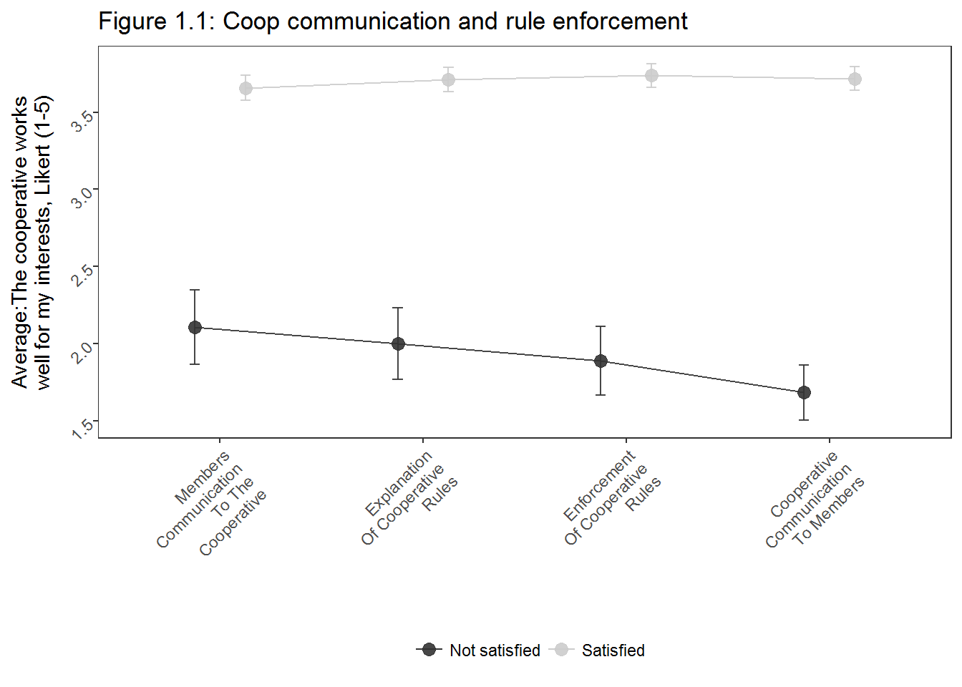

|  |  |  |  |
| --- | --- | --- | --- |
| Table 1.1: Logistic regression – The cooperative works well for my interests (dp) | | | |
|  | Equation 1 | Equation 2 | Equation 3 |
|  | *B* | *B* | *B* |
| (Intercept) | -2.05 *** | -3.65 *** | -3.18 ** |
| Explanation of cooperative rules | 1.56 ** | 1.36 ** | 1.38 ** |
| Enforcement of cooperative rules | 1.46 *** | 0.95 * | 0.80 ₮ |
| Cooperative communication to members |  | 1.69 *** | 1.59 ** |
| Members communication to cooperative |  | 1.11 ** | 1.22 *** |
| Gender (female is reference) |  |  | 0.13 |
| Age |  |  | -0.02 |
| Coop B |  |  | 1.00₮ |
| Coop C |  |  | -0.03 |
| Coop D |  |  | -0.16 |
| Coop E |  |  | 1.20 * |
| Observations | 250 | 250 | 250 |
| R2 / adj. R2 | .233 / .313 | .326 / .437 | .360 / .483 |
| ₮ p < .1, * p < .05, ** p <.01, *** p < .001 | | | |