**VHDL Exercise – Z0965020**

**Circuits and Coding**

**Ripple Adder**

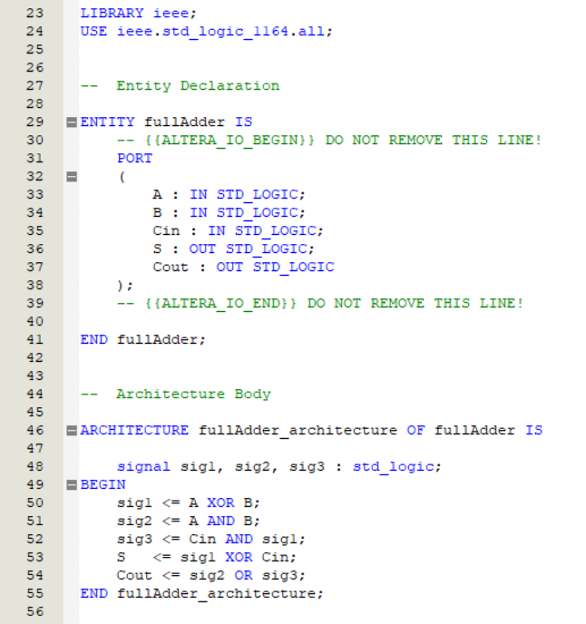

Figure 1

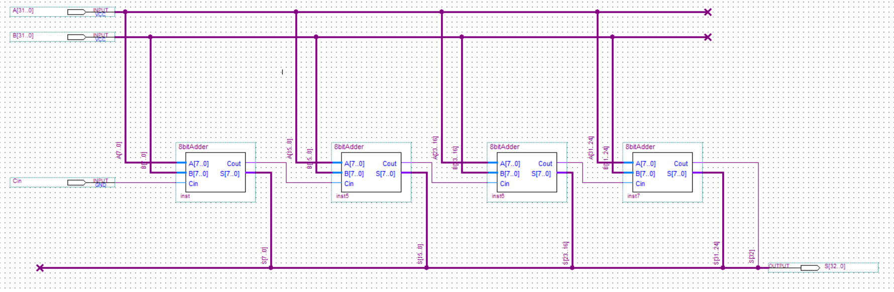

Figure 2

To create the 32-bit ripple adder (figure 2), I first created a full adder in VHDL (figure 1), created a symbol file for it, then created a 2 bit, 4 bit and 8bit adder (pictures omitted due to similarity to 32 bit adder). By creating these smaller adders first, I could keep the schematic diagrams small so that any errors in the diagram can be spotted easily.

**Carry Select Adder (CSA)**

The carry select adder makes use of the 8-bit ripple adder I had already created, but also required a 1-bit 2 input MUX and an 8-bit 2 input MUX, both of which I created in VHDL (figures 3 and 4)

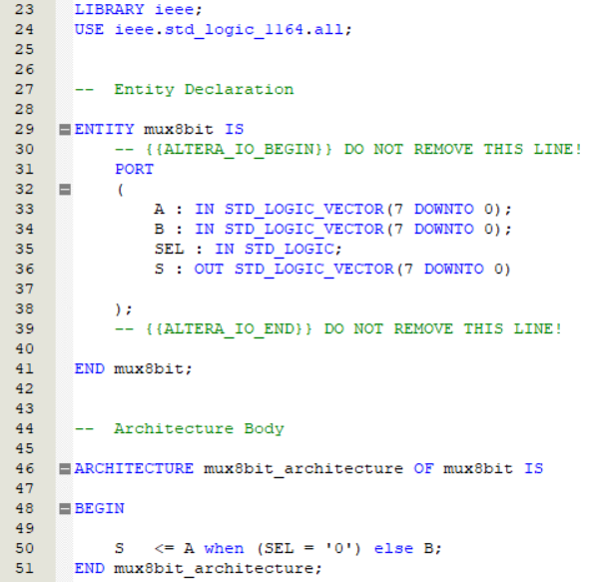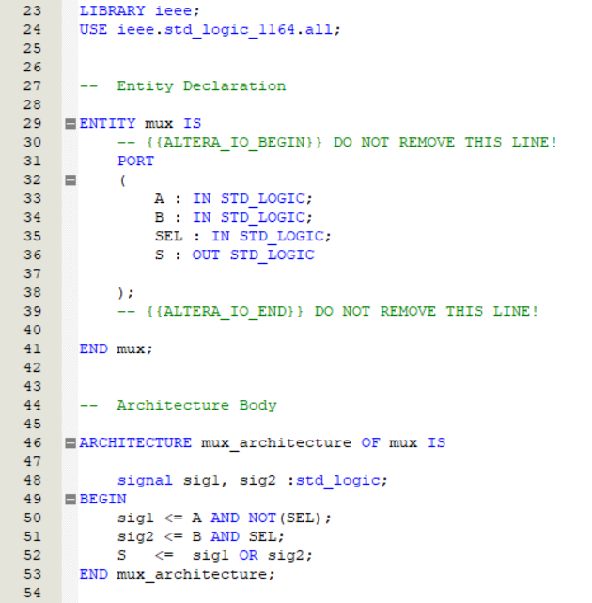

Figure 3

Figure 4

Once I had created the required Multiplexors, I could create the sub-circuits (figure 5) which were comprised of two 8-bit adders and one of each type of MUX

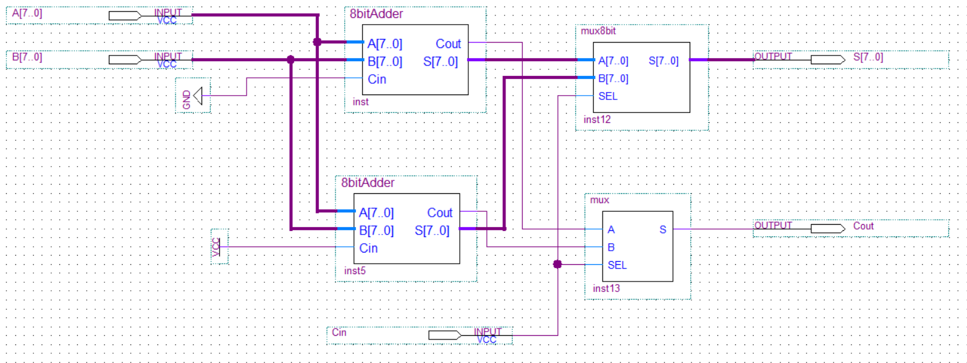

Figure 5

The 32-bit CSA could then be constructed by using one 8-bit ripple adder followed by 3 of these sub-circuits.

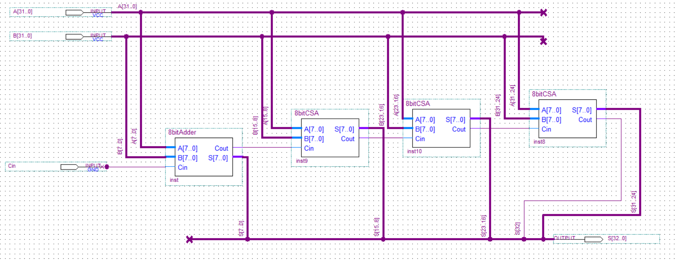

Figure 6

**Speed and Operation**

For each of the two adders I created a waveform which had the same changes in input values. I could not test the timings for all possible combinations of input values, so I chose the values of all bits set to 1 (all_1), the least significant bit set to 1, or all bits set to 0

|  |  |  |  |  |  |  |  |  |  |  |
| --- | --- | --- | --- | --- | --- | --- | --- | --- | --- | --- |
| Input Values | | |  | CSA |  |  |  | Ripple |  |  |
| A | B | Cin |  | input change | output change | delay (ns) |  | input change | output change | delay (ns) |
| 1 | 1 | 0 |  | 30 | 41.72 | 11.72 |  | 30 | 41.464 | 11.464 |
| 1 | 1 | 1 |  | 60 | 71.548 | 11.548 |  | 60 | 69.239 | 9.239 |
| all_1 | 1 | 0 |  | 90 | 126.024 | 36.024 |  | 90 | 147.158 | 57.158 |
| all_1 | 1 | 1 |  | 180 | 191.548 | 11.548 |  | 150 | 159.238 | 9.238 |
| all_1 | all_1 | 0 |  | 240 | 255.103 | 15.103 |  | 210 | 222.334 | 12.334 |
| all_1 | all_1 | 1 |  | 300 | 311.548 | 11.548 |  | 270 | 279.238 | 9.238 |
| 0 | 0 | 0 |  | 360 | 376.194 | 16.194 |  | 330 | 346.414 | 16.414 |

Figure 7 (all times are in ns)

Observations to be made from this data:

Highlighted cells in Figure 7 represent output changes that were preceded by glitches before the correct value was reached. Both types of adder experienced glitches at the same input changes. These happened to be changes where many bits had their value changed. These glitches are likely caused by the ripple effect, as the output value will rapidly change values as the carry bit propagates through the adder.

Secondly, the results show that the Ripple adder generally performs faster than the CSA. I had expected the CSA to be faster due to the reduced carry delay. I expect that these unexpected results may be due to the limitations of the software’s timing simulator.

Another detail with remark is that the delay when changing many bits in A is much larger than the delay when changing the same number of bits in B.

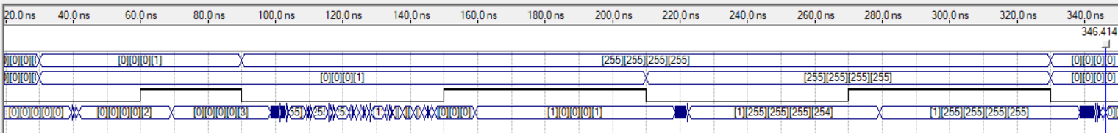

Figure 8: Ripple adder waveform

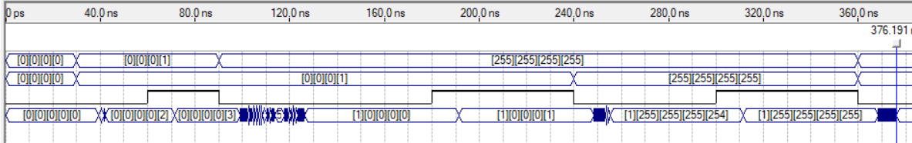

Figure 9: CSA waveform

**FPGA implementation**

While FPGAs will always perform worse than a specifically designed ASIC, in the case of our circuit it would not be worth investing in an ASIC, as due to the small size of the circuit the delays produced are also very small, so even if an ASIC performed 10 times faster, it would only reduce the delay by no more than 50ns, which is not worth paying the huge development cost for.