# **CSC 431 –** R (Spring 2025) UScore - The Sports Score & Noise Tracker Software Requirements Specification (SRS)

**Team Number 4**

| Shane O’Neill | Project Manager/Software Engineer |
| --- | --- |
| Samuel Schell | Project Manager/Software Engineer |
| Elliot Wright | Project Manager/Software Engineer |
|  |  |

# Version History

| Version | Date | Author(s) | Change Comments |
| --- | --- | --- | --- |
| 1.0 | 02/12 | Shane O’Neill | Initial draft of the SRS document. |
| 1.1 | 02/14 | Samuel Schell | Added functional requirements and use cases. |
| 1.2 | 02/16 | Elliot Wright | Updated non-functional requirements section. |
| 1.3 | 02/17 | Shane O’Neill | Updated system constraints section. |
| 1.4 | 02/18 | Shane_O’Neill, Samuel_Schell, Elliot_Wright | Improved clarity in non-functional requirements. |
| 1.5 | 02/19 | Samuel Schell | Integrated peer feedback and resolved comments. |
| 1.6 | 02/20 | Elliot Wright | Integrated peer feedback and resolved comments. |
| 1.7 | 02/21 | Shane O’Neill | Integrated peer feedback and resolved comments. |
| 1.8 | 02/23 | Samuel Schell | Created use-case diagrams for core features. |
| 1.9 | 02/24 | Elliot Wright | Conducted proofreading and formatting adjustments. |
| 2.0 | 02/25 | Shane_O’Neill, Samuel_Schell, Elliot_Wright | Final review and submission of the SRS document. |

# Table of Contents

1. **System Requirements** 6

1.1 Functional Requirements 6

1.1.1 Live Score Updates 6

1.1.2 Noise Meter 6

1.1.3 Quick-Reaction Chat System 7

1.1.4 Game Recaps 7

1.1.5 Customizable Feeds 8

1.2 Non-Functional Requirements 8

1.2.1 Performance 8

1.2.2 Security 8

1.2.3 Scalability 9

1.2.4 Compliance 9

2.**System Constraints** 10

2.1 Tool Constraints 10

2.1.1 Programming Languages 10

2.2 Language Constraints 10

2.2.1 Supported Languages 10

2.3 Platform Constraints 10

2.3.1 Web Accessibility 10

2.4 Hardware Constraints 11

2.4.1 Server Requirements 11

2.5 Network Constraints 11

2.5.1 API Connectivity 11

2.6 Deployment Constraints 11

2.6.1 Hosting 11

2.7 Transition & Support Constraints 12

2.7.1 Future Expansion 12

2.8 Budget & Schedule Constraints 12

2.8.1 Timeline 12

2.9 Miscellaneous Constraints 12

2.9.1 Compliance 12

3. **Requirements Modeling** 13

3.1.1 Live Score Updates 13

3.1.2 Noise Meter 13

3.1.3 Quick-Reaction Chat System 14

3.1.4 Game Recaps 14

3.1.5 Customizable Feeds 15

4. **Evolutionary Requirements** 16

4.1 Functional Requirements 16

4.1.1 Future Features 16

4.2 Non-Functional Requirements 16

4.2.1 Scalability Improvements 16

### System Requirements

#### Functional Requirements

##### Live Score Updates

| Title | Live Score Updates |
| --- | --- |
| Description | The system shall provide real-time sports scores for multiple leagues using APIs |
| Priority | 0 |
| Precondition(s) | API connection established |
| Basic Flow | User selects a game, system retrieves and displays latest score updates |
| Postconditions(s) | Scores update dynamically |
| Use Case Diagram | 3.1.1 |

##### Noise Meter

| Title | Noise Meter |
| --- | --- |
| Description | The system shall measure fan excitement based on reactions, crowd energy, and key game events |
| Priority | 1 |
| Precondition(s) | Active game in progress |
| Basic Flow | System aggregates reactions and generates an intensity score |
| Postconditions(s) | Display updated noise levels |
| Use Case Diagram | 3.1.2 |

##### Quick-Reaction Chat System

| Title | Quick-Reaction Chat System |
| --- | --- |
| Description | The system shall allow users to post quick reactions to game events |
| Priority | 2 |
| Precondition(s) | User logged in |
| Basic Flow | User selects a game event, posts a reaction, and sees others' responses in real time |
| Postconditions(s) | Reaction appears in chat |
| Use Case Diagram | 3.1.3 |

##### Game Recaps

| Title | Game Recaps |
| --- | --- |
| Description | The system shall generate automated game summaries based on API data |
| Priority | 2 |
| Precondition(s) | Game completed |
| Basic Flow | System compiles key game events, player statistics, and fan engagement levels |
| Postconditions(s) | Summary displayed to users |
| Use Case Diagram | 3.1.4 |

##### Customizable Feeds

| Title | Customizable Feeds |
| --- | --- |
| Description | The system shall allow users to follow their favorite teams and leagues |
| Priority | 1 |
| Precondition(s) | User logged in |
| Basic Flow | User selects preferred teams, system filters content accordingly |
| Postconditions(s) | Personalized content displayed |
| Use Case Diagram | 3.1.5 |

#### Non-Functional Requirements

##### Performance

| Title | Performance |
| --- | --- |
| Description | The system shall update scores within 5 seconds |
| Priority | 0 |
| Applicable FR(s) | Live Score Updates |

##### Security

| Title | Security |
| --- | --- |
| Description | The system shall use secure authentication for user interactions |
| Priority | 1 |
| Applicable FR(s) | Quick-Reaction Chat System, Customizable Feeds |

##### Scalability

| Title | Scalability |
| --- | --- |
| Description | The system shall handle increased traffic during peak games |
| Priority | 1 |
| Applicable FR(s) | All Functional Requirements |

##### User Experience

| Title | User Experience |
| --- | --- |
| Description | The system shall ensure an intuitive, engaging, and responsive interface for users |
| Priority | 2 |
| Applicable FR(s) | Customizable Feeds, Quick-Reaction Chat System |

### System Constraints

#### Tool Constraints

##### Programming Languages

| Title | Programming Languages |
| --- | --- |
| Description | The system shall be developed using Java, Python, and C++ |
| Priority | 1 |

#### Language Constraints

##### Supported Languages

| Title | Supported Languages |
| --- | --- |
| Description | The system shall initially support English, with plans for multilingual expansion |
| Priority | 2 |

#### Platform Constraints

##### Web Accessibility

| Title | Web Accessibility |
| --- | --- |
| Description | The system shall be accessible via web browsers on desktop and mobile |
| Priority | 1 |

#### 

#### Hardware Constraints

##### Server Requirements

| Title | Server Requirements |
| --- | --- |
| Description | The system shall run on Unix-based servers with cloud deployment capability |
| Priority | 1 |

#### Network Constraints

##### Stable Internet

| Title | Stable Internet |
| --- | --- |
| Description | The system shall rely on stable internet connection |
| Priority | 0 |

#### Deployment Constraints

##### Hosting

| Title | Hosting |
| --- | --- |
| Description | The system shall be deployed using cloud-based hosting solutions |
| Priority | 1 |

#### Transition & Support Constraints

##### Future Expansion

| Title | Future Expansion |
| --- | --- |
| Description | The system shall be designed with modular components for easy updates |
| Priority | 2 |

#### Budget & Schedule Constraints

##### Timeline

| Title | Timeline |
| --- | --- |
| Description | The system shall adhere to the project schedule outlined in the proposal |
| Priority | 1 |

#### Miscellaneous Constraints

##### Complianc**e**

| Title | Compliance |
| --- | --- |
| Description | The system shall comply with legal regulations regarding user data protection |
| Priority | 1 |

### Requirements Modeling

##### Live Score Updates

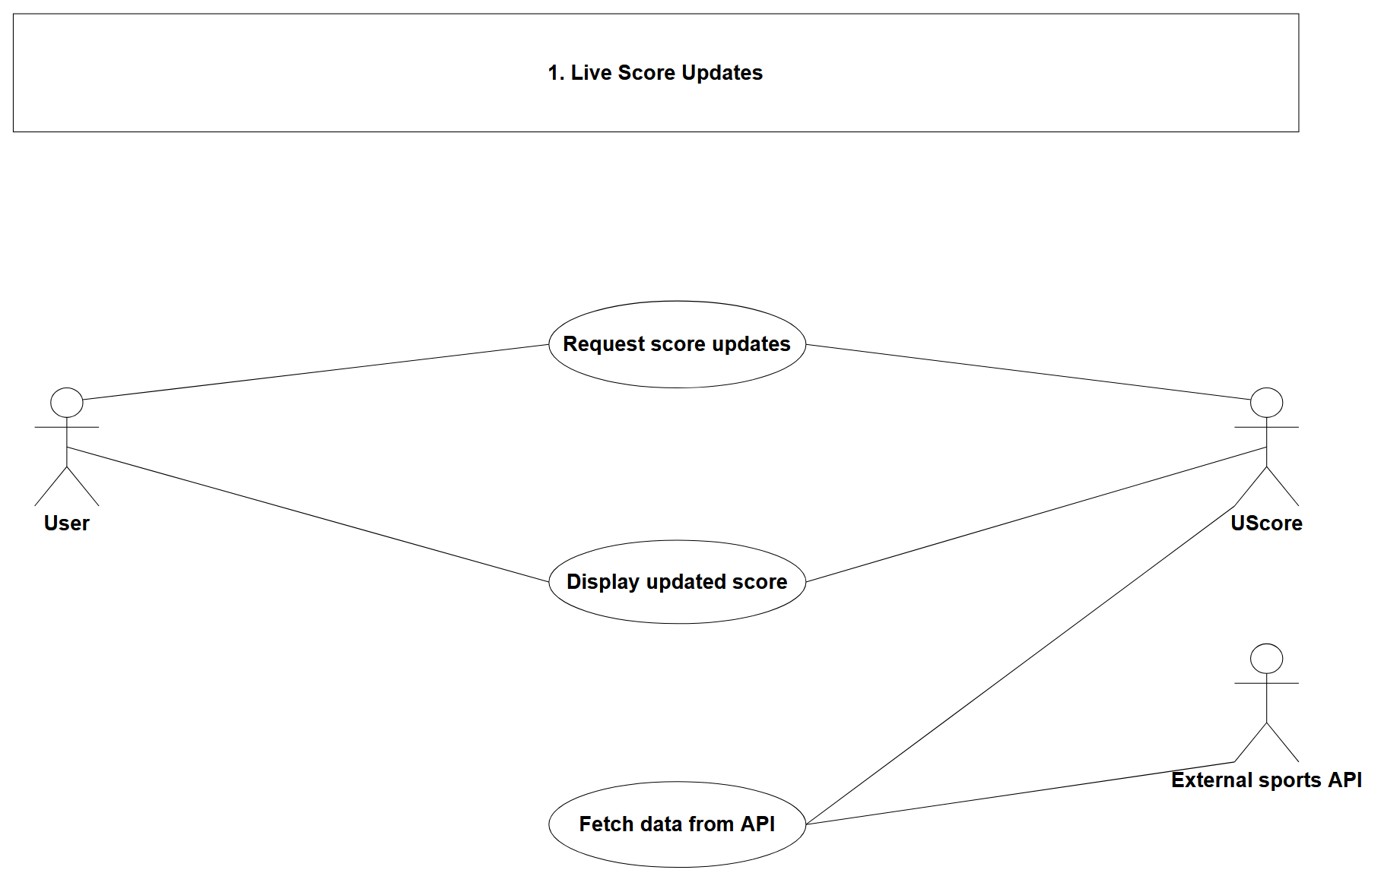

##### Noise Meter

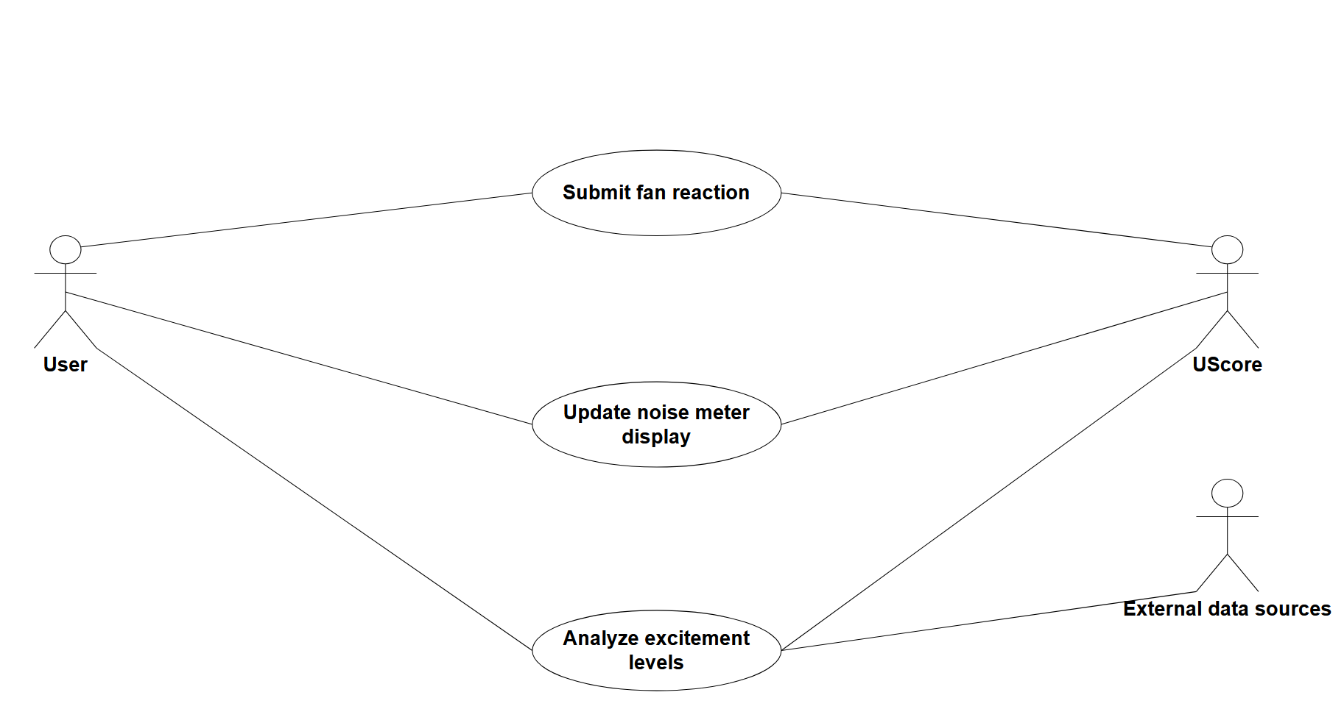

##### Quick-Reaction Chat System

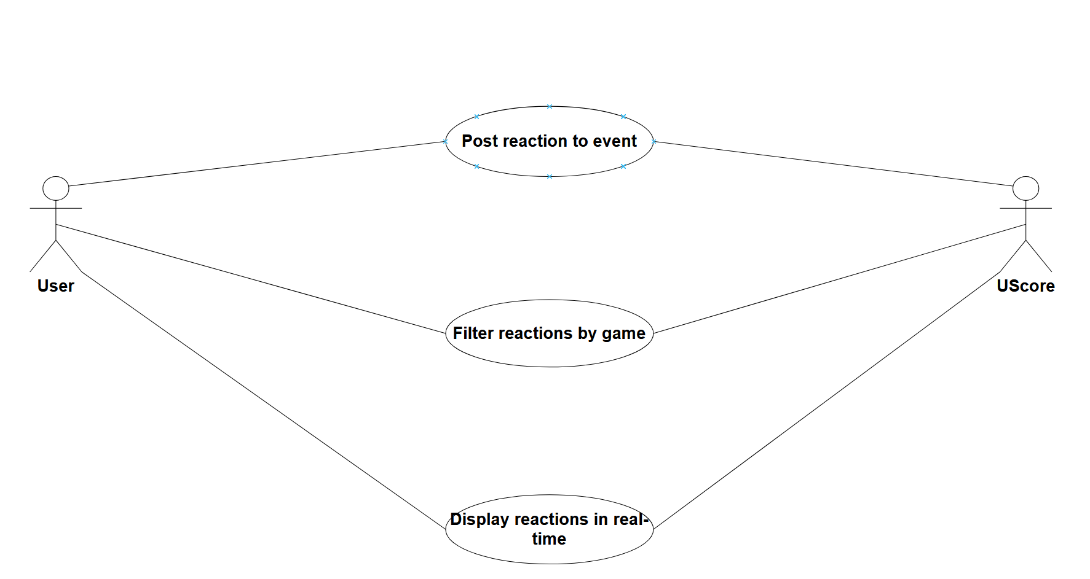

##### Game Recaps

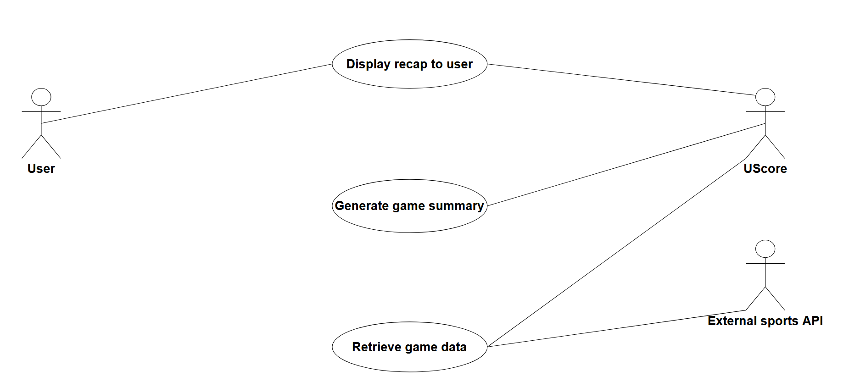

##### Customizable Feeds

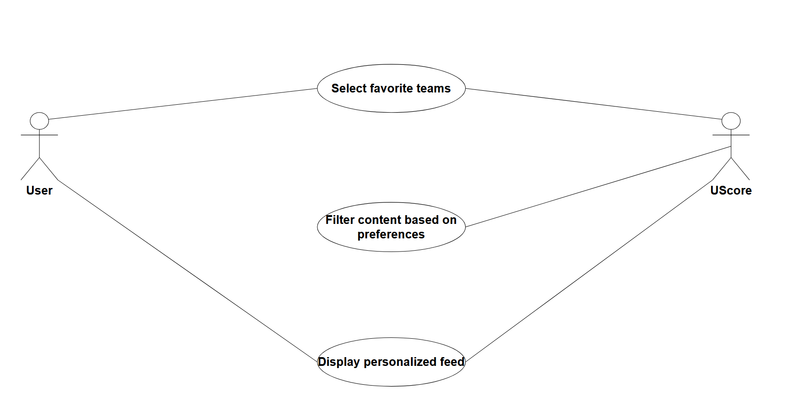

### Evolutionary Requirements

#### Functional Requirements

##### Future Features

| Title | Future Features |
| --- | --- |
| Description | The system shall be designed to incorporate AI-based game predictions |
| Priority | 3 |
| Precondition(s) | Stable real-time data available |
| Postconditions(s) | Predictive insights displayed to users |
| Use Case Diagram | N/A |

#### Non-Functional Requirements

##### Scalability Improvements

| Title | Scalability Improvements |
| --- | --- |
| Description | The system shall increase server capacity dynamically based on demand |
| Priority | 2 |
| Applicable FR(s) | All Functional Requirements |