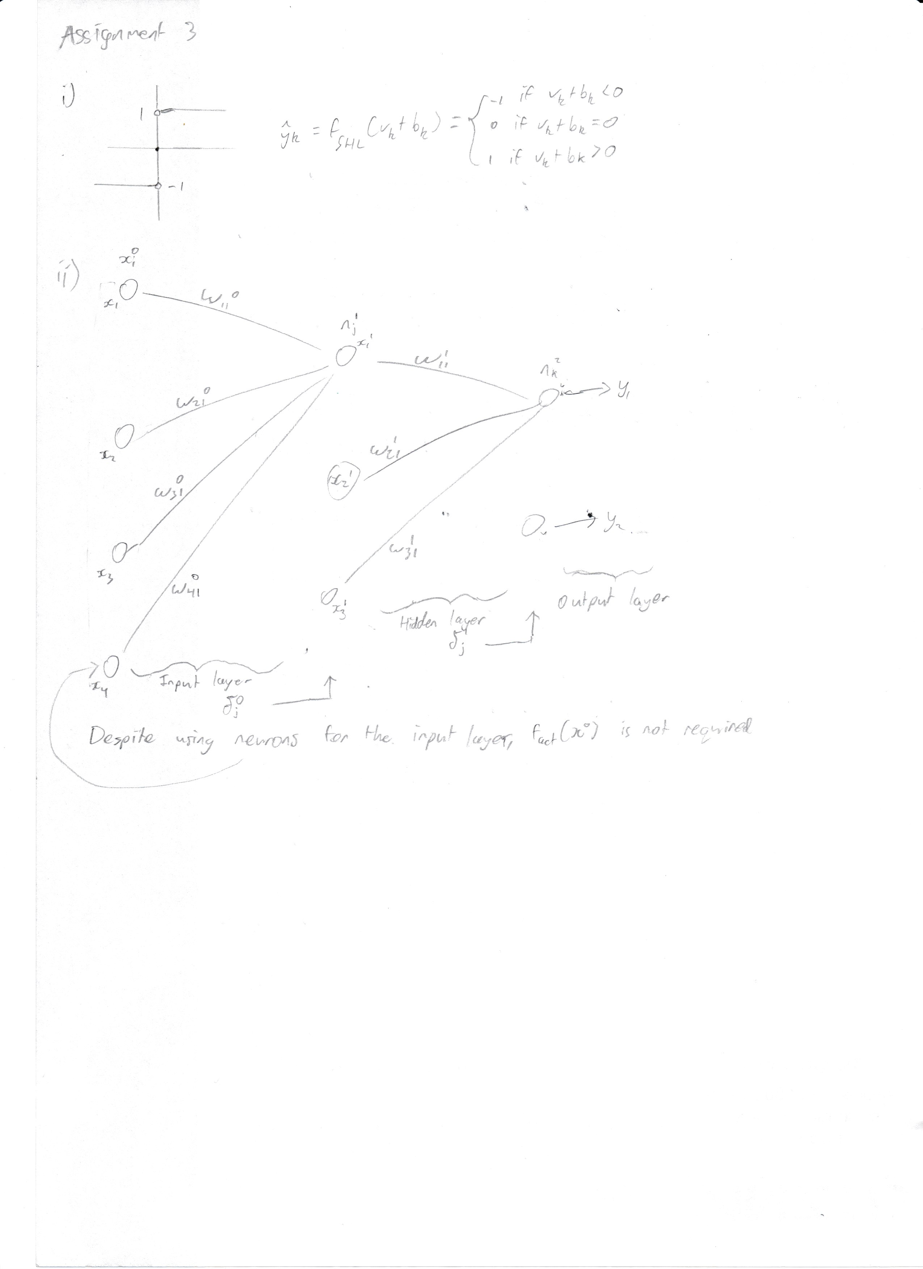

• = dot multiply, XT = transpose(X), \* = cross product/ matrix multiplication (\* in matlab)

