Note the scales (particularly y-axis)

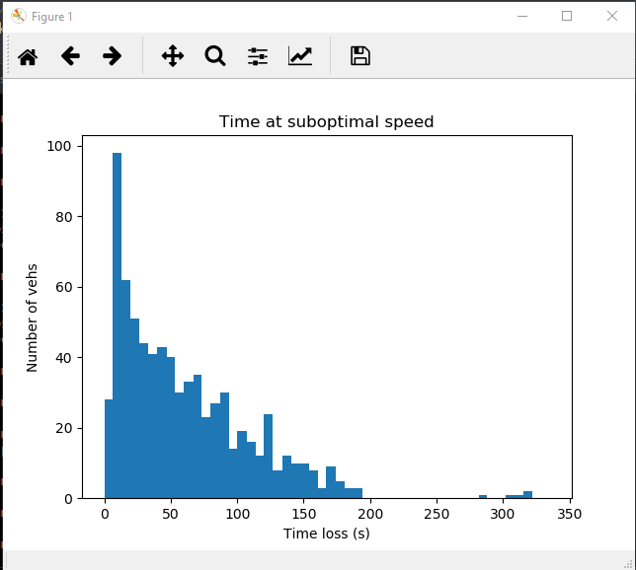

Figure : EDF time loss

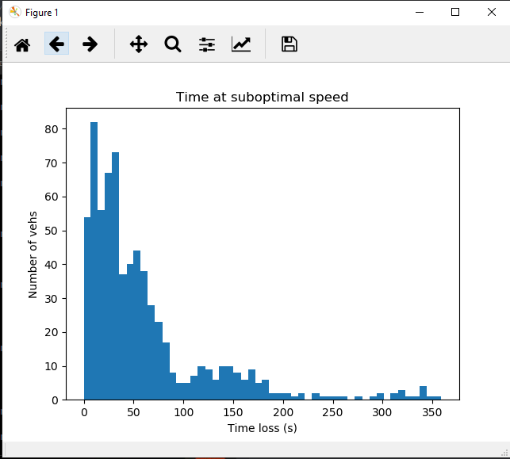

Figure : SCATS time loss

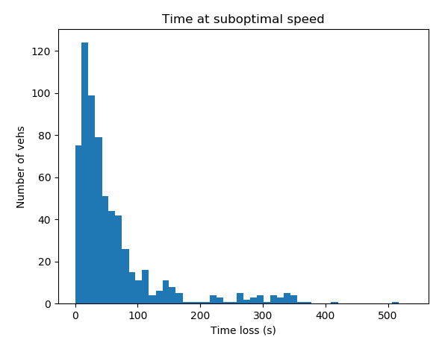

Figure : RL time loss

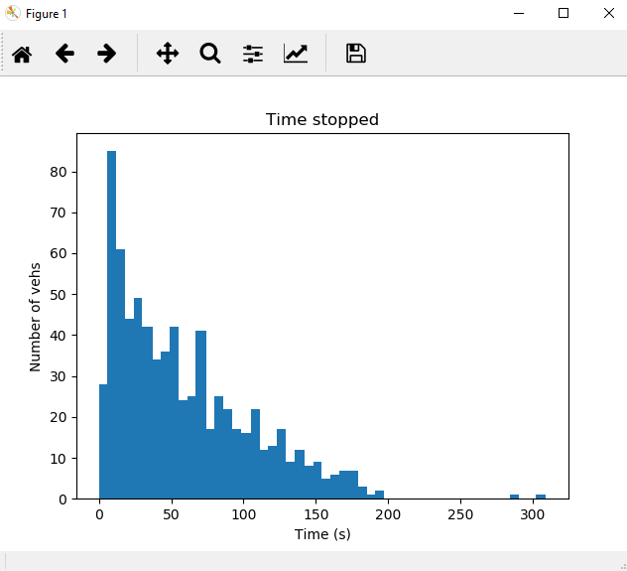

Figure : EDF time stopped

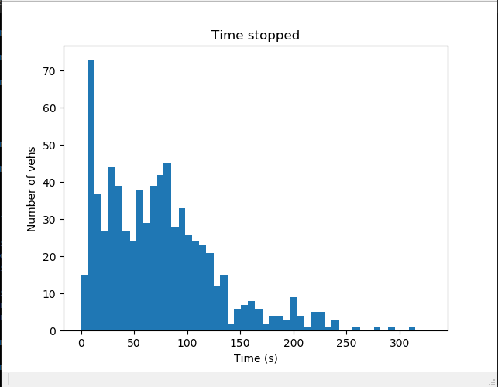

Figure : SCATS time stopped

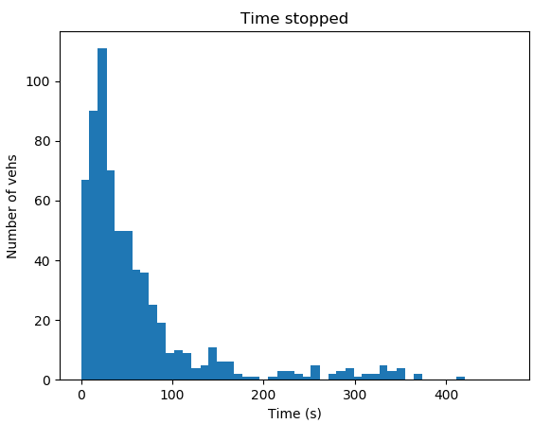 REDO

Figure : RL time stopped

EDF:

timeLoss: mean = 49 Std Dev = 43

timeStopped: mean = 31 Std Dev = 41

number of vehicle that completed their routes = 711in

SCATS:

timeLoss: mean = 73.89 Std Dev = 55.03

timeStopped: mean = 53.47 Std Dev = 50.91

number of vehicle that completed their routes = 736

RL:

timeLoss: mean = 62.93 Std Dev = 77.31

timeStopped: mean = 39.23 Std Dev = 69.82

routes completed = 665

Hypothesis: vehicles may not be generated? Thus timeloss isn’t counted? Could try extend incoming roads and test again.

Or: RL could be overfitting to training set, and must be tested on new set

Continued on next page

