FLOWGUARD

Proof of Use
Replit workspace and RunPod inference evidence
DRAFT — SUPPORTING EVIDENCE ONLY · NOT THE OFFICIAL SDC PROOF FORM

Project details | Information
Project | FlowGuard — shared workspace for travel requests, manager decisions, and activity history
Team | Avengers · Asia Pacific University
Event | SDC 2026
Document date | 25 October 2026
Evidence scope | Replit workspace use, one direct RunPod inference test, and supporting demo timeline

Executive summary
FlowGuard was developed and run in a Replit workspace. The current evidence image shows the app preview, but not the Replit workspace or its running-workflow panel. A genuine workspace capture is still needed for a complete Replit proof.
The project evidence index records one direct synthetic-data request to RunPod’s Qwen3 32B AWQ public endpoint on 24 October 2026. The reported response was HTTP 200 with status COMPLETED, but the generated content was irrelevant and was not used for a decision. This supports only a limited endpoint-utilization claim; it does not prove a working or reliable FlowGuard manager-to-RunPod feature.
Evidence item | Current status and claim limits
Replit | App preview screenshot is included. Workspace identity and running workflows are not visible; capture them in Replit before submission.
RunPod | One direct test is recorded in the team evidence note. The provider dashboard request/usage record is not attached or independently verified.
Demo transcript | Timestamped narration supports the product workflow walkthrough only. It does not by itself prove Replit or RunPod utilization.

Demo transcript timeline
These timestamps come from the supplied transcript. They identify the narrated product-demo sections; they are not provider logs or independent proof of platform use.
Time | Section | What the narration describes
00:00–00:14 | Introduction | Introduces FlowGuard and the request-to-outcome walkthrough.
00:14–00:39 | The Request | Synthetic travel details are entered and submitted as pending.
00:39–01:01 | The Review Flag | An illustrative MYR 1,000 threshold flags a MYR 1,500 request; it does not decide it.
01:01–01:25 | Manager’s Decision | A separate manager reviews the request, enters a reason, and makes the decision.
01:25–01:43 | The Outcome | The employee sees the updated status and manager note.
01:43–02:04 | Activity History | The submission and manager decision appear in the request history; no booking is claimed.
02:04–02:34 | Closing | Summarizes the workflow and human control.

Evidence still required before official submission
- Replit: add a screenshot of the Replit workspace showing the FlowGuard web and API Server workflows running. Keep secret values hidden.
- RunPod: add the provider request/usage record for the 24 October synthetic test, showing endpoint and status; redact keys, tokens, account email, and unrelated private information.
- Confirm the organiser’s current proof form and whether the attached screenshots meet its required format.
- Do not repeat a RunPod request solely for evidence unless the team checks current pricing and explicitly approves any possible charge.
- Do not describe the unrelated model output as a successful product feature, or claim tested manager-route integration, model quality, measured savings, automatic approval, or travel booking.

Exhibit A — Existing app and test-note image
Existing file: submission/evidence/flowguard-demo-and-runpod-note.png
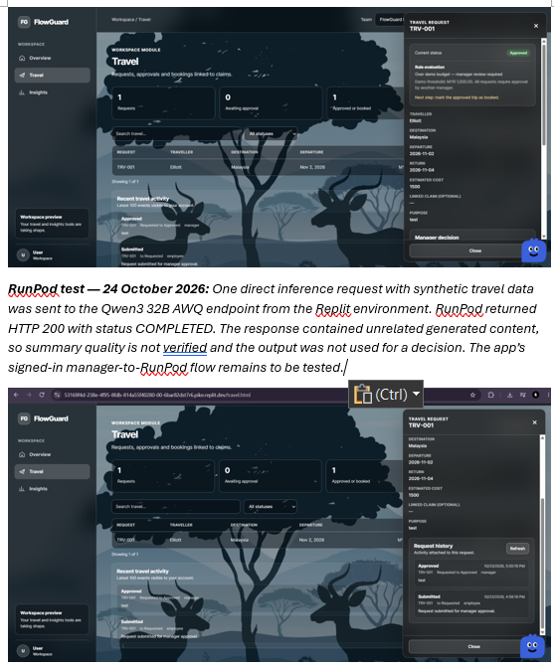
The composite shows the FlowGuard Travel interface and includes a written note about the direct RunPod test. The app screenshot is supporting demo evidence. The note is team-authored and is not a provider-side usage record.

Submission note
This document is a draft evidence summary, not a completed official declaration. Replace or supplement it with the organiser’s current form and genuine Replit/RunPod screenshots. Do not submit it as complete while the required provider/workspace records are missing.

