Intensive Care Unit

Introduction

What are your chances of surviving a trip to the hospital if you are admitted to the intensive care unit? A study was conducted on this very idea. Using a much larger data set, a group of 200 subjects who were admitted to the intensive care unit were studied to develop a logistic regression model to predict the probability of survival to be able to be discharged from the hospital and to study the risk factors associated with ICU (Intensive Care Unit) mortality.

Literature review

Studying a patient’s admittance to the ICU is a study that has been done very extensively and is one that will go on for a very long time as the ICU itself deals with live-or-death scenarios, and getting not only the best but most efficient treatment to the patient is top priority, for both the patient and the hospital. A study on the prognosis and quality of life of elderly patients after they have been in intensive care help was published in the Swiss Medical Weekly journal. Titled *Prognosis and Quality of Life of Elderly Patients After Intensive Care[1]*, it was published on September 10th, 2012. Some of the more interesting bits of data from the article cite that the length of the stay and the mortality doesn’t seem to differ when compared to a younger population.

Another article worth mentioning is one titled *Hospital volume and the outcomes of mechanical ventilation*. This little study, published in July of 2006, looked at the survivability after admission in regards to the volume the hospital can take on. The study found that, generally speaking, the more patients a hospital could take on, the better the chances for the patient’s survival.

Data

A study conducted at the Baystate Medical Center in Springfield Massachusetts was conducted in 1988 that wished to study the outcome of Intensive Care Unit patients. A sample of 200 subjects from this larger data set was collected and 21 variables categorized the subjects. Some of those variables include their race, gender, age, if they were admitted to the ICU on a voluntary basis or if it was an emergency, what their heartrate was at the time of ICU admission, and their level of consciousness at the time of ICU admission was.

Methodology

Most of the data was presented in a 0 or 1 format meaning 0 was some value while 1 was some respected opposite. The big dependent variable was if the patient who was admitted to the ICU lived to be discharged (to where, such as a nursing home or to their actual home, is not relevant to this study) or if the patient died, and I wanted to see if any one of those other variables served some sort of relation to the patient’s vitality or not. Therefore, given the study’s setup and what I’m looking for, I decided upon a logistics regression to test a few of these variables and see if they held any significance in the vitality of the patient. In total, three separate tests were run against the dependent variable, STA, that is their status, did they live or die? The first test tested if their age had any significance to their survival. The second test tested if there was any relation between the patient’s race and gender if that had any significance to them making it alive to discharge. The third test tested to see if the patient’s level of consciousness has any significance on them living or dying when admitted to the ICU.

Plots

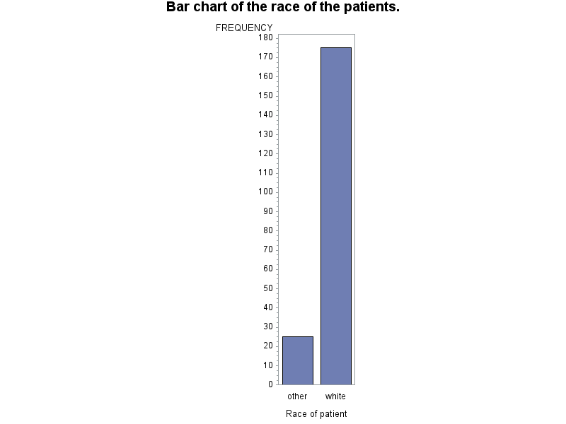

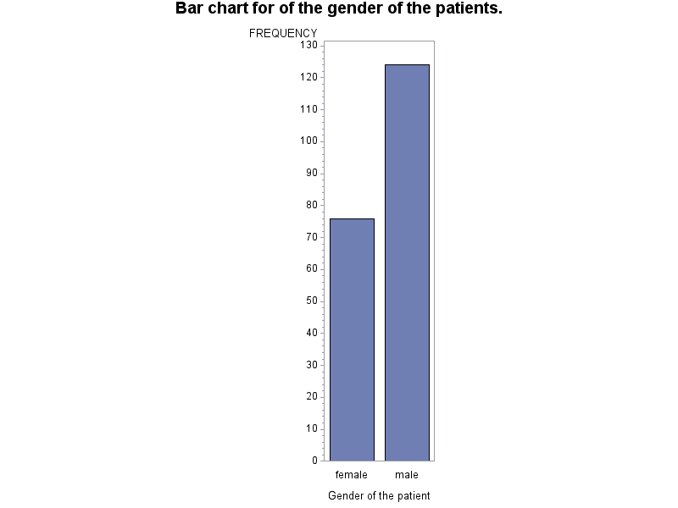

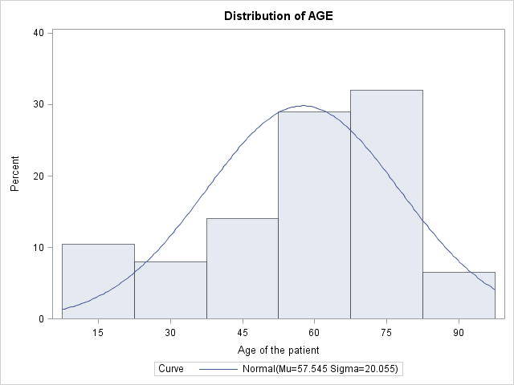

Analysis

Starting with some simple descriptive statistics,

First and most importantly, how many patients lived and how many of them died? Using the frequency count of SAS, the following are the numbers of patients who lived and who died:

* 160 lived
* 40 died
* Total = 200

Next, using the proc univariate function in SAS, it outputted the following data on the age of the patient:

* N = 200
* Mean (Age) = 57.5
* Std Dev = 20.0
* Variance = 400
* Median = 63
* 1st Quantile = 46.5
* 3rd Quantile = 72.0
* Min = 16
* Max = 92

Concerning the patient’s race:

* 175 patients were white.
* 25 were other.

Concerning the patient’s gender:

* 76 were females
* 124 were males.

Finally, what was the level of consciousness at the time of the patient’s ICU admission:

* 185 were conscious
* 15 were either in a stupor or were unconscious

Getting into the inferential part of the test, let’s run those aforementioned tests as stated in the “methodology” section. For this we wanted to see if any of the aforementioned tests had any significance on if the patient survived and made it out of the hospital to be discharged. Starting with age, our hypothesis testing is as followed.

* Hypotheses
  + H0 = Age plays no significance in the patient living.
  + HA = Age has a significance in the patient living.
* Alpha
  + I used an alpha of 0.05.
* P- value
  + Using the forward selection method and using dummy variables of young and old (young < 40 and old > 63), the p-value of young is = 0.0140.
* Conclusion
  + We’d reject the null hypothesis. One’s age plays a significant factor in if they’d survive to discharge after being admitted to the ICU.

Running the “risklimits” function to see the odd’s ratio, SAS gave us the odds of 5.320. That is, you’re a little more than 5 times more likely to make it to discharge after being admitted to the ICU if you are under the age of 40.

Next we’ll test to see if one’s race and gender play a significant role in their vitality.

* Hypotheses
  + H0 = Neither their race nor their gender plays no significance in the patient living.
  + HA = Race and/or gender has a significance in the patient living.
* Alpha
  + I used an alpha of 0.05
* P- value
  + Using the forward selection method, neither race nor gender met the 0.05 significance level for entry into the model.
* Conclusion
  + We would fail to reject our null hypothesis. The evidence does not say if one’s race or gender plays a role in their vitality after being admitted to the ICU.

For our third test, we’ll test to see if the patient’s level of consciousness prior to their admittance to the ICU plays a significant factor in their survival.

* Hypotheses
  + H0 = The level of consciousness plays no significant role in the patient’s vitality.
  + HA = The level of consciousness plays a significant role in the patient’s vitality.
* Alpha
  + I used an alpha of 0.05
* P- value
  + Using the forward selection method, LOC had a p-value of near zero.
* Conclusion
  + We can reject our null hypothesis. The level of the patient’s consciousness does play a significant role in their vitality.
  + Using the “risklimit” function in SAS, the odd’s ratio is 0.135, meaning you have a 0.135 chance of surviving if you’re conscious versus in a stupor or unconscious prior to your admittance to the ICU.

Summary

Unsurprisingly, the patient’s age did play a significant role in their vitality after being admitted to the ICU. The people under the age of forty had a huge chance of making it to discharge versus those over 40, and this makes sense. Older bodies are not designed like they were; they can not take the traumas and stresses that come with the medical procedures and if anything, the very old patients are almost close to death as it is (to put it bluntly.)

Just as unsurprisingly, the person’s race and gender did not play a significant role in their vitality after admittance to the ICU. While it is true white males dominated this study, as a personal note, I do find it significant myself the data says gender and race don’t play a significant role. Essentially it says women and non-whites are just as equally likely to live or die based on other factors as white men are.

The patient’s level of consciousness plays a significant role in their vitality. If they are admitted to the ICU and they are conscious, chances are good they should be able to make It to discharge as it begs the question, “why would that level change?” While it’s true the patient could be conscious when admitted and then ultimately die, those cases are rare in comparison to being admitted conscious and then discharged alive.

One last thing I want to note given the raw frequencies of the patients surveyed, that is 160 (80%) of those surveyed lived and 40 died, I find it substantial that today’s medicine can keep that many proportionally alive given the number of variables. While other factors may help or hinder your chances of survival, just those numbers alone should bring some comfort into knowing you’re probably going to get out of the hospital alive if you’re admitted to the ICU.

Appendix

*Intensive Care Infection Survival Rates Boosted* (<http://www.stuff.co.nz/national/health/9845536/Intensive-care-infection-survival-rates-boosted>)

1. Prognosis and Quality of Life of Elderly Patients After Intensive Care( <http://www.smw.ch/content/smw-2012-13671/>)
2. Hospital Volume and the Outcomes of Mechanical Ventilation (<http://www.ncbi.nlm.nih.gov/pubmed/16822995>)

The SAS code:

/* Reformats the variable's values so as to make it easier to analyze. */

**proc** **format**;

value live_or_dead **0** = 'lived'

**1** = 'died';

value agegroup **0** = '40 to 63 (inclusive)'

**1** = '<40 or >63';

value $gendergroup **0** = 'male'

**1** = 'female';

value $racegroup **1** = 'white'

**2** , **3** = 'other';

value medsurg **0** = 'medical'

**1** = 'surgical';

value cancer **0** = 'no'

**1** = 'yes';

value renal **0** = 'no'

**1** = 'yes';

value infection **0** = 'no'

**1** = 'yes';

value cpradmin **0** = 'no'

**1** = 'yes';

value previous **0** = 'no'

**1** = 'yes';

value admintype **0** = 'elective'

**1** = 'emergency';

value fracture **0** = 'no'

**1** = 'yes';

value oxygen **0** = '=> 60'

**1** = '=< 60';

value pH **0** ='=> 7.25'

**1** = '=< 7.25';

value carbond **0** = '=< 45'

**1** = '=> 45';

value bicarb **0** = '=> 18'

**1** = '=< 18';

value creatinine **0** = '=< 2.0'

**1** = '=> 2.0';

value consciousness **0** = 'conscious'

**1**, **2** = 'stupor or unconscious';

**run**;

**data** icu; /* begins the data step */

infile "C:\Users\Elliott\Documents\STAT696\Final Project\icu.csv" dlm=',' firstobs=**2**;

input ID $ STA AGE GENDER $ RACE $ SER CAN CRN INF CPR SYS HRA PRE TYP FRA PO2 PH PCO BIC CRE LOC;

/* The following comments will explain some of the finer details of the variables. These are the original valued before

being formatted by the above values.

ID = Identification number,

STA = vital status,

0 = lived

1 = died

AGE = Age of the patient,

GENDER = Gender of the patient,

RACE = Race of patient,

1 = White

2 = Black

3 = Other

SER = service,

0 = medical,

1 = surgical.

CAN = Was cancer a part of the problem,

0 = No

1 = Yes

CRN = History of Chronic Renal Falure,

0 = No

1 = Yes

INF = Infection probable at time of admittmitance to ICU,

0 = No

1 = Yes

CPR = Was CPR issued prior to ICU admission,

0 = No

1 = Yes

SYS = Systolic Blood Pressure at ICU admission

HRA = Heart Rate at ICU Admission

PRE = Has the patient been into the ICU within 6 months

0 = No

1 = Yes

TYP = Type of Admission

0 = Elective

1 = Emergency

FRA = Was there a long bone (such as the thigh), multiple bones broken

a neck fracture, a single area (such as the ribs), or a hip fracture involved,

0 = No

1 = Yes

PO2 = PO2 from initial blood gases,

0 => 60

1 =< 60

PH = pH of initial blood gasses,

0 => 7.25

1 =< 7.25

PCO = PCO2 from initial blood gases,

0 =< 45

1 => 45

BIC = Bicarbonate from initial blood gases,

0 => 18

1 =< 18

CRE = Creatinine from initial blood gases,

0 =< 2.0

1 => 2.0

LOC = Level of Consciousness at ICU admission,

0 = No coma or stupor

1 = Deep Stupor

2 = Coma

*/

if not missing(AGE) then do;

if AGE GE **40** and AGE LE **63** then agegroup = **0**;

else agegroup = **1**;

if AGE GT **63** then old = **1**;

else old = **0**;

if AGE LT **40** then young = **1**;

else young = **0**;

end;

if RACE in ('1' '2' '3') then do; /* Creates dummy variables for race for use in proc logistic step.

with 'Other', '3' as reference.*/

WHITE = (RACE = '1');

AF_AM = (RACE = '2');

end;

if GENDER in ('0' '1') then female = (GENDER = '1'); /* Creates dummy variables for gender with 'Female' reference. */

label ID = 'Identification number' /* Adds labels to the variables for easier references in the date */

STA = 'vital status'

AGE = 'Age of the patient'

GENDER = 'Gender of the patient'

RACE = 'Race of patient'

SER = 'Service'

CAN = 'Was cancer a part of the problem'

CRN = 'History of Chronic Renal Falure'

INF = 'Infection probable at time of admittmitance to ICU'

CPR = 'Was CPR issued prior to ICU admission?'

SYS = 'Systolic blood pressure at ICU admission'

HRA = 'Heart rate at ICU admission'

PRE = 'Has the patient been into the ICU within 6 months'

TYP = 'Type of Admission'

FRA = 'Was there a long bone (such as the thigh), multiple bones broken'

PO2 = 'PO2 from initial blood gases'

PH = 'pH of initial blood gasses'

PCO = 'PCO2 from initial blood gases'

BIC = 'Bicarbonate from initial blood gases'

CRE = 'Creatinine from initial blood gases'

LOC = 'Level of Consciousness at ICU admission';

format STA live_or_dead. /* Assigns what we put up in the 'proc format' statement to our variables in the datastep */

GENDER $gendergroup.

AGE agegroup.

RACE $racegroup.

SER medsurg.

CAN cancer.

CRN renal.

INF infection.

CPR cpradmin.

PRE previous.

TYP admintype.

FRA fracture.

PO2 oxygen.

PH pH.

PCO carbond.

BIC bicarb.

CRE creatinine.

LOC consciousness. ;

**proc** **print** data = icu (obs = **5**); /* Simple 'proc print' to check output. */

**run**;

**proc** **univariate** data = icu normal; /* Will give us a very thourough set of descriptive statistics of

the listed variables. The 'normal' in both the 'proc univariate' statement and with the individual

variables below will first print the histogram of each of the respected variables and will then superimpose a normal curve on it.*/

title " Descriptive statistics for the age of the patient.";

var AGE;

histogram AGE / normal midpoints= **15** to **95** by **15**;

**run**;

**quit**;

**proc** **freq** data = icu; /* Will show us the frequency of the following variables by their values. */

title 'Frequency count for the following variables';

tables STA GENDER RACE / nocum nopercent;

**run**;

**proc** **gchart** data = icu;

title 'Bar chart for of the gender of the patients.';

vbar GENDER;

**run**;

**proc** **gchart** data = icu;

title 'Bar chart of the race of the patients.';

vbar RACE;

**run**;

**proc** **corr** data = icu nosimple;

title 'Correlation amongst the variables';

var STA AGE LOC;

**run**;

**proc** **logistic** data = icu descending;

title 'Predicting vitality if admitted to the ICU based on age';

model STA = old young /

risklimits /*Will see if age has any affect on living or dying */

selection = forward;

**proc** **logistic** data = icu descending; /* Begins the logistics test. */

title 'Predicting vitality if admitted to the ICU based on race and gender.';

model STA = female WHITE/ /* will look at if the person's race or gender is significant in their survival

with Ho= they live and Ha = they die. */

risklimits

selection = forward;

**proc** **logistic** data = icu descending;

title ' Predicting vitality if admitted to the ICU based on the consciousness of patient. ';

model STA = LOC / /* Does their level of consciousness affect their chances of survival if

admitted to the ICU? */

risklimits

selection = forward;

**run**;

**quit**;