Example Analysis

Martin Barner

1 February 2019

# Needs Overview

How do needs differ across regions? We will look at this by sector.

## Health

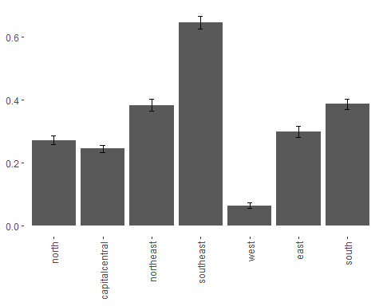

It appears that the health need differ significantly (p < 0.001) across regions.