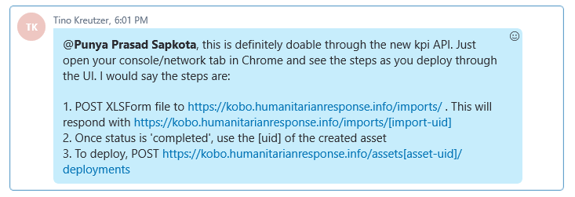

Download

<https://kobo.humanitarianresponse.info/assets/aYmvAkuS6R4TUxdmkVmQ6z.xml>

{

"uid": "pR4VFGCzhgteBGYr7NFP4N",

"kind": "objectpermission",

"url": "<https://kobo.humanitarianresponse.info/permissions/pR4VFGCzhgteBGYr7NFP4N/>",

"user": "<https://kobo.humanitarianresponse.info/users/wosaturkey/>",

"permission": "add_submissions",

"content_object": "<https://kobo.humanitarianresponse.info/assets/aYmvAkuS6R4TUxdmkVmQ6z/>",

"deny": false,

"inherited": false

},