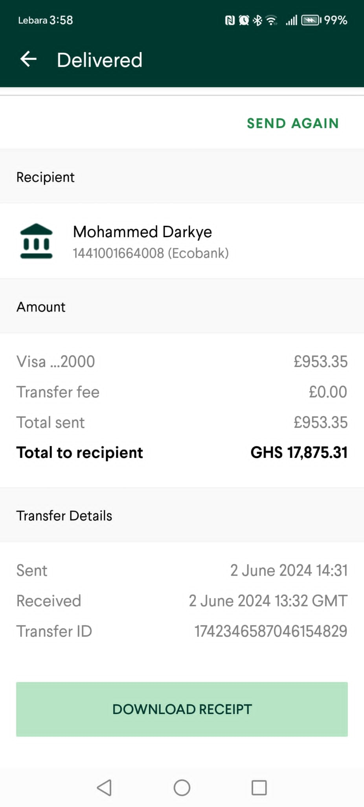

Status:- Delivered

Amount 17,875GHC

2nd June 2024

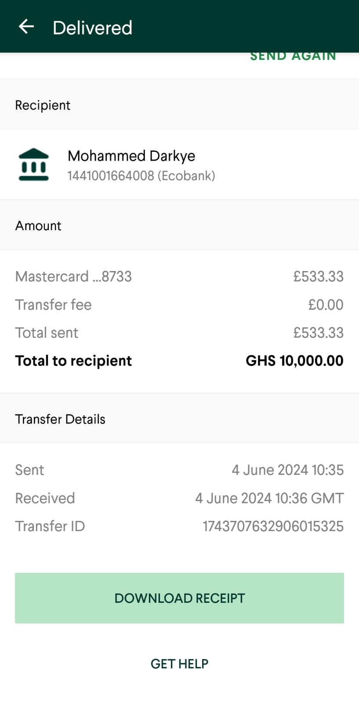

Status:- Delivered

Amount:- 10,000 GHC

Date :- 4th June 2024

Transaction ID – 1743707632906015325

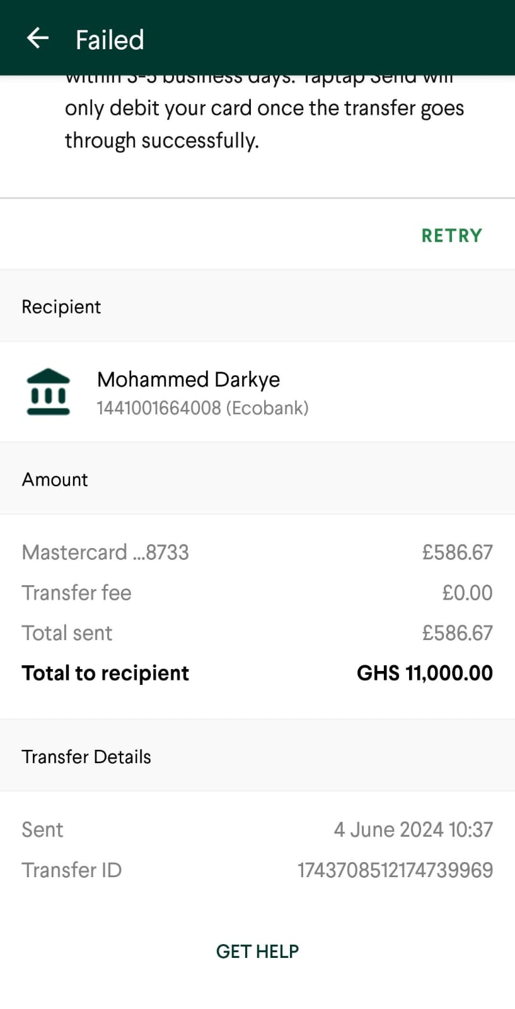

Status:- Failed

Amount:- 11,000 GHC

Date :- 4th June 2024

Transaction ID – 1743708512174739969

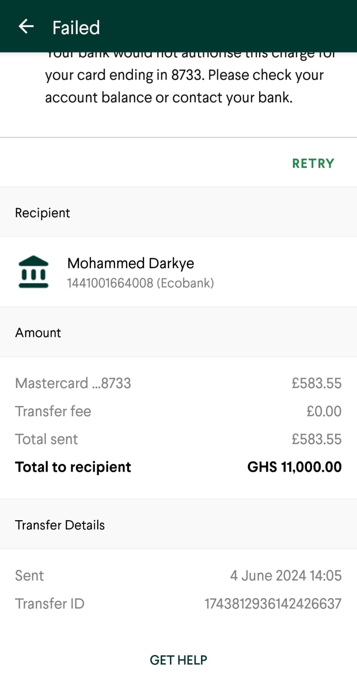

Status:- Failed

Amount:- 11,000 GHC

Date :- 4th June 2024 - 2:05pm

Transaction ID – 1743812936142426637

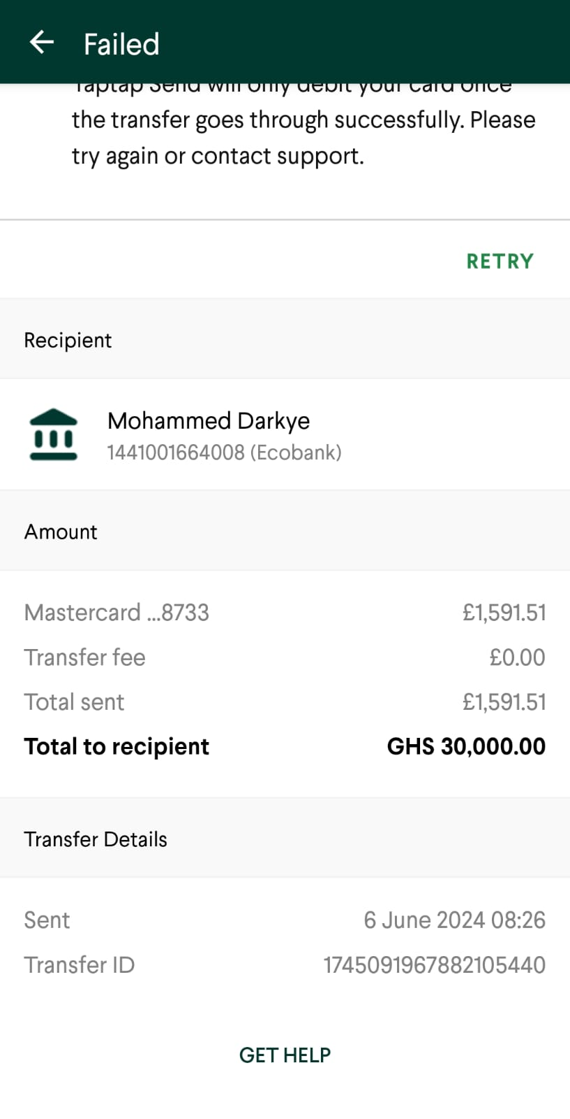

Status:- Failed

Amount:- 30,000 GHC

Date :- 6th June 2024

Transaction ID – 1745091967882105440

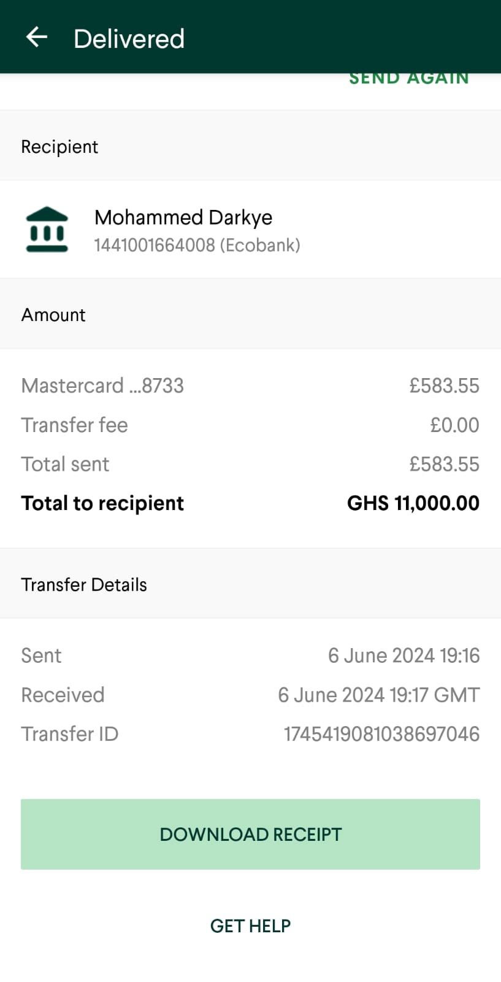

Status:- Delivered

Amount:- 11,000 GHC

Date :- 6th June 2024

Transaction ID – 1745419081038697046

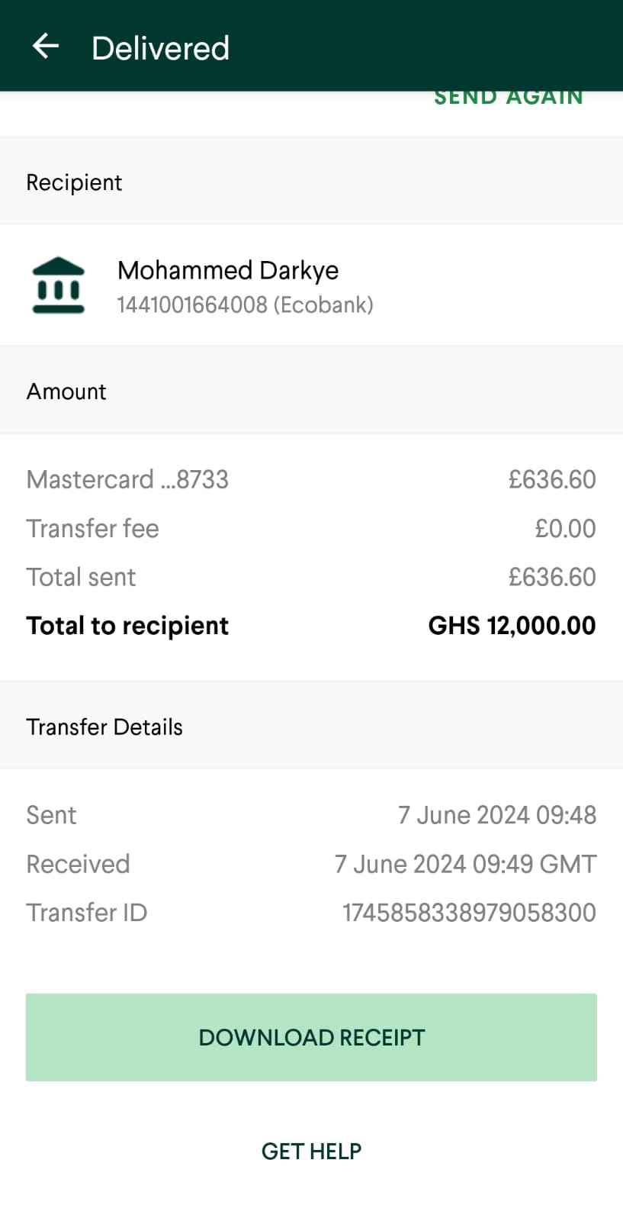

Status:- Delivered

Amount:- 12,000 GHC

Date :- 7th June 2024

Transaction ID – 1745858338979058300