NIKON LOGFILE README

Tuesday, May 12, 2015 10:00:05 AM EDT

This document describes the data gathering for a Nikon CMM machine that updates a tab separated log file. Multiple adapters to Nikon software are possible, each contained within one MTConnect Agent.

The NIKON Agent contains back end adapters that read a log file generated from the CMM periodically (typically when an event occurs within the CMM). The log file contains events and not samples, but all the events are time stamped and in absolute order of occurrence.

The file is specified as a Window cross-platform file, so it must contain the PC or computer name. UNC is short for Universal Naming Convention and specifies a Windows syntax to describe the location of a network resource, such as a shared file, directory, or printer. The UNC syntax for Windows systems has the generic form:

\\ComputerName\SharedResource

In our case the SharedResource is a shared file that must be explicitly sharable. In order to use the UNC file, Microsoft File Operations: CreateFile, ReadFile and CloseFile are used as other generic C++ file operations did not work (but were originally tried.) UNC files on Windows seem to require Windows specific File operations. Note, the UNC file path must be accessible to other computers or it cannot be read.mInside the Agent are Adapters for each UNC file. Each Adapter runs as a thread, hence the distinction between 64 bit and 32 bit C++ solutions must be explicitly acknowledged in installing the binary exe. That is, 32-bit MTConnect agents do not on 64 bit platforms, although they may appear to.

In the Nikon file, it saves all events with each line within the UNC shared file. The delimiter between fields is “tab”. Each line contains an event describing a machine state transition, so that all the lines of the UNC file must be read to understand the current state (machine on is one event, and then run program is another event). Note, no error detection of runaway date or times is done.

Below is a sample of the last line found in the Nikon shared file.

2013-04-30 14:13:21.078 64 1024 CAMIO72u [0001] CAMIO Studio started

There are five fields: timestamp, ??, ??, version, and a status event.

|  |  |
| --- | --- |
| Field | Example |
| timestamp | 01/23/2014 9:48:56 |
| ?? | 64 |
| ?? | 1024 |
| version | CAMIO72u |
| status | [0001] CAMIO Studio started |

Below is a snippet from a sample log file generated by Nikon camio:

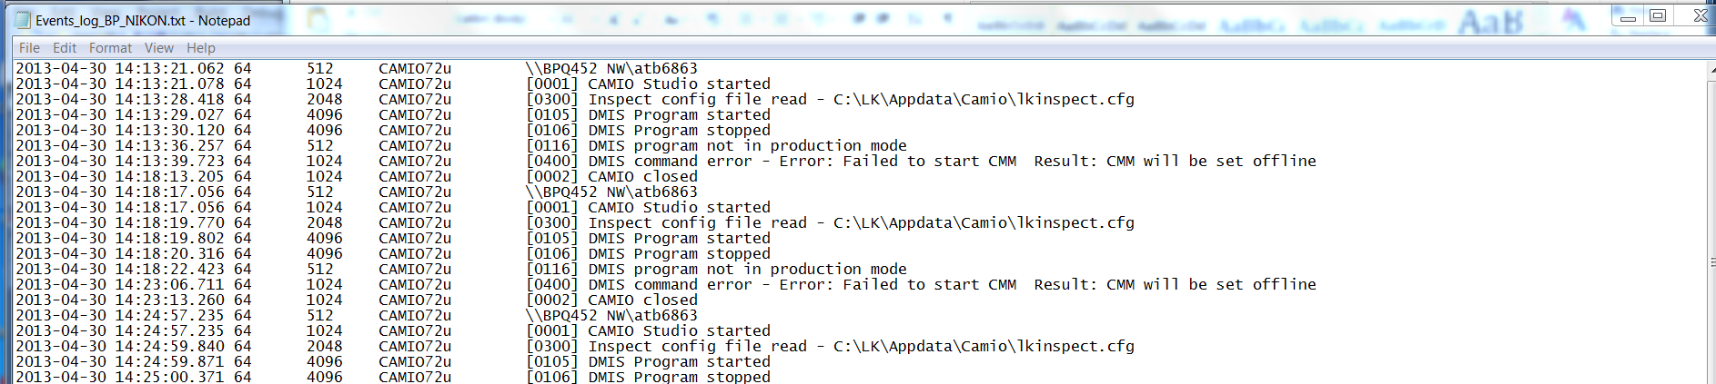

These log fields, specifically the field 5 “status” offers sufficient information to develop a stack lite state model. Below is the translation of the Nikon status messages into MTConnect controller logic:

|  |  |
| --- | --- |
| State | Action |
| CAMIO Studio started | power=ON  controllermode=MANUAL  execution=IDLE |
| CAMIO Studio stopped | power=OFF  controllermode=UNAVAILABLE  execution= UNAVAILABLE |
| DMIS Program started | power=ON  controllermode=AUTOMATIC  execution=EXECUTING |
| DMIS Program stopped | power=ON  controllermode=MANUAL  execution=IDLE |
| DMIS command error - | power=ON  controllermode=MANUAL  execution=IDLE  error=message following dash |
| DMIS Program opened - | power=ON  controllermode=MANUAL  execution=IDLE  program=message following dash |
| Side effects | RPM and xyz move if automatic and executing |
|  |  |

Because of the deficiency of the MTConnect state logic, some side effects are generated to make the controller appear to be operating: positions for x,y,z and RPM change after every update if the controller is in automatic mode and executing.