|  |  |  |  |
| --- | --- | --- | --- |
| **1** | **2** | **3** | 4 |
| **IDLE:**  RPM-Zero  Execution: Ready  Mode-Manual data input  Program- XYZ program  Axis- X,Y,Z,I,J,K not moving  Power-ON | **RUN:**  RPM->Zero  Execution: Executing  Mode-Auto  Axis- X,Y,Z,I,J,K is moving  Program- XYZ program  Power-ON | **Set up -(Yellow)**  RPM-Zero  Execution: Paused  Mode-Manual data input  Axis- X,Y,Z,I,J,K not moving  Program- XYZ program  Power-ON | Minor Stoppage:  RPM-Zero  Execution: Paused  Mode-Automatic  Axis- X,Y,Z,I,J,K not moving  Program- XYZ program  Power-ON |

Et, al,

Below is an attempt to “map” the data that we send to OEE, to the resulting OEE states on the webpage.

Basically, we send 9 pieces of information to the file (MTconnect)…. And the website displays numerous pieces of information, 6 of which we are interested in directly impacting with the data we send. (note… we don’t understand the “planned” status)

Things to note for this particular machine may be…

1. The machine is Always in automatic…. Never manual… manual mode is considered a fault
2. We have “pad changes” during the processing that are operator assisted that we need to collect information on and want to keep separate from “setup”

ALSO, an area that we need to still work.

…the cell processes 6 part numbers total,… most times multiple parts of the same part number are ran in succession,   3,4 8 parts in a row….

It would be good if we could to count each part and note them individually.   Not sure you can do that…. Maybe we can change the partnumber on our end.

Let us know when you can change these states on the interpretation to the web page….  We will then work the robot side to assure that it is in alignment with this chart as well by viewing the website and running tests on the robot until it does

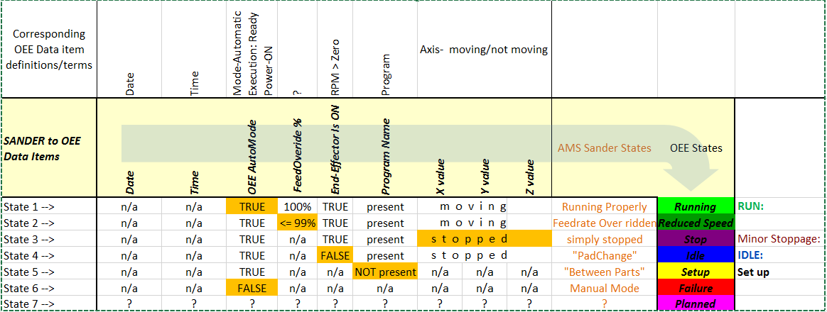

|  |  |  |  |
| --- | --- | --- | --- |
| **IDLE 1** | **RUN 2** | **Set up 3** | Minor Stoppage: 4 |
| **IDLE:**  RPM-Zero  Execution: Ready  Mode-Manual data input  Program- XYZ program  Axis- X,Y,Z,I,J,K not moving  Power-ON | **RUN:**  RPM->Zero  Execution: Executing  Mode-Auto  Axis- X,Y,Z,I,J,K is moving  Program- XYZ program  Power-ON | **Set up -(Yellow)**  RPM-Zero  Execution: Paused  Mode-Manual data input  Axis- X,Y,Z,I,J,K not moving  Program- XYZ program  Power-ON | Minor Stoppage:  RPM-Zero  Execution: Paused  Mode-Automatic  Axis- X,Y,Z,I,J,K not moving  Program- XYZ program  Power-ON |

Mike Kegley

253-653-5463

Capture

**From:** Venkatesh, Sid   
**Sent:** Friday, August 26, 2016 12:58 PM  
**To:** Kegley, Mike <[mike.kegley@Boeing.com](mailto:mike.kegley@Boeing.com)>  
**Cc:** Carroll, Robert A <[Robert.A.Carroll@boeing.com](mailto:Robert.A.Carroll@boeing.com)>  
**Subject:** RE: oee on the AMS sander

Mike,

Attached is the information on the OEE mapping.

Thanks,  
Sid Venkatesh

**From:** Kegley, Mike   
**Sent:** Thursday, August 25, 2016 8:15 PM  
**To:** Venkatesh, Sid <[sid.venkatesh@boeing.com](mailto:sid.venkatesh@boeing.com)>  
**Cc:** Carroll, Robert A <[Robert.A.Carroll@boeing.com](mailto:Robert.A.Carroll@boeing.com)>  
**Subject:** RE: oee on the AMS sander

…. And …now it’s running again… there may be some manual “pad” changes… where the robot doesn’t move, but program is running.

We should probably talk over this together and define the various catagories that we want to note in the data….. there may be more that pad changes that we need to delineate out from the “running” status.

**From:** Kegley, Mike   
**Sent:** Thursday, August 25, 2016 8:10 PM  
**To:** Venkatesh, Sid <[sid.venkatesh@boeing.com](mailto:sid.venkatesh@boeing.com)>  
**Cc:** 'Carroll, Robert A' <[Robert.A.Carroll@boeing.com](mailto:Robert.A.Carroll@boeing.com)>  
**Subject:** RE: oee on the AMS sander

Sid,

I think there is some mis-information on the web page, because the chart shows that it’s been running constantly for several hours now, and the data in the file shows that it hasn’t changed it’s xyz position in over an hour.

Note, you will need to use the xyz positions to determine “running”… because many of the robots “run” eternally….. but the fact that they are actively “running” doesn’t mean that they are processing a path program….

**From:** Venkatesh, Sid   
**Sent:** Thursday, August 25, 2016 1:50 PM  
**To:** Kegley, Mike <[mike.kegley@Boeing.com](mailto:mike.kegley@Boeing.com)>  
**Subject:** RE: oee on the AMS sander

Try the link to the webpage below.

[*http://lsdi-oee.web.boeing.com/admin/tools/startpage.aspx?sitekey=2&appname=NEM+Machine+Monitoring+Data+Analysis+-+ADC*](http://lsdi-oee.web.boeing.com/admin/tools/startpage.aspx?sitekey=2&appname=NEM+Machine+Monitoring+Data+Analysis+-+ADC)