Fanuc Lan Installation

This MTConnect Fanuc agent will not work on 64-bit Windows platforms. Only MTConnect Adapters run on 32-bit windows plaforms. You will need to install a 32-bit Fanuc Lan adapter (with 32 bit focas dll) to get data.

# Run MSI script:

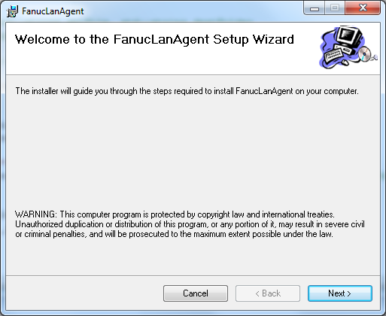

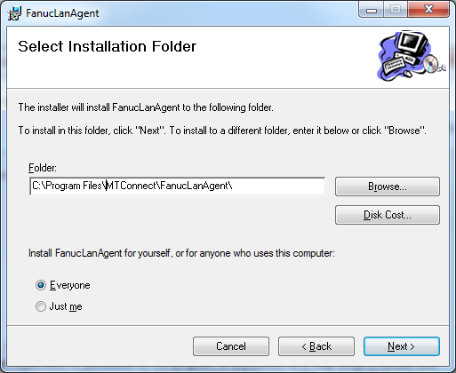

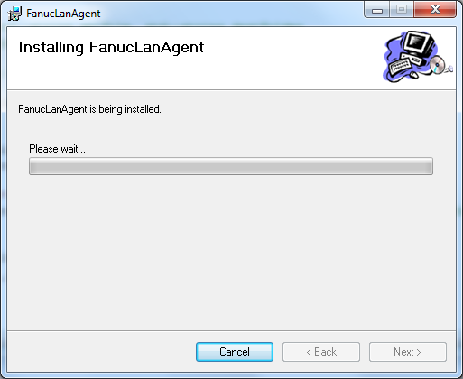

You should see black CMD screens pop up in the background. This is

If you get this Error popup, you do not have Focas installed on your Fanuc controller:

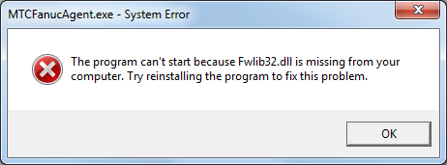

On Windows XP it will install at : C:\Program Files\MTConnect\FanucLanAgent

On Windows 7 it will install at C:\Program Files (x86)\MTConnect\FanucLanAgent **BUT WONT RUN**. YOU NEED 64 bit for some agent threading and debugging.

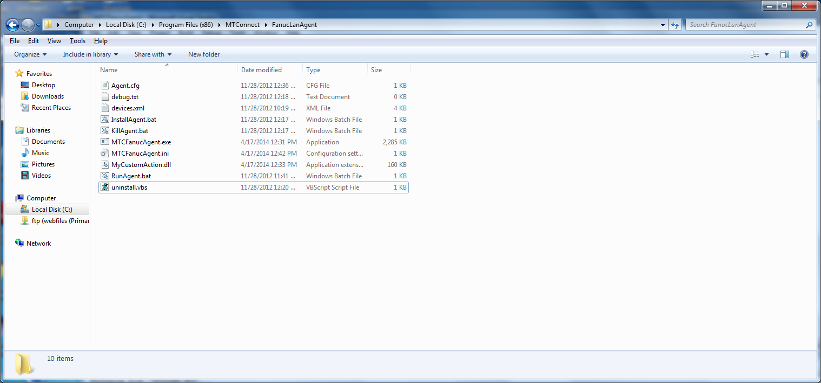

If you don’t seed MTCFanucAgent in Services:

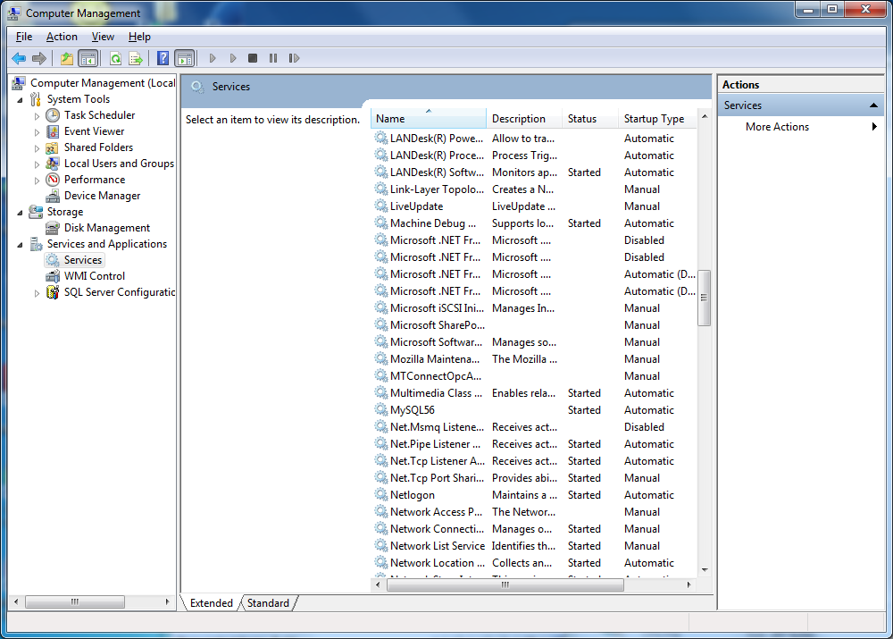

You will need to run Install – BUT YOU WILL NEED FWLIB32.DLL (focas library). There are correct and incorrect fwlib32.dll TOO!