This upgrade now uses fanuc fwlib64, but still uses the mtconnect agent core version 1.2. It was hoped that less moving parts will make it easier to debug.

1) Problem: redefinition of boost::noncopyable_::noncopyable.

From: <https://sourceforge.net/p/dclib/discussion/442517/thread/cfd6538b/>

In file dlib/noncopyable.

#ifndef DLIB_BOOST_NONCOPYABLE_HPP_INCLUDED

#define DLIB_BOOST_NONCOPYABLE_HPP_INCLUDED

namespace dlib {

class noncopyable {

protected:

noncopyable() {}

~noncopyable() {}

private:

noncopyable(const noncopyable&);

const noncopyable& operator=(const noncopyable&);

};

}

#endif // DLIB_BOOST_NONCOPYABLE_HPP_INCLUDED

2) Missing lib Add to project properties-> Linker->General

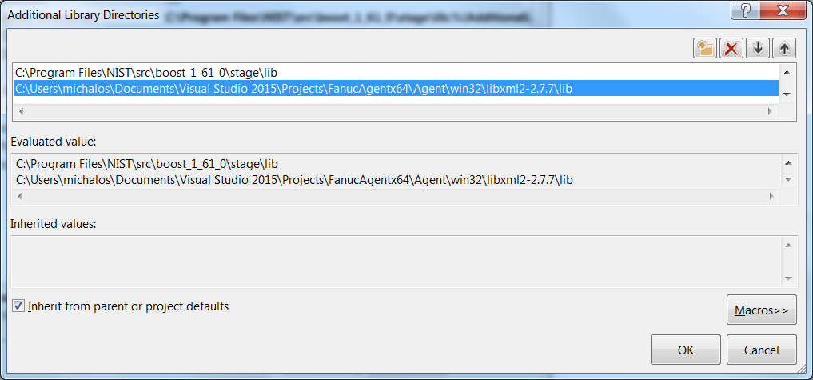

0) Create console project - no precompiled ATL, etc.  
a) Setup project as multibyte not Unicode string  
b) Make Project options: Compiler-> code generation-> Runtime static lib use of C lib

1) Create MTCAgent folder copy in agent/lib/win32 code

2) Preprocessor - Add these definitions  
a) _Windows  
  
b) WIN64 for 64 bit configurations for later #pragma lib includes described below  
c) _NO_CRT_STDIO_INLINE for problem (9) doesn't solve but should

3) Include file : In project properties, Projects->Compiler->Command line Add: @IncludeDirs.txt  
You will have to adapt the full path to the location of your   
FIle IncludeDirs.txt:

-I"C:\Program Files\NIST\src\boost_1_61_0"

-I.

-I"C:\Users\michalos\Documents\Visual Studio 2015\Projects\FanucAgentx64"

-I"C:\Users\michalos\Documents\Visual Studio 2015\Projects\FanucAgentx64\Agent\agent"

-I"C:\Users\michalos\Documents\Visual Studio 2015\Projects\FanucAgentx64\Agent\lib"

-I"C:\Users\michalos\Documents\Visual Studio 2015\Projects\FanucAgentx64\Agent\win32\libxml2-2.7.7\include"

4) No gets() in service.cpp in VS 2015

*The most recent revision of the C standard (2011) has definitively removed this function from its specification.  
The function is deprecated in C++ (as of 2011 standard, which follows C99+TC3).*  
from  
<http://stackoverflow.com/questions/12893774/what-is-gets-equivalent-in-c11>

Subsituted:

while(gets_s(line, sizeof(line)) != NULL) {

5) timezone not declared   
globals.cpp(241): error C2065: 'timezone': undeclared identifier

uint64_t time = (mktime(&timeinfo) - timezone) * 1000000;

Removed timezone to make it compile - but not really FIXED!

8) ibxml2d_a_v120_64.lib(error.obj) : error LNK2001: unresolved external symbol __iob_func

<http://stackoverflow.com/questions/30412951/unresolved-external-symbol-imp-fprintf-and-imp-iob-func-sdl2>

Added to project main file:

FILE _iob[] = {*stdin, *stdout, *stderr};  
extern "C" FILE * __cdecl __iob_func(void)  
{  
return _iob;  
}

9) unresolved external symbol vfprintf   
#pragma comment(lib, "legacy_stdio_definitions.lib")

10) Add fwlib64.lib to linker path: used pragma with path. This will have to be customized. Lib is same for debug as well as release builds.

#define FANUCLIBPATH(X) "C:\\Users\\michalos\\Documents\\Visual Studio 2015\\Projects\\FanucAgentx64\\Fwlib64\\" ## X

#if defined( WIN64 ) && defined( _DEBUG )

#pragma message( "DEBUG x64" )

#pragma comment(lib, FANUCLIBPATH("fwlib64.lib"))