SHDR Test README

Monday, October 30, 2017

The document briefly explains how to run SHDR output testing facility.

In the folder C:\Users\michalos\Documents\GitHub\Agents\MTConnectAgentFromShdr\Deployment\FakeWashDMGShdrAdapter you can find a DOS batch file that will start a simulated SHDR adapter. It uses the Config.ini file, which tells the shdr exe to reads file telnet DMG.txt.

The telent DMG.txt file was massaged to that it was acceptable to the , since it was a telent capture, which injects carriage returns and line feeds after the output fills a window. So all ^p were replaced with a null character (nothing), and then the 2017 was replaced by a ^p2017 so that every new SHDR line starts on a separate line. This was done in Word, but any text editor that can match a new line should work. Otherwise the SHDR text will be misread and exception will be thrown and the exe app will terminated.

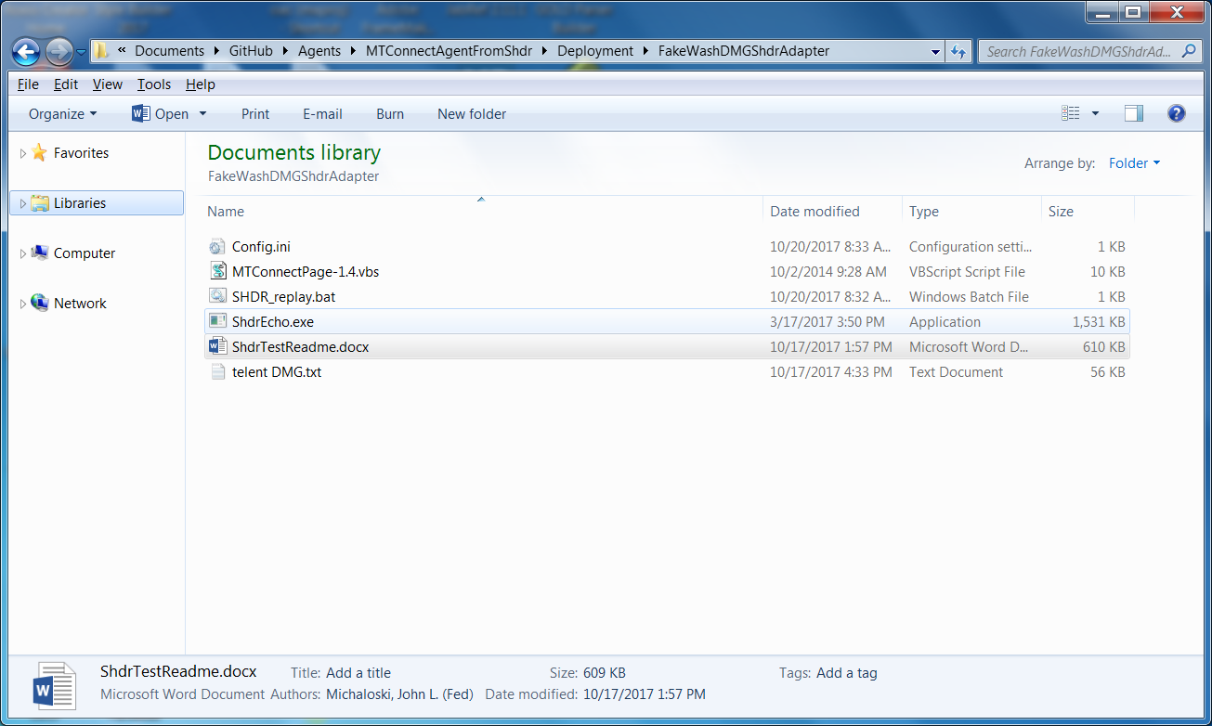

1. Copy in your SHDR file into a new folder and copy over the files in the above folder:
2. You will need to configure the ini file so that the ShdrEcho.exe app will work properly. You will need to set the filename to the fullpath of the new folder and the saved SHDR filename. Below is an exmpale from the existing folder. The

[GLOBALS]

Filename= C:\Users\michalos\Documents\GitHub\MTConnectSolutions\ShdrEcho\ShdrEcho\x64\Debug\Mazak157_198602_3-9-17.txt

Repeat=1

Wait=1

PortNum=7878

IP=127.0.0.1

TimeMultipler=1.0

