XYZIJK Shdr Adapter Instructions

6/9/2017 10:19:24 AM

# XYZIJK Exe

The XYZIJK Exe was built with QT using 32 bit mingw to compile C++ code so it can run on either 32 or 64 bit Windows platforms. There is an C++ open source version of the Adapter on <https://github.com/mtconnect/adapter>.

1. Extract the contents of the zip file into a folder. You should see:

Config.ini

libgcc_s_dw2-1.dll

libstdc++-6.dll

libwinpthread-1.dll

out.txt

Qt5Core.dll

ShdrEcho.exe

* The dll are required for QT execution.
* The out.txt contains a timestamp list of xyzijk that are adjusted to the current time and output in sequence based on the timing differential between SHDR lines.
* Configuration is done with Config.ini
* ShdrEcho.exe is the application which reads out.txt and listens for connection on port 7878 (configurable in Config.ini).

1. Double click ShdrEcho.exe to run. A command window should pop up.
2. You should then start a telnet session to connect to the XYZIJK streaming (described next). The Pongs are sent every second of so, and if the client socket does not receive one, it disconnects and reconnects (to overcome potential socket hanging that occurs if the program is run for a long time.)
3. To terminate program, click the X in upper right hand corner of the DOS window that is associated with ShdrEcho.exe app.

# Telnet Operation

To start a telnet session on windows make sure telnet is installed as a windows component. <https://technet.microsoft.com/en-us/library/cc771275(v=ws.10).aspx>

Then start telnet in a cmd window. To open a cmd windows, Start->Run and after the Run dialog pops up enter cmd:

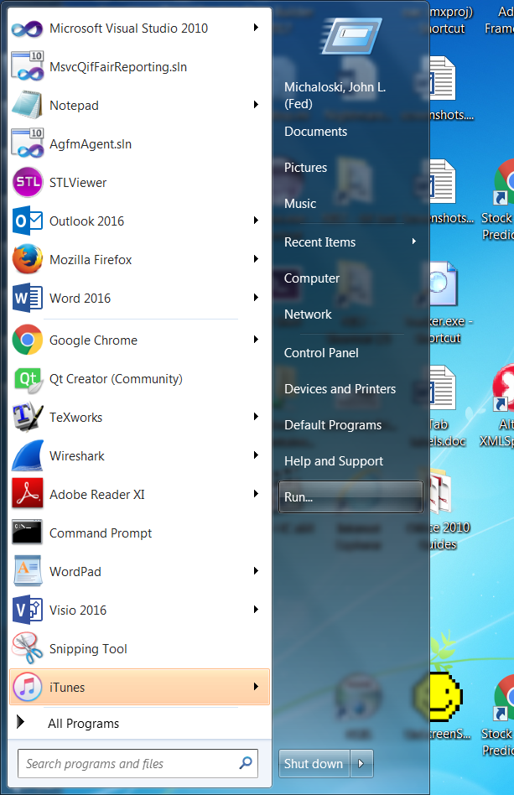

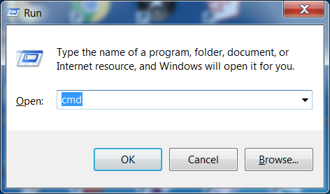

You will then see a cmd window and then you enter "telnet" command:

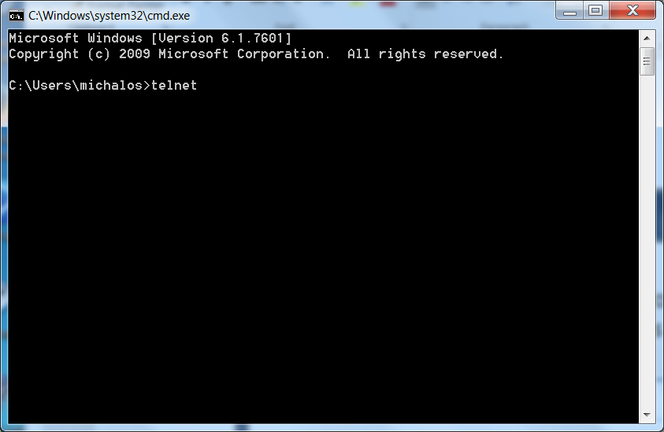

After telnet has started, enter ip and port number you wish to communicate with (in this case localhost (127.0.0.1) and port 7878).

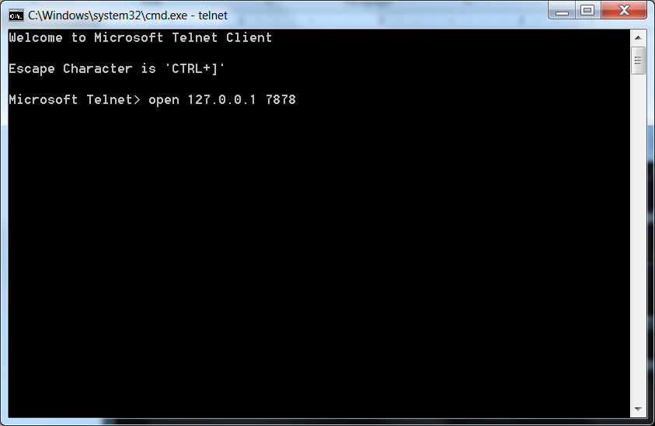

If the XYZIJK adapter code is running you should see a timestamp "SHDR" format streaming:

