

ASIA PACIFIC UNIVERSITY OF TECHNOLOGY AND INNOVATION
CT029-3-2-ISE-L-4 IMAGE AND SPECIAL EFFECTS
GROUP ASSIGNMENT – PROPOSAL

AuraTable
Lecturer: Ms. Mary Ting
No. | Student Name | TP Number | Signature
1 | Ellisa Thong Wei Zi | TP078056 | 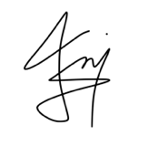
2 | Foo Yee Cheng | TP079833 | 
3 | Ivan Ong Hai Wen | TP080397
4 | Loh Zi Ching | TP080732

Intake Code: APU2F2602CS / APU2F2602CS (AI)
Hand Out Date: 6 August (WEEK 1)
Hand In Date: 17 September (WEEK 7)

Table of Contents
1. Project Overview 2
1.1 Intended User Experience 2
1.2 Objectives 2
1.3 Core Gameplay Loop 3
2. Narrative 4
2.1 Story Summary 4
2.2 Main Characters and Abilities 4
2.3 Setting and Mood 4
2.4 Rules and Progress Variables 5
2.5 Character Reference Sheet 5
3. Workload Matrix 6
3.1 Shared Group Responsibilities 6
3.2 Integration Agreement 7
4. Storyboard 8
4.1 Scene 1 The Welcome Table 8
4.2 Scene 2 Preparation Counter 8
4.3 Scene 3 The Living Stove 9
4.4 Scene 4 Plate and Serve 10
4.5 Storyboard Panels (Visual Layout Sketches) 10
5. Asset Plan 13
5.1 Visual Assets 13
5.2 Character Animation Plan 13
5.3 Audio Assets 14
5.4 Mood Board and Colour Palette 14
6. Technical and Interaction Plan 15
6.1 Proposed Arcade Structure 15
6.2 Event Driven Mechanics 15
6.3 Special Effects and Purpose 16
6.4 Applied Image Processing and Computer Graphics Techniques 16
7 Asset Production and Management 18
7.1 Creation and Source Strategy 18
7.2 File Specification 18
7.3 Proposed Folder Structure 18
7.4 Risks and Mitigation 19
7.5 Tools and Software 19
7.6 Production Timeline (Weeks 1 to 7) 20
7.7 Sample Asset Register 20
8 Phase 1 Deliverables Checklist 22
9 Conclusion 22

1. Project Overview
AuraTable is a four-scene interactive dining experience in which the player helps a young chef prepare a meaningful meal for a guest. Each scene represents a different part of dining: welcoming and ordering, ingredient preparation, cooking, and plating and service. The experience combines mouse and keyboard input, animated sprites, timed challenges, scene transitions, sound cues, particles, lighting, and simple decision-making. The connected structure allows every group member to build one scene independently while following one shared narrative and visual style.

1.1 Intended User Experience
The player should feel that the meal is being created through their actions rather than shown as a passive animation. Clear prompts introduce each task, immediate audiovisual feedback confirms successful actions, and mistakes remain recoverable. Performance in earlier scenes changes the final meal rating, encouraging the player to replay the experience.

1.2 Objectives
- Create a coherent dining narrative across at least four interactive scenes.
- Apply event-driven programming through mouse clicks, dragging, keyboard input, timers, collision checks, and scene-state changes.
- Integrate original or properly licensed backgrounds, characters, food sprites, interface graphics, animations, music, and sound effects.
- Use meaningful special effects such as steam, splashes, sparks, glow, screen fades, and celebratory particles.
- Build each scene as a separate Arcade View so individual work can be integrated into one application.

1.3 Core Gameplay Loop
Step | Player Action | System Response
1. Explore | Read the guest request and inspect visual prompts. | Highlights usable objects and explains the objective.
2. Interact | Click, drag, press keys, or complete a timed action. | Updates animation, sound, progress, and score.
3. Receive Feedback | Correct mistakes or continue after success. | Displays particles, colour changes, status icons, and short messages.
4. Transition | Select Continue after completing the scene. | Carries order, quality, and timing values into the next Arcade View.

2. Workload Matrix
Each member owns one scene and its assets, code, testing, and documentation. Shared conventions are agreed before implementation so the four Arcade Views can be integrated without rewriting scene logic.
Member | Assigned Scene | Primary Responsibilities | Expected Output
Member 1 | Scene 1:  The Welcome Table | Narrative opening, dialogue system, order selection, character animations, dining-room ambience, transition to preparation. | welcome_view.py and Scene 1 assets
Member 2 | Scene 2: Preparation Counter | Ingredient dragging, wash and chop interactions, collision zones, chopping animation, splash and slice particles, preparation score. | prep_view.py and Scene 2 assets
Member 3 | Scene 3:  The Living Stove | Heat meter, stirring input, timer, ingredient transformation, steam and spark effects, cooking score. | cook_view.py and Scene 3 assets
Member 4 | Scene 4:  Plate and Serve | Drag-and-drop plating, garnish logic, table lighting, guest reaction, ending grades, replay function, final integration support. | serve_view.py and Scene 4 assets

2.1 Shared Group Responsibilities
Task | Lead | All Members Contribute By
Project structure and naming | Member 1 | Following agreed filenames, screen dimensions, asset folders, and state-variable names.
Visual consistency | Member 2 | Using the shared colour palette, sprite scale, line style, and interface components.
Audio consistency | Member 3 | Normalising volume, trimming clips, and avoiding abrupt loops.
Integration and final test | Member 4 | Testing another member’s scene and recording issues before the final build.
Storyboard and report evidence | All | Saving screenshots, asset sources, test notes, and individual technical explanations.

2.2 Integration Agreement
- Use a 1280 by 720 window and a shared game_state dictionary passed between Arcade Views.
- Store visual files in assets/images, audio in assets/audio, fonts in assets/fonts, and scene modules in views.
- Use snake_case filenames without spaces and transparent PNG files for sprites.
- Each scene must provide setup, on_draw, on_update, on_key_press, on_mouse_press, and any required drag handlers.
- A scene is complete only when it can start independently, complete its objective, and transition using test state values.

3. Narrative

3.1 Story Summary
Mira, a new chef at the enchanted restaurant AuraTable, receives her first special guest of the evening. The guest, Sol, arrives carrying a dim Aura Crystal that brightens only when a meal is prepared with care. Guided by Lumi, a small floating kitchen spirit, the player must understand Sol’s preference, prepare fresh ingredients, control the stove, and plate the final dish. Every successful action adds light to the crystal. Careless preparation, excessive heat, or poor plating reduces the meal-quality score but does not stop the story. At the final table, the dish reveals a coloured aura based on the player’s choices and performance.

3.2 Main Characters and Abilities
Character | Design | Role and Abilities
Mira the Chef | Young chef in a teal apron; idle, walk, chop, stir, carry, and celebrate animations. | Player-controlled character. Moves between stations, picks up items, prepares food, cooks, and plates the dish.
Lumi the Kitchen Spirit | Small golden floating flame with expressive eyes and a soft glow. | Tutorial guide. Points toward objectives, gives hints after repeated mistakes, and reacts to success.
Sol the Guest | Calm traveller with a dim crystal pendant; seated and reaction poses. | Presents a random preference, evaluates the completed meal, and changes expression according to the result.
Aura Crystal | Interactive story object with dim, warm, bright, and radiant states. | Visual progress indicator. Its colour and particle intensity represent the cumulative meal-quality score.

3.3 Setting and Mood
The restaurant changes from a quiet evening dining room to a lively preparation counter, a warm cooking station, and an intimate final table. The art direction uses hand-painted 2D visuals, rounded interface elements, warm amber lighting, teal accents, and readable silhouettes. Soft restaurant ambience connects all scenes, while each stage introduces its own sound layer and colour temperature.

3.4 Rules and Progress Variables
Variable | Range | Purpose
order_choice | Herbal Bowl or Spicy Bowl | Determines the correct ingredients and final dish artwork.
quality_score | 0 to 100 | Increases for accuracy and decreases for mistakes.
prep_score | 0 to 30 | Records washing, cutting accuracy, and ingredient selection.
cook_score | 0 to 40 | Records heat control, stirring, and cooking time.
plate_score | 0 to 30 | Records placement, garnish, cleanliness, and serving.

3.5 Character Reference Sheet
A relative-scale layout sheet fixes each character's size, role, and colour identity before individual sprites are drawn, so all four scene owners keep the cast consistent. Final line art and full pose sets follow in Phase 2.

3.5.1 Mira the Chef
Player-controlled protagonist who moves between the four stations, picking up ingredients, operating the stove, and plating the final dish. Her actions drive the pacing of every scene, and how well she performs at each station feeds directly into the quality score that shapes the ending.
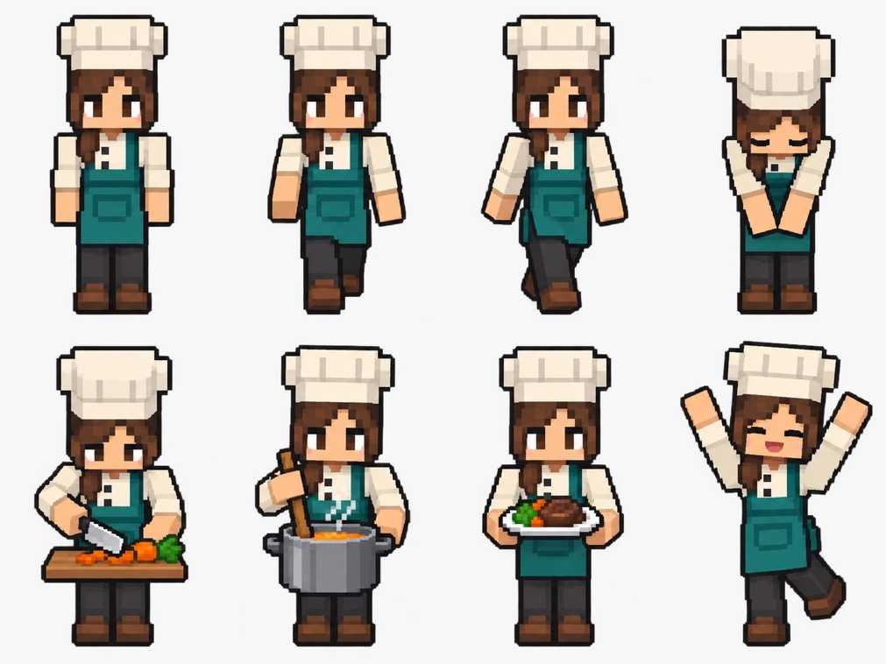
Figure 1 - All Mira Sprites

3.5.2 Lumi the Kitchen Spirit
Tutorial guide and emotional barometer for the player. Lumi floats near Mira to point toward the next objective, offers a hint after repeated mistakes, and visibly brightens or dims in response to the player's successes and failures, reinforcing feedback without needing extra on-screen text.
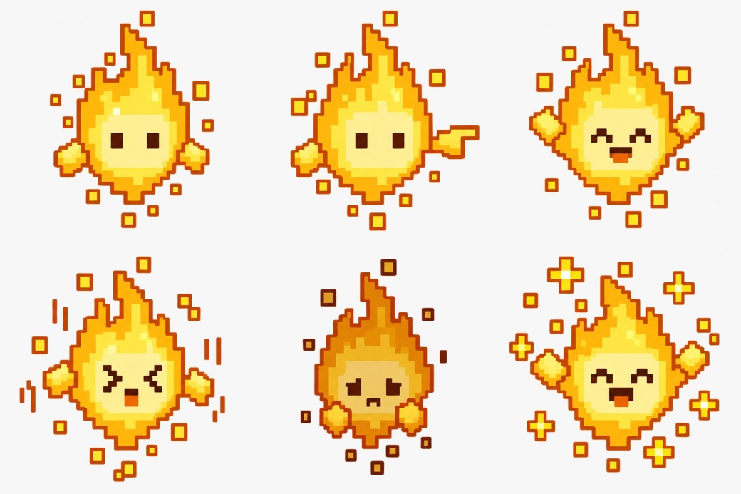
Figure 2 - All Lumi Sprites

3.5.3 Sol the Guest
Seated guest whose stated preference (Herbal Bowl or Spicy Bowl) sets order_choice at the very start of the story, and whose final reaction is the emotional payoff of the whole run. Sol's expression shifts across the meal to reflect the quality of what Mira has prepared.

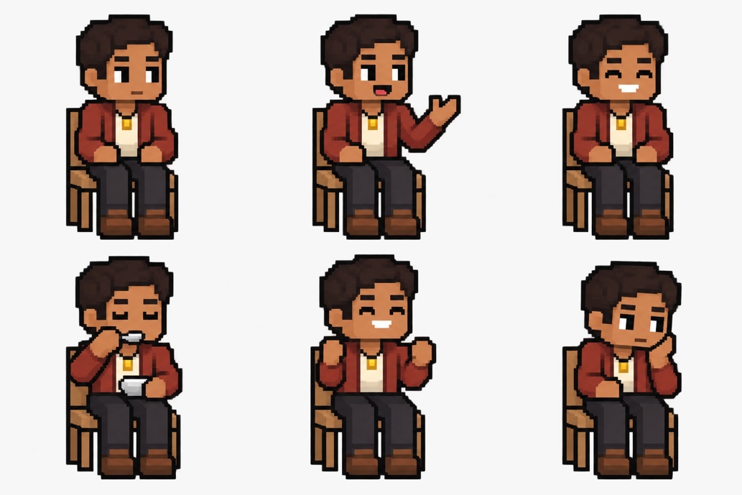
Figure 3 - All Sol Sprites

3.5.4 Aura Crystal
Non-character story object that visually tracks player performance across all four scenes. Every successful action adds light to it, and its final state — Fading, Warm, or Radiant — determines which ending the player sees.

Figure 4 - All Aura Crystals

4. Storyboard

4.1 Backgrounds
Title Screen
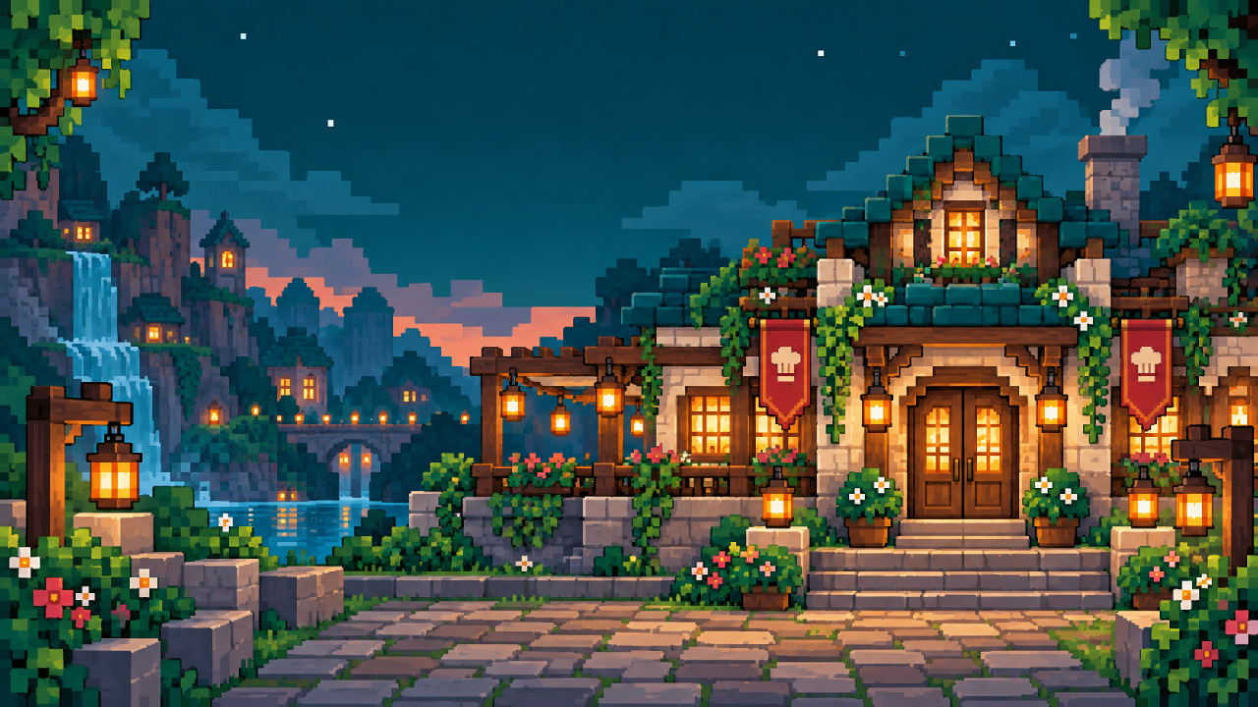
Figure 5 - Title Screen
Welcome Room
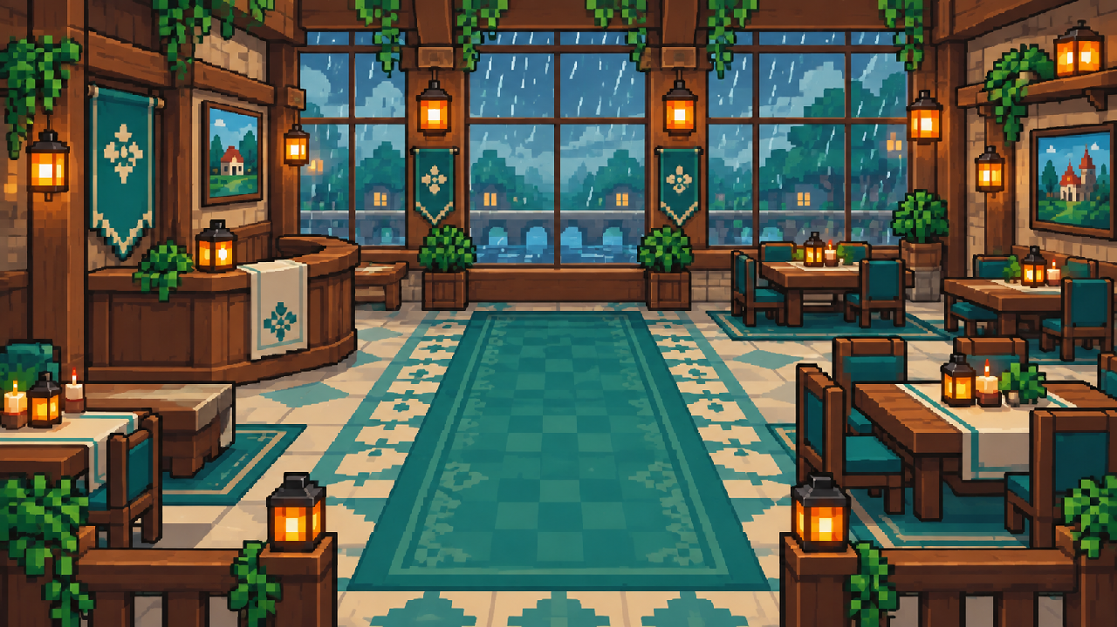
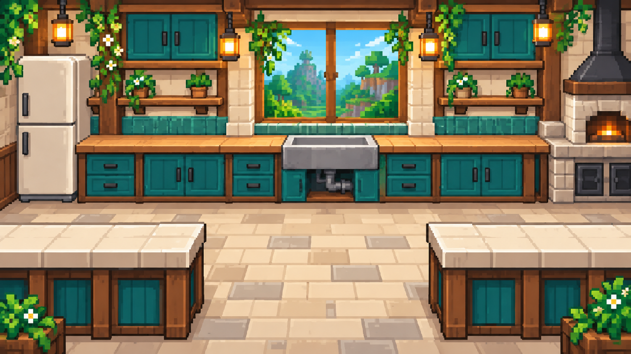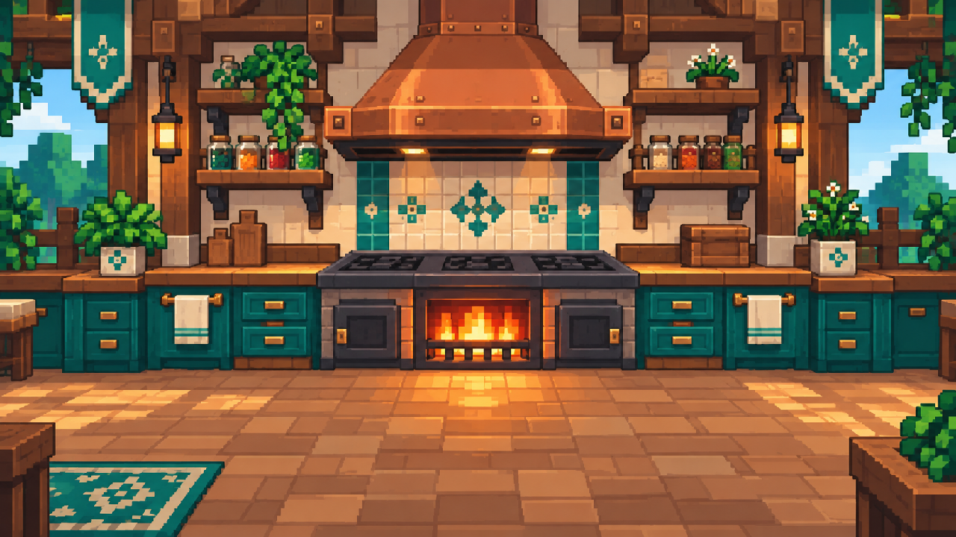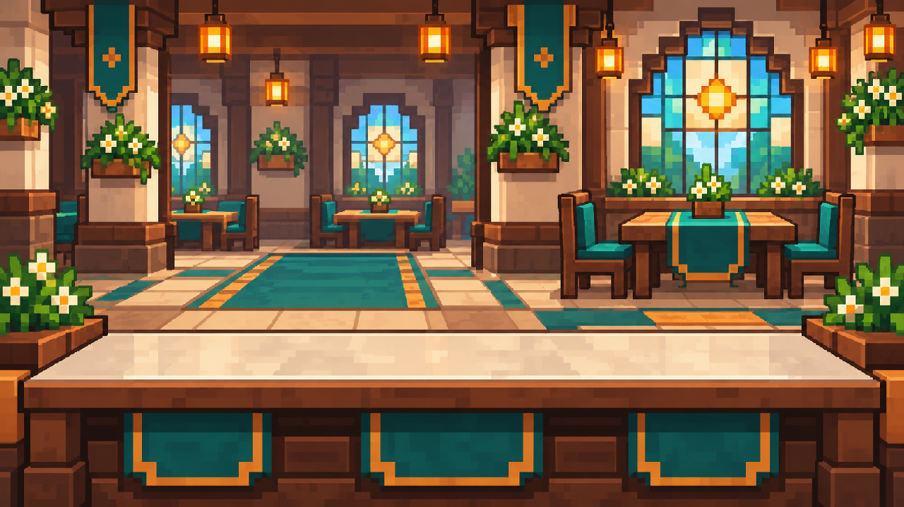
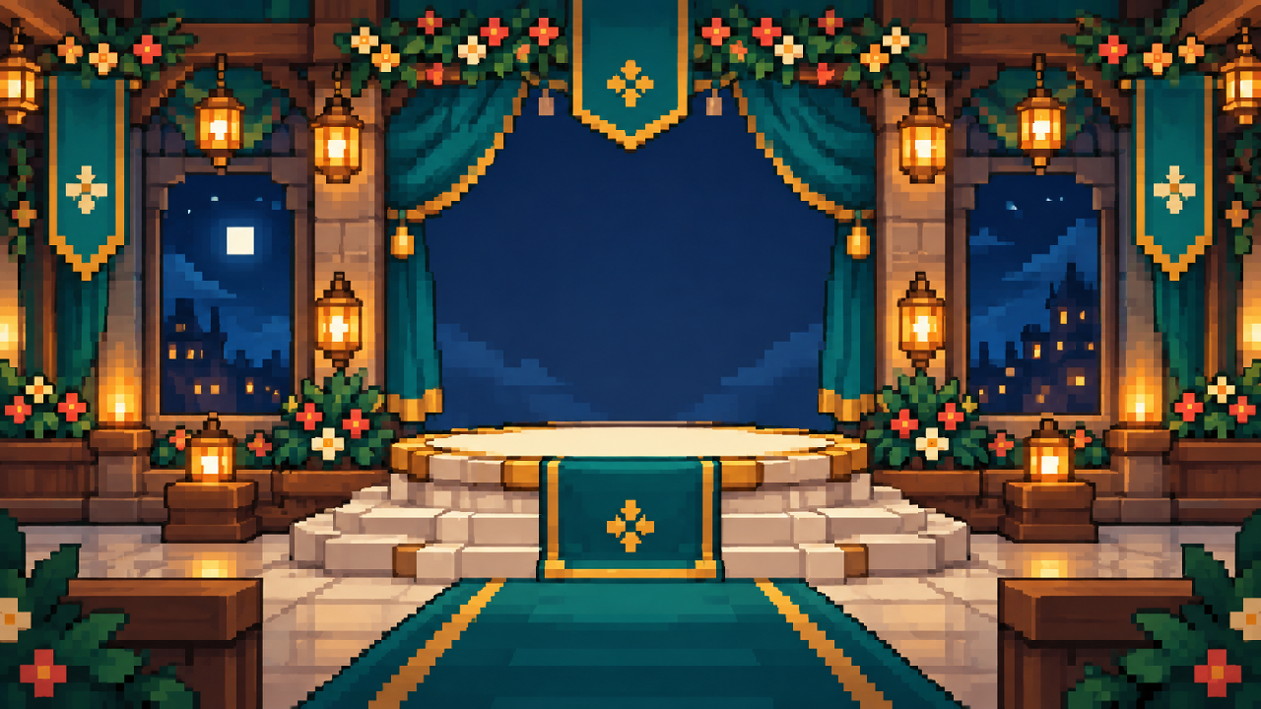

4.2 Scene 1: The Welcome Table
Element | Storyboard Detail
Dining Context | An evening restaurant entrance and table where Mira welcomes Sol and discovers the desired meal.
Opening Visual | Fade in from black. Rain moves outside the window, candles flicker, and Lumi floats beside Mira.
Player Goal | Approach the guest, advance the dialogue, and select the correct meal card from Sol’s preference clues.
Controls | Arrow or WASD keys move Mira. E starts dialogue. Mouse click selects a meal card and Continue.
Events and Logic | Entering the guest trigger zone enables dialogue. The selected card sets order_choice. A wrong choice prompts one retry and a clue from Lumi.
Animation | Mira walks and bows; Lumi bobs and glows; Sol changes from neutral to smiling; candle and rain loops continue.
Special Effects | Dialogue-card fade, crystal pulse, golden particles on a correct choice, and a full-screen wipe into the kitchen.
Audio | Soft restaurant music, rain ambience, footsteps, dialogue chime, card click, and crystal shimmer.
Completion | Correct order confirmed. quality_score starts at 10 and the preparation scene loads.

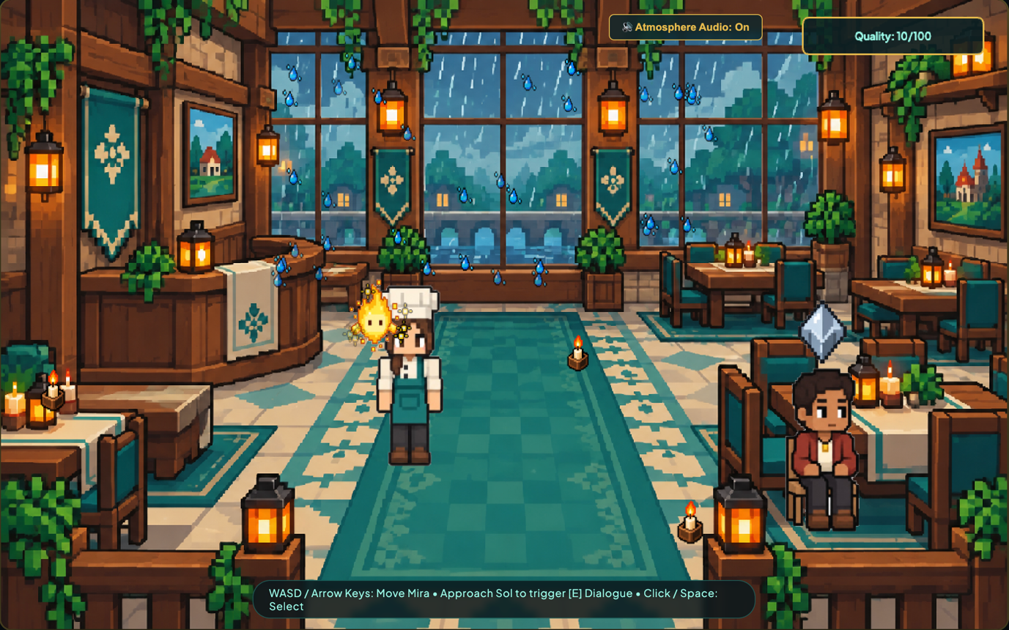
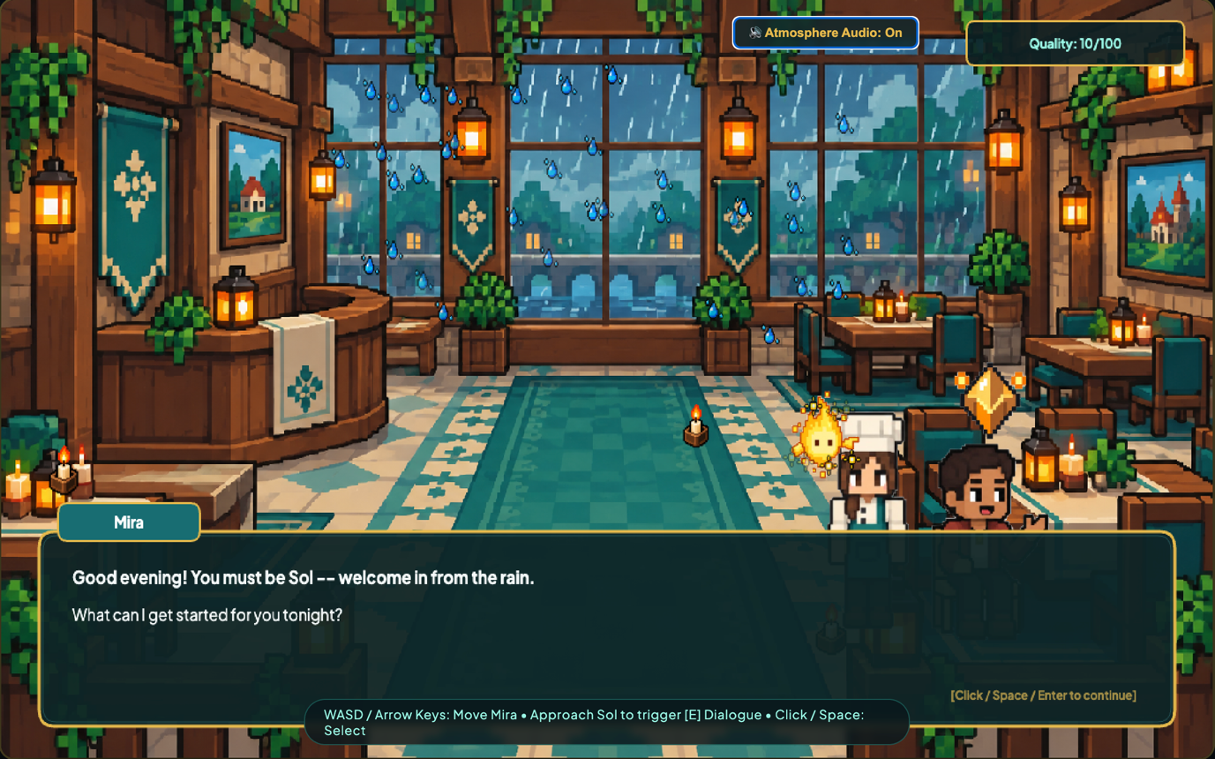

4.3 Scene 2 Preparation Counter
Element | Storyboard Detail
Dining Context | A visible open-kitchen counter where fresh ingredients are selected, washed, and chopped.
Opening Visual | Camera-like slide reveals ingredient baskets, sink, cutting board, knife, recipe card, and progress icons.
Player Goal | Drag three correct ingredients to the sink, wash them, then complete controlled chopping sequences.
Controls | Mouse drag moves ingredients. Hold mouse over the tap to wash. Press Space in the timing zone to chop.
Events and Logic | Drop-zone collision accepts or rejects items. Wash progress increases while held under water. Three accurate chop inputs complete each item.
Animation | Water flows, knife rises and falls, food changes into sliced sprites, Mira performs a chopping loop, Lumi reacts.
Special Effects | Water droplets, vegetable fragments, board shake, brief green glow for accuracy, and red outline for a wrong ingredient.
Audio | Water loop, basket rustle, knife taps with slight pitch variation, success bell, and soft error sound.
Completion | prep_score is calculated from correct selection and timing, then stored before the stove scene.

4.4 Scene 3 The Living Stove
Element | Storyboard Detail
Dining Context | A magical cooking station where ingredients visibly transform into the selected bowl.
Opening Visual | The pan slides onto a glowing stove. A recipe strip shows the required heat zone and cooking duration.
Player Goal | Add prepared ingredients, maintain safe heat, stir regularly, and stop cooking at the correct time.
Controls | Click ingredients to add them. Left and Right adjust heat. Circular mouse movement or repeated S presses stir. Enter serves.
Events and Logic | Temperature changes continuously. Leaving the target zone too long lowers cook_score. Stir events prevent burning. Ingredient sprites change through raw, cooking, and cooked states.
Animation | Pan contents bubble; Mira stirs; Lumi changes colour with temperature; sauce colour and texture develop over time.
Special Effects | Steam particles, tiny oil sparks, heat-wave overlay, stove glow, pan shake, and smoke if the food begins to burn.
Audio | Flame ignition, sizzling loop linked to heat, stirring scrape, bubbling, warning tick, and completion flourish.
Completion | cook_score is saved. A successful dish glows warmly; an overcooked dish remains playable but produces a lower final rating.

4.5 Scene 4 Plate and Serve
Element | Storyboard Detail
Dining Context | A plating bench followed by the guest’s candlelit table, completing the dining journey.
Opening Visual | Empty plate appears with transparent placement guides. Cooked food and garnishes rest on the side.
Player Goal | Arrange the main dish and garnish neatly, wipe any spill, then carry and serve the plate to Sol.
Controls | Mouse drag positions food. Click cloth and drag over spills. Arrow or WASD keys carry Mira to the table. E serves.
Events and Logic | Snap zones assess placement without demanding pixel-perfect accuracy. Correct garnish depends on order_choice. The final score combines prep, cook, and plate scores.
Animation | Food settles with bounce, sauce pours, Mira carries the plate, Sol tastes the meal, and the crystal changes state.
Special Effects | Sauce trail, garnish sparkle, spotlight vignette, crystal aura, confetti for high scores, and gentle fade to results.
Audio | Ceramic placement, sauce pour, cloth wipe, footsteps, chair movement, tasting reaction, crystal chord, and ending music.
Completion | Display Radiant, Warm, or Fading result with score breakdown and Replay or Exit buttons.

4.6 Storyboard Panels (Visual Layout Sketches) (Can delete)
The panels below give each scene's rough blocking — camera framing, background zones, character placement, and key UI regions — matching the panel-based visual storyboard format covered in class. These are pre-production layout sketches; final backgrounds and character art are produced in Phase 2.
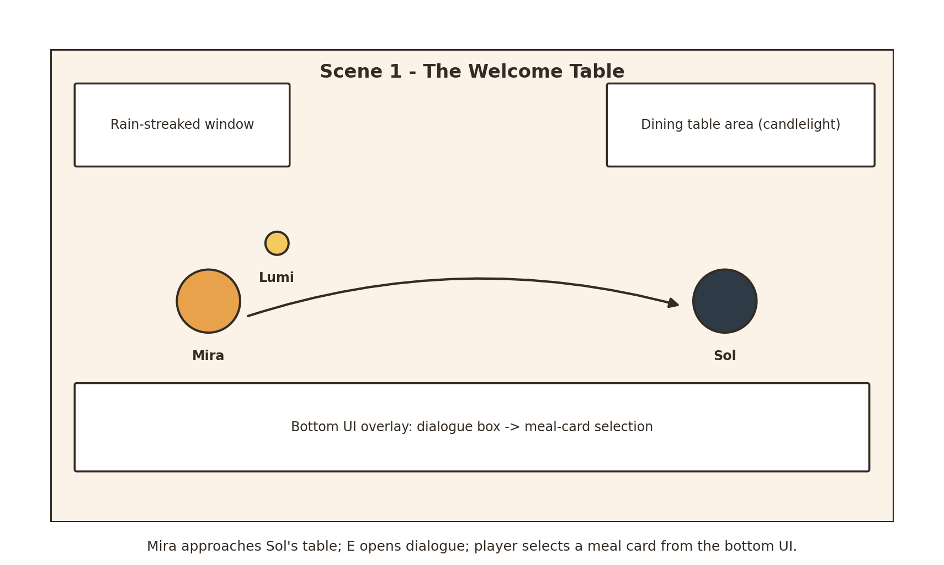
Figure 4.1 — Scene 1: The Welcome Table.
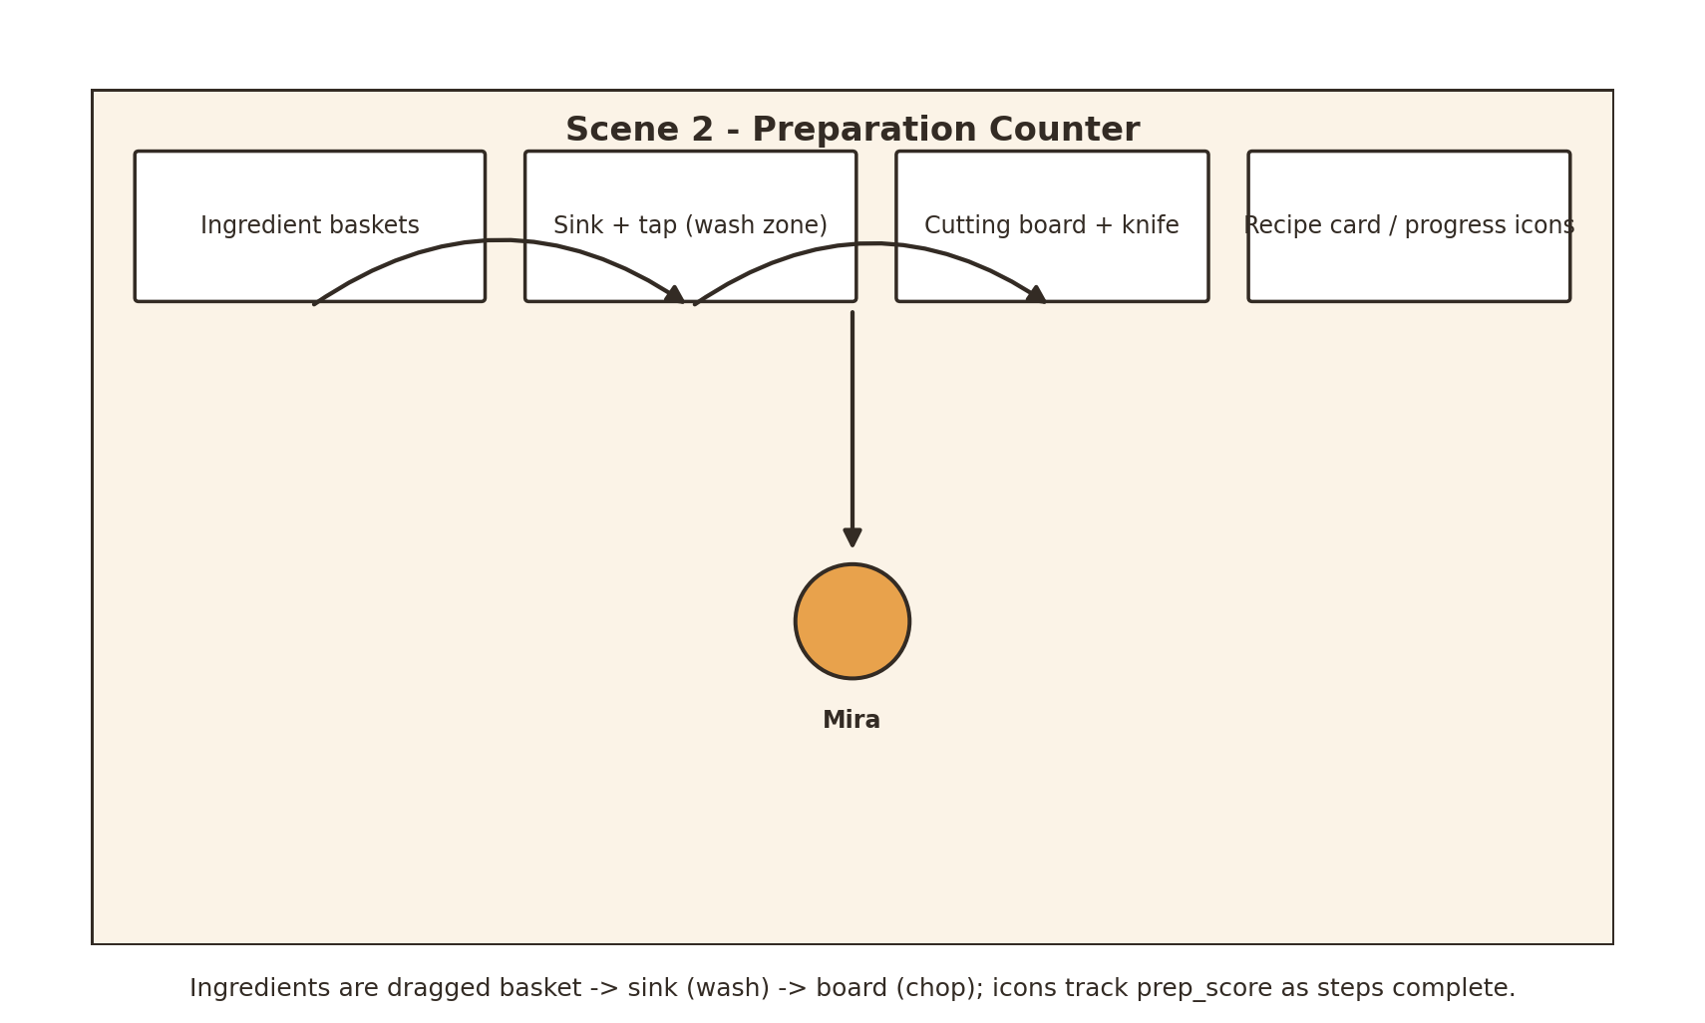
Figure 4.2 — Scene 2: Preparation Counter.
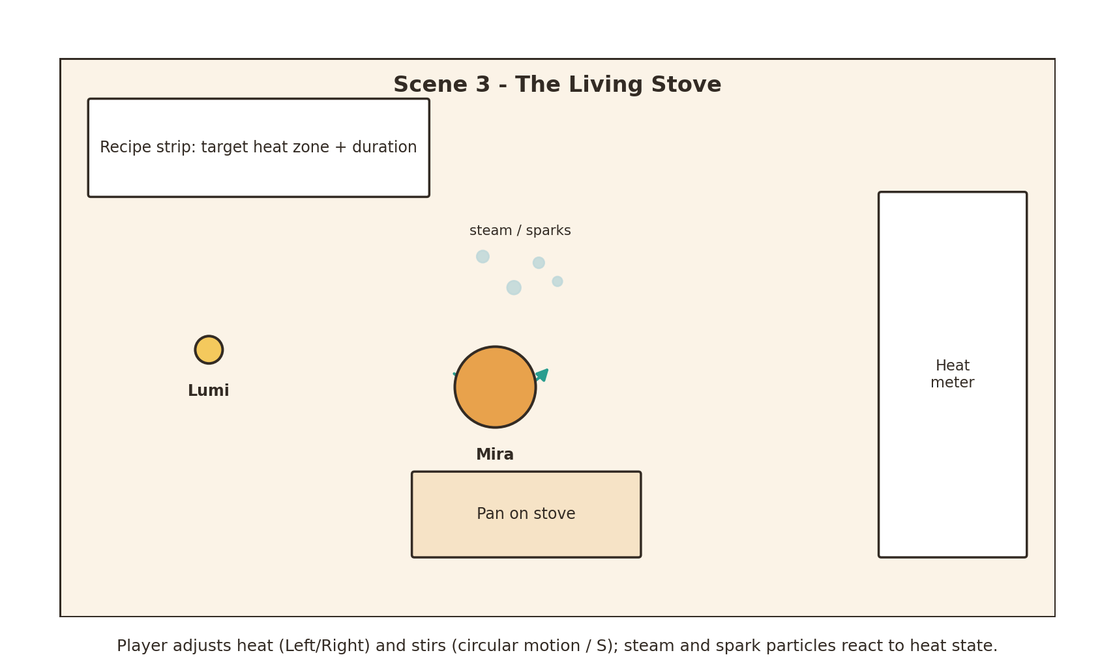
Figure 4.3 — Scene 3: The Living Stove.
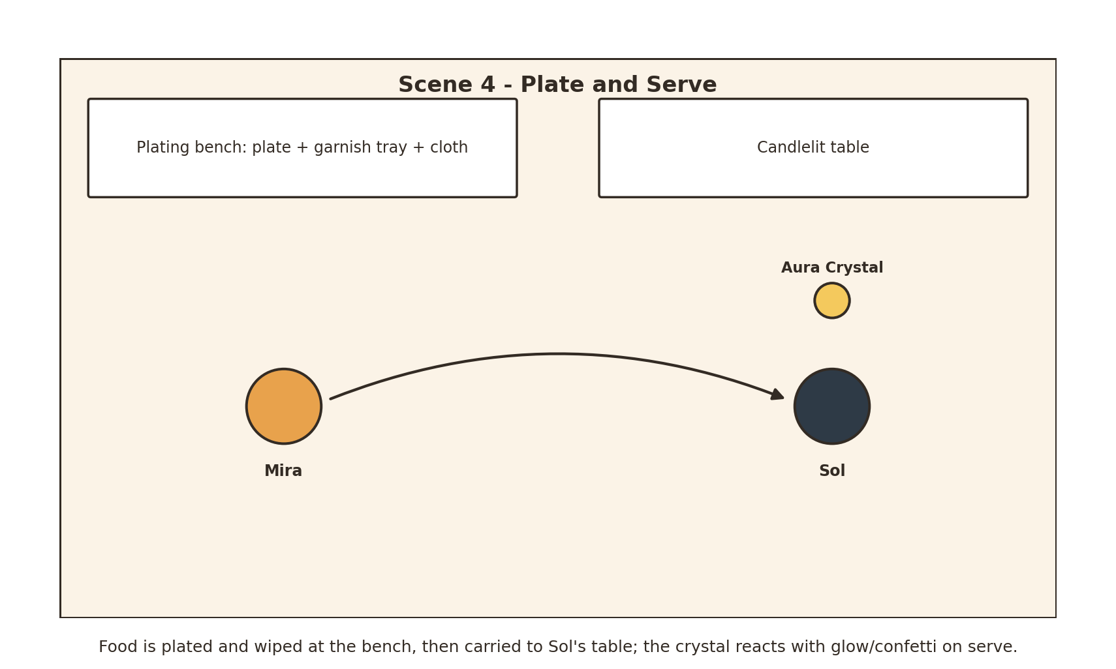
Figure 4.4 — Scene 4: Plate and Serve.

5. Asset Plan

5.1 Visual Assets
Category | Required Assets | Format and Notes | Owner
Backgrounds | Restaurant entrance, guest table, open kitchen, stove station, plating bench, result screen | 1280 by 720 PNG; layered foreground where needed | One per scene owner
Characters | Mira, Lumi, and Sol sprite sheets | Transparent PNG; consistent scale; idle and scene-specific actions | Members 1 and 2 coordinate
Food | Whole, washed, chopped, raw, cooking, cooked, plated, garnish, burnt variants | Transparent PNG; anchor points agreed before coding | Members 2 to 4
Props | Tables, chairs, candles, sink, tap, baskets, board, knife, stove, pan, bowl, cloth | PNG objects separated when interactive | Scene owner
Interface | Dialogue box, recipe card, buttons, heat meter, timer, score icons, cursor states | PNG or shapes drawn in Arcade; readable at 1280 by 720 | Shared set
Textures | Wood, ceramic, cloth, steam mask, glow gradient, vignette | Seamless or transparent PNG; compressed for loading | Members 2 to 4
Particles | Spark, droplet, food fragment, steam puff, smoke, glow mote, confetti | Small transparent PNG sprites reused by particle emitters | Scene owner

5.2 Character Animation Plan
Character | Animation States | Suggested Frames
Mira | Idle, walk four directions, bow, chop, stir, carry plate, celebrate | 4 to 8 frames per loop or action
Lumi | Float, point, happy pulse, warning shake, dim, radiant | 4 to 6 frames plus scale and glow animation
Sol | Idle seated, speak, smile, taste, delighted, disappointed | 3 to 6 frames per reaction
Food and Props | Water flow, chopping knife, bubbling pan, sauce pour, candle flame, crystal pulse | 3 to 8 frames or procedural movement

5.3 Audio Assets
Type | Asset List | Use and Trigger
Background Music | Calm dining theme; rhythmic kitchen variation; warm ending theme | Loop per scene at low volume; cross-fade during transitions.
Ambience | Rain, restaurant murmur, kitchen room tone, stove flame | Loop by environment; stop or reduce when leaving the scene.
Interaction Sounds | Footsteps, click, pickup, drop, water, chop, sizzle, stir, plate, wipe | Triggered by input and collision; short clips to maintain responsiveness.
Feedback Sounds | Correct chime, soft error, warning tick, score reveal, crystal shimmer | Triggered by success, error, time warning, results, and major story events.
Voice Clips Optional | Short non-verbal reactions from Mira, Lumi, and Sol | Used sparingly so the experience remains understandable without voice acting.

5.4 Mood Board and Colour Palette
The palette below anchors the RGB colour values every scene owner should sample from when producing backgrounds, sprites, and UI elements, keeping Section 2.3's art direction consistent across four independently built scenes.
Use | Colour code | Colour
Warm Amber | #E8A24C | 
Teal Accent | #2A9D8F | 
Ink / Outline | #332B24 | 
Parchment BG | #FBF3E7 | 
Crystal Glow | #F4C95D | 

6. Technical and Interaction Plan

6.1 Proposed Arcade Structure
Component | Planned Implementation
Application | A main Arcade Window launches a title view and switches between four scene Views.
Scene State | One game_state dictionary stores order choice, scores, tutorial state, and final result.
Sprites | Arcade Sprite and SpriteList manage characters, food, props, particles, and collision checks.
Input Events | Keyboard and mouse callbacks control movement, dialogue, dragging, timing actions, heat, stirring, and buttons.
Animation | Texture lists and frame timers animate sprites; interpolation provides bounce, fades, slides, and camera-like transitions.
Particles | Reusable emitter classes create droplets, fragments, steam, sparks, smoke, glow motes, and confetti.
Audio | Arcade sound objects play loops and event sounds, with volume levels stored centrally.
Testing | Each View is tested independently before integration; a debug key may jump between scenes during development.

6.2 Event Driven Mechanics
Event | Condition | Response
Guest Interaction | Mira enters trigger zone and presses E | Dialogue opens and movement temporarily pauses.
Ingredient Drop | Mouse releases ingredient over a target zone | Correct item snaps into place; wrong item returns with feedback.
Accurate Chop | Space is pressed while timing marker is green | Slice advances, sound plays, fragments appear, and score increases.
Unsafe Heat | Temperature remains outside target range | Warning flashes, smoke increases, and cooking score decreases gradually.
Successful Plate | Food overlaps an acceptable plate zone | Item snaps smoothly, sparkles appear, and plating progress updates.
Final Evaluation | Player serves the plate | Total score selects guest reaction, crystal state, result text, and ending audio.

6.3 Special Effects and Purpose
Effect | Scene | Purpose
Crystal glow and particles | 1 and 4 | Connect player performance to the story and provide a clear visual reward.
Water splash and food fragments | 2 | Make washing and chopping actions feel responsive and physical.
Steam, sparks, smoke, and heat waves | 3 | Communicate cooking state, temperature, success, and danger without relying only on text.
Sauce trail, spotlight, and confetti | 4 | Emphasise creative plating and celebrate the final dining result.
Fades, slides, and audio cross-fades | All | Join separately developed scenes into one continuous experience.

6.4 Applied Image Processing and Computer Graphics Techniques
Section 6.3 names the effects; this section names the specific technique behind each one, using the vocabulary from the module's Computer Graphics and Computer Graphic Modeling topics.
Effect in AuraTable | Scene(s) | Technique Applied
Steam rising from the pan | 3 | Particle system: a point emitter above the pan continuously spawns semi-transparent particles; an upward force plus turbulence drives the swirl, and each particle's life cycle fades its alpha and grows its size before removal.
Oil sparks | 3 | Particle system: short-lifespan bright particles emitted from the pan edge, pulled back down by a gravity force.
Water droplets and food fragments | 2 | Particle system: a burst emitter fires on the wash/chop event, with gravity and a short life cycle.
Crystal glow (dim -> warm -> bright -> radiant) | 1, 4 | Colour interpolation: linear interpolation between four defined RGB colour keyframes drives the crystal's tint and particle intensity as quality_score changes.
Golden particles on correct order / confetti on high score | 1, 4 | Particle system: a burst emitter with randomised velocity vectors and a gravity force for the fall-back motion.
Scene fades, wipes, and cross-fades | All | Post-processing / interpolation: the frame's alpha value is linearly interpolated between 0 and 1 over a fixed duration to fade between scenes.
Mira's walk, chop, stir, and carry animations | All | Frame-by-frame animation: a sprite-sheet texture list is cycled at a fixed frame rate rather than redrawn per frame.
Camera-like slide reveal at scene open | 2 | Translation transformation: the background layer's x-position is translated across several frames to simulate a camera pan.
Food bounce on plate placement | 4 | Scaling transformation: a brief non-uniform squash-then-stretch scale is applied to the sprite the instant it snaps into the plate zone.
Heat meter and timer bar fill | 3 | Linear interpolation: the current heat or time value is mapped onto bar width/colour between fixed minimum and maximum bounds.
Candlelight, stove glow, and plating spotlight | 1, 3, 4 | Lighting: point lighting for the candles and stove (light radiating from a single source); a directional-lighting spotlight with a post-processing vignette darkens the plating table's edges.

7 Asset Production and Management

7.1 Creation and Source Strategy
The group will prioritise original assets created with drawing, image-editing, modelling, or animation software. If third-party materials are used, only assets with suitable licences will be selected and recorded in an asset register containing creator, source link, licence, edits, and scene usage. All external assets will be modified where necessary to match the project’s scale, palette, and visual style. Music and sound effects will also be checked for reuse permission.

7.2 File Specification
Asset | Specification
Background | PNG, 1280 by 720 pixels, RGB colour, optimised file size
Sprite | Transparent PNG, power-of-two-friendly dimensions where practical, consistent centre or bottom-centre anchor
Sprite Sheet | Equal frame dimensions, labelled state and direction, no accidental padding
Sound Effect | WAV or OGG, trimmed silence, normalised volume, short duration
Music and Ambience | OGG, seamless loop where required, separate volume category
Filename | scene_category_description_state_number, for example s2_food_carrot_chopped_01.png

7.3 Proposed Folder Structure
auratable/
main.py
game_state.py
views/ welcome_view.py prep_view.py cook_view.py serve_view.py
assets/
images/backgrounds images/characters images/food images/ui images/effects
audio/music audio/ambience audio/sfx
fonts
documentation/ storyboard asset_register test_evidence

7.4 Risks and Mitigation
Risk | Mitigation
Different art styles or sprite sizes | Approve a palette, reference sheet, canvas scale, and sample sprite before producing the full asset set.
Scenes fail during integration | Agree on shared state keys and View interface early; test transitions using temporary placeholder assets.
Audio is too loud or loops poorly | Normalise files, trim silence, test with headphones and speakers, and store central volume settings.
Too many effects reduce performance | Limit particle counts, reuse sprites, remove off-screen particles, and test on the target computer.
Missing asset permission evidence | Maintain the asset register from the first download or creation date rather than completing it at the end.

7.5 Tools and Software
Suggested tools for each production task, so the brief's requirement to name "appropriate modelling tools, engines, and APIs" is addressed up front. Confirm against what the group already has access to and adjust before production begins.
Task | Suggested Tool / Library | Purpose
Game engine / runtime | Python 3 and the Arcade library | Core Views, sprites, input events, audio playback.
Sprite and background art | Adobe Photoshop, Procreate, or Aseprite | Drawing and colouring backgrounds, characters, food, and UI elements.
Sprite-sheet animation | Aseprite or Photoshop timeline | Building the frame-by-frame texture lists used for walk, chop, stir, and carry cycles.
Audio recording and editing | Audacity | Trimming, normalising, and looping sound effects and music.
Audio sourcing | freesound.org (CC0 / CC-BY tracks) | Royalty-free ambience and SFX where a clip isn't recorded originally.
Version control and asset storage | GitHub and a shared Google Drive folder | Code versioning and a single source of truth for image/audio assets.

7.6 Production Timeline (Weeks 1 to 7)
Week | Milestone
Week 1 (6 Aug) | Kickoff: roles confirmed, colour palette and style reference approved, shared folder structure created.
Week 2 | Narrative and characters finalised and signed off by the group; workload matrix locked.
Week 3 | Individual scene storyboards drafted; per-scene asset lists finalised.
Week 4 | Character reference sheet finalised; first-pass sprites and backgrounds started.
Week 5 | Sample assets reviewed for visual consistency; audio sourcing and recording begins.
Week 6 | Asset register kept current; one placeholder scene transition tested end-to-end.
Week 7 (17 Sept) | Phase 1 report finalised, proofread, and submitted.

7.7 Sample Asset Register
Example entries to seed the register described in Section 7.1 — replace with real filenames, creators, and sources as assets are produced; every asset used in the artefact should have a row here before Phase 2 submission.
Filename | Type | Creator / Source | Licence | Modifications
s1_bg_dining_room_v01.png | Background | Original (group) | N/A — original work | —
s1_char_mira_idle_01.png | Character sprite | Original (group) | N/A — original work | —
sfx_rain_ambience_01.ogg | Ambience | freesound.org | CC0 | Trimmed to a seamless 30s loop, normalised volume.
sfx_knife_chop_01.wav | Sound effect | freesound.org | CC-BY 3.0 (credit creator) | Pitch-varied into three copies for variety.
music_kitchen_theme_01.ogg | Music | Original (group) | N/A — original work | —

8 Phase 1 Deliverables Checklist
Deliverable | Included | Action Before Submission
Four-member workload matrix | Yes | Replace Member 1 to Member 4 with actual names and student IDs.
Overall narrative | Yes | Confirm the group accepts the title, characters, meal choices, and ending.
Four-scene storyboard | Yes | Add lecturer-required storyboard sketches or screenshots if requested.
Character and ability descriptions | Yes | Create a simple character reference sheet before production.
Environment, plot, and mechanics | Yes | Confirm each mechanic can be implemented within the available weeks.
Visual and audio asset plan | Yes | Assign exact asset filenames and record sources in an asset register.
Technical integration plan | Yes | Create the shared folder structure and test one View transition.

9 Conclusion
This pre-production plan gives AuraTable one connected story while keeping the workload suitable for four members. Each scene presents a distinct dining context and a clear interactive objective. The planned use of Arcade Views, sprites, collision zones, timers, mouse and keyboard events, animation, particles, lighting, and audio provides a realistic foundation for Phase 2. Before production begins, the group should confirm member assignments, approve the visual reference sheet, finalise asset filenames, and build a minimal transition prototype linking all four scenes.

