# Report 1: Entity-Relationship Conceptual Modelling

The E-R components are:

**Music Band**: band-name, band webpage; each band has several releases. (1: M)

**Band Release**: title of release, year of release, release rate, release type.

**Songs:** songtitle, award; songs associate with band release, band produce songs.

**Musician**: musician name, personal website;

**Membership**: musician name, start year, end year, band name, role;

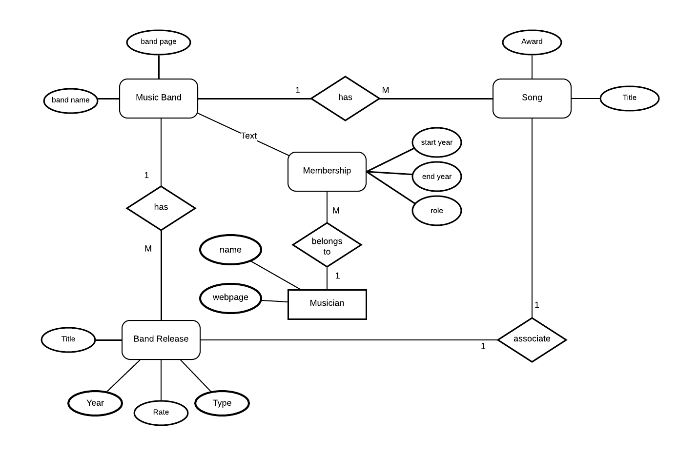

Figure 1: The E-R Diagram of “Band” Database

# Report 2: Relational Schema Modelling

## Relational Schema3

**Music Band**: band-name, band webpage.

**Release**: Release-ID, release title, year of release, release rate, release type.

**Songs:** Release-ID，Songtitle, award.

**Musician**: Musician name, Personal webpage.

**Membership**: Membership-ID, Musician name, start year, end year, band name, role.

It has been claimed that the different bands may have the same band name before it was registered as a trademark, as there are millions of bands online [1]. Therefore, this report assume that the “Band” is discriminated by a combination of band name and webpage. Although a musician for a specific time period is a member of a specific band only, the time period cannot be used as a primary key, for the primary key cannot be null value. A membership ID was therefore introduced as the primary key of membership.

# Bibliography

|  |  |
| --- | --- |
| [1] | T. Griffin, “Mark My Word: Trademark Your Band Name,” *Texas Review of Entertainment & Sports Law,* pp. 177-192, 2014. |