Software Requirements Specification
for
Sales Forecasting Software
Prepared by recess group

GROUP MEMBERSHIP:

# | Names | Registration Number | Signature
1 | OKELLO TIMOTHY | 17/U/9576/PS
2 | TINDYEBWA FORTUNATE ALLAN | 17/U/10441/EVE
3 | MULUMBA HUZAIFA | 17/U/6545/PS
4 | LUBOWA WANYENZE VIVIEN J | 16/U/6627/PS

Table of Contents
1. Introduction 1
1.1 Purpose 1
1.2 Product Scope 1
1.3 References 1
2. Overall Description 2
2.1 Product Perspective 2
2.2 Product Functions 2
2.3 User Classes and Characteristics 3
2.4 Operating Environment 3
2.5 User Documentation 3
3. External Interface Requirements 3
3.1 User Interfaces 3
4. System Features 4
4.1 Use case diagram 4
5. Nonfunctional Requirements 5
5.1 Performance Requirements 5
5.2 Security Requirements 5
6. Supporting Information 5

Introduction

Purpose
The purpose of the document is to collect and analyze all assorted ideas that have come up to define the system, its requirements with respect to consumers.
This document also provides a detailed overview of the entire software product, its parameters and goals. It describes the project's target audience and its user interface, hardware and software requirements. It defines how our client, team and audience see the product and its functionality. Nonetheless, it helps any designer and developer to assist in software delivery lifecycle (SDLC) processes.

Product Scope
Bigmart is a big supermarket chain, with stores all around the country and its current board set out a challenge to all Data Scientist out there to help them create a model that can
predict the sales, per product, for each store. BigMart has collected sales data from the year 2013, for 1559 products across 10 stores in different cities. With this information the corporation hopes we can identify the products and stores which play a key role in their sales and use that information to take the correct measures to ensure success of their business.
The objectives of carrying out the project is to establish sales performance goals for the organization, with such a target, the organization will improve on its services, help it focus only on revenue generating products and stores rather than dealing with non-beneficial products and to predict expenses. It will also be useful in preparing credit policy for BIGMART

References
The ultimate guide to sales forecasting by HubSpot
https://blog.hubspot.com/sales/sales-forecasting
Forecasting methods by corporate finance institute
https://corporatefinanceinstitute.com/resources/knowledge/modeling/forecasting-methods/

Overall Description

Product Perspective
In this model, a five-step procedure is used to solve the problem of predicting the Sales revenue for different products at different outlet locations for Big Mart Companies. First, the data is acquired, collected and divided into training and test label. This data undergoes a preliminary analysis which includes data analysis. In the second stage, data pre-processing is performed which takes care of missing and erroneous values in the dataset. In the third stage, the features are selected and modified to get the best results. In the fourth stage, feature transformation is used to convert categorical
features to numerical features. In the fifth stage, using various algorithm techniques models are built and the results are evaluated. These results are communicated to the firm and finally, after approval the results are applied by the firm to generate a business model for next year.

Product Functions
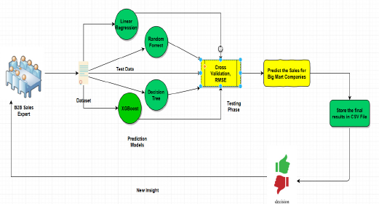

User Classes and Characteristics
The system will be used by sales personnel, managers and administrators.
Sales personnel will use the results of the system which they will access from the web. to draft reports on future sales of the products which will be used by the managers to make decisions and proper planning.
The administrators will have access to the entire system in case of maintenance.

Operating Environment
The software will be run on a computer device with Anaconda on any operating system.

User Documentation
The user manual will be provided in the final project report and a readme added to the git hub commits.

External Interface Requirements

User Interfaces
All users will access the system using a web-based interface.
Initially all users will be required to login with their credentials given by the admin using a login form as shown below.

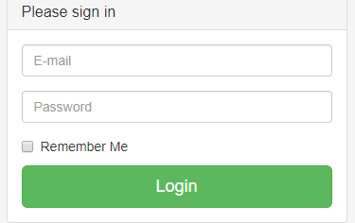

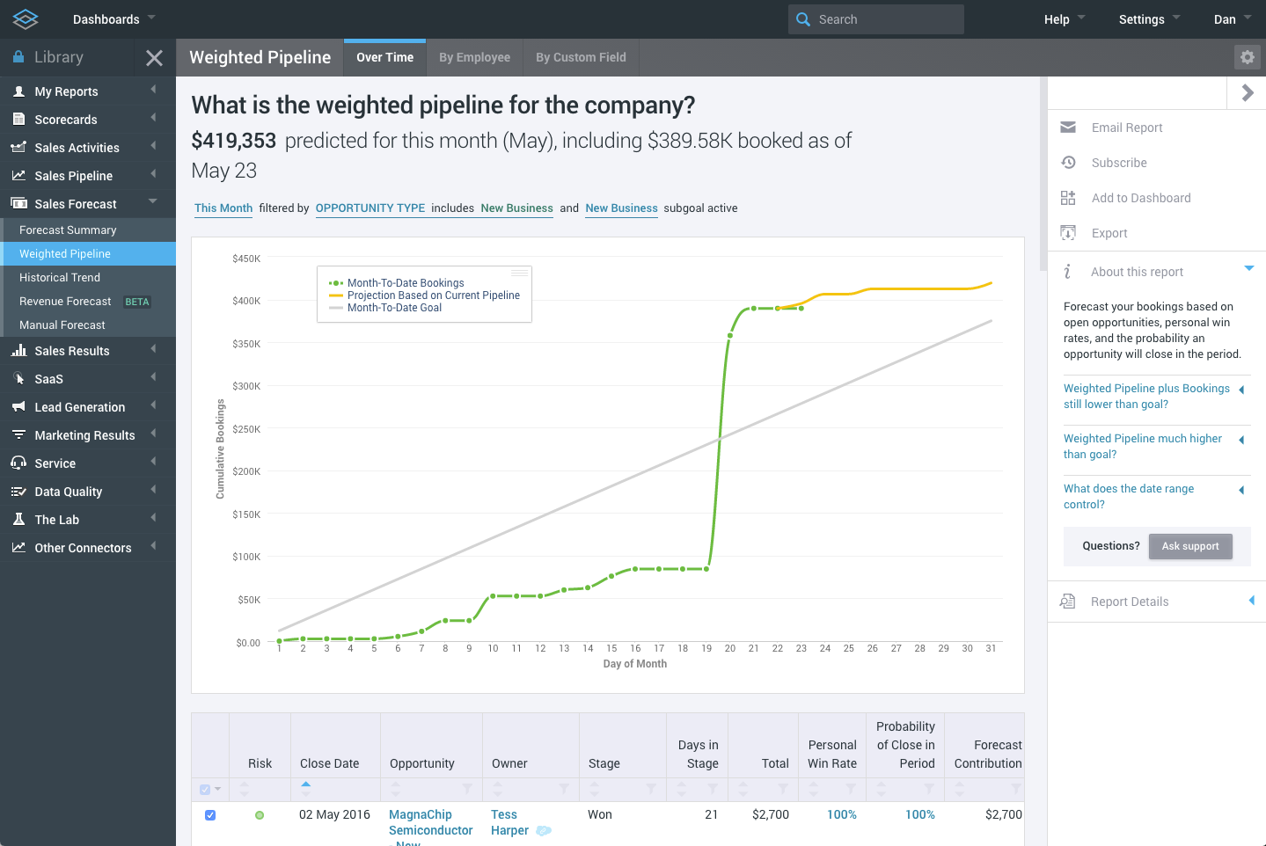
They will then be able to access a dashboard similar to the one shown below that will allow them perform the different tasks provided by the system

System Features

Use case diagram
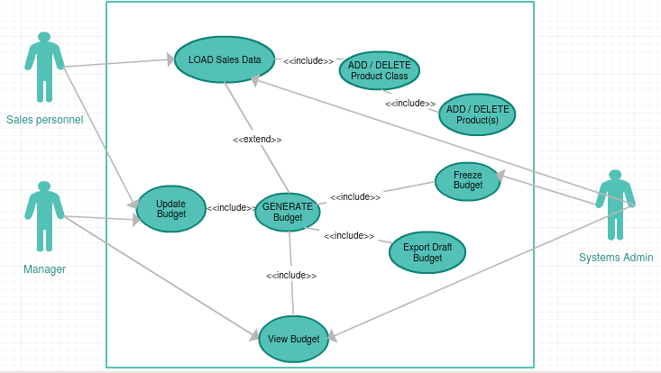

4.1.1 Description
The sales personnel will be able to load the sales, generate a budget and update it.
The manager can only view and update the budget that has been generated by the sales personnel.
The admin can do all the tasks for both users.

Nonfunctional Requirements

Performance Requirements
The product shall be based on web and has to be run from a web server remotely via localhost.
The performance shall depend upon hardware components of the user.

Security Requirements
The system shall automatically log out all users after a period of inactivity.
The system shall not leave any cookies on the user’s computer containing any of the user’s confidential information.
The user’s web browser shall never display a user’s password. It shall always be echoed with special characters representing typed characters.
The system’s back-end servers shall only be accessible to authenticated administrators.
The system’s back-end databases shall be encrypted.

Supporting Information
Please refer the following document:
- Project concept report.

