SALES FORECASTING PROJECT

DEPARTMENT OF INFORMATION SCIENCES
SCHOOL OF COMPUTING AND INFORMATICS TECHNOLOGY
A Concept Paper submitted to the School of Computing and Informatics Technology
For the Study Leading to a Project Proposal in Partial Fulfillment of the
Requirements for the Award of the Degree of Bachelor of
Software Engineering of Makerere University.

Supervisor
Kamulegeya Grace
gkamuleg@cit.ac.ug

GROUP MEMBERSHIP:

# | Names | Registration Number | Signature
1 | OKELLO TIMOTHY | 17/U/9576/PS
2 | TINDYEBWA FORTUNATE ALLAN | 17/U/10441/EVE
3 | MULUMBA HUZAIFA | 17/U/6545/PS
4 | LUBOWA WANYENZE VIVIEN J | 16/U/6627/PS

Introduction
Sales Forecasting is the process of using a company’s sales records over the past years to predict the short-term or long-term sales performance of that company in the future. This is one of the pillars of proper financial planning. As with any prediction-related process, risk and uncertainty are unavoidable in Sales Forecasting too.
Hence, it’s considered a good practice for Sales forecasting teams to mention the degree of uncertainties in their forecast. Sales Forecasting is a globally-conducted corporate practice where a number of objectives are identified, action-plans are chalked out as well as budgets and resources are allotted to them.
The first step to proper Sales Forecasting is to know the things that fall within your domain directly as a salesperson. This usually relates to your sales staff, clients and prospects. Other factors to consider during the setup of a forecast are the negative ones like − uncertainty, abrupt changes in consumer shopping patterns, etc.
One of the most common yet basic challenges that the management of companies face in making business sales forecasts is that their usual approach is a “top to down” one. This approach leaves very little scope for interaction with the sales manager and the salespersons during the data collection process.

Background to the Problem
Regression is an important machine learning model for these kinds of problems. Predicting sales of a company needs time series data of that company and based on that data the model can predict the future sales of that company or product. So, in this research project we will analyze the time series sales data of BigMart and will predict the sales for the coming quarter and for a specific product.
For this kind of project of sales predict, we will apply the linear regression and logistic regression and evaluate the result based on the training, testing and validation set of the data.
The dataset is BigMart dataset obtained from KAGGLE and collected in 2013 sales data for 1559 products across 10 stores in different cities. Also, certain attributes of each product and store have been defined.
Problem Statement
Most stores and supermarkets have major problem of either stocking more or less products at certain seasons thus affecting their profits. Sales prediction in this case would help them determine which product to stock more than the other at a certain point of the year so that they can maximize their profits.
Objectives
To set the sales target, the primary purpose of sales forecasting is to establish sales performance goals for the organization.
To decide plant capacity, on the basis of sales forecasting the organization can plan the plant with output of desired capacity.
To predict expenses, it helps in predicting the expenses and planning budget. It is also useful in preparing credit policy of the company. It is also required for uninterrupted supply of input resources.
Methodology
Linear regression and logistic regression will be used for this kind of problem where we can easily fit a line of high sale and low sale product, quarters and zone for a product as shown below.
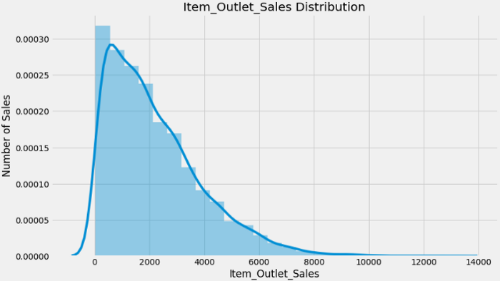
Python based Computer Vision and Deep Learning libraries will be exploited for the development and experimentation of the project. Tools such as Anaconda Python, and libraries such as, Numpy, Scipy, pandas, sklearn, will be utilized for this process.
Outcomes
This project will use regression models to predict sales of different products for the given store based on a time series data for that company. Sales personnel will therefore use this prediction which will be in tabular format to make decisions on which product to stock and not stock in order to maximize profits and minimize costs at a certain trade period.
References
The ultimate guide to sales forecasting by HubSpot
https://blog.hubspot.com/sales/sales-forecasting
Forecasting methods by corporate finance institute
https://corporatefinanceinstitute.com/resources/knowledge/modeling/forecasting-methods/

